To achieve goals of organization with personal growth by applying practical skills.

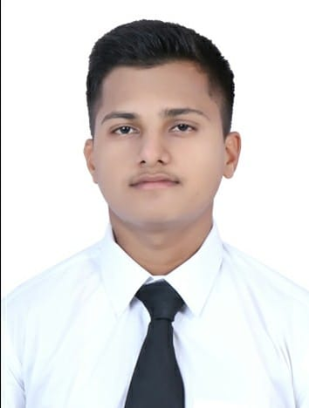

- Trained for 4 months at ITC Fortune Select Exotica, Vashi in all core departments.
- Industrial visit at Renaissance convention center hotel Powai.
- Done ODC’s at Taj Land’s End, Mumbai and Trident, BKC.
- Working in KFC from last 1 year & 9 months as a shift manager.
- Currently working as a Shift manager at pizza hut from last 1 year 6 months.

Industrial Exposure

I hereby declare that the information stated above is true to the best of my knowledge and belief

signature

Student
Bharti Vidyapeeth college of hotel and tourism management studies

Declaration

- 2018-21 Bachelor’s Degree in Hospitality studies
Bharti Vidyapeeth College of Hotel and Tourism management studies
Sem I- B | SEM II- B+ | SEM III- B+
SEM IV- A | SEM V- A+ | SEM VI- A+
- 2017-18 Higher Secondary certificate -
56 % V. K. High school and jr. college Panvel Navi Mumbai.
- 2015-16 Secondary school certificate -

70 % V. K. High school Panvel Navi Mumbai.

Education

More Information
Professional summary

Hobbies

Vaibhav Shamrao Babar
Mob:7400335268
Email: vbabar157@gmail.com
Address: 201,sai-him-pushpak,sec-R2, plot no.89 Karanjade, Panvel 410206,Navi-Mumbai.

Gender – MALE
Date of birth 10-10-2000
Known languages:, Hindi, : English Marathi.
Blood Group: A+

- Travelling
- Watching movies
- Reading
Area of interest:
- food and beverage production
- food and beverage service.

- Ability to multi-task, work under tight deadline and also work under minimal supervision.
- I have planning skills with abilities in working as team for achieving goals.

