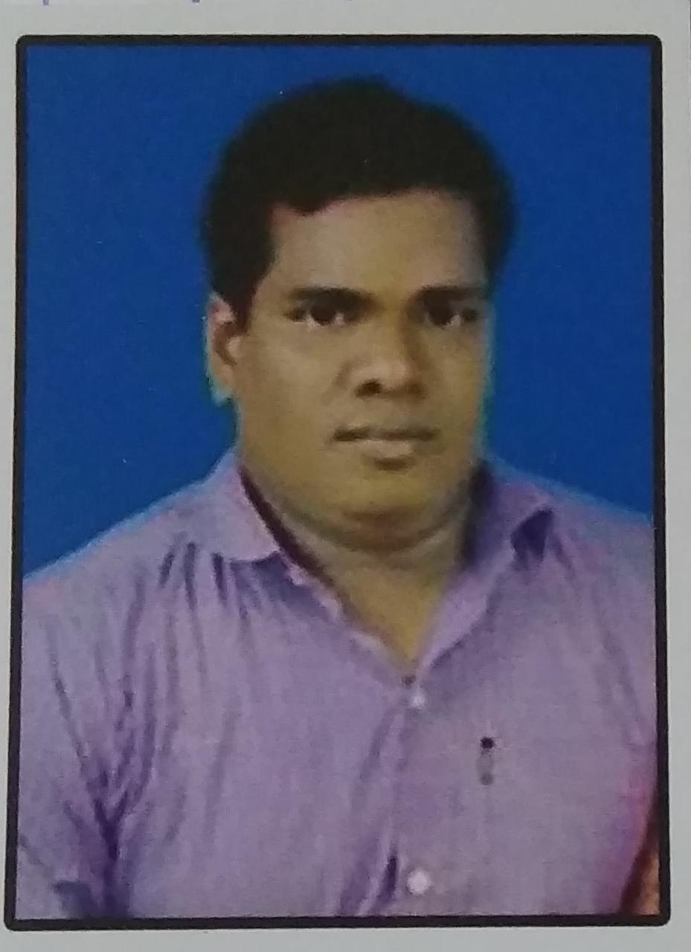
CURRICULAM VITAE
Ajit Kumar Barik
AT/PO-Badakharida
C/O:-Mitika Barik
Dist:-Ganjam,ODISHA,761041

Personality Traits

- Dedicated, sincere and optimistic.
- Faith in myself.

Academic Qualifications.

- Done my 10th in 2002.

Job Experiance
- Worked in MODI TECH (INDIA)PVT LTD. Electrician , House wiring , Fabrication work ,Motor winding . From March 2005 To Feburary 2017.

Personal Profile

Father Name : Mr. Mitika Barik
Date of Birth : 18-07-1987
Gender : Male
Marital Status : Married
Personal Assets : Communication skills, task and time management
Languages Known : English,Hindi and odiya
Hobbies : Exploring new places.

Date :
Place : ODISHA (AJIT KUMAR BARIK)

