Change Request:
- Make this logo at the bottom, above lets talk: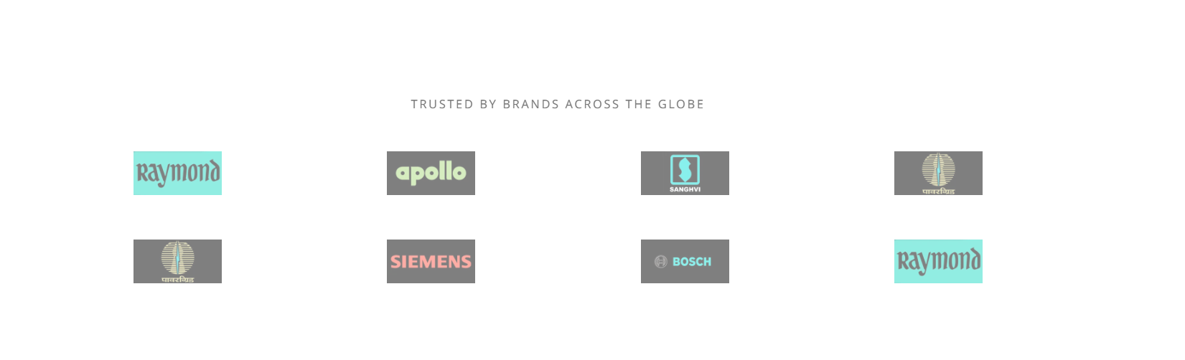
- Check this error on the Antiseize Compount. Also Remove Black Box, just keep images.

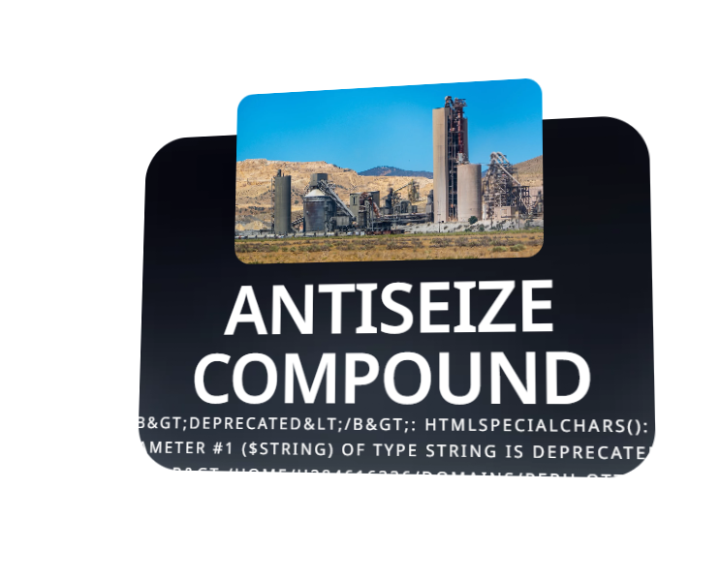
- Can you add one more line for Highly Insulating Anti Track Compound. With a bit smaller test
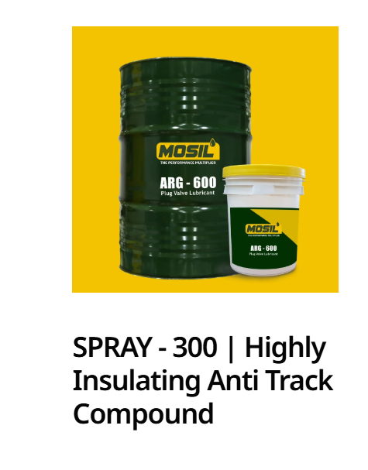
- Icon image on product page
- News section to be implemented along with categories
- Categories on blog page
- Check TDS on email
- Check contact form
- Check career forms
- Add client logo inside product listing page

