**Question 1(3 point)**

Write a Python program with 2 digits, x, y that receives values from input is correspond to the row and column of the 2-dimensional array and complete some function in **Q1.py** file:

* **def f1(x, y)**: creates a 2-dimensional array. The element value in the ith row and jth column of the array must be i*j
* **def f2(x, y)**: Compute the total in each row of matrix and compute the total in each row of matrix

Output for **f1()**:

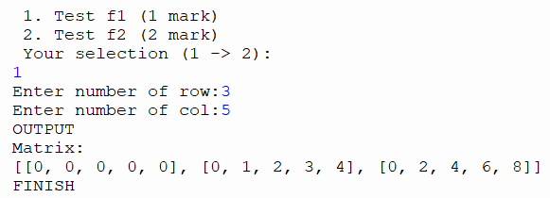

Ouput for **f2()**:

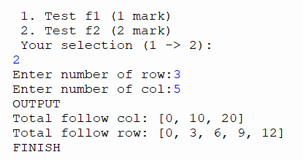

**Question 2(4 point)**

Write a Python program to read file from the data.txt file and complete some function in **Q2.py** file

* **def f1()**: Count the number of character “a” occur in file(**1 point**)
* **def f2()**: In each line in file data.txt, replace all character “a” with the number is the last of each line and compute sum of each line, if the last number has length > 1 then we replace all character in this line with the fist number in number(**3 point**)

**EX**: a, aa, aaa, 1 => output: 1+11+111 = 123

a, aa, aaa, 20 => output: 2+22+222 = 246

The data in data.txt file:

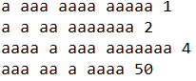

Output for **f1()**:

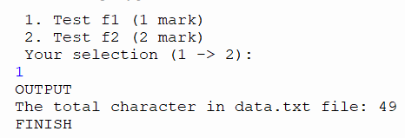

Output for **f2():**

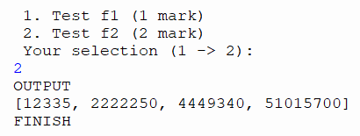

**Question 3(3 point)**

Write a program in the python programing language using object-oriented programing techniques. The program enters a list of points in the space, each with information on x coordinates, y coordinates. You should complete some function in file **Q3.py**:

* **def f1()**: Compute distance from each point to point have coordinates x0=1, y0=2 (**1 point**)
* **def f2()**: Sort all point follow to coordinates y(**1 point**)
* **def f3():** Find the point with multiplication x * y is maximum and print information of this point(**1 point**)

Output for **f1()**:

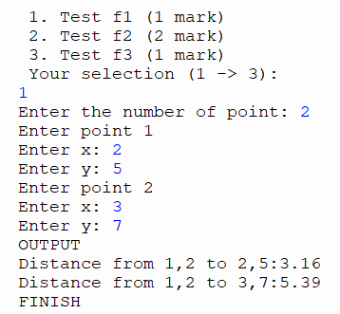

Output for **f2()**:

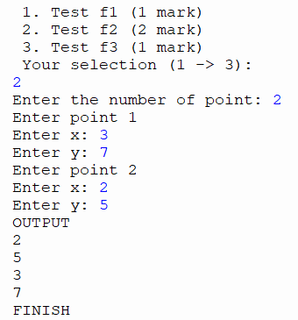

Output for **f3()**:

