NOTE: This template is shareware downloaded from www.processimpact.com. All shareware payments are donated to the Norm Kerth Benefit Fund to help a consultant who is disabled with a brain injury. Please visit http://www.processimpact.com/norm_kerth.html to make a shareware payment ($10 suggested). Thank you!
Software Requirements Specification
for
<E-Shopping>
Version 5.0 approved
Prepared by <Dhruv> <Lucky> <Anvit> <Palak>
<Chitkara University>
<18th March 2025>
eLearning versions of several popular Process Impact training seminars are available at www.processimpact.com/elearning.shtml, including “In Search of Excellent Requirements,” “Exploring User Requirements with Use Cases,” “Writing High-Quality Requirements,” “Software Inspections and Peer Reviews,” and “Project Management Best Practices”. Single-user and corporate-wide site licenses are both available.
Table of Contents
1. Introduction
1.1 Purpose
1.2 Document Conventions
1.3 Definations
1.4 References
1.5 Overview
2. System Overview
2.1 System Achitecture
2.2 System context
2.3 System Functions
2.4 User Characterstics
3. System Features
3.1 User Registeration and Authentication
3.2 Product Management
3.3 Shopping Cart
3.4 Checkout Process
3.5 Order Management
3.6 Payment Gateway Integration
3.7 Customer Account Management
3.8 Review and Rating
3.9 Admin Dashboard
3.10 Notifications and Alerts
3.11 Search and Filter
4. External Interface Requirements
4.1 User Interfaces
4.2 Hardware Interfaces
4.3 Software Interfaces
4.4 Communications Interfaces
5. System Overview
5.1 Performance
5.2 Reliability
5.3 Security
5.4 Usability
5.5 Maintainability
5.6 Portability
6. Other Nonfunctional Requirements
6.1 Performance Requirements
6.2 Safety Requirements
6.3 Security Requirements
6.4 Software Quality Attributes
7. System Model
7.1 State Transition Diagram
7.2 Sequence Diagram
7.3 Use Case Diagram
7.4 Data Flow Diagram
7.5 ER Diagram

Appendix A: Glossary

Revision History
Name | Date | Reason For Changes | Version

Chapter 1: Introduction

1.1 Purpose

The intent of this Software Requirements Specification (SRS) document is to detail exhaustively the requirements required to develop an efficient and scalable e-commerce platform. This document is meant to be a reference of primary importance for every stakeholder, such as developers, designers, project managers, quality assurance, and end-users.

The main goal of this platform is to offer a smooth, secure, and easy-to-use online shopping experience. This SRS document outlines the functional and non-functional requirements, system features, external interfaces, and technical characteristics required for the successful implementation and deployment of the platform. It will act as a development guide, test guide, and maintenance guide for development, testing, and maintenance teams during the software life cycle.

1.2 Scope

This online shopping platform is intended to provide online shopping convenience by allowing users to search for products, handle their shopping cart, and make secure transactions. The system will be designed to serve both customers and administrators for easy running and management of the online store.

1.1.1 Features Included:

Customer Interface: An online shopping platform should have basic features to provide better user experience and security. It should allow user registration and authentication to provide secure access. The customer must be able to search and browse products effortlessly using filters and search. Adding products to a shopping cart must be supported by the platform to facilitate easy shopping. A safe payment and checkout system is necessary to secure user transactions and information. Users should also be able to view order history and tracking for monitoring purposes. Features like a wishlist and product recommendations can personalize the shopping experience, increasing engagement and customer satisfaction.

Administrator Interface: An efficient e-commerce system should include robust user management, allowing administrators to add, edit, and delete user accounts. It should also support product catalog management, enabling the addition, modification, and removal of products, along with stock level management and categorization for better organization. An orderly processing system with status notification keeps customers updated about their orders. Secure payment verification and handling are necessary to process transactions securely. The system should also include sales reports and analytics to provide valuable insights about business performance and guide strategy optimization for growth.

Third-Party Service Integration: A secure e-commerce website should have secure payment gateways like PayPal, credit/debit cards, and digital wallets to facilitate secure and easy transactions for the customers. It should also provide shipping providers for effective order processing and real-time tracking so that customers can track their shipments easily.

1.2 Features Not Included:

Physical Store Operations: The system is designed solely for online transactions and order fulfillment, so it will not have the capacity to handle in-store transactions, point-of-sale (POS) systems, or any retail store management features. The main focus is to offer a smooth digital shopping experience without having to combine physical retail operations.

1.3 Definitions, Acronyms, and Abbreviations

To maintain clarity, the following definitions and acronyms are specified:

•SRS: Software Requirements Specification

UI: User Interface

• API: Application Programming Interface

• PCI-DSS: Payment Card Industry Data Security Standard

• GDPR: General Data Protection Regulation

•HTTPS: HyperText Transfer Protocol Secure

•OTP: One-Time Password

•SKU: Stock Keeping Unit

1.4 References

This report cites industry best practices, laws, and compliance guidelines to meet the security and compliance standards of the system:

•PCI-DSS: Payment Security Standard

•GDPR: General Data Protection Regulation

•OWASP: Open Web Application Security Project for best web application security practices

1.5 Overview

This paper contains a detailed breakdown of the requirements of the e-commerce platform. The paper has been organized in the following manner:

•Chapter 2: System Overview – Delivers a top-level description of the environment of the system, the classes of users, constraints, and assumptions.

•Chapter 3: System Features – Splits apart each system component and its specification

•Chapter 4: External Interface Requirements – Enumerates necessary integrations with third-party services like payment processors and shipping companies

•Chapter 5: System Attributes – – Indicates performance, security, scalability, and usability requirements.

•Chapter 6: Non-Functional Requirements – Indicates Scalability, Availability, Data Integrity and Compliance.

•

Chapter 7: System Models - Includes all diagram like DFD, ER Diagram etc. By using this systematic format, this paper is a detailed roadmap for planning, building, and sustaining the e-commerce website. Each part offers a detailed analysis of key elements so that every party involved understands the scope and deliverables of the project.

Chapter 2: System Overview

2.1 System Architecture
The e-commerce site is developed with a three-tier architecture to provide scalability, maintainability, and security. The three major layers are :
- Presentation Layer:
The front-end layer is the user interface where both customers and administrators can interact with the system. Customers will be able to access the necessary features such as product browsing, shopping cart management, order placement, and account management for seamless shopping. At the same time, administrators will utilize a specialized interface to effectively handle products, users, and orders. The front-end will be implemented based on contemporary web technologies, such as HTML, CSS, JavaScript, and frameworks such as React Angular, providing a smooth and responsive user experience
- Application Layer:
The backend layer is responsible for handling the core business logic, including order processing, user authentication, payment handling, and database interactions. It will be developed using a backend framework such as Node.js with Express or Django to ensure scalability and efficiency. Additionally, API endpoints will facilitate seamless communication between the front-end and external services like payment gateways and shipping providers, ensuring smooth and secure transactions.
- Data Layer:
The database layer is responsible for storing and managing system data, including user information, product catalogs, shopping cart data, and order details. It will be implemented using a relational database like PostgreSQL or MySQL for structured data management or a NoSQL database like MongoDB for greater flexibility. To enhance performance, proper indexing and caching mechanisms will be employed, ensuring fast data retrieval and optimized query execution.

2.2 System Context
The online store will operate in an interconnected environment, making use of sever external services to provide a seamless online shopping experience The most significant integrations are :
- Payment Gateways:
The system will be safe in transactions by incorporating well-known payment gateways like PayPal, Stripe, and credit/debit card processors. For the protection of user payment information, it will follow PCI-DSS standards to provide a secure and trustworthy payment processing environment.
- Shipping Providers:
The system will be integrated with large shipping carriers such as FedEx, UPS, and USPS, enabling customers to choose shipping options and monitor their orders in real-time. Shipping prices will also be dynamically calculated depending on destination, package weight, and chosen shipping option, providing accurate and transparent pricing.
- Inventory Management Systems:
The platform will be integrated with inventory management software to keep stock levels up to date and avoid overselling. The automatic stock updates will be triggered on successful buys and when administrators replenish products, to achieve real-time inventory accuracy .

2.3 System Functions
The online shopping platform is built to offer several key functionalities to customers and administrators alike. These are core functions:
- Product Browsing:
Customers can browse products easily via categories, search features, and filters for a hassle-free shopping experience. Each product will have in-depth descriptions, high-quality images, customer reviews, and price details to enable users to make informed buying decisions.

- Shopping Cart:
Users will enjoy complete control of their shopping cart, enabling them to add or delete items and update the number of items they wish to have. A dynamic subtotal will be visible at all times, facilitating transparency and allowing users to assess their costs prior to checkout.
- Checkout Process:
At checkout, customers can view their chosen items, input shipping information, and select a payment option for an easy buying process. The system will have multiple shipping options and give estimated delivery dates for added convenience. For security, there will be a secure transaction process with encryption and fraud protection mechanisms to safeguard user information and payments.

- User Account Management:
Shoppers can register, securely sign in, and easily manage their own information. They will be able to view order history, invoices, and payment methods for improved account management. Password recovery features and multi-factor authentication (MFA) will be added to the system to provide increased security, ensuring safe access and data protection.
- Admin Dashboard:
Administrators will be able to access a control panel to manage the platform effectively. They can add, modify, or delete products in the catalog, manage customer accounts and permissions, and process orders, monitor payments, and issue refunds. They will also be able to generate sales reports and analyze customer buying patterns, assisting in optimizing business operations and making better decisions.

2.4 User Characteristics
The platform will cater to different types of users, each with distinct roles and responsibilities:

Customers: Customers are the key users of the e-commerce website, having the flexibility to search for products, place items in their shopping cart, make payments, and monitor their orders in a hassle-free manner. They will have recommendations provided based on their history of browsing and buying, thereby increasing their convenience of shopping. The site will be optimized for ease of navigation and use with a seamless user interface, accessible for both technically sound and not-so-technically sound customers.

Administrators: Admins will be in charge of the overall e-commerce site, ensuring things run smoothly. They will handle user accounts, track transactions, update product offerings, and fix order and payment issues. For added efficiency, admins will enjoy robust data analysis, fraud analysis, and performance tracking tools. Role-based access control (RBAC) will also be employed to make sure various levels of admin users are granted the proper permissions, securing security and operation management.
- Support Staff: Support staff will assist customers with queries, complaints, and technical issues, ensuring a smooth shopping experience. They will process refund requests, product-related questions, and dispute resolutions efficiently. To effectively deliver customer service, support staff will be granted access to customer order information and chat support facilities, which will enable them to solve issues promptly and correctly .By providing all user groups with clearly defined functionalities, the system will offer a seamless and safe online shopping experience.

Chapter 3: System Features

3.1 User Registration and Authentication
In order to provide a safe and personalized shopping environment, the system will have comprehensive user registration and authentication features.
- User Registration:
The customer has to create a user account via their email and a secure password. Confirmation via email would be required in order to start using the account. Third-party authentication service signup via Google or Facebook login has also been allowed, thus facilitating a fast, easy, as well as a secure mode of signup.
- Login/Logout:
Users will be able to log in securely with their registered details, providing secure access to their account. For added security, Multi-Factor Authentication (MFA) will also be offered as an extra layer of security. Also, to avoid unauthorized access, users will be logged out automatically after a specified time of inactivity.
- Password Management:
Users can reset their password through a secure email link, ensuring a safe and convenient recovery process. To protect user data, passwords will be securely stored using encryption and hashing techniques, preventing unauthorized access.

3.2 Product Management
The system allows administrators to manage the product catalog efficiently.
- Product Addition & Updates:
Admins can add new products by entering information like name, description, price, stock status, images, and categories. They can also edit or delete products as necessary to maintain accurate and current listings.
- Category Management:
Products can be categorized into various categories to facilitate user navigation and enhance the shopping experience. Categories can be updated or deleted as necessary based on demand and inventory fluctuations.

- Stock Management:
Inventory levels will be automatically reflected after every purchase to maintain an accurate stock record. Low-stock alerts will also inform admins whenever stock drops below a specified amount, enabling them to restock on time.

3.3 Shopping Cart
A user-friendly shopping cart system will allow customers to manage their purchases before checkout.
- Adding & Removing Products:
Shoppers can simply click to add items to their cart for a smooth shopping experience. They also have the option to delete items or change quantities at any moment prior to checking out.
- Cart Summary:
Customers will be able to view a real-time item price breakdown, taxes, and total cost, maintaining transparency in their shopping. If any discount or offer is applicable, it will automatically be deducted, ensuring a hassle-free and smooth checkout process.
- Persistent Cart:
Shopping cart will be stored persistently, enabling customers to retrieve their chosen items even after log out and revisiting later, providing a convenient and unbroken shopping experience.

3.4 Checkout Process
A smooth and secure checkout experience will be implemented.
- Order Review:
Users will get to see their chosen items, i.e., price and estimated delivery, before they make payment, to ensure accuracy and satisfaction with order.
- Shipping Options:
Users will be offered various shipping options, i.e., standard, express, and priority shipping. Estimated delivery dates will be shown depending on the location of the user, to provide clarity and convenience in shipping.
- Payment Integration:
Customers have several payment options, such as credit/debit cards, PayPal, and digital wallets, to ensure flexibility and ease of payment. Secure encryption methods will be employed to protect transaction information to ensure safety.

3.5 Order Management
Users and admins will have access to detailed order tracking and management.
- Order Status Updates:
Clients are able to monitor their orders in real time, receiving status notifications like Pending, Shipped, Delivered, or Canceled. Users will receive automatic notifications regarding any update to their order status, providing a seamless and transparent buying experience.
- Order History:
Users are able to view their purchase history, download invoices, and easily re-order past items, facilitating the tracking of expenses and re-purchase of favorite products.
- Order Cancellation & Refunds:
Users will be able to cancel orders or get refunds under defined conditions. Admins will be able to approve, process, and review refund requests for a fair and efficient resolution.

3.6 Payment Gateway Integration
A secure and reliable payment system will be integrated to handle transactions efficiently.
- Multiple Payment Methods:
The site will have multiple secure payment methods, such as Credit/Debit Cards, PayPal, Stripe, and other reputable payment processors to provide a safe and easy transaction experience.
- Security Compliance:
Payment transactions will be PCI-DSS compliant to provide utmost data security. Moreover, fraud detection and encryption mechanisms would be put in place to protect user details and prevent unauthorized transactions.
- Transaction Logging:
Payment history will be tracked for administrators and users alike for transparency purposes.

3.7 Customer Account Management
Users will have control over their personal accounts and preferences.
- Profile Management:
Personal information such as name, address, and contact details can easily be updated by customers to maintain their account data accurate and current.
- Security Features:
Users can update their password and activate two-factor authentication (2FA).
- Order & Payment Preferences:
Users can store their payment methods and default shipping addresses, facilitating a quicker and more convenient checkout process.

3.8 Review and Rating System
A feedback system will be implemented to enhance transparency and trust.
- Product Reviews:
Customers are able to give feedback by posting detailed, image, text, and star-rating-enabled reviews, enabling other consumers to make informed purchases.
- Moderation:
The admins will be allowed to moderate and delete inappropriate reviews.
- Review Visibility:
Customers are able to view, select by rating, newest, or most helpful.

3.9 Admin Dashboard
A powerful dashboard will be available for administrators to manage the platform effectively.
- User Management
Admins can add, modify, or deactivate customer accounts when necessary. Role-based permissions will be enforced to make sure that various admin levels have proper access and control.
- Order & Payment Tracking:
Admins can view and handle pending, completed, and refunded orders.
- Product & Inventory Management:
Admins will be able to add/edit/remove products and track stock quantities.
- Reports & Analytics:
Sales information, customer behavior, and site traffic reports will be provided to aid business analysis and make well-informed decisions.

3.10 Notifications and Alerts
A notification system will keep users informed about important updates.
- Email & SMS Notifications:
Customers will be notified for order confirmations, shipping updates, and payment receipts. Emails will be sent for promotions like discounts, sales, and special events.
- Admin Alerts:
Admins will receive a notification for low stock, payment issues, and other system important events.

3.11 Search and Filtering System
To enhance user experience, an advanced search and filtering system will be implemented.
- Product Search:
Users can find products by using keywords, category, and brands.
- Advanced Filters:
Filters will allow shoppers to narrow their searches according to price point, customer rating, availability, and discount promotion to provide a more streamlined and targeted shopping experience.
- Sorting Options:
Products can be sorted by popularity, latest addition, price (low to high or high to low), and best rated for easier discovery of desired products.

Chapter 4: External Interface Requirements
This chapter outlines the different ways users and systems interact with the e-commerce platform. These interfaces ensure smooth communication between customers, administrators, hardware, and external services such as payment gateways and shipping providers.

4.1 User Interfaces
The e-commerce platform will provide two main types of interfaces tailored for different users:

Customer Interface:
• The customer-facing website or mobile app is designed to be intuitive and user-friendly. Customers are able to navigate products easily by using search and filter tools, add items in the shopping cart, and go to checkout smoothly. They are able to make secure payments using various payment methods, track their orders, and control their account settings for a seamless and hassle-free shopping experience.
• Modern web technologies (e.g., React, Vue.js, or Angular for websites and Flutter or React Native for mobile applications) will be employed to create an interface that provides a seamless experience.
• Responsiveness: The website will be optimized for various devices, such as desktops, tablets, and smartphones.

Admin Interface:

A web-based secure administration dashboard will be made available to administrators to oversee the site efficiently. The dashboard will feature:
Product Management – Creating, modifying, or removing products and categories.
Order Management – Visibility, processing, and tracking customer orders.
User Management – Customer account management, refund requests, and conflict resolution.
Reports & Analytics – See sales numbers, stock, and business analytics.

The admin interface must be authenticated securely, for example, role-based access control (RBAC) for limiting access based on the level of the admin's authority.

4.2 Hardware Interfaces
If the e-commerce platform integrates with physical retail stores, it will need to interact with different hardware components to streamline business operations.

POS (Point-of-Sale) Systems: If the business is a physical store, the system will be connected to POS terminals to handle in-store transactions. POS systems will allow customers pay with credit/debit cards, mobile wallets, or cash .Accept electronic or paper receipts.

Barcode Scanners: Barcode scanners will be used by warehouse staff and managers to monitor stock easily.
.

4.3 Software Interfaces
The platform will connect with various third-party services to enhance functionality and provide a seamless shopping experience. These integrations include:

Payment Processing: We can pay through PayPal, Stripe, and Square . We can also use Credit/Debit Cards, Digital Wallets (Apple Pay, Google Pay) ,PayPal for Transactions

Shipping & Logistics Services: The site will be integrated with top carriers like FedEx, UPS, and USPS to:

Provide live shipping estimates based on package weight and destination. Helps users to select other shipping options (express, standard, same-day shipping).

Make tracking numbers for customers when they order.

Inventory Management Integration:

If the company has more than one store or warehouse, the system will be integrated with stock management software such as SAP, QuickBooks, or TradeGecko. This provides real-time synchronization of inventory across all stores.Third-Party APIs for Marketing &

Customer Engagement:
The platform may also integrate with Email marketing tools for sending promotions and newsletters . Chatbots & Live Chat Services for customer support.

4.4 Communication Interfaces
To ensure seamless communication between different parts of the system, the platform will rely on secure and efficient communication protocols:

Web Communication (HTTP/HTTPS Protocols):

If the company has more than one store or warehouse, the system will be integrated with stock management software such as SAP, QuickBooks, or TradeGecko. This provides real-time synchronization of inventory across all stores.

Email & Notification Services:
The system will send email and SMS notifications for Order confirmations, Shipping updates , Payment receipts, Promotional offers and discounts

Chapter 5: System Attributes
This chapter presents the essential properties that the e-commerce system should uphold to ensure performance, security, reliability, usability, maintainability, and portability. These properties determine the performance of the system under various circumstances and the simplicity with which it can be utilized and administered.

Performance

Performance is also a key factor in user satisfaction. Slow transactions or a slow website can be discouraging. The system will be built to deliver fast response times and smooth interactions.

Page Load Time: The site will be optimized to load within 3 seconds to provide users with an uninterrupted experience while surfing. Performance will be boosted through efficient caching to maintain current frequently accessed data, optimized media and images for faster loading, and compressed and minimized CSS, JavaScript, and HTML files for faster rendering. In addition, Content Delivery Network (CDN) integration will be employed to enhance global data delivery speed and overall performance.

Transaction Speed: The checkout and payment processing will be optimized to be done within 10 seconds or less, offering a hassle-free and seamless buying experience. The system will include rapid payment gateways like Stripe, PayPal, and Apple Pay for rapid transactions. The system will also include payment information pre-validation in the background to catch and fix errors in advance so there are no interruptions and a seamless checkout experience.

5.2 Reliability
A reliable system ensures that users can access the platform without unexpected failures.
Uptime: The system will have an uptime of 99.9%, which means that it will be available and running with minimal downtime. This will be achieved through cloud hosting with auto-scaling to cater to high traffic, load balancing to distribute traffic evenly and prevent server overload, and redundant servers to ensure round-the-clock availability in case of failures
Backup and Recovery: The system will support automated daily backups to avoid data loss and maintain reliability. There will be a disaster recovery plan to enable rapid restoration in the event of system failure. There will also be regular testing of restoration of backups every month to maintain data integrity and readiness for any unexpected problems.

5.3 Security
Security is a top priority to protect customer data, transactions, and system integrity.

Encryption: All sensitive data, including passwords, payment details, and user information, will be encrypted using SSL/TLS to ensure security. Both data at rest (stored data) and data in transit (data sent over the internet) will be encrypted, preventing unauthorized access and safeguarding user privacy.

Secure Authentication:
- Multi-Factor Authentication (MFA) will be required for sensitive actions like:
  - Logging in from a new device.
  - Changing passwords or payment details.
  - Making high-value transactions.
- Session timeouts will be implemented to log out inactive users automatically, reducing the risk of unauthorized access.

Protection Against Cyber Threats:The system will implement firewalls and intrusion detection systems to monitor and block suspicious activity, ensuring robust security. Regular security audits and vulnerability testing will be conducted to identify and mitigate potential threats. Additionally, the platform will adhere to industry standards such as PCI-DSS for payment security and GDPR for user privacy, ensuring compliance and data protection.

5.4 Usability
A good user experience is critical for keeping customers engaged and ensuring they can navigate the platform effortlessly.

User-Friendly Design: The interface will be intuitive, allowing users to easily search for products and complete orders without confusion. Key features will include clear navigation menus for quick access, a consistent design across pages to ensure familiarity with buttons, fonts, and icons, and a streamlined checkout process with minimal steps to reduce frustration and enhance the shopping experience.

Responsive Design: The platform will be fully responsive, meaning it will automatically adapt to different screen sizes:
  - Desktop users will have a full-featured interface with advanced filtering options.
  - Tablet users will see a compact but complete version of the website.
  - Mobile users will have a simplified view with easy touch-based navigation.

Accessibility:
The platform will adhere to Web Content Accessibility Guidelines (WCAG) to ensure ease of use for individuals with disabilities. It will include features such as text-to-speech support, keyboard navigation, and high-contrast modes, enhancing accessibility and providing an inclusive user experience.

5.5 Maintainability
To keep the system functional, scalable, and easy to update, it must be built with a maintainable code structure.

Modular Architecture:
The system will be built using a modular design, where components such as user authentication, product management, and payments function independently while remaining interconnected. This structure will make it easier to update features, fix bugs, and scale the platform without disrupting other functionalities.

Clear Documentation:
Developers will have access to detailed technical documentation to help them understand the system's functionality and architecture. This documentation will include API endpoints and their usage, instructions for adding new features, and guidelines for troubleshooting common issues, ensuring smooth development and maintenance.

Regular Updates & Bug Fixes:
The system will adopt an agile development approach, enabling continuous improvements based on user feedback to enhance functionality and user experience. Additionally, automated testing will be conducted before each update to ensure stability and prevent disruptions to existing features.

5.6 Portability
Portability ensures that the system works across different devices, browsers, and operating systems.

Browser Compatibility:
- The platform will be optimized for all modern web browsers, including:
  - Google Chrome
  - Mozilla Firefox
  - Safari
- Progressive Enhancement techniques will be used to ensure that the core functionality works even on older browsers.

Device Compatibility:
- The system will support multiple devices, including:
  - Desktops and laptops (Windows, macOS, Linux)
  - Tablets (iPads, Android tablets)
  - Smartphones (iOS, Android)
  - A mobile-first approach will be used to optimize for smartphones, ensuring fast loading and easy navigation.

Bottom of Form
Chapter 6. Non-Functional Requirements
6.1 Scalability
• The system must support a maximum of 100,000 concurrent users without a degradation of performance. The infrastructure needs to expand horizontally to accommodate increasing traffic.
6.2 Availability
- available 24/7.
6.3 Data Integrity
- Data integrity must be ensured for all transactions. The system will implement validation and error-checking mechanisms.
6.4 Compliance
- The system must comply with GDPR for user data protection and PCI-DSS for secure payment processing.

s
Chapter 7. System Model
7.1 State Transition Diagram

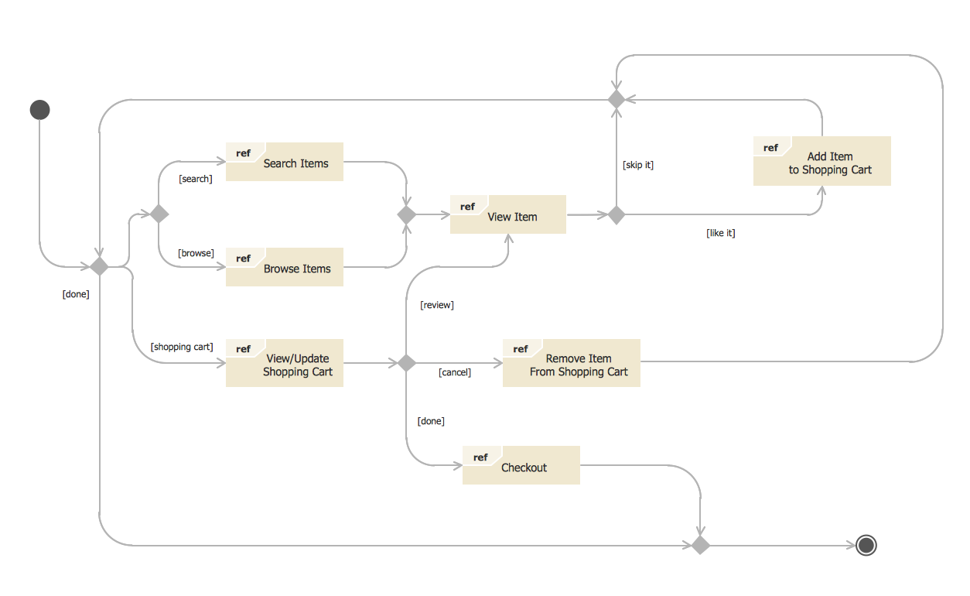

7.2 Sequence Diagram
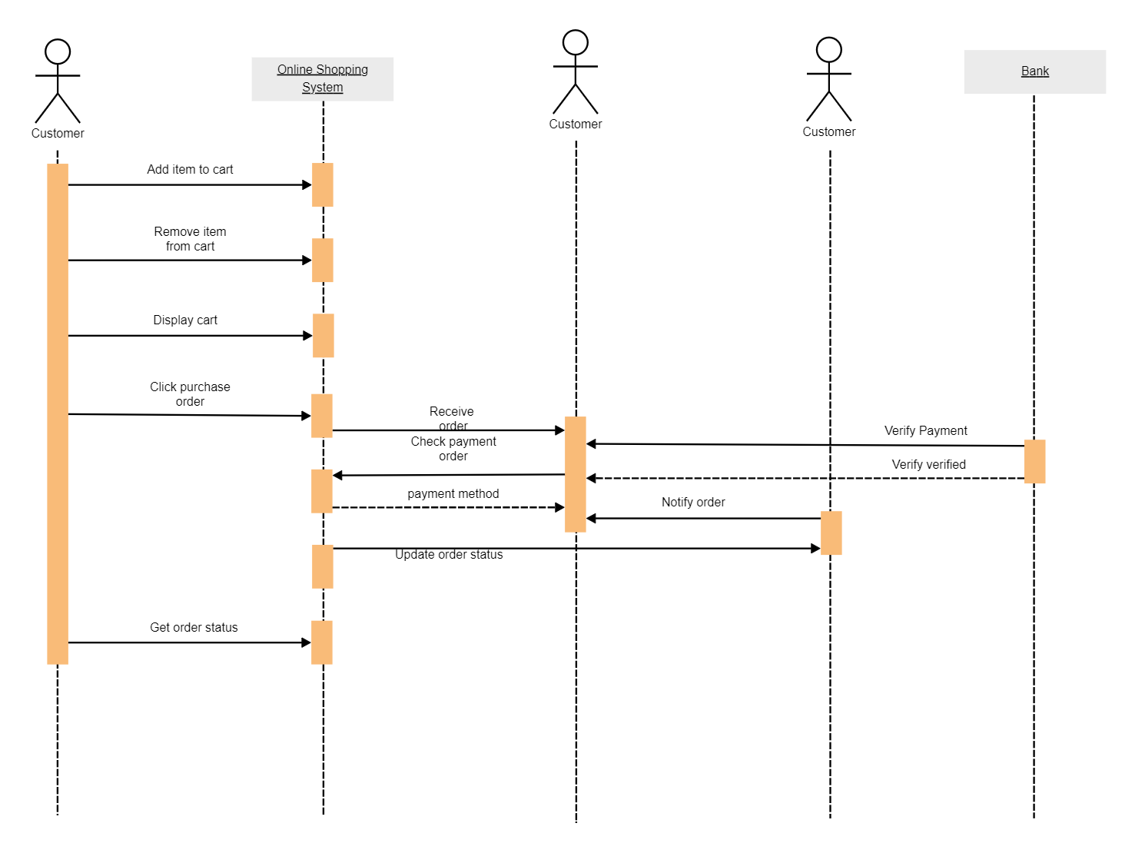

7.3 Use Case Diagram

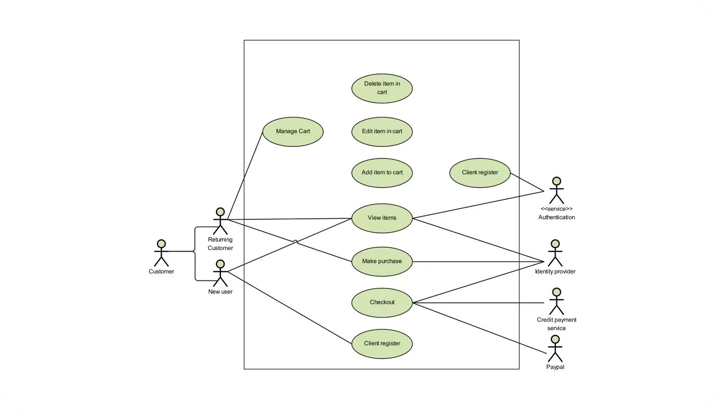

7.4 Data Flow Diagram

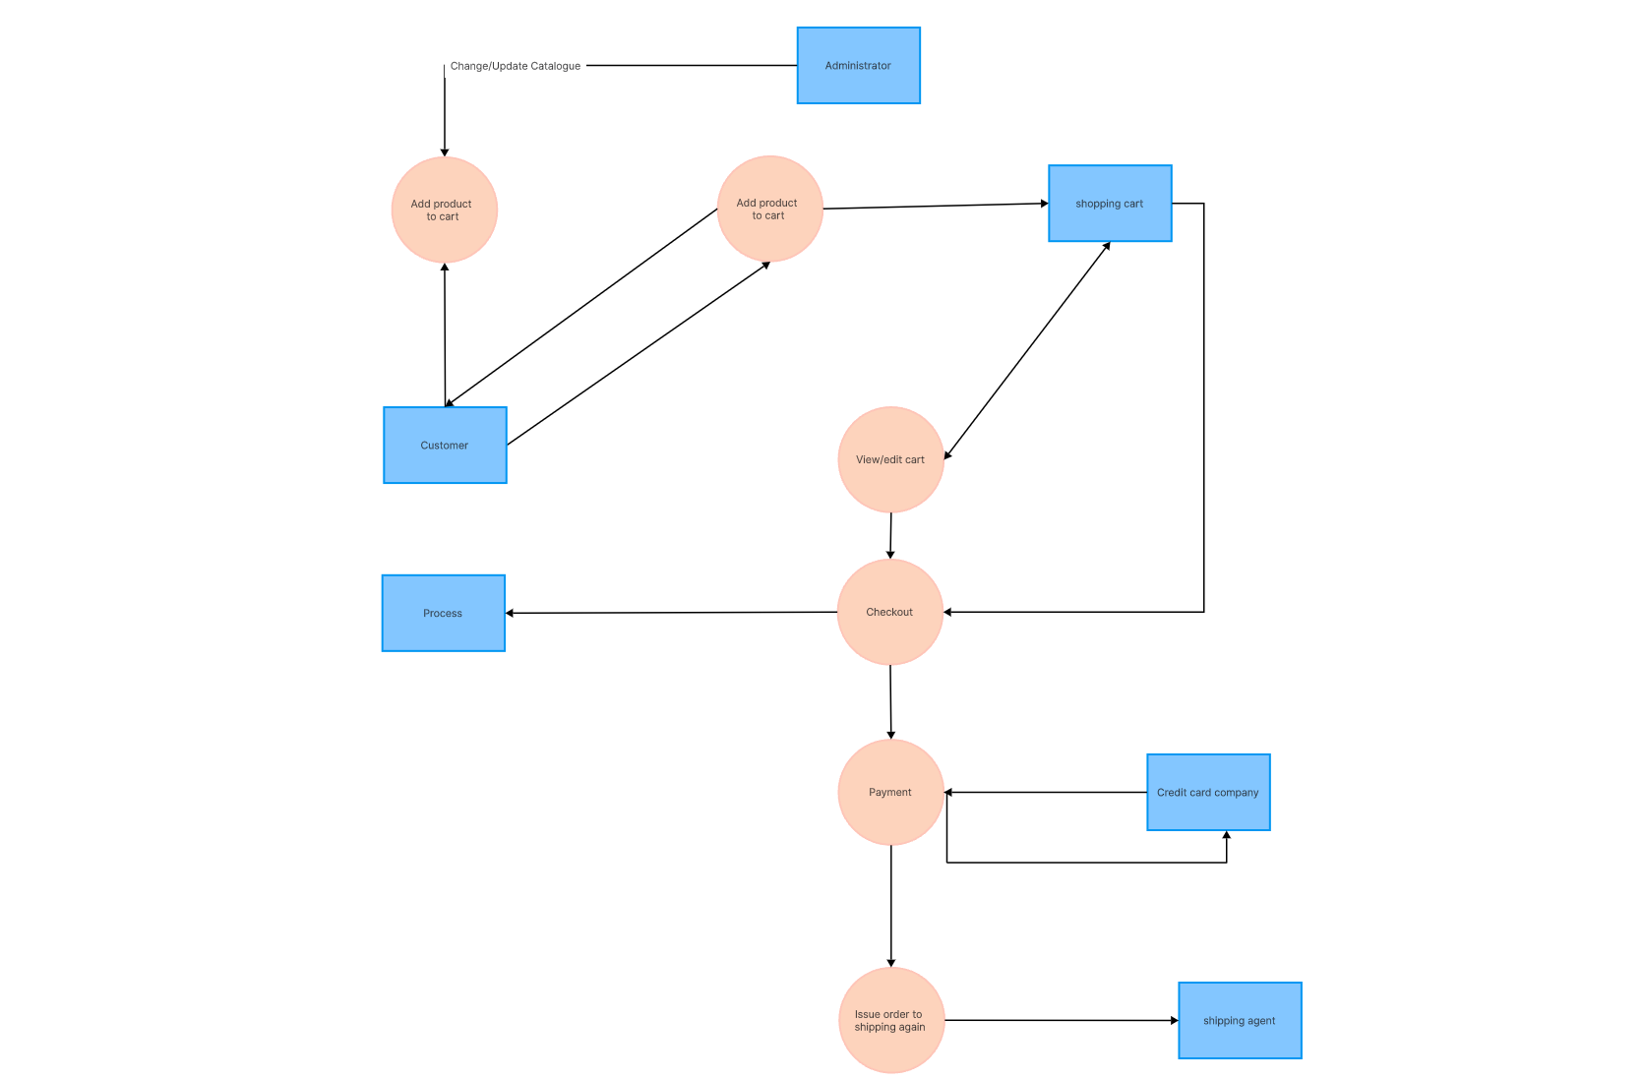

7.5 ER Diagram

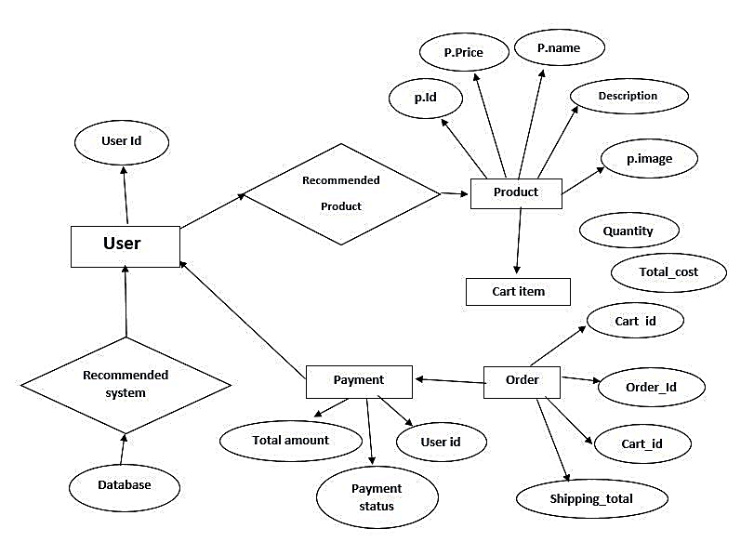

Appendix A

Glossary

- Session: A user's interaction period with the system, usually tracked via cookies.
- Order Status: The state of an order, such as "Pending," "Shipped," or "Delivered."

Additional Information

- Wireframes: Visual representation of the system’s user interfaces will be provided separately.
- Data Flow Diagrams: To illustrate the system's process flow.

