MySQL LAB-2
Problem 1: Online Shopping System
Practice Questions CREATE
a) Create a database named OnlineShoppingDB.
b) Create the Customers table.
c) Create the Orders table with an appropriate foreign key.
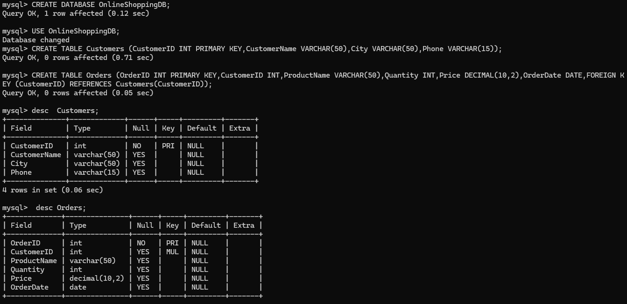

INSERT
a) Insert all 25 customer records.
b) Insert all 25 order records.

a) Insert all 25 customer records.
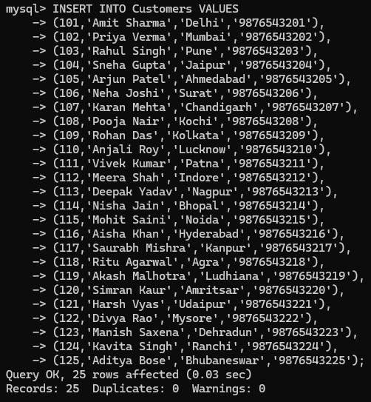

b) Insert all 25 order records.
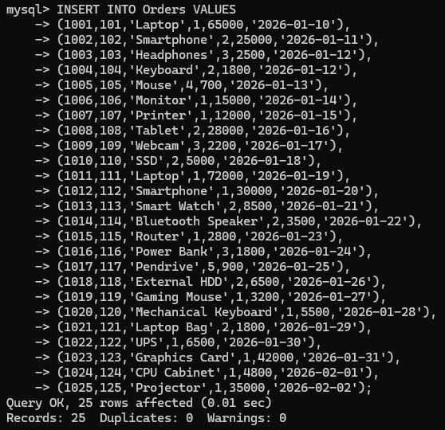

UPDATE
a) Change the city of Customer ID 115 from Noida to Gurugram.
b) Update the phone number of Customer ID 122.
c) Change the quantity of Order ID 1017 from 5 to 8.
d) Increase the price of the Projector to ₹37,000.
e) Change the product name Router to WiFi Router.
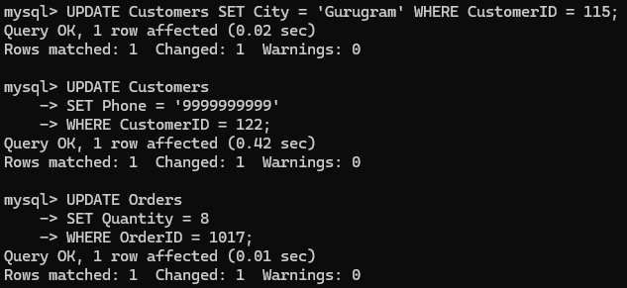
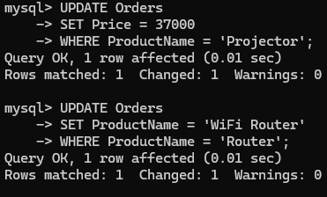
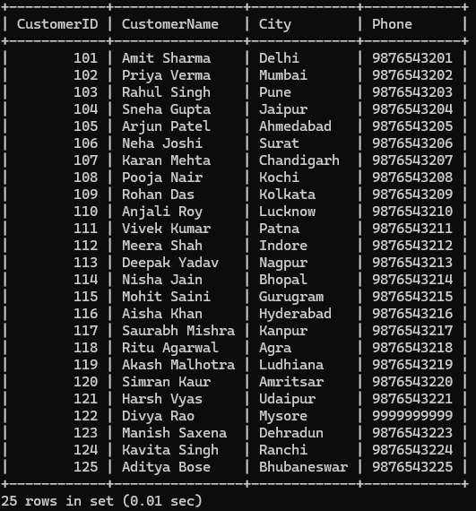
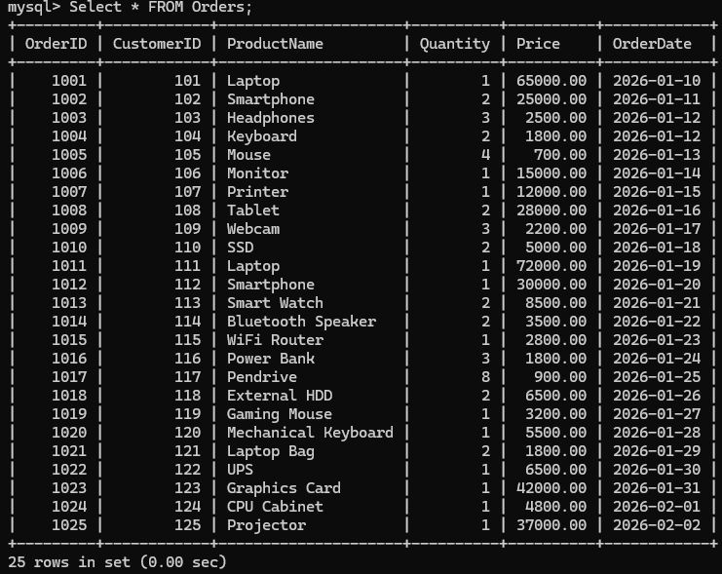
DELETE
a) Delete Customer ID 125.
b) Delete Order ID 1025.
c) Delete the order for Gaming Mouse.
d) Delete the customer whose name is Harsh Vyas.
e) Delete the order placed on 2026-01-14.
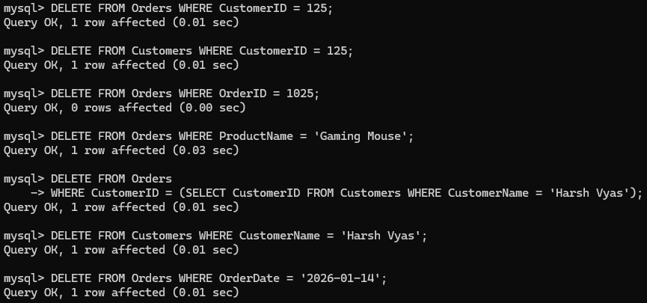
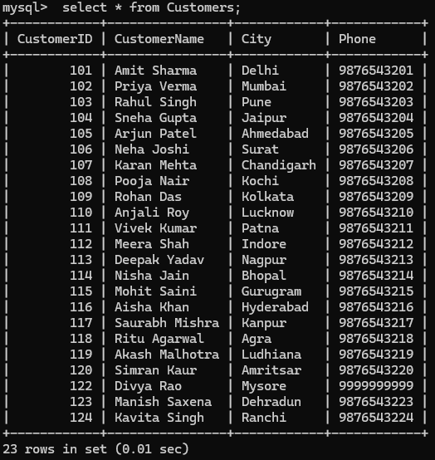
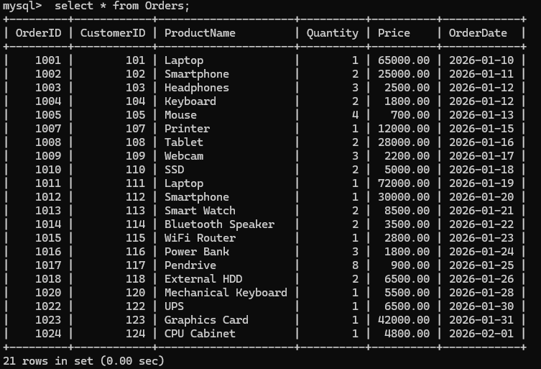
JOIN
a) Display customer name along with the product they ordered.
b) Display customer city along with product name.
c) Display order ID, customer name, product name, and order date.
d) Display all orders along with customer phone numbers.
e) Display customers who have placed orders for Laptop.

a) Display customer name along with the product they ordered.
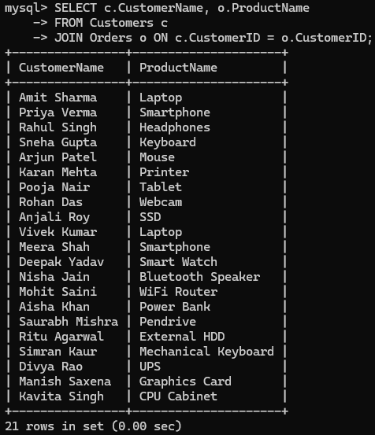
b) Display customer city along with product name.

b) Display customer city along with product name.
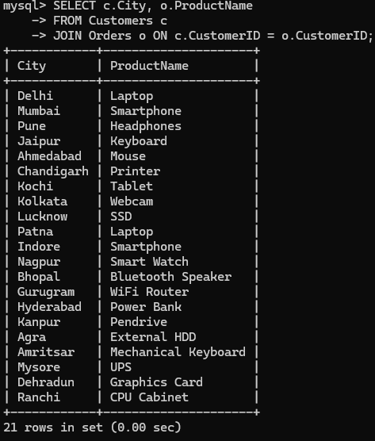
c) Display order ID, customer name, product name, and order date.
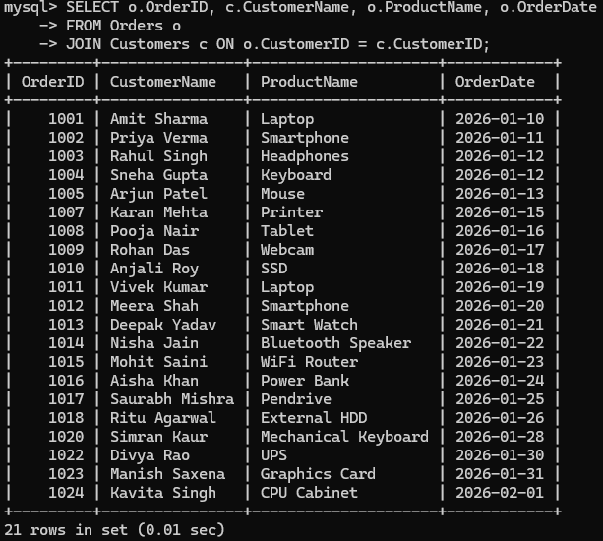

d) Display all orders along with customer phone numbers.
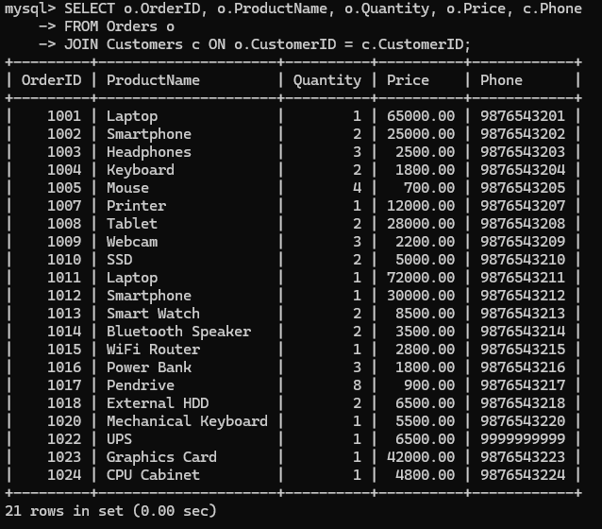

e) Display customers who have placed orders for Laptop.
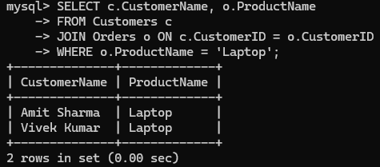

Problem 2: Hospital Management System
A multi-specialty hospital wants to maintain information about its doctors and patients. Each patient is assigned to one doctor. Students need to create the tables, insert the records, and practice CREATE, INSERT, UPDATE, DELETE, and JOIN operations.
CREATE
a) Create a database named HospitalDB.
b) Create the Doctors table.
c) Create the Patients table with an appropriate foreign key.
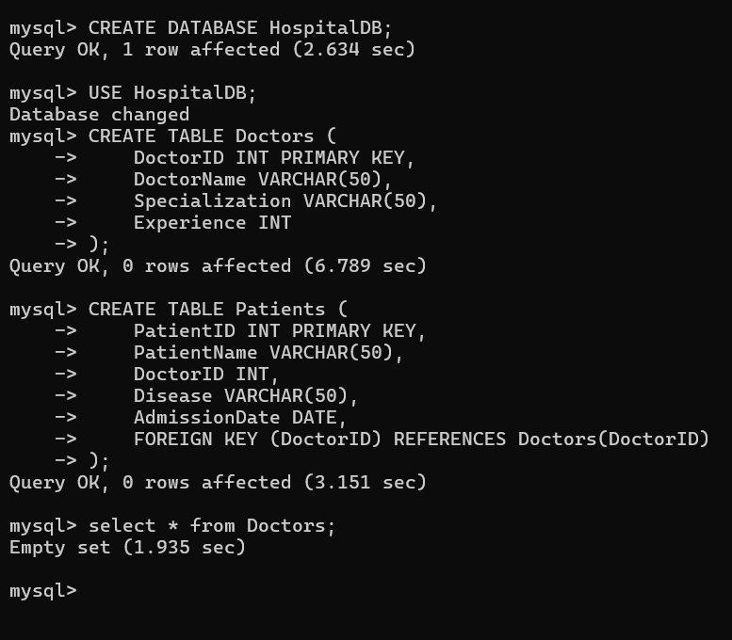

INSERT
a) Insert all 25 doctor records.
b) Insert all 25 patient records.

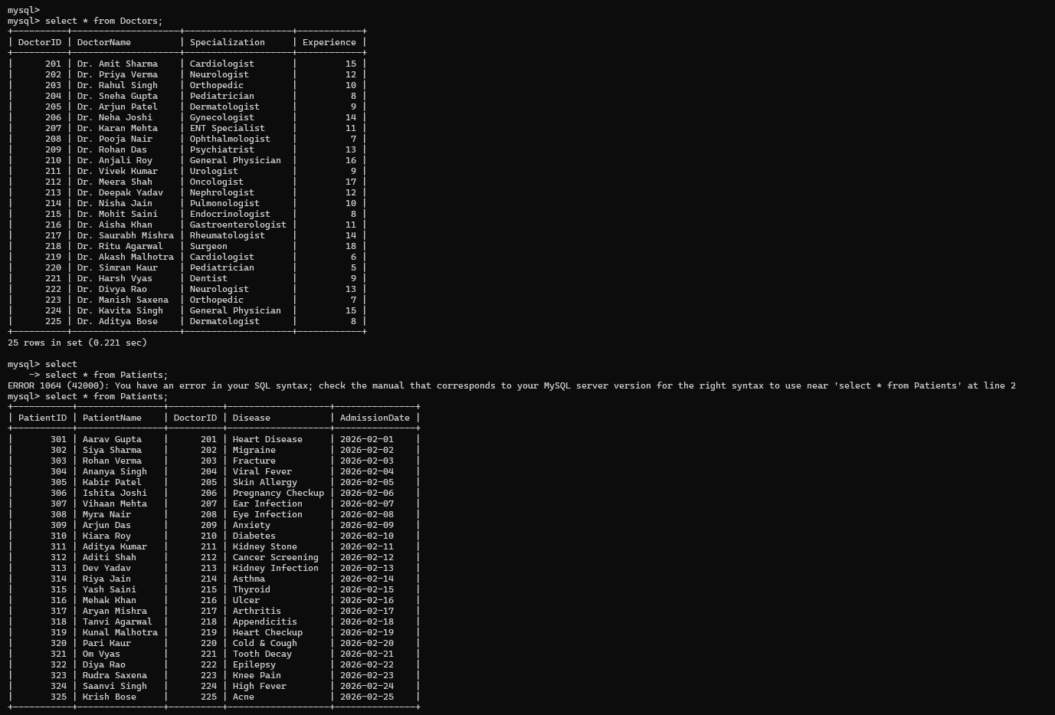

UPDATE
a) Change the specialization of Doctor ID 225 from Dermatologist to Cosmetologist.
b) Update the experience of Doctor ID 220 from 5 years to 7 years.
c) Change the disease of Patient ID 309 from Anxiety to Depression.
d) Update the admission date of Patient ID 320 to 2026-02-22.
e) Assign Patient ID 323 to Doctor ID 203.
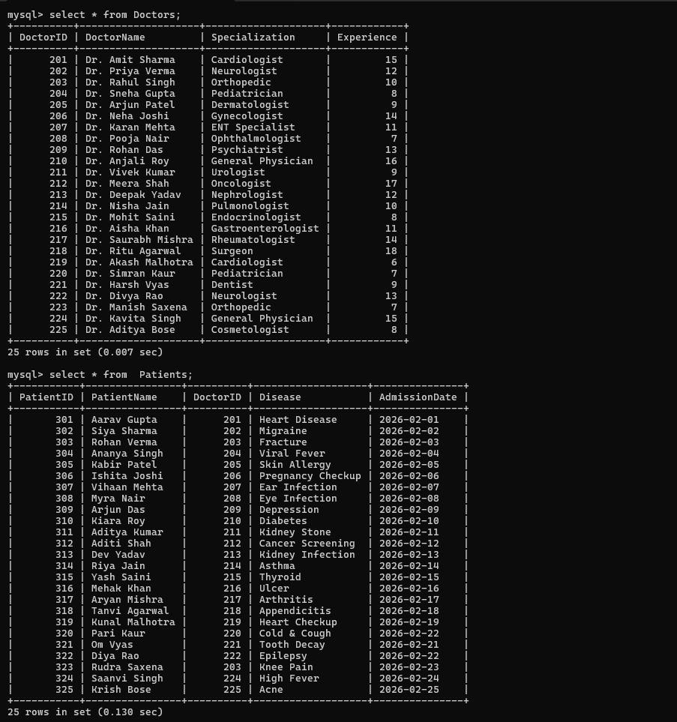

DELETE
a) Delete Patient ID 325.
b) Delete Doctor ID 225.
c) Delete the patient whose name is Pari Kaur.
d) Delete the doctor whose name is Dr. Harsh Vyas.
e) Delete the patient admitted on 2026-02-06.
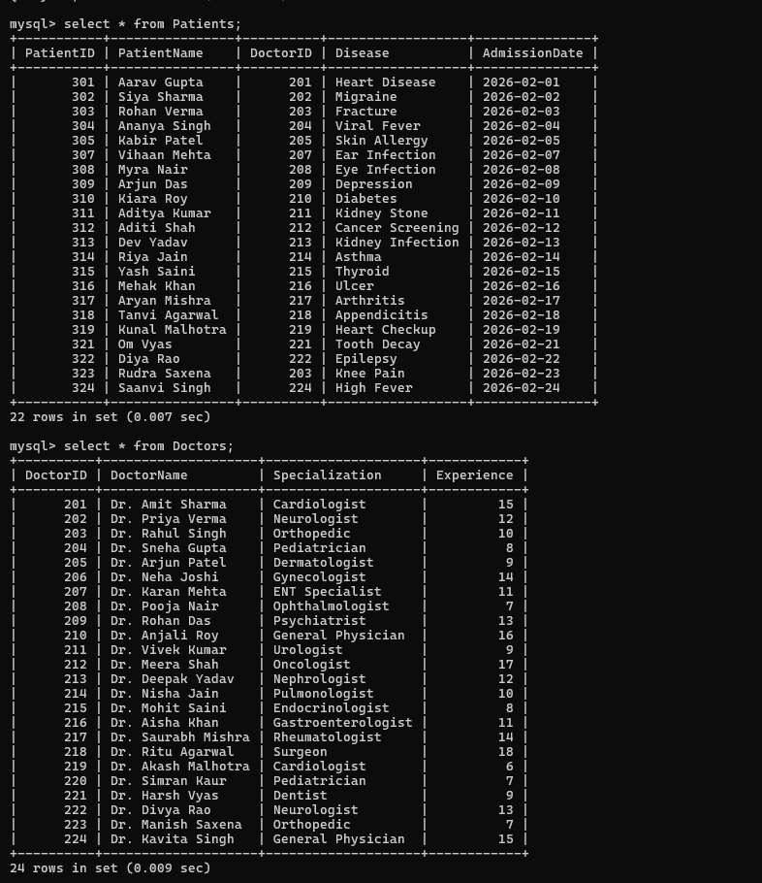

JOIN
a) Display patient names along with their doctor names.
b) Display patient name, disease, and doctor's specialization.
c) Display patient name, doctor name, and admission date.
d) Display doctor experience along with the patients assigned to them.
e) Display all patients treated by Cardiologists.
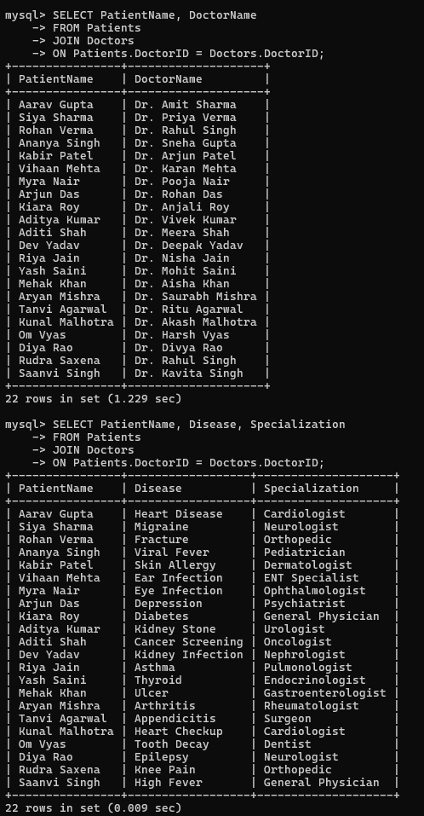
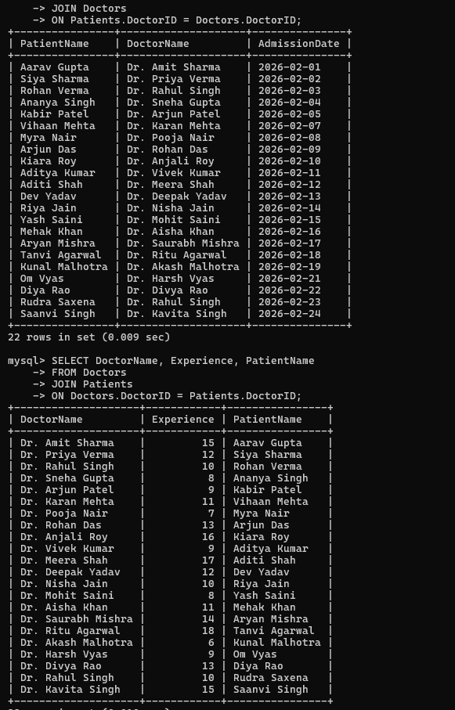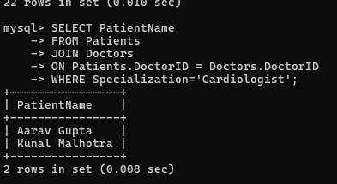

Problem 3: College Management System
Scenario A college wants to maintain information about its departments and students. Each student belongs to one department. Students need to create the tables, insert the records, and practice CREATE, INSERT, UPDATE, DELETE, and JOIN operations.

CREATE
a) Create a database named CollegeDB.
b) Create the Departments table.
c) Create the Students table with an appropriate foreign key.

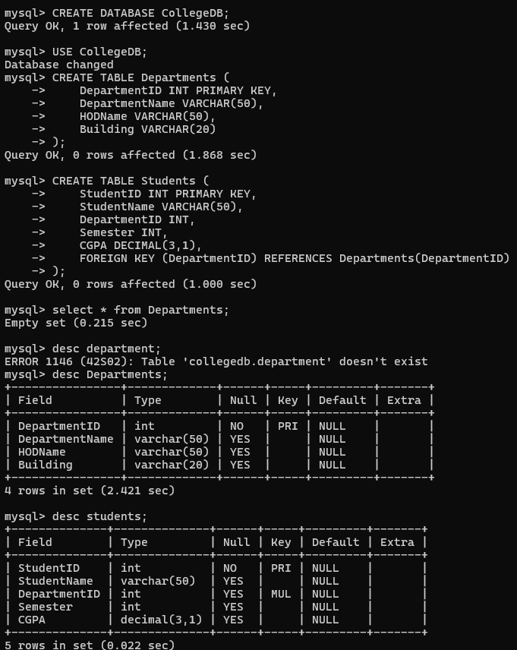
INSERT
a) Insert all 25 department records.
b) Insert all 25 student records.
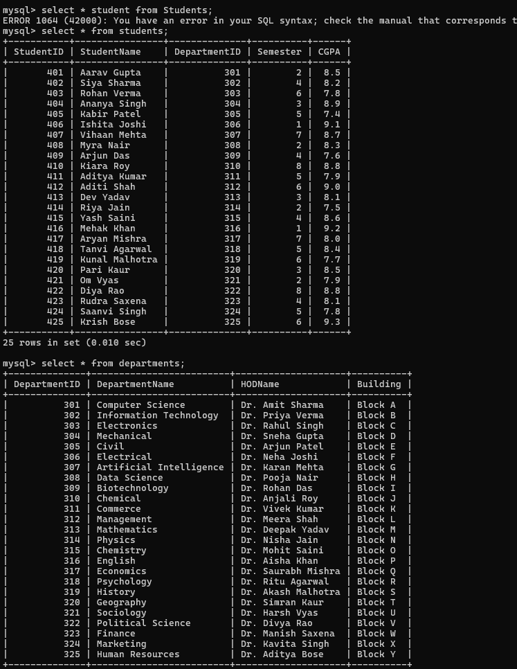

UPDATE
a) Change the specialization of Doctor ID 225 from Dermatologist to Cosmetologist.
b) Update the experience of Doctor ID 220 from 5 years to 7 years.
c) Change the disease of Patient ID 309 from Anxiety to Depression.
d) Update the admission date of Patient ID 320 to 2026-02-22.
e) Assign Patient ID 323 to Doctor ID 203
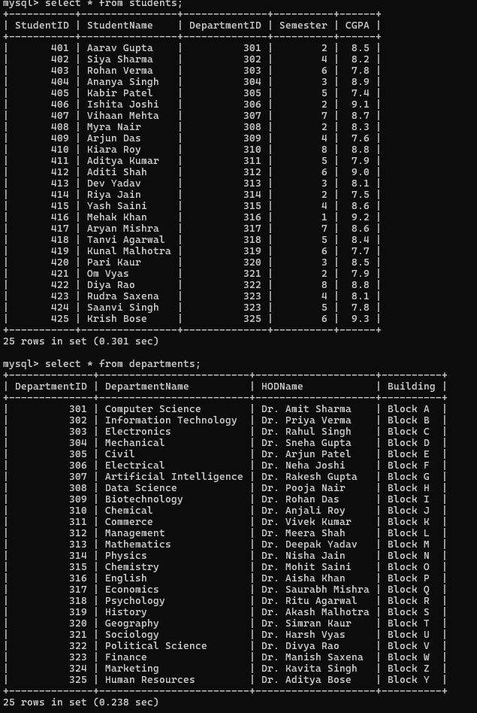
DELETE
a) Delete Patient ID 325.
b) Delete Doctor ID 225.
c) Delete the patient whose name is Pari Kaur.
d) Delete the doctor whose name is Dr. Harsh Vyas.
e) Delete the patient admitted on 2026-02-06.
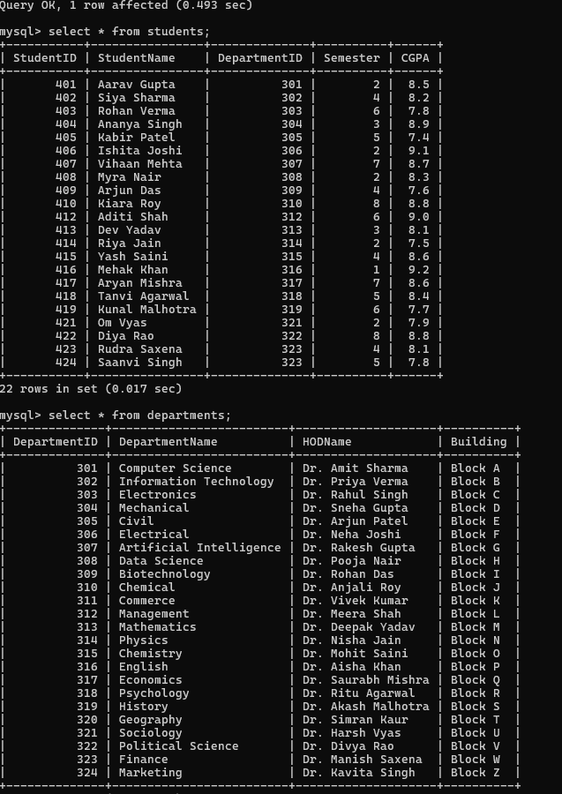

JOIN
a) Display patient names along with their doctor names.
b) Display patient name, disease, and doctor's specialization.
c) Display patient name, doctor name, and admission date.
d) Display doctor experience along with the patients assigned to them.
e) Display all patients treated by Cardiologists.
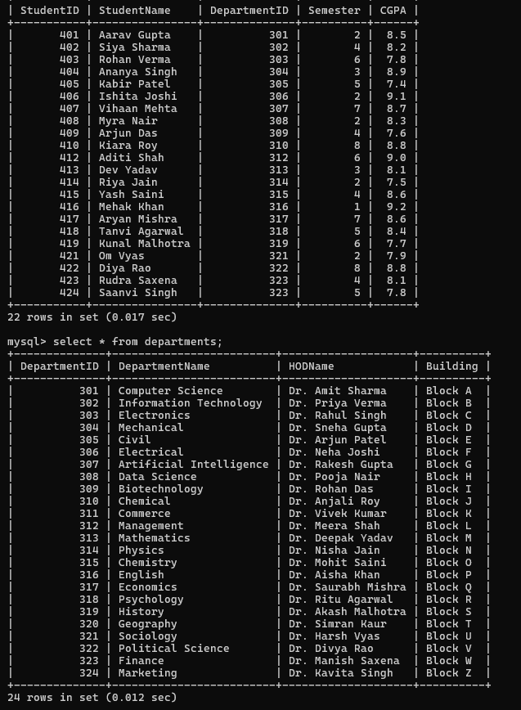
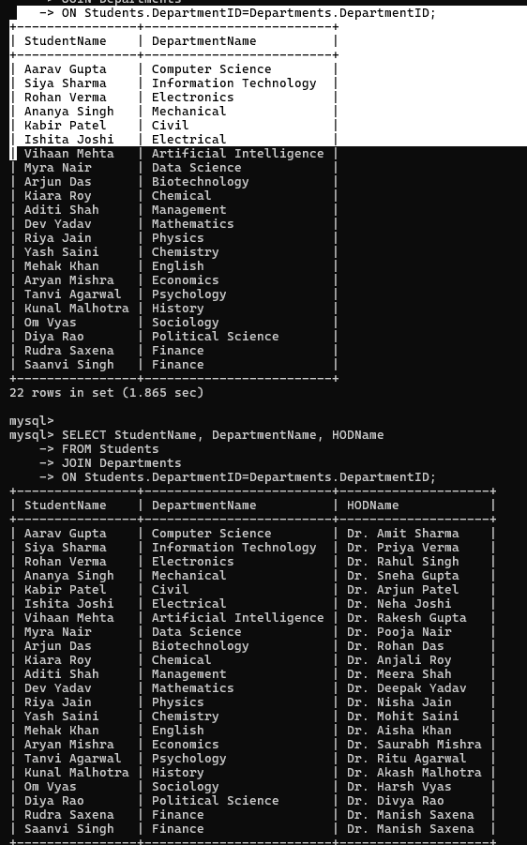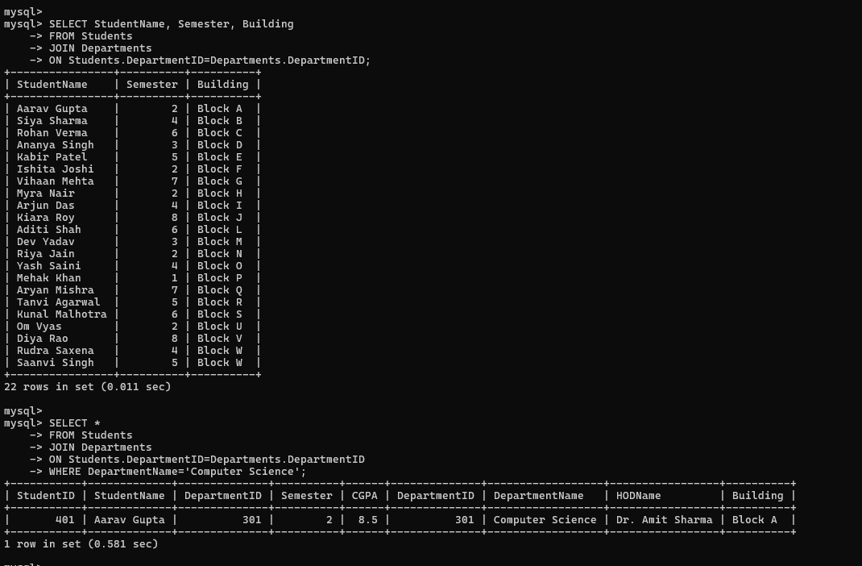

Problem 4: Movie Ticket Booking System
Scenario A multiplex cinema wants to maintain information about the movies currently running and the tickets booked by customers. Each booking is associated with one movie. Students need to create the tables, insert the records, and practice CREATE, INSERT, UPDATE, DELETE, and JOIN operations.
CREATE
a) Create a database named MovieBookingDB.
b) Create the Movies table.
c) Create the Bookings table with an appropriate foreign key.
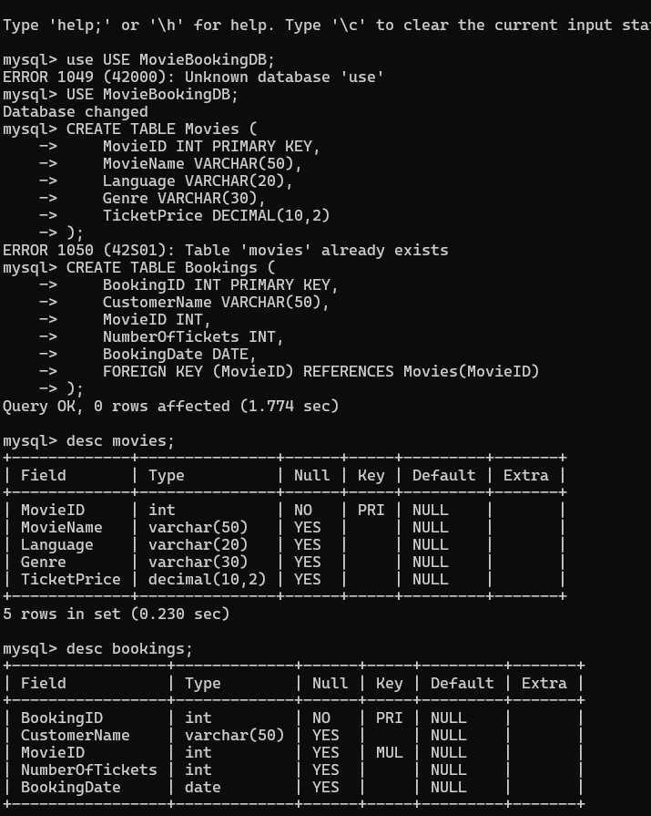

INSERT
a) Insert all 25 movie records.
b) Insert all 25 booking records.
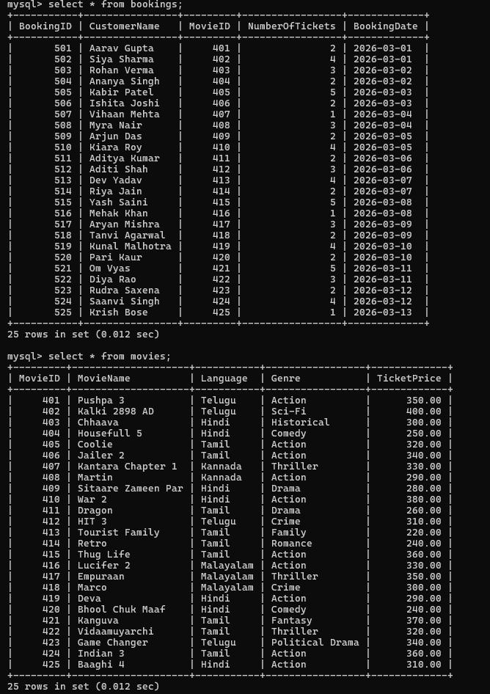

UPDATE
a) Change the ticket price of War 2 from ₹380 to ₹400.
b) Update the genre of Housefull 5 from Comedy to Comedy Drama.
c) Change the number of tickets booked by Siya Sharma from 4 to 5.
d) Update the booking date of Booking ID 516 to 2026-03-10.
e) Change the movie booked by Krish Bose from Baaghi 4 to Pushpa 3
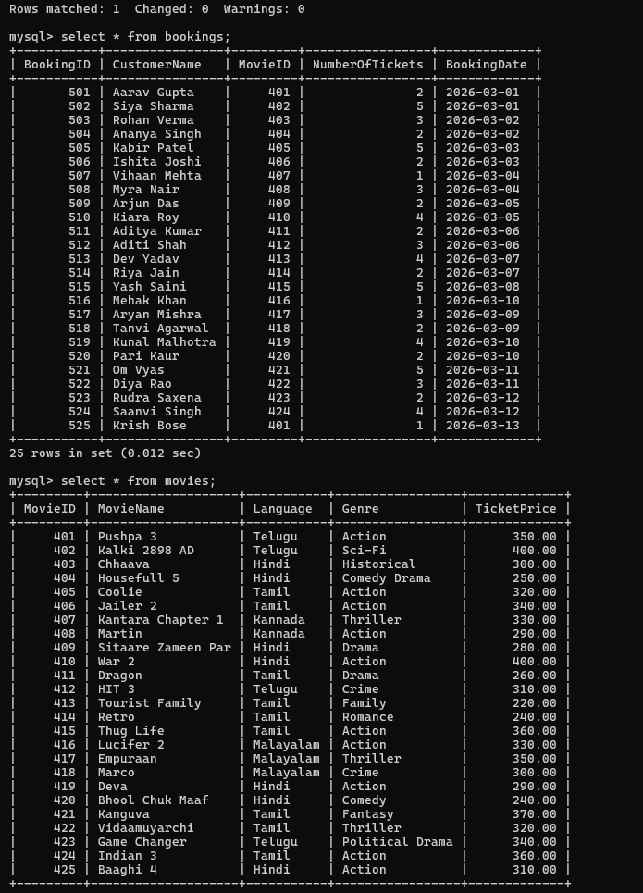

DELETE
a) Delete Booking ID 525.
b) Delete the movie Indian 3.
c) Delete the booking made by Vihaan Mehta.
d) Delete the movie Dragon.
e) Delete the booking made on 2026-03-03 by Kabir Patel.
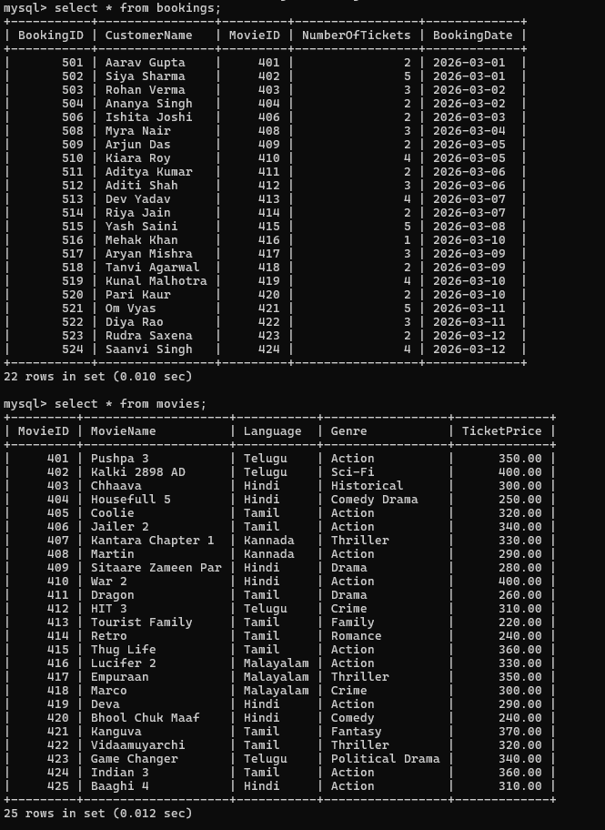

JOIN
a) Display the customer name along with the movie name they booked.
b) Display the customer name, movie language, and booking date.
c) Display the customer name, movie genre, and number of tickets booked.
d) Display all customers who booked Hindi movies.
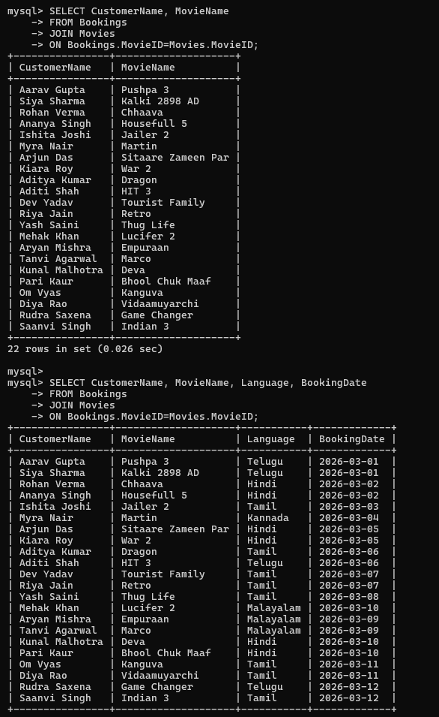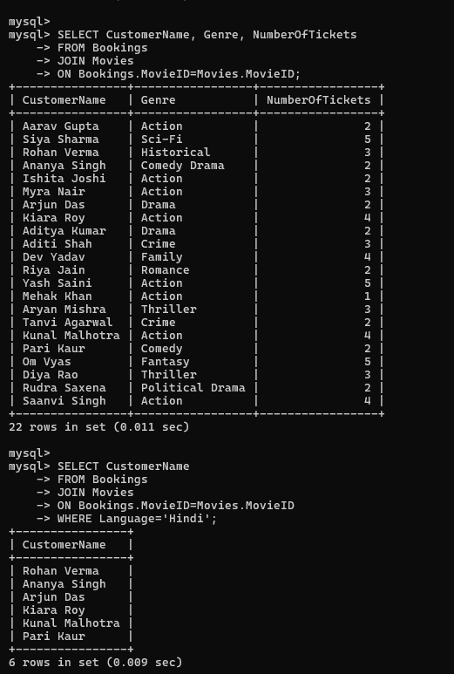e) Display the customer name, movie name, and ticket price.

