**Minutes**

|  |  |
| --- | --- |
| Meeting: | Amadeus Quick-Connect - Project Kick off |
| Date: | 02/03/2022 |
| Location: | Teams |
| Attendees: | Wang Xiaonan  Pei Xutong  Zhang Qianfeng  Adebukola Adekeye  Ayodapo Adigun |
| Owner: | Gladys Santos |
| Recorded by: | Gladys Santos |

# Roles, Responsibilities and Contacts

The directory for communication with Stakeholders during the project is as follows:

* Amadeus

|  |  |  |
| --- | --- | --- |
| Name | Role | Email |
| Gladys Santos | API Consulting Project Leader | apiconsulting-wemea@amadeus.com |
| Adebukola Adekeye | Delivery Segment Manager | adebukola.adekeye@amadeus.com |

* Tutu Travel Ltd

|  |  |  |
| --- | --- | --- |
| Name | Role | Email |
| Xutong/Pei | Web developer | [peilanglang@gmail.com](mailto:peilanglang@gmail.com) |
| Zuqun/Ren | Travel consultant | [kingwong202120201@gmail.com](mailto:kingwong202120201@gmail.com) |
| Qianfeng/Zhang | Project Manager | [shihouqianjiu@163.com](mailto:shihouqianjiu@163.com) |
| Xiaonan/Wang | Managing Director | [94154413@qq.com](mailto:94154413@qq.com) |

# Company and Application information:

TUTU TRAVEL is a leading online travel agency that helps today’s business and leisure travellers search, compare, and book the best flight options with all airlines.

### List of services discussed during Kick-Off:

* FlightOrderIssue
* FlightOffersSearch
* FlightOffersPrice
* FlightCreateOrders
* FlightOrderManagement
* GetFlightOrderByRecordLocator

Customer wishes to integrate:

* Bags: as per general market preference, they only wish to sell fares with a bag (whether it is included in fare or a chargeable bag added);
* Pyton (For test purpose for now, but not to certify);
* No ticketing will be done online, once the PNRs are created they should be sent to a queue and ticketing by the Sunair Ticket Robot;
* The updates can be done online using PATCH or DELETE;

It was also informed that no bags can be included after the order is created and the pricing is mandatory for pricing confirmation.

### Functional Gaps:

While the Dedicated access is being prepared by the API Consulting team, the customers should ensure they can access all documentation in the Developers Portal and thoroughly read it to identify possible functional gaps. If a functional gap is identified after the construction phase, the API Consulting team will conduct an evaluation of the impact of the change to cost, risk, schedule, and scope. Please note that modification to the project scope after the construction phase is subject to the API Consulting team’s agreement and may be subjected to a follow up enhancement project.

# Project life cycle:

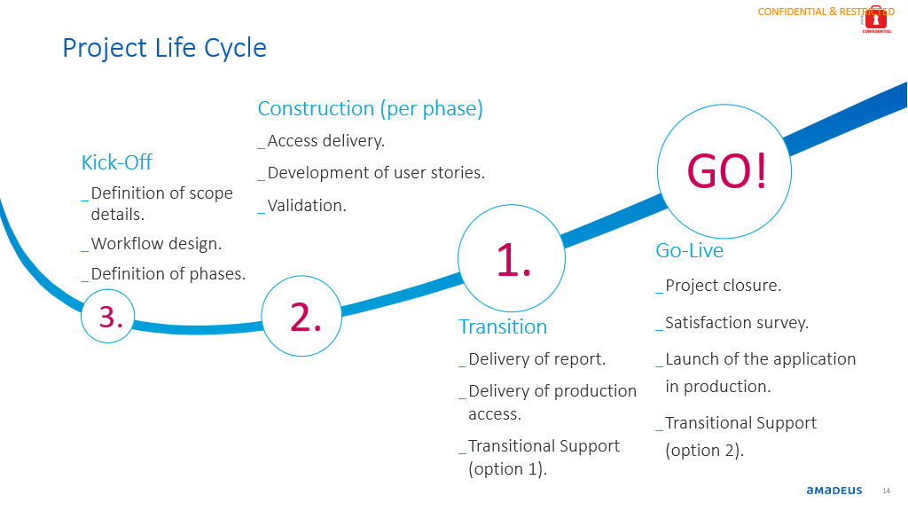

**Estimated project time frame:** 30 Days

**Agreed project completion date:**

**User Stories discussed:**

|  |  |  |
| --- | --- | --- |
| **Test Case Scenario** | **Ama-client-ref** | **Pending/Completed** |
| Use Case 1 – FSC no bags: 2ADTs, 1CHD, 1 INF. **Calendar Search**, Roundtrip (RT), Full-Service Carrier (FSC) content, Published fares, No bags. |  |  |
| Use Case 2 – FSC with bags: 2ADTs, 1CHD, 1 INF; Roundtrip (RT), Full-Service Carrier (FSC) content, published fares, Bags. |  |  |
| Use Case 3 – Pyton no bags: 2ADTs, 1CHD, 1 INF; Roundtrip (RT), Pyton content, Published fares, No Bags. |  |  |
| Use Case 4 – Pyton with bags: 2ADTs, 1CHD, 1 INF; Roundtrip (RT), Full Pyton content Published fares, Bags. |  |  |
| Use Case 5 – OWC: 2ADTs, 1CHD, 1 INF; Roundtrip (RT) One-way combinable (OWC) FSC and Pyton (or FSC), published fares with Bags. |  |  |
| Use Case 6 – GET: Retrieve an AQC Flight Order. |  |  |
| Use Case 7 – Patch: Add remark to an AQC order. |  |  |
| Use Case 8 – Delete: Cancel a PNR |  |  |
| Use Case 9 – FlightGetOrderByRecloc: Retrieve a PNR created outside of AQC. |  |  |

# Out of Scope

Items classified as Out of Scope include:

* Office settings*.
* Any services, deliverables and activities not defined in the Project.
* Support of any functionality not discussed during the kickoff meeting.
* Support of already certified services unless the enhancement creates a significant impact.
* Coding queries.
* Application testing**

* Request for update to OID setting should be done via Account Manager to be actioned locally.

**The application testing is not included in the scope of the project. This is solely the responsibility of the client. If this application includes any fare search functionality, the client is fully responsible for testing their application to ensure that all fares are returned as expected once the application is launched in the Production environment.

# Project Definition Acceptance

If any of the above information is incorrect, please contact the API Consulting team within a week to clarify the discrepancy. Failure to do so will be considered as an agreement to be above.