**EMBROID-IT1.0**

**QUICK START GUIDE**

**Embroid-It 1.0**

Embroid-It offers a clean, easy-to-use interface containing simple tools for the user to create and edit embroidery projects.

***Embroid-It Workspace***

**Layer Bar**: The area that

contains the layer buttons.

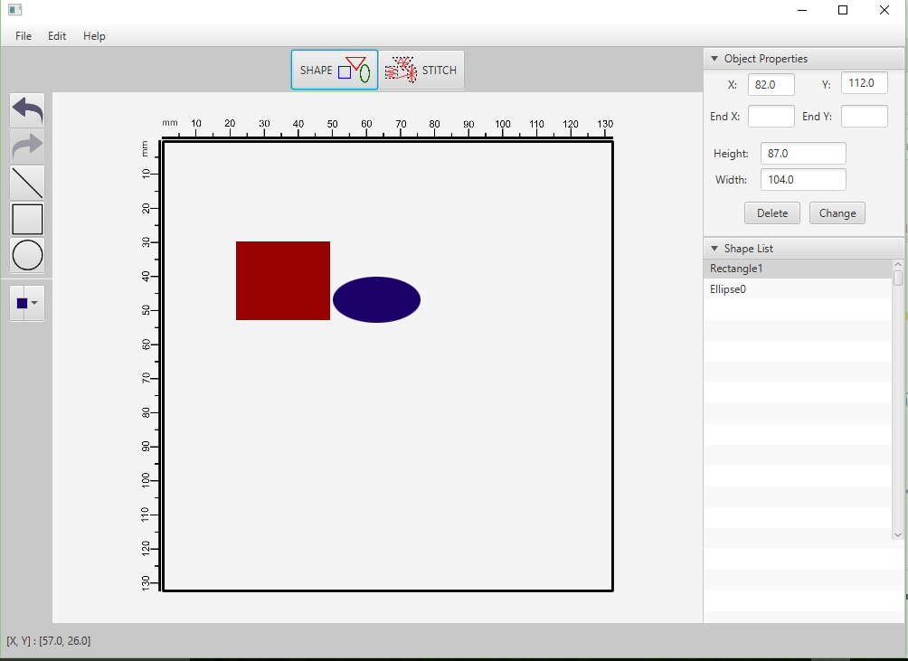**Menu Bar:** The area

containing pull-down

options and commands **Properties Window**: A

collapsible window that

contains options to

adjust and modify

**Toolbox**: Contains objects in the drawing.

tools for creating and

modifying objects.

**Shape Box:** The area

that contains a list of

all the shapes in the

**Rulers:** Calibrated lines current drawing.

with markers to

determine size of objects

in a drawing

**Status Bar**: Displays the x, y coordinates

of the current curser location in the

drawing area **Canvas:** The drawing area that contains a

visual representation of the current project.

Projects

You can easily start a new embroidery project (**File -> New**, or **Ctl + N**), as well as open a project that has previously been created (**File -> Open**, or **Ctl + O**). The file management system within Embroid-It also allows you to save your current project (**File -> Save**, or **Ctl +S**).

Importing Files

Embroid-It lets you import (**File->Import,** or **Ctl + I**) PES formatted files to use in your projects.

Exporting Files

You can export (**File->Export**, or **Ctl + E**) your projects to be saved as a PES formatted file to use with an embroidery machine. Keep in mind, the PES format is not compatible with all embroidery machines, but is used mainly with *Brother* and *Babylock* name brand machines.

Layers

Embroid-It provides two layers for viewing your project. You can select either view by clicking the buttons in the Layer Bar:

The *Shape* layer view shows the project as complete shapes with a full color fill.

The *Stitch* layer view shows your project as stitches, allowing you to see the stitch fill in each shape.

Drawing Lines and Shapes

***Lines***

The **Line** tool lets you draw straight lines on the canvas with a simple click and drag of the mouse.

***Rectangles***

By dragging diagonally with the **Rectangle** tool, you can draw rectangles and squares.

***Ellipses***

You can draw an ellipse or circle by dragging diagonally with the **Ellipse** tool.

Tools

In addition to the drawing tools mentioned above, Embroid-it provides you with a few other tools as well.

You can take back your last action by clicking the **Undo** button. Similarly, you can re-do any undo action by clicking the **Redo**  button.

Embroid-it also lets you choose a color for each shape you create. Before shape creation, you can select a color by clicking on the **Color Picker** tool, and selecting your desired color from the list.

Working with shapes

Each shape created is stored in the **Shape List** box by their shape name and sequential number in which they were created. For example, *Ellipse0*, would be the first ellipse that was created in the project and would be followed by *Ellipse1*.

***Selecting a shape***

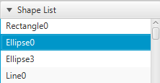You can select a shape by clicking its corresponding name from the **Shape List**. Once the shape is selected, its x/y coordinates, height, and width will be displayed in the **Properties Window** above.

***Moving a shape***

You can move a shape by keying in the desired values into the x and y coordinate field, and then click the **Change**  button.

*Note:* ***Lines*** *also contain an ‘****end x****’ and ‘****end y****’ value that represents the endpoint of the line.*

***Resizing a shape***

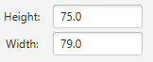To change the size of a shape, after the shape has been selected, you can change the values in the height and/or width fields. The size will be adjusted when you click the

**Change** button

***Deleting a shape***

To delete a shape from your project, just select the desired shape from the **Shape List**, and click the **Delete** button