High End Merchandiser Standards:
Most, if not all, of our locations will have multiple high end merchandisers.
The challenge with this type of Merchandiser is the type of product that typically provides the best revenue, is a narrow market.
It is imperative that we make each of these machines as unique as possible.

High End Merchandisers should have a 25% Payout

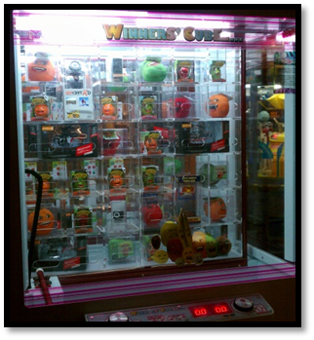
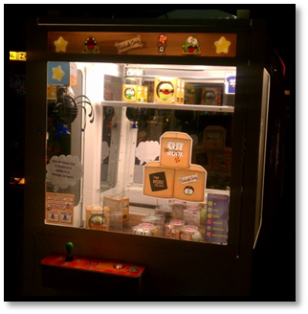
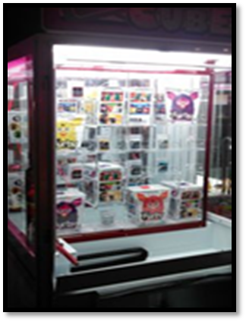
Merchandising Multiple High End Merchandisers:
Products used in games such as Winners Cube, Stacker, Cut the Rope, Keymaster, Barber Cut, Bullseye, Lighthouse, Road Trip:
- Major Game Systems- Xbox 360, PS3 Wii & Wii U
- Small Handheld Game Systems- PSP VITA & 3DS
- Music Players- ipod touch, ipod nano, ipod scuffle
- Tablets- ipad, & android tablets
- E Books- Nook, Kindle, Sony
- Misc Electronics- GPS, Sports Cameras (helmet camera)
Making every merchandiser unique in your location is important to maximize the potential revenue. To do this, you will need to be strategic with the merchandise you put in so that there is little overlap with another game.
For Example: If you had in one location a Barber Cut, Winners Cube, Giant Stacker, & a Keymaster-
Barber Cut- Samsung Tablets
Winners Cube- Music Players-nanos, ipod touch,
Giant Stacker-Game systems- Wii U, XBOX 360 bundle, PS3, PS Vita & a high end Ebook such as a Kindle Fire
Keymaster- Android tablets for the top row, shuffle for medium row, earbuds for bottom.
With this Merchandise plan there is little to no overlap in the prizes offered in the other high end Merchandisers, each has become more unique with desirable product.
Security & Storage:
- High end products should be ordered every week so that the game has back up items but not an excessive amount.
- Product, when possible, should be removed from the display outer box & displayed empty. – Please contact the Graphics Dept for decals that state: Box is empty to protect the prize- Please bring this box to the prize counter to receive this prize.
- Stock of items should be locked inside a changer or a safe when not in use.
Winners Cube Game filled With Furby’s.
This $60.00 hot new toy is a great solution to add verity to High End prizes.

