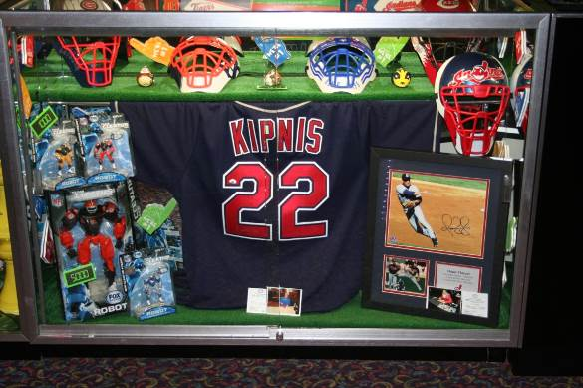
Redemption Décor Standards
- We hold the highest standards for Redemption display.
- Prizes for your redemption counter are to be handpicked for verity & profitability.
- Each point value should contain: One Boy item, One Girl item, & One Gender Neutral item
Budget & Stock Accountability:
- We should never be in the habit of keeping unused product in back stock. Unused stock is money wasted. If you are unsure of how to utilize product, please call for guidance.
  - Prize bags or chest are to be utilized to move through older merchandise
- Ticket prices are logged on FEGllc.com on your order site. If you have an issue with the marked ticket price, please contact Merchandise Dept.
- Budget amounts are based off your past years revenue. If this does not apply to your location, for any reason, please contact Merchandise Dept for your customized projections.
- Budgets are tracked on FEGLLC.com
Décor & Display:
- Theming is an easy way to start the décor process. Most theme items can be found on FEG order site under supplies & décor. Start by finding one or two items to add to your counter for items to sit on or divide price categories, if you use bins, these items can be added under the prizes, or in front of the bins on the shelves. Add a third or fourth décor option for slat wall, & tower displays. Use your architecture- garland & lights are good alternative for columns, & celling.
- Decorations should never block or hinder product, it should ask as an enhancer.
- Decorations should be carried throughout the location.
- Product display is part of the Guest experience. If you do a Jungle theme for example, have an assortment of prizes that allow them to take that theme home… This will let your customer take the experience home with them. You also want to switch your theme up every 4 months. Your repeat guest will notice. We have had several location guest comments on how they notice our new decorations. This brings to mind store front window displays such as Macy’s & Tiffany’s.

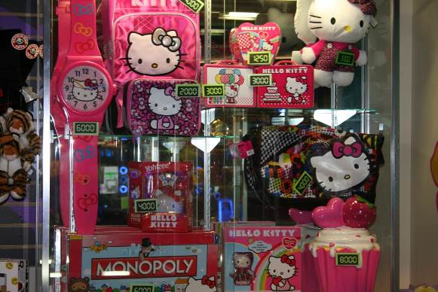
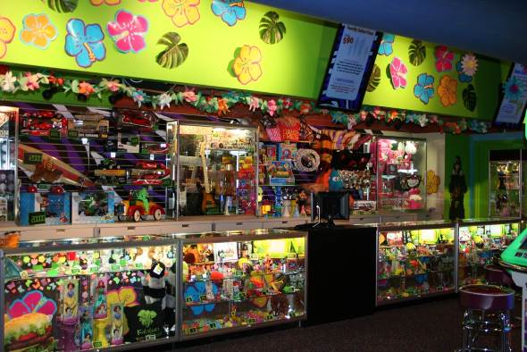
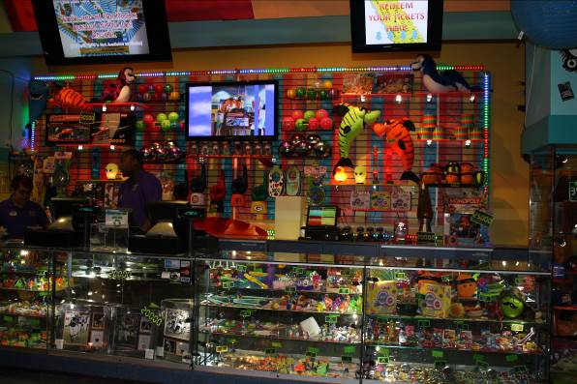
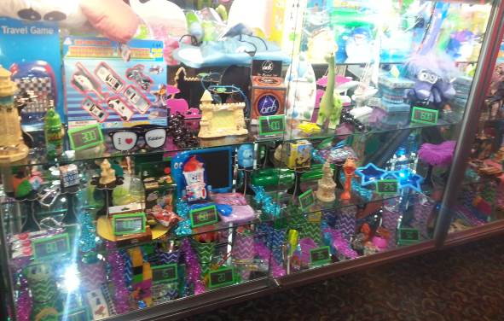
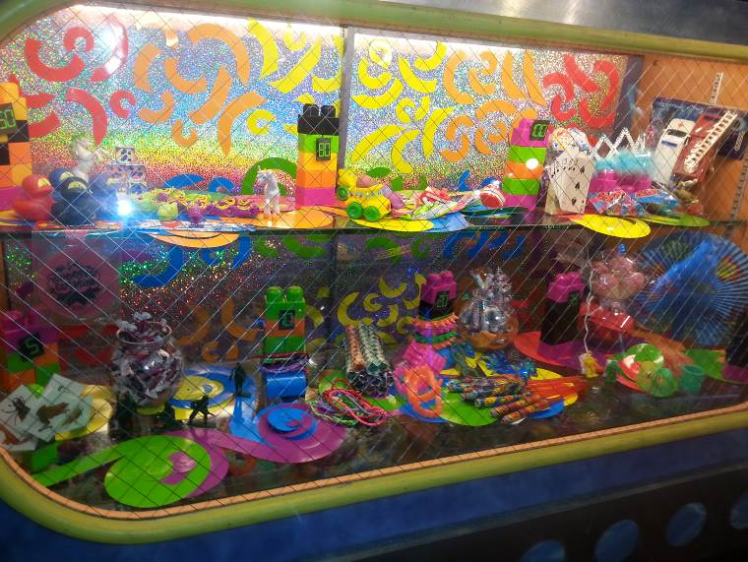
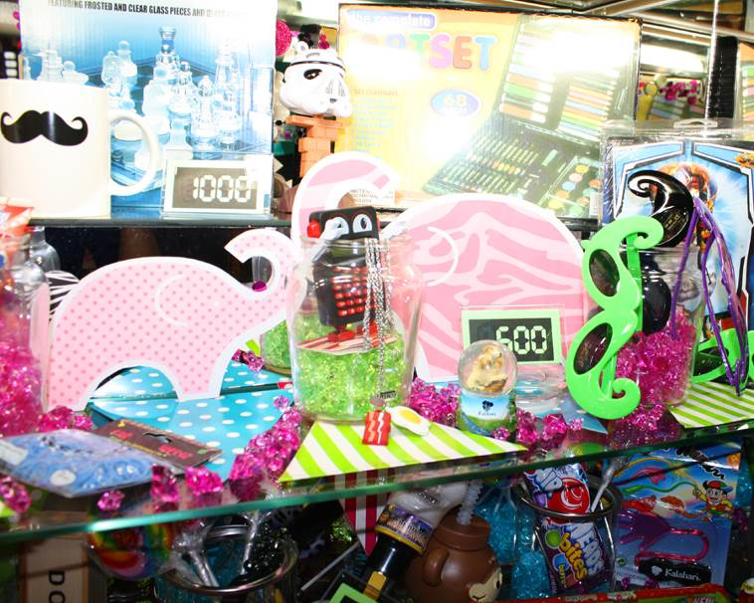
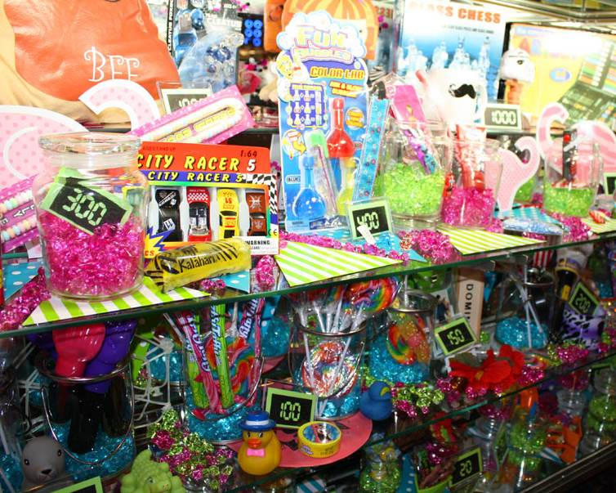
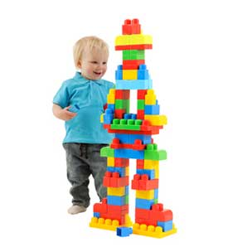
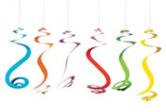
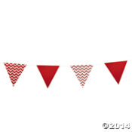
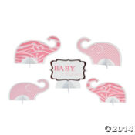
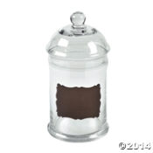
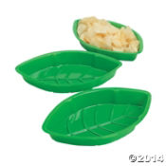
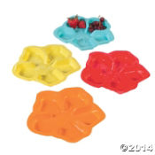
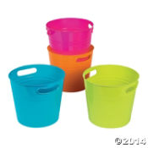
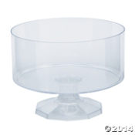
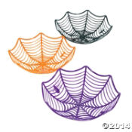

This case uses “hanging” spirals & Neon Blocks to add color!
Cardboard Elephant cut outs & Cardboard banners Used in this case to give an updated circus look

Addition of Acrylic Ice and glass candy jars give you 4 décor items to mix & match per row
Décor items can also act as a ”basket” to hold prizes. Here are a few ideas:

