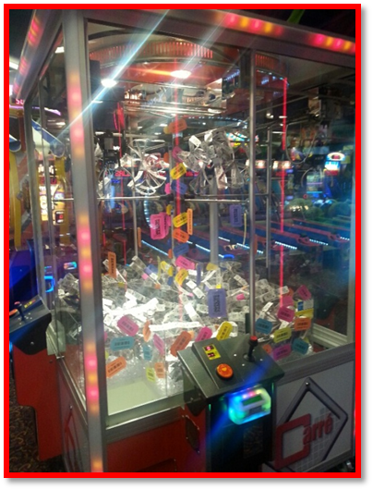
Ticket Bow 101
Where it is permitted, each store should have at least one instant win game that uses tickets as a prize or incentive piece. A common way to implement this is by using the “ticket bow.” Ticket bows can be made in many different values & can be used in several ways: Fill a gravel crane (pictured left Carre crane) with many bows at several different values to add a surprise appeal. Can be used in a “brick” format in a candy crane or rotary, Can be added to mix plush crane to boost game play, can be added to coin pushers as an extra bonus.
Well-made ticket bows will hold up in your game throughout plays & add attraction.

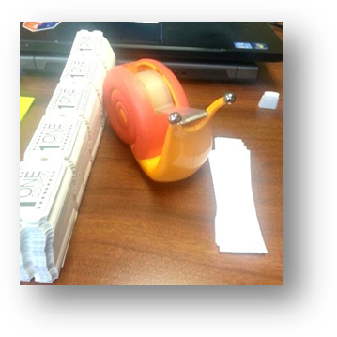
Supplies to Get Ready: Tape, Tickets, and Paper Strips: Paper strips are perfectly sized by cutting a piece of standard copy paper in half length ways (4.25 inches). Then cut the two sections each into one inch wide increments.

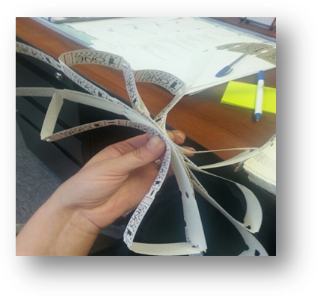
To Construct a Ticket Bow: You can do any increment that fits your target pay out, in the picture I used 45 tickets to make this bow. Start with a small end first & gradually build your ticket bow bigger for the middle row then work your way back down to the starting size to end. It is preferred to keep a FLAT ticket at the end of each row so that your bow keeps shape once you put it in the machine.
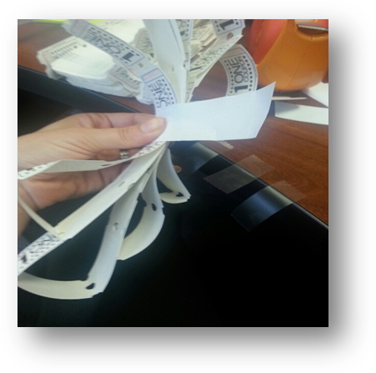
Finish your Bow off by tightly wrapping a paper strip around the middle of the bow & finish with a piece of tape. Be careful to not tape the actual ticket. Place made ticket bows into a trash bag. Be careful when storing your bags so you do not flatten the bows.

It is a good idea to have several bags of bows made to anticipate busy time periods. Check your crane often to refill.
Other Uses for Tickets in Instant Win Games:

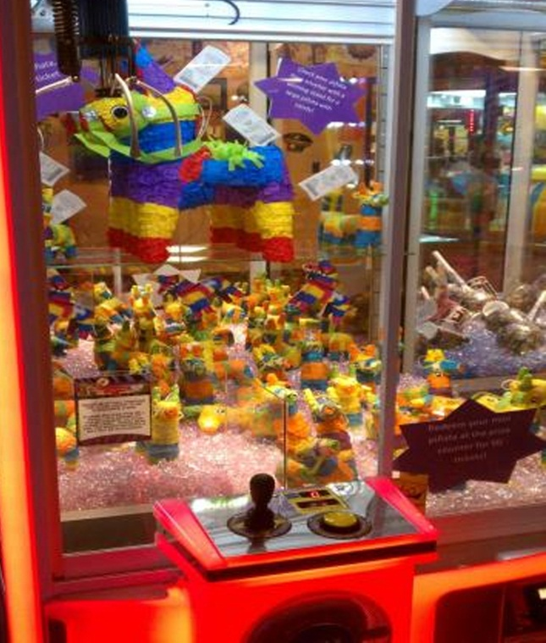
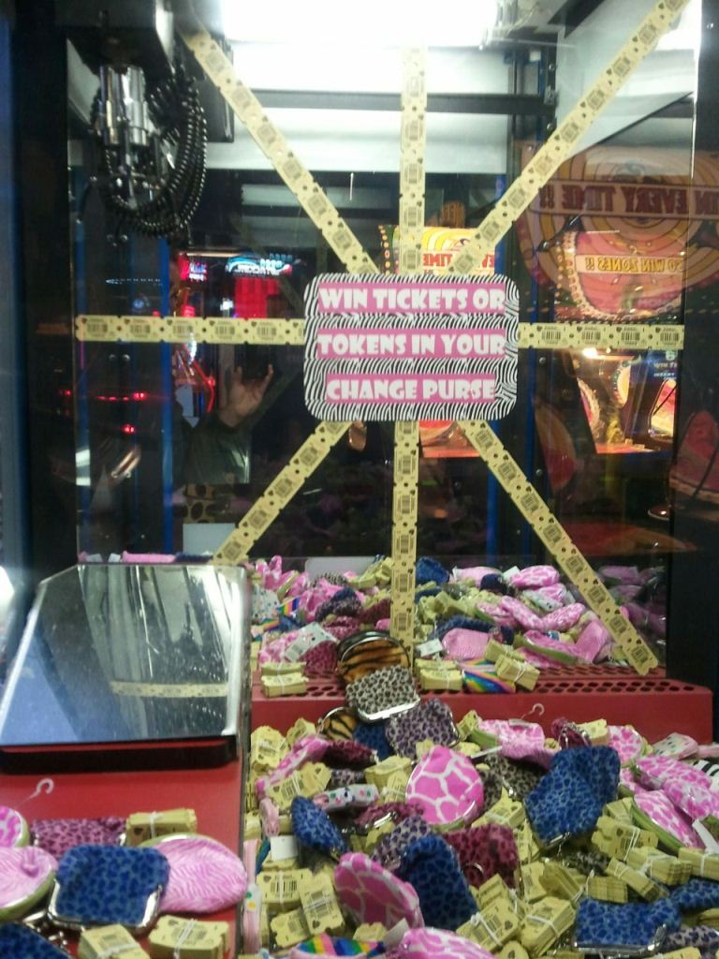
Example of ticket bricks used in a re-purposed Chocolate Factory Game
Ticket Vouchers used inside mini Piñatas (instant win Eclaw prize)

