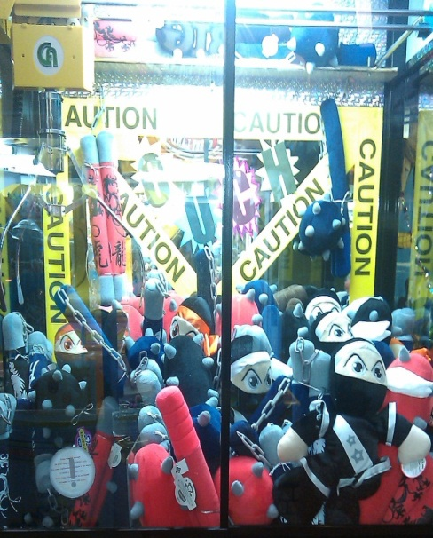
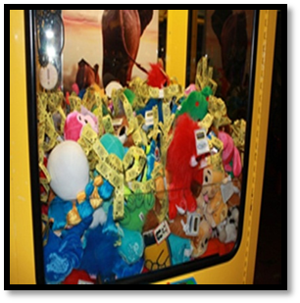
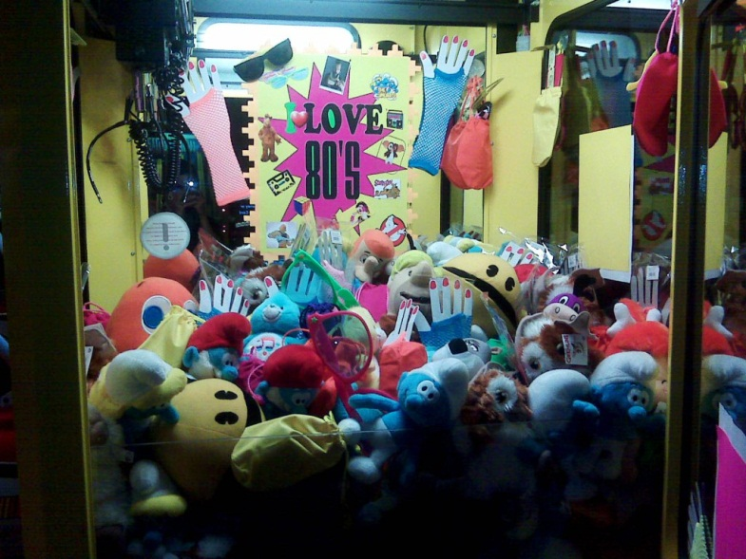
Traditional Crane Standards:
Pictured, right, & left: All items mixed together to make theme cranes. The central theme & décor keep them from being a “mixed Plush” cranes.

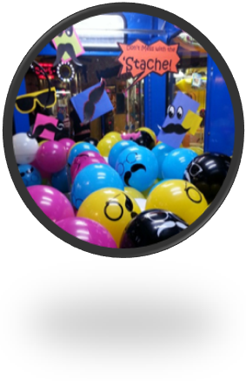
Traditional Plush cranes are claw games such as Winner Every time, Plush Bus, Hot Stuff, Toy Taxi, Toy Soldiers, Moving Castle, Ufo Catcher, etc.
If you have three or more in your location the formula is such: One ball crane per location, One Mix Plush Crane per location, & the remainder will be single load or themed prizes.
Ball Cranes: A traditional Crane filled with balls.
- Does not include games such as Super Bounce & The Big One Crane
- Balls should be loosely placed & full at all times
- Graphics on the balls should face the customer
- No deflated or under inflated balls should be visible
- Typically want this seen as an affordable game with a high payout
- Product includes: 6 inch graphics balls, small basket balls, knobby balls,
- & jump balls.
- Ball style should be switched out every three months.
- Ball Crane should be decorated

Mix Plush Crane: a traditional Crane filled with miscellaneous or older plush.

Mix Plush Crane: a traditional Crane filled with miscellaneous or older plush.
- Should have one per location to push through older product
- Payout should be 25%
- Plush should be mixed evenly throughout the crane to offer the verity
- Plush cranes are to be decorated
- “Sprinkled” items or toppers such as ticket bows should be added to this crane in locations where it is permitted. If ticket bows cannot be added, hot licensed plush can be added to make it more desirable.

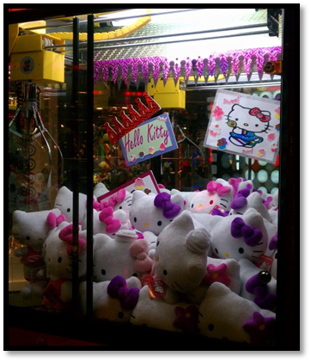
Single Load or Themed prize Cranes
- The difference between a Themed Crane & a Mixed Crane is a single central thought, topic, idea, or subject that ties the individual items together.
- Crane payout should be set to a 25% win
- Cranes should never appear “impossible” to win. Pack lower levels of the plush tightly with easier to grab items peeking out.
- Crane Plush should be switched out often. Items should be fully redecorated & remerchandised every three months.

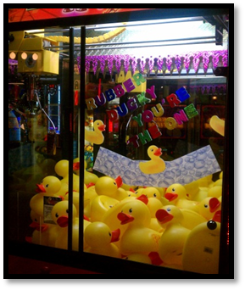
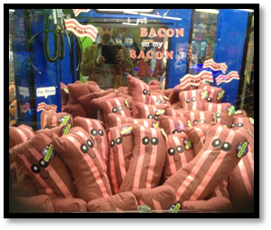

Price Guides & Maintenance:
- Formulating Throw % = retail value X pieces given out / Revenue of game.
- Pricing Game Play Guide: DOES NOT INCLUDE WIN-EVERY-TIME LOCATIONS
  - $0.00-$1.00 prize - 2 tokens
  - $1.00-$3.50 Prize - 4 tokens
  - $3.50 -$10.00 - 8 tokens (or more depending on game)
  - $10.00 & up - 12 tokens (or more depending on game)
- All Cranes should be checked multiple times a day for maintenance & fill
  - An improperly filled game, under filled or no easy win pieces, will lose revenue
  - A crane with a high payout will cost revenue

Flashing & Crane Décor Standards: All Cranes Should be decorated to some extent
- Decorating your cranes can be something as simple as adding a team sports poster to the back of a Basketball Mix Crane.
- Decorating tools can be found on the Redemption order page under Supplies & Décor. Additional items can be found at hobby store, office supply store, or even in the craft center of your local department store.
- Clip art cut out and placed on bright construction, or scrapbook material can be used, as well as shiny or bright wrapping paper.
- These decorations should never require a significant amount of time or money.
- If this is not something you feel comfortable doing, contact the Merchandise Manager or Regional Manager for ideas or tips.
- Tools that are helpful to have: two-sided tape, scissors, suction cups with hooks, multiple colors of construction paper, shaped cardstock, metallic paper, cardboard, premade posters, and even fringed table skirting can go a long way.

