

GUARDIAN DENTAL

How to locate a Dentist

- Open your web browser and enter the following website: www.guardianlife.com
- Click on “Provider Online Search” under Resources

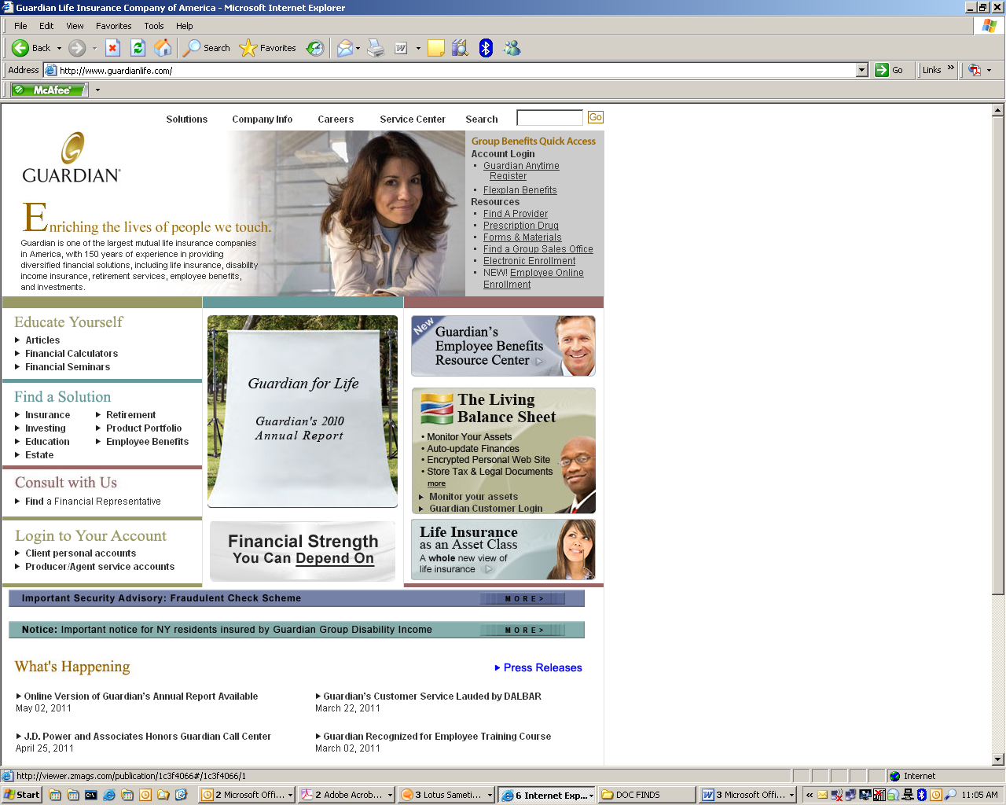

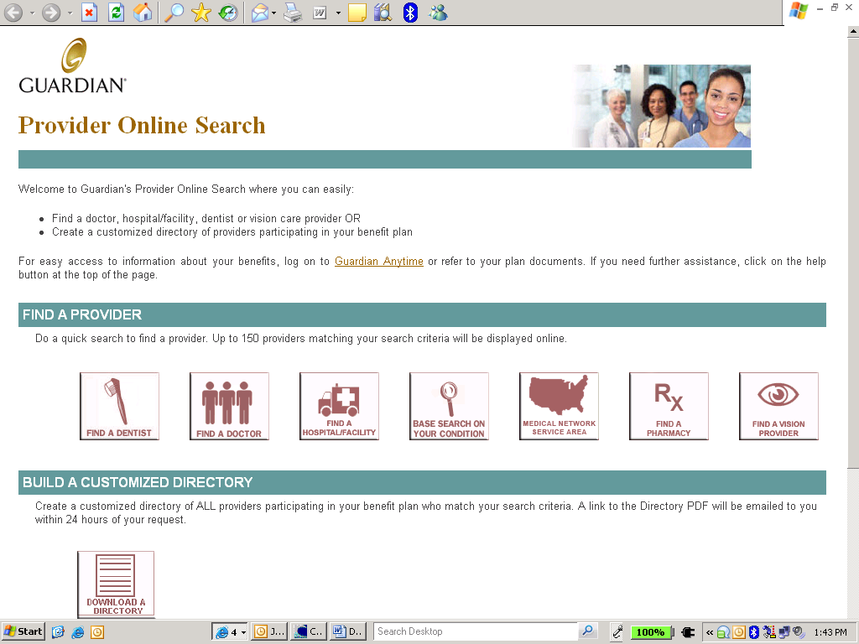

- Click on “Find a Dentist”

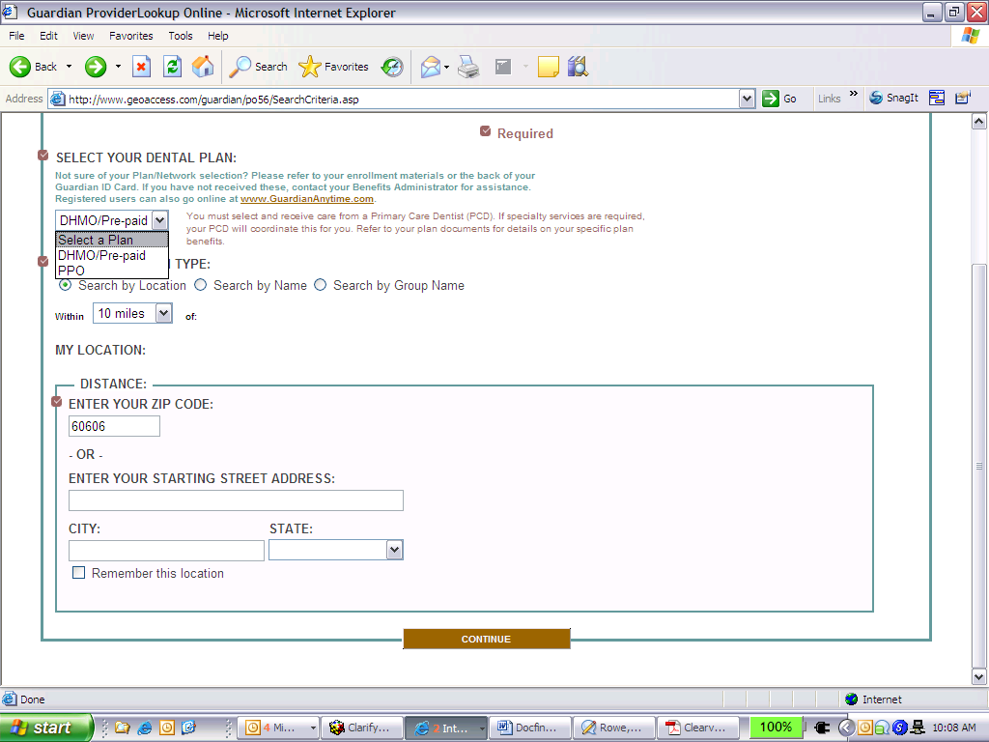

- Select either “PPO” or “DMO/Prepaid”
- Choose your search option
- If you choose to search by location you are required to enter a zip code of the area that you would like to search
- Click on “Continue” at the bottom of the page

Depending on whether you choose PPO or Managed Dental Care your screen will look like this:

If you chose DMO select “First Commonwealth DHMO” Network

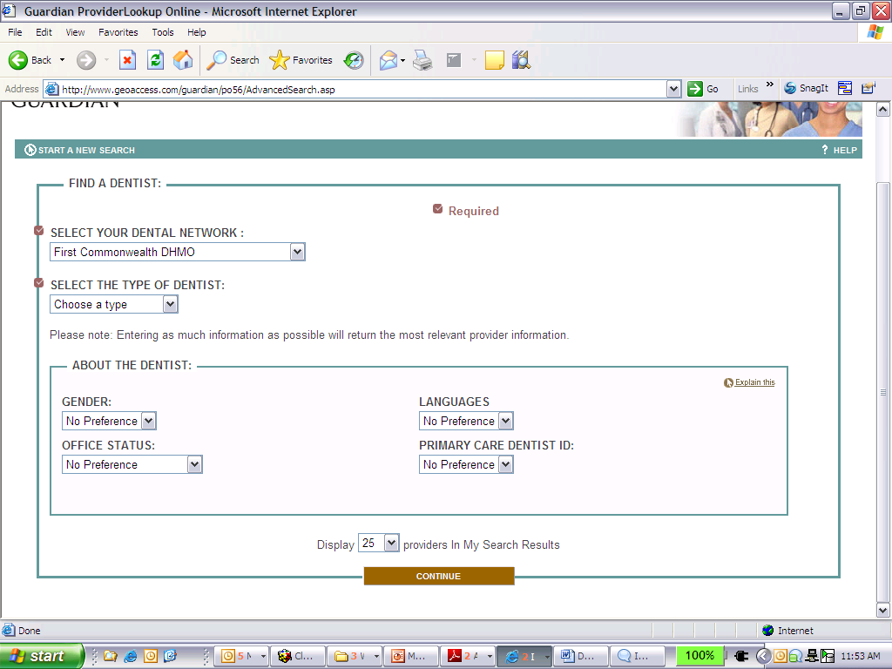

- You will be required to “Select Your Dental Network”
- Click on “Continue” and a list of dentists will appear for you to review
- This completes your search and on your screen will be dentists that meet your plan and dental criteria. You can always go back and make changes (e.g. look in other areas, search by name, select a specialist)

If you chose PPO select “DentalGuard Preferred” network

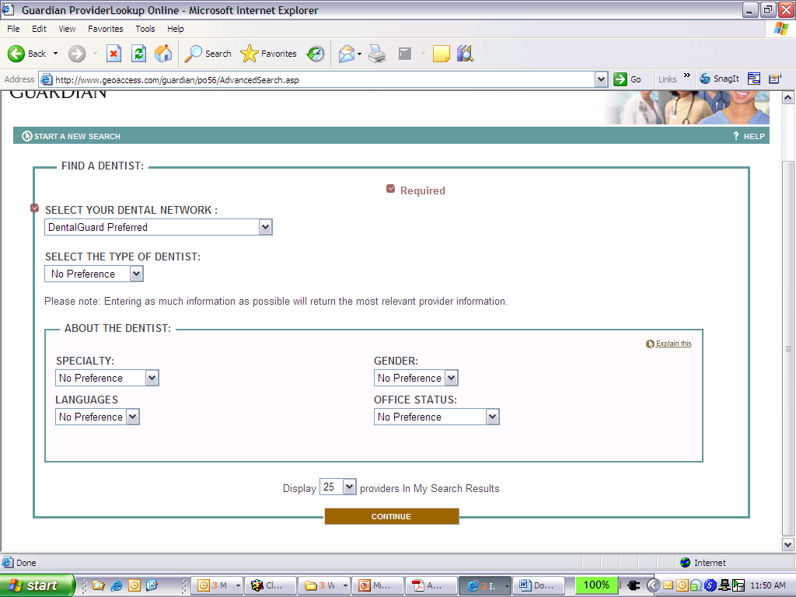

- You will be required to “Select a Plan” - Choose “DentalGuard Preferred”
- You may also select a “Type of Dentist”
- Click on “Continue” and a list of dentists will appear for you to review
- This completes your search and on your screen will be dentists that meet your plan and dental criteria. You can always go back and make changes (e.g. look in other areas, search by name, select a specialist)

