

UnitedHealthcare:

How to Locate a Provider Directory Online

- Open your web browser and enter in the following website: www.uhc.com
- Click on “Find a Physician”
Step
1
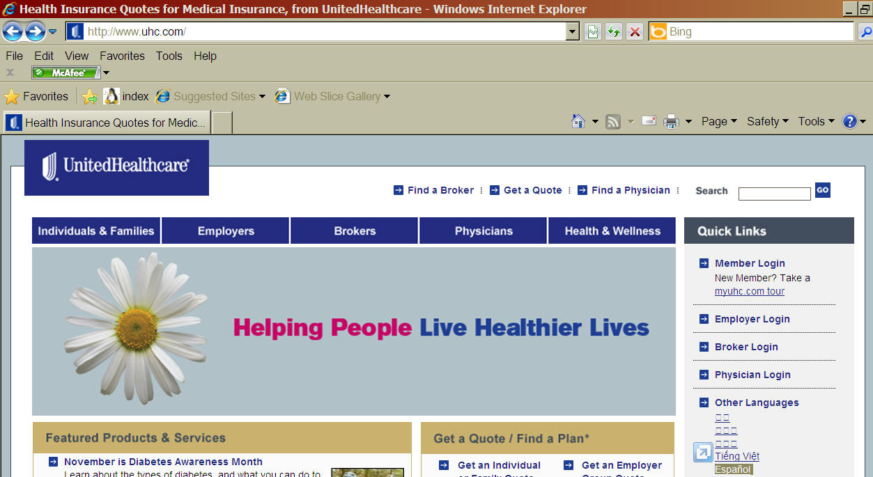
Step 2

- Click on “Find a Physician” again

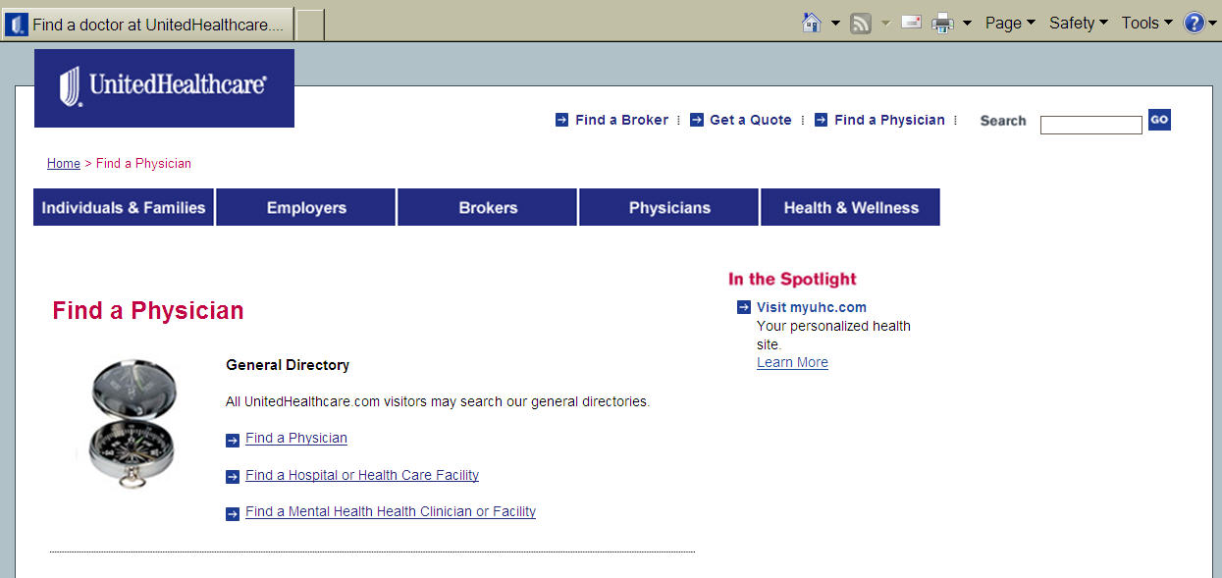
Step 3

- Click on “Search for a Physician” or “ Search for a Hospital…” and “Continue”

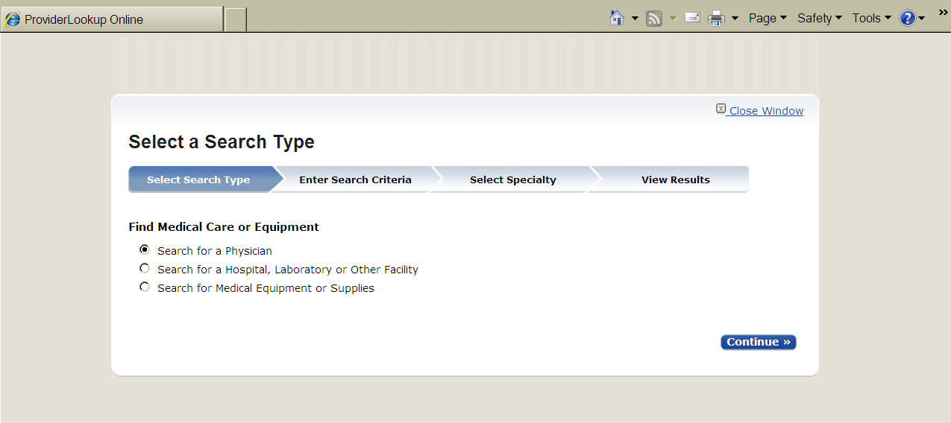
Step 4

- You must identify how you would like to search in section 1

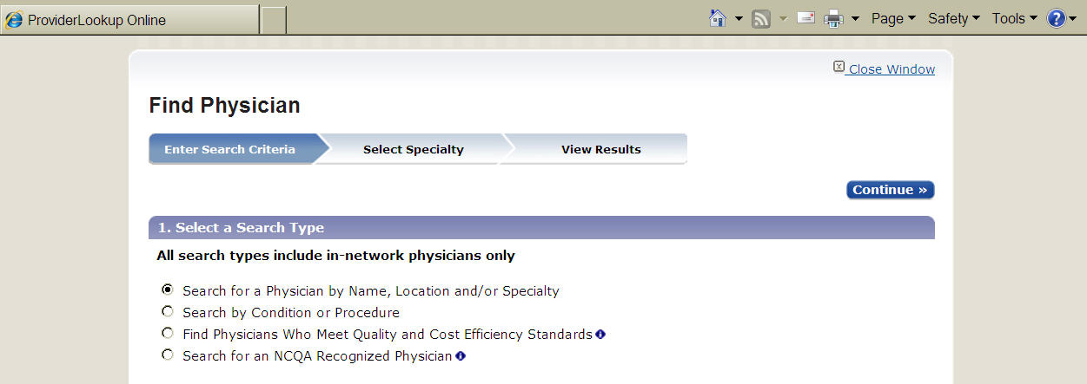
Step 5

- Select a Plan: “UnitedHealthcare Choice Plus” in section 2
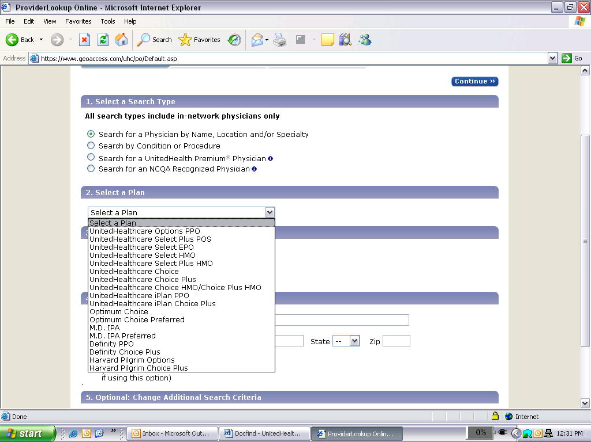
Step 6

- You can choose to search by physician name, address/zip code, or gender and language. But you MUST choose an option in section 4. Click on “Continue”
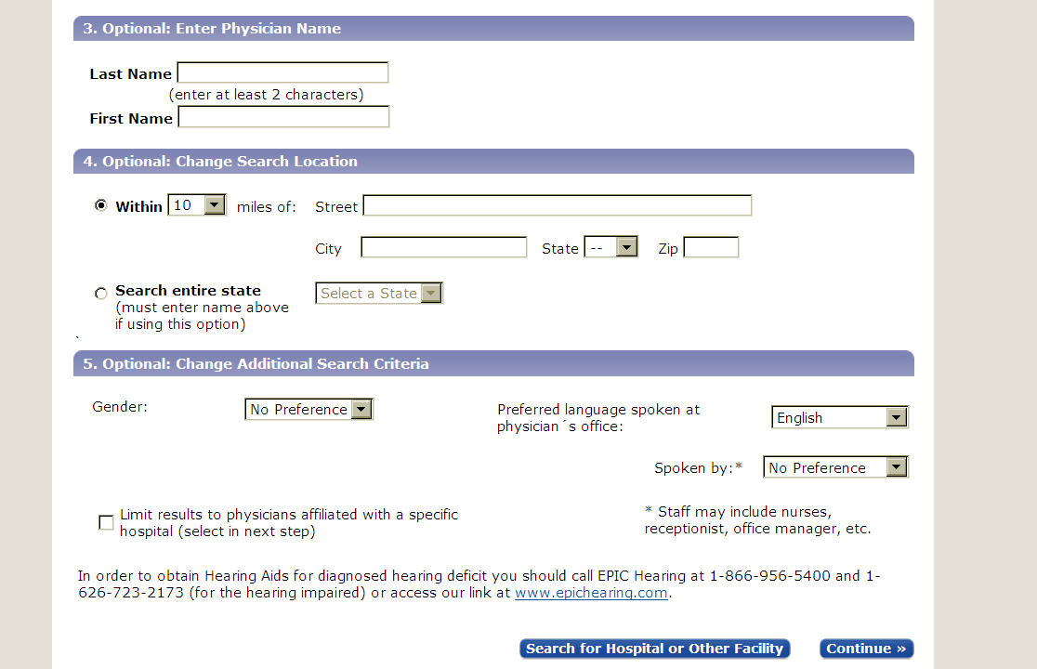

- Select up to five specialties or choose “All Specialties”
- Click on “Continue” and a list of Physicians will appear for you to review.

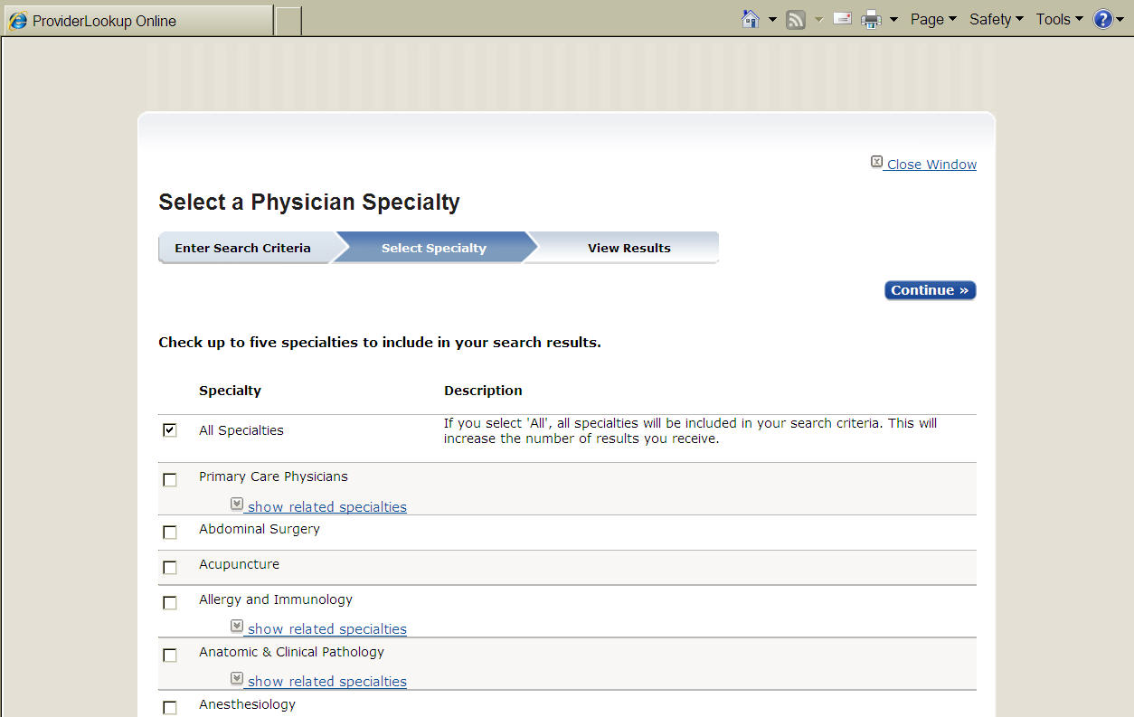

- This completes your search. You can always go back and make changes (e.g. look in other areas, search by name, and select a specialist).

