
Vision Care Plan:

- Open your web browser and enter the following website address: www.vsp.com.
- Under Prospective Members, click on “Choose VSP through your employer”

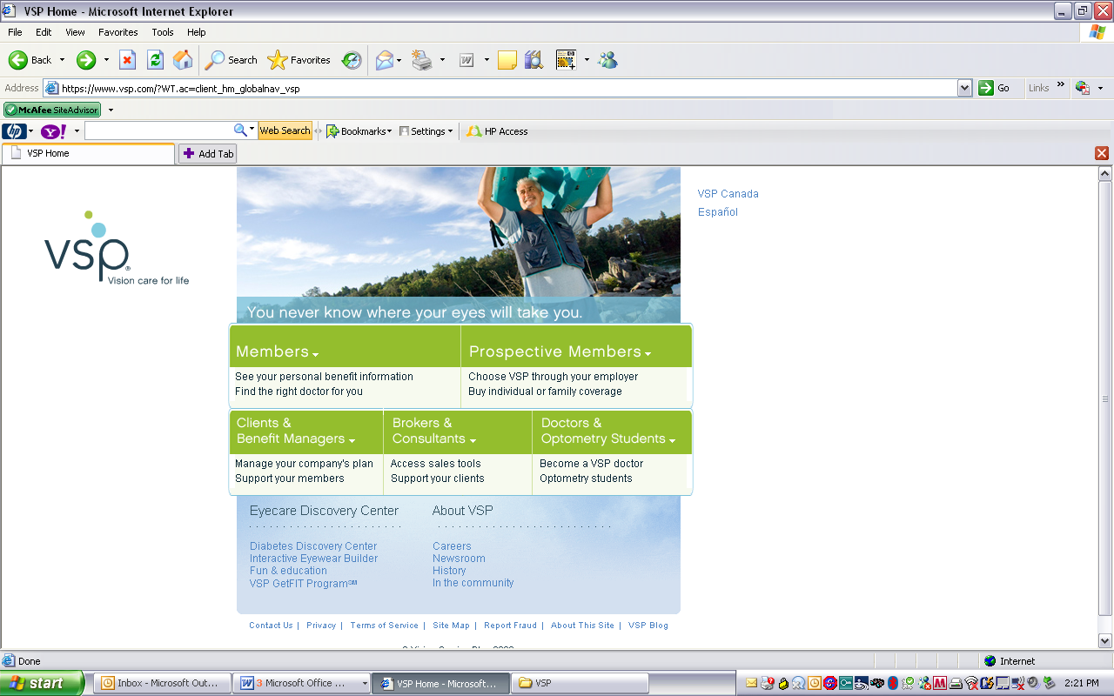

- On the left side of the screen, click on “Find VSP Doctor”

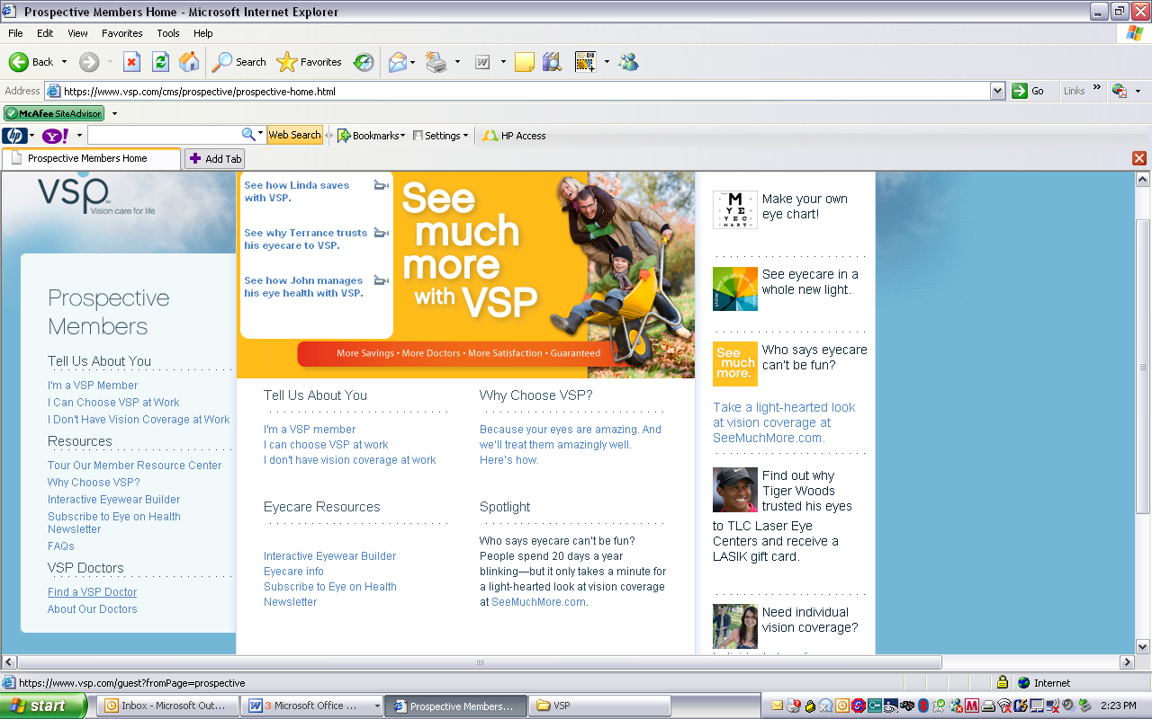

4. Click on the box that states “Continue as a Non Member”
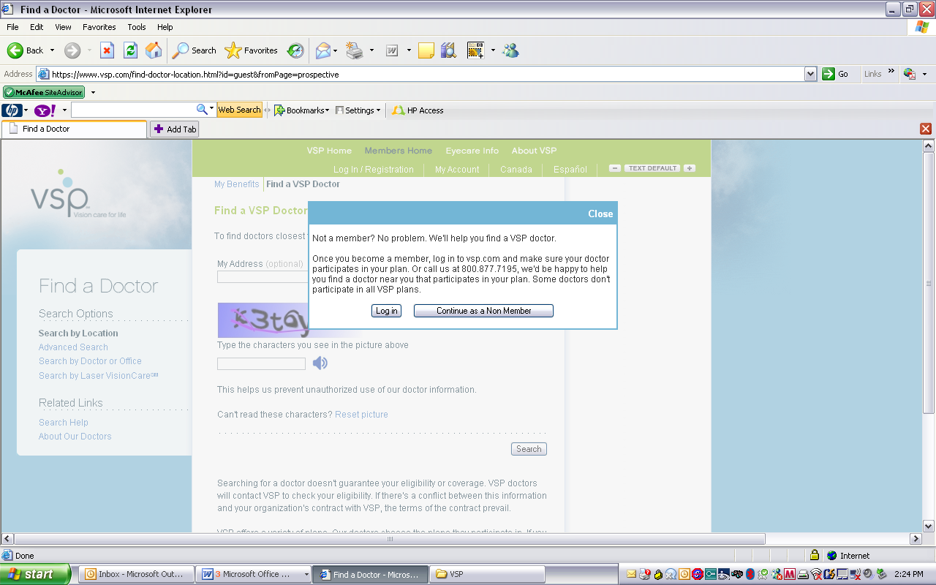

5. Enter your address, city, state and zip and the characters in the picture display. Then click “search”
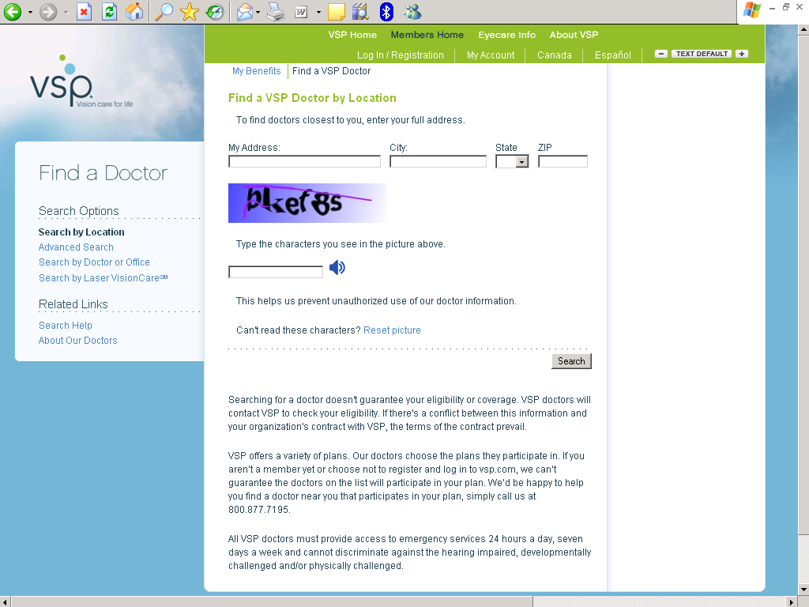

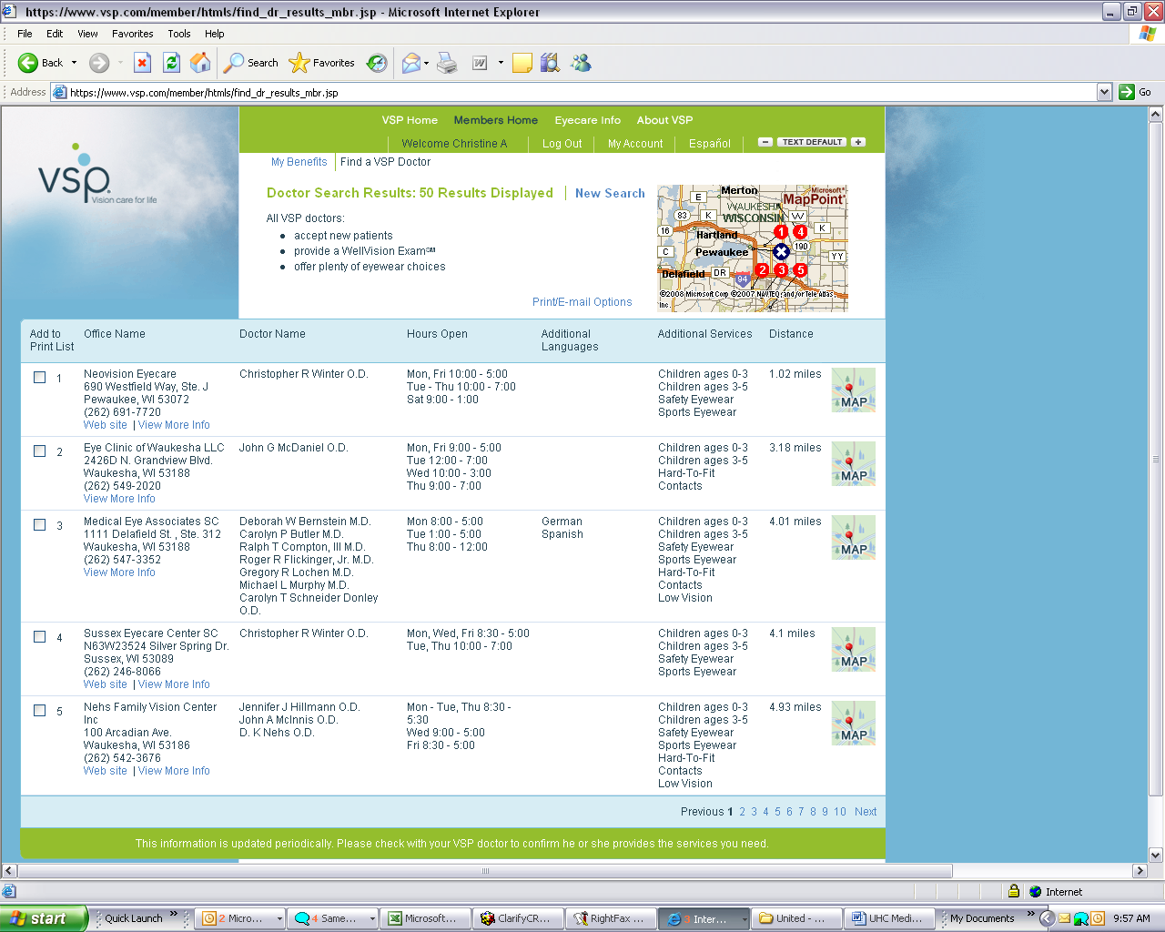

Results page can be printed.

