Prize Ordering on FEGLLC.COM

Placing orders on Fegllc.com

* Go to Fegllc.com
* Log in
* Hover over Orders/Requests
* Select Shop FEG Request Store
  + Click on Select order Type
    - Select the order type
  + Click on Select Product Type
    - Select the product type

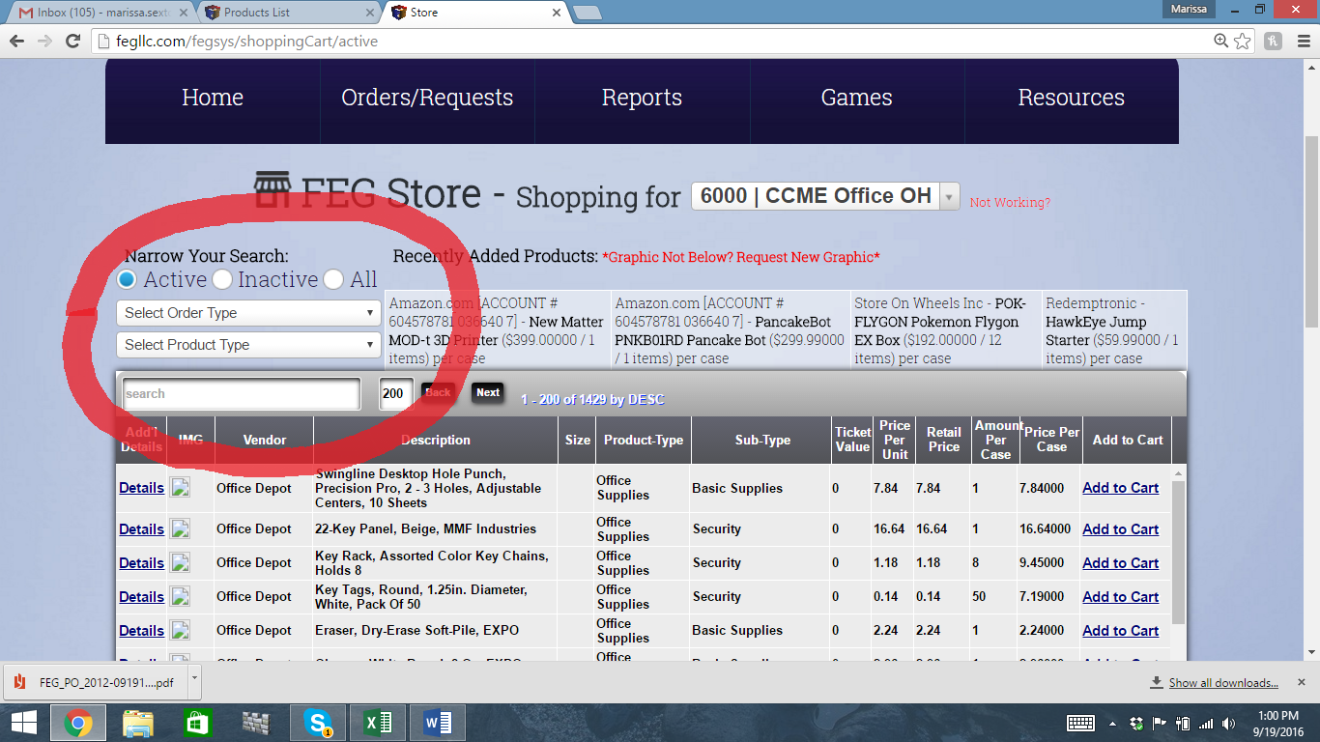

* Scroll through the options and select the desired prize
  + Click Add to Cart
  + A window will pop open with your cart
  + 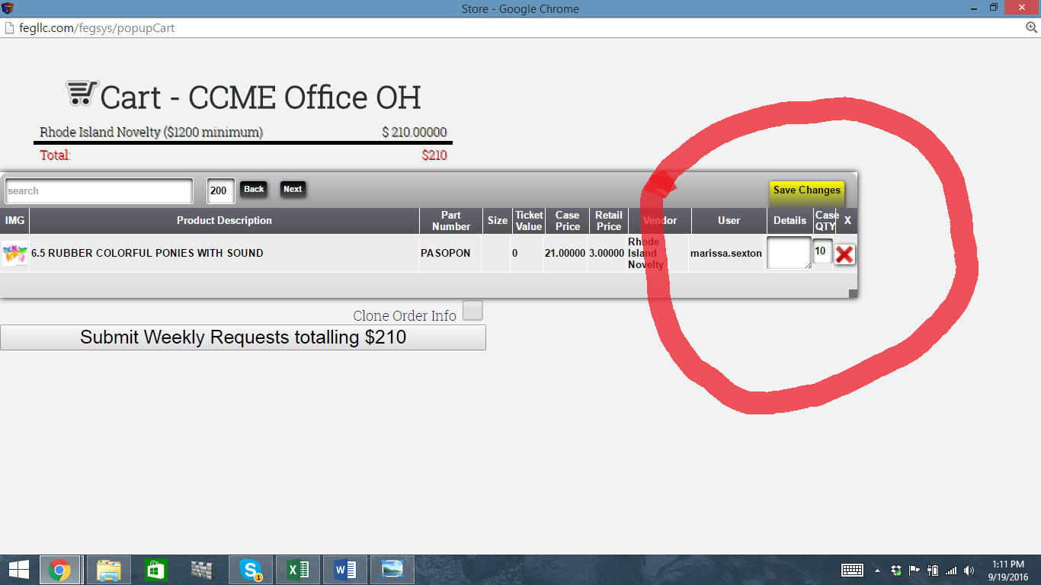Add the desired amount in the Case QTY section and click Save Changes
  + Once you have selected and entered all of your order click on Submit Weekly Requests
  + If you are ordering uniforms add amount and the sizes in the Detail section and click Save Changes
* Send an email to Lisa Price, Mandee Cooke, and Marissa Sexton to let them know an order has been placed. Emails: [lisa.price@fegllc.com](mailto:lisa.price@fegllc.com) [mandee.cook@fegllc.com](mailto:mandee.cook@fegllc.com) [marissa.sexton@fegllc.com](mailto:marissa.sexton@fegllc.com)

Checking orders in on fegllc.com

* Locate packing slip, if needed you can print a copy of your purchase order for reference by generation a PO off of your open orders
* Check entire order against the packing slip to assure all items were received, if you find something is missing or you receive an item you didn’t order look at the notes section on your open orders for any communication in regards to it. If you cannot locate an item that is on your PO, contact Lisa, Mandee, and Marissa with the PO# in the email for our reference and a brief explanation of what is wrong with the order.
* If all merchandise is accounted for click Receive order select the date the order was received, select All items received, click on receive.
* If there is merchandise missing from the pack slip under Order Status select Some items Received put in the notes what you are missing along with an email sent to Lisa, Mandee, and Marissa with the PO# in the email with a brief explanation of what is missing from the order
* If the missing items are not on the packing slip that means we were not billed for the item, select All items Received still put in the notes that you didn’t receive the item but it was not on the packing slip.