Hello, this is a basic tutorial on how to convert multiple images into a single pdf output file

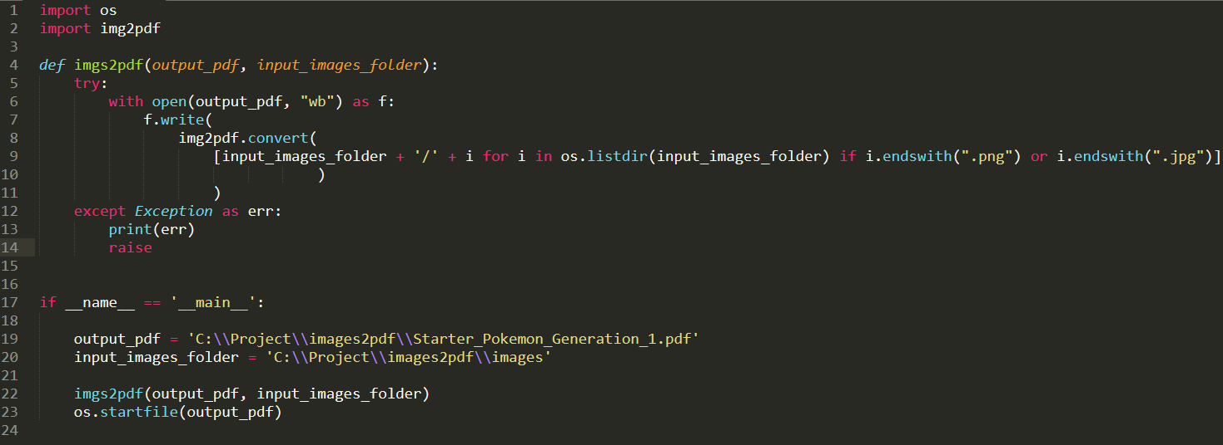

**The steps are easy and as follows:**

1. Choose the path of your images that you want to convert
2. Give the path to ***output pdf file*** with its name where you want to store the pdf file



1. Run the code

**Explanation:**

Inside if main:

* + Line 19 & 20 – are path to the *output_pdf file* and *input_image_folder respectively*
  + We pass both the path to the *imgs2pdf* function
  + Inside *imgs2pdf* function
    - In line 6 - we open the pdf file as write byte

(if file exists, it opens the file else it creates a new file with the name provided)

* + - In line 7 - we write to the file the images
    - In line 8 and 9 - we get all the images which have extension ‘.jpg’ or ‘.png’ from the folder path using os.listdir

This creates a pdf file in the path provided with all the jpg and png images into a single pdf file

