Egmilan, Julie Jean Abigail, C.
BSCpE-4
914843

Valid Statement Assignment

State | Iden | = | Expression | ; | Others | Simple Nos.
0 | 1 | 5 | 5 | 5 | 5 | 5
1 | 5 | 2 | 5 | 4 | 5 | 5
2 | 1 | 5 | 3 | 5 | 5 | 1
3 | 5 | 5 | 5 | 4 | 5 | 5
4 | 5 | 5 | 5 | 5 | 5 | 5
5 | 5 | 5 | 5 | 5 | 5 | 5

Q= q0, q1, q2, q3, q4, q5
Initial State = q0
Final State = q4

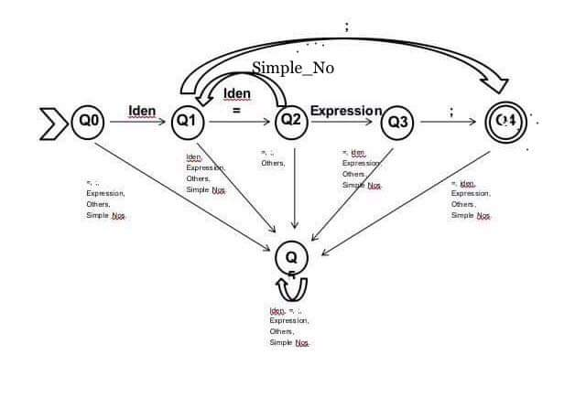

using System;
using System.Collections.Generic;

namespace midterm
{
class Program
{
char []save1;
string []save2;
string []save3;
public int splitting(string state_ment)
{
//converting string to char array
char []str = state_ment.ToCharArray();
//to save the delimiter, make a copy
char []strdup = state_ment.ToCharArray();
save1 = state_ment.ToCharArray();

string[]split = state_ment.Split(new char[] {'=',';'},StringSplitOptions.RemoveEmptyEntries);
try{
var str1 = new List <string>();
int from = 0;
int testme=0;
//hello=num;
//5
//
// Console.WriteLine("adding on the list");
foreach(string ch in split)
{
// Console.WriteLine("string {0}",ch);
str1.Add(ch);
// Console.WriteLine("inserting {0}",ch);
from = ch.Length+from;
// Console.WriteLine(from);
str1.Add(str[from+testme].ToString());
testme++;
}
//testing the List
//saving it to public variable
// Console.WriteLine("Transferring");
int cap = str1.Count;
save2 = new String[cap];
int count=0;
foreach(string gh in str1)
{
// Console.WriteLine(gh);
save2[count] = gh.ToString();
// Console.WriteLine(save2[count]);
count++;
}
}
catch{
// Console.WriteLine("Invalid");
}

return 1;
}

int check_simpleno(string simplenum)
{
int state=0;
int [,]table = new int [,] {
{1,4,4},
{1,2,4},
{3,4,4},
{3,4,4},
{4,4,4}
};
int input=0;
int flag = 0;
//test simple number function
//checking each char if its digits
foreach (char n in simplenum)
{
// Console.WriteLine(n);
if(n=='.')
{
input = 1;
// Console.WriteLine("state_1");
}
else if (char.IsDigit(n))
{
input=0;
// Console.WriteLine("state_0");
}
else {
input=2;
// Console.WriteLine("state_2");
}
state = table[state,input];
if(state==1)
{
flag=1;
}
else if (state==3)
{
flag =1;
}
else {
flag =0;
}
}
if(flag == 1)
{
// Console.WriteLine("simplenumber_accepted");
return 1;
}
else
{
// Console.WriteLine("simplenumber_notaccepted");
return 0;
}
}

int check_identifier(string simpleidentifier)
{
int state =0;
int [,] table = new int [,] {
{1,1,2,2},
{1,1,1,2},
{2,2,2,2}
};
int input;
int flag=0;
// Console.WriteLine("identifier function");
foreach (char m in simpleidentifier)
{
if(m=='_')
{
input=0;
// Console.WriteLine("identifier detects _ ");
}
else if (char.IsLetter(m))
{
input = 1;
// Console.WriteLine("identifier detects letter");
}
else if (char.IsDigit(m))
{
input = 2;
// Console.WriteLine("identifier detects digit");
}
else {
input =3;
// Console.WriteLine("?");
}
state = table [state,input];
if (state==1)
{
flag =1;
}
else {
flag = 0;
}
}
// Console.WriteLine("identifing");
if(flag==1)
{
// Console.WriteLine("identifier");
return 1;
}
else {
// Console.WriteLine("Not identifier");
return 0;
}
}
int check_expression(string expressme)
{
// Console.WriteLine("New string {0}",expressme);
int state=0;
int input;
int [,] table= new int [,] {
{1,4,1,4},
{4,2,4,4},
{3,4,3,4},
{4,2,4,4},
{4,4,4,4}
};
char a='+';
char b = '-';
char c = '*';
char d = '/';
char e = '%';
string plus = a.ToString();
string minus = b.ToString();
string multi = c.ToString();
string divide = d.ToString();
string modul= e.ToString();
int l = splitting2(expressme);
int flag = 0;
foreach (string lastme in save3)
{
if(check_identifier(lastme)==1)
{
input=0;
// Console.WriteLine("identifier");
}
else if (lastme == plus || lastme== minus || lastme == multi || lastme==divide || lastme==modul)
{
input=1;
// Console.WriteLine("operator");
}
else if (check_simpleno(lastme)==1)
{
input=2;
// Console.WriteLine("simple number");
}
else {
input=3;
}
state=table[state,input];
if(state==3)
{
flag=1;
}
else {
flag=0;
}
}
if (flag == 1)
{
// Console.WriteLine("expressing");
return 1;
}
else {
// Console.WriteLine("not expressing");
return 0;
}
}
int splitting2(string state_ment)
{
Console.WriteLine();
// Console.WriteLine("expression: {0} ",state_ment);
char [] str = state_ment.ToCharArray();
string[]split = state_ment.Split(new char[] {'+','/','-','*','%'},StringSplitOptions.RemoveEmptyEntries);
var str1 = new List <string>();
str1.Clear();
int from = 0;
int testme=0;
// Console.WriteLine("max capacity {0} ",str1.Count);
//hello=num;
//5
//
// Console.WriteLine("split array lenght {0}",split.Length);
foreach(string ch in split)
{
// Console.WriteLine("string {0} length {1}",ch,ch.Length);
str1.Add(ch);
// Console.WriteLine("inserting {0}",ch);
if(from+ch.Length+testme < str.Length)
{
from = ch.Length+from;
// Console.WriteLine("{0} {1}",from,str[from+testme]);
str1.Add(str[from+testme].ToString());
testme++;
}
// Console.WriteLine("list count {0} from {1} testme {2}",str1.Count,from,testme);
}
// Console.WriteLine("data in list str1 {0}",str1.Count);
int cap = str1.Count;
save3 = new String[cap];
int count=0;
// Console.WriteLine("transferring list count= {0}",str1.Count);
foreach (string hh in str1)
{
// Console.WriteLine(hh);
save3[count] = hh.ToString();
// Console.WriteLine(save3[count]);
count++;
}
return 1;
}
public static void Main(string[] args)
{
Program a = new Program();
int [,]table = new int[,] {
{1,5,5,5,5,5},
{5,2,5,4,5,5},
{1,5,3,5,5,3},
{5,5,5,4,5,5},
{5,5,5,5,5,5}

};
string statement;
/*getting the string statement */
statement = Console.ReadLine();
int h=0;
int state=0;
int input;
char eq='=';
char semi=';';
string equall = eq.ToString();
string semicol = semi.ToString();
int flag=0;
/*splitting the statement */
try{
h = a.splitting(statement);
// Console.WriteLine(a.save2.Length);
// valid statement operation
foreach(string testme in a.save2)
{
try{
// Console.ReadKey(true);
if(a.check_identifier(testme)==1)
{
input=0;
// Console.WriteLine("identifier");
} /*
else if (a.check_simpleno(testme)==1)
{
Console.WriteLine("simple number");
}*/
else if (testme == equall)
{
input=1;
// Console.WriteLine("equal detected");
}
else if (a.check_expression(testme)==1)
{
input=2;
// Console.WriteLine("expression");
}
else if(testme == semicol)
{
input=3;
// Console.WriteLine("semi");
}
else if (a.check_simpleno(testme)==1)
{
input=5;
// Console.WriteLine("simple number");
}
else {
input=4;
// Console.WriteLine("error detected");
}
state=table[state,input];
if(state==4)
{
flag =1;
}
}
catch(Exception)
{
// Console.WriteLine("error");
}

}
}
catch
{
}
if(flag==1)
{
Console.WriteLine("Valid Assignment Statement");
}
else {
Console.WriteLine("Invalid Assignment Statement");
}
// TODO: Implement Functionality Here
// Console.Write("Press any key to continue . . . ");
// Console.ReadKey(true);
}
}
}

