JULIE JEAN ABIGAIL C. EGMILAN BSCPE-4
914843

B. L = {W ϵ(a,b)*|W has both ba & ab as substring }

L = ϵ*ba ϵ* ϵ*ab ϵ* + ϵ*ab ϵ* ϵ*ba ϵ*

State Diagram:

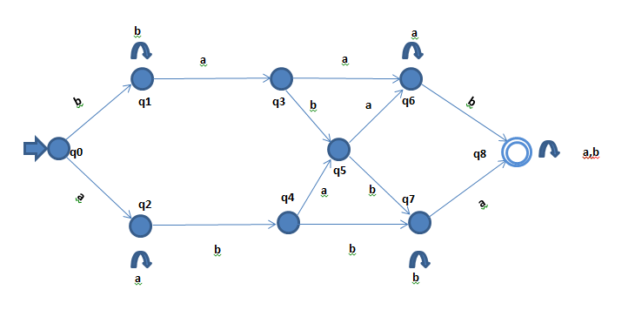

 | a | b
q0 | q2 | q1
q1 | q3 | q1
q2 | q2 | q4
q3 | q6 | q5
q4 | q5 | q7
q5 | q6 | q7
q6 | q6 | q8
q7 | q8 | q7
q8 | q8 | q8

Q = q0,q1,q2,q3,q4,q5,q6,q7,q8
ϵ = (a,b)
Initial State = {q0}
Final State ={ q8}

#include<iostream>
using namespace std;

int main() {
int j=0, state=0;
int table[9][2]={{2,1},{3,1},{2,4},{6,5},{5,7},{6,7},{6,8},{8,7},{8,8}};
int input;
int flag=0;
char st[10];
cin>>st;
while(st[j]){

switch (st[j]){
case 'a': input=0;break; //collumn
case 'b': input=1;break; //collumn

}
state=table[state][input];
if (state ==8){flag =1; break;}
j++;

}
if (flag==1){cout<<"accepted";}
else {cout<<"not accepted";}
return 0;
}

