HEALTHCARE DATA
PREDICTIVE MODELING

Algorithm Selection, Feature Engineering & Model Evaluation
WEEK 4 TASK

Prepared by: Megha Sharma
Case study: Predicting 30-day hospital readmission
Public dataset reference: UCI Diabetes 130-US Hospitals, 1999–2008

Executive Summary
This report presents a practical, step-by-step plan for designing a predictive model in a healthcare analytics context. The case study is the hypothetical prediction of whether an eligible hospital encounter will be followed by readmission within 30 days. The UCI Diabetes 130-US Hospitals dataset is used as a public reference for the types of encounter, demographic, diagnosis, medication, and utilization variables that may be available. The exact target definition and feature timing must be verified against the dataset documentation before any implementation.
The proposed workflow covers problem definition, target construction, data understanding, feature engineering, feature selection, patient-aware or time-aware data splitting, algorithm selection, model training, validation, threshold selection, and interpretation. Logistic Regression is recommended as an interpretable baseline, Decision Tree as a transparent non-linear comparator, and Random Forest as a more flexible ensemble. Model selection is not based on accuracy alone: precision, recall, specificity, F1-score, ROC-AUC, PR-AUC, calibration, subgroup performance, and operational consequences must also be considered.
To address the need for practical examples, the report includes worked calculations using a clearly labelled illustrative confusion matrix, a small hypothetical feature-engineering example, a model-comparison example, and a complete workflow flowchart. All invented figures are explicitly marked as teaching examples and must not be represented as results from the UCI dataset. No code has been executed and no model has been trained for this assignment.

1. Project Overview and Problem Definition

1.1 Healthcare problem
Hospital readmission is an important healthcare quality and service-planning topic. For this academic scenario, the task is binary classification: estimate whether an eligible hospital encounter is followed by a readmission within 30 days. A hypothetical care-quality team could use a validated risk estimate to identify cases for further human review and to study patterns in follow-up needs. The model must not independently determine treatment, discharge, eligibility, or access to care.

1.2 Define the prediction point and outcome
The prediction point must be fixed before selecting features. This report uses discharge as an example prediction point. Only information available by discharge may be used. The source dataset's readmission categories and documentation must be checked to determine exactly how the positive class is defined. Do not assume that every field or label maps directly to the proposed 30-day outcome.
Project element | Proposed definition | Reason / decision rule
Unit of analysis | One eligible hospital encounter. | If patients have multiple encounters, account for dependence between records.
Prediction point | At discharge (hypothetical design choice). | Prevents using information that becomes available only after prediction.
Target / positive class | Readmission within 30 days, subject to verification of source labels. | Defines what the model is learning to estimate.
Negative class | No readmission within 30 days, subject to source documentation. | Do not combine categories without checking the label meaning.
Predictors | Encounter and history fields known by discharge. | Exclude direct outcome proxies and future information.
Intended use | Academic analysis and hypothetical human review. | Not a validated clinical decision-support system.

1.3 Success criteria
- The target and prediction point are unambiguous and reproducible.
- No predictor contains information from after the prediction point.
- Candidate models are compared on held-out data using multiple metrics.
- The selected model's probability estimates and subgroup errors are examined.
- The report explains the limitations and does not claim clinical readiness.

2. Dataset Reference and Understanding
Public dataset reference: UCI Diabetes 130-US Hospitals for Years 1999–2008
The UCI repository describes encounter-level data from 130 US hospitals and integrated delivery networks during 1999–2008. It includes demographic, admission, diagnosis, medication, laboratory-related, and utilization information. This is a historical US dataset; patterns may not generalize to current hospitals or other countries. Before use, inspect the repository description, data dictionary, version, missing-value conventions, target definition, and license.
Feature family | Examples to investigate | Checks before modeling
Demographic | Age category and documented demographic fields. | Check missingness, representation, category definitions, and fairness implications.
Encounter | Admission type/source, discharge disposition, length of stay. | Confirm each field is available at the selected prediction point.
Prior utilization | Prior inpatient, outpatient, and emergency encounter counts. | Ensure counts refer only to history before the index encounter.
Diagnosis | Primary, secondary, and additional diagnosis codes. | Review coding meaning and consider documented grouping for sparse categories.
Medication / laboratory | Medication indicators and laboratory-related fields. | Check measurement timing, coding, units, and whether values are available at prediction time.
Target | Readmission category. | Keep separate from predictors and map according to source documentation.

The analyst should also identify whether one row represents an encounter rather than a unique patient. If a patient contributes multiple encounters, random row-level splitting can place the same person's records in both training and test sets and produce an over-optimistic estimate.

3. Feature Engineering and Selection

3.1 Feature engineering methods
Method | Healthcare example | Why / caution
Categorical encoding | One-hot encode admission-source categories. | Avoids assigning an artificial numeric order to nominal categories.
Ordinal encoding | Encode an ordered age band only if its order is documented. | Do not use for unordered categories.
Numeric transformation | Apply log1p to a highly skewed prior-visit count if diagnostics support it. | Can reduce skew; document handling of zeros.
Aggregation | Create a total of eligible prior inpatient and emergency visits. | All component counts must precede the index encounter.
Missingness indicator | Create a flag showing whether a selected laboratory field is missing. | Missingness may reflect workflow; assess stability and fairness.
Scaling | Standardize numeric predictors for Logistic Regression. | Fit mean and standard deviation on training data only; tree models usually do not need scaling.
Interaction | Test a pre-specified interaction between prior utilization and length of stay. | May capture combined patterns but increases complexity and overfitting risk.

3.2 Worked feature-engineering example (illustrative)
Suppose a hypothetical encounter has 2 prior inpatient visits, 3 prior emergency visits, and 1 prior outpatient visit. A simple prior-utilization total would be 2 + 3 + 1 = 6. This feature is only valid if all three counts refer to events before the index encounter and are available at the prediction point. It must not include the current encounter or any future visit.
Raw input (hypothetical) | Value | Engineered feature
Prior inpatient visits | 2 | Prior utilization total = 6
Prior emergency visits | 3 | 2 + 3 + 1 = 6
Prior outpatient visits | 1 | Use as a separate feature too, if justified.

For a skewed count, log1p(6) = ln(7) ≈ 1.946. This numerical value is a mathematical illustration, not a measured result from the public dataset. The transformation should be retained only if it improves the training/validation workflow.

3.3 Feature selection strategy
- Remove direct identifiers and fields that reveal the target or are recorded after the prediction point.
- Review missingness, near-zero variance, rare categories, and redundant predictors.
- Use domain reasoning and descriptive analysis to shortlist relevant variables.
- Use regularization or model-based importance as supporting evidence, not as proof of causation.
- Perform feature selection within training folds; never select features using the full dataset before splitting.
- Record selected and excluded variables with a brief justification.

4. Data Splitting and Leakage Prevention
A starting design may use 80% of eligible records for training and 20% for a final held-out test set. The training portion can be evaluated using stratified cross-validation. However, the split must match the data structure and intended deployment: use group-aware splitting if patients have repeated encounters, and consider chronological splitting if the goal is to predict future encounters. A simple random split is not automatically appropriate.
Subset | Purpose | Controls
Training | Fit transformations and candidate models. | Imputers, encoders, scalers, and selectors learn only from training folds.
Validation / cross-validation | Compare algorithms, tune hyperparameters, and select a threshold. | Repeat the complete preprocessing pipeline inside each fold.
Held-out test | Estimate final generalization performance. | Use after model choices are fixed; do not tune against test results.

4.1 Leakage examples
Leakage risk | Why it is wrong | Prevention
Using post-readmission data | It reveals information that would not exist at discharge. | Exclude variables recorded after the prediction point.
Scaling before splitting | Test-set statistics influence the training pipeline. | Fit scaler only on each training fold.
Selecting features on all rows | Test labels influence which predictors are chosen. | Perform selection within cross-validation.
Same patient in train and test | The model may recognize patient-specific patterns. | Use patient-grouped splitting where identifiers allow it.
Using outcome-derived fields | The predictor is a proxy for the target itself. | Audit definitions and timing of every feature.

5. Algorithm Selection and Justification
Algorithm | How it works | Strengths | Limitations / role
Logistic Regression | Estimates the probability of a binary outcome through a logistic function. | Fast, interpretable baseline; coefficients can be inspected; regularization available. | May miss complex non-linear relationships. Use as baseline.
Decision Tree | Splits observations using feature-based rules to reduce impurity. | Can represent non-linear patterns and simple decision rules. | Can overfit and be unstable. Limit depth and minimum leaf size.
Random Forest | Combines predictions from many decision trees trained on resampled data and feature subsets. | Can capture interactions and non-linear patterns; often more stable than a single tree. | Less directly interpretable; importance and calibration need careful review.

A sensible comparison begins with Logistic Regression because it provides a transparent reference. A Decision Tree tests whether simple non-linear splits add value. Random Forest tests a more flexible ensemble. The final model should be chosen using pre-defined validation criteria, not simply because one algorithm is more complex.

5.1 Illustrative model-selection example
The following scores are invented solely to demonstrate how a comparison table might be interpreted. They are NOT results from the UCI dataset, and no models were trained for this report.
Candidate (hypothetical) | Recall | Precision | ROC-AUC | Interpretation example
Logistic Regression | 0.70 | 0.42 | 0.74 | More interpretable baseline; may miss some complex patterns.
Decision Tree | 0.66 | 0.39 | 0.69 | Simple rules, but illustrative discrimination is lower.
Random Forest | 0.78 | 0.45 | 0.81 | Illustratively strongest ranking and recall, but needs interpretability and calibration checks.

In this made-up comparison, Random Forest has the highest recall and ROC-AUC, but it would not automatically be selected. The team would also examine calibration, subgroup errors, threshold workload, and whether the gain justifies reduced transparency. The table demonstrates the decision process only.

6. Model Development Plan: Step by Step
- Confirm the target definition, unit of analysis, prediction point, intended use, and evaluation population.
- Inspect the data dictionary and profile variables, missingness, categories, and ranges.
- Remove identifiers and leakage-prone variables; retain only features available at prediction time.
- Choose patient-aware, chronological, or stratified splitting based on the data structure.
- Build a preprocessing pipeline for imputation, encoding, and scaling where required.
- Train Logistic Regression as the baseline model.
- Train a constrained Decision Tree and tune depth and minimum leaf size.
- Train Random Forest and tune number of trees, maximum depth, and minimum samples per leaf.
- Compare candidates using cross-validation and pre-selected metrics.
- Assess calibration and choose an operating threshold using validation data.
- Evaluate the finalized pipeline once on held-out test data.
- Document model behavior, limitations, subgroup results, and next steps.

6.1 Python libraries and proposed pipeline
Library / tool | Purpose in this task
Pandas | Load and inspect data, select columns, group records, and create train/test data frames.
NumPy | Numerical calculations, arrays, masks, and transformations.
scikit-learn | Preprocessing pipelines, train/test splitting, Logistic Regression, Decision Tree, Random Forest, cross-validation, and metrics.
Matplotlib / Seaborn | Plot ROC and precision-recall curves, confusion matrices, calibration plots, and feature summaries.

Pseudocode (description only): load and inspect the data; define target and permitted predictors; split data; create a pipeline that imputes missing values, encodes categories, scales numeric variables where needed, and fits a classifier; evaluate the pipeline using cross-validation; compare candidate models; select threshold on validation data; evaluate once on the test set.

7. Worked Evaluation Example: Confusion Matrix and Metrics
To demonstrate metric calculations, assume a hypothetical held-out test sample of 200 encounters. Suppose 40 encounters are actually readmitted within the defined 30-day period and 160 are not. A model produces the following illustrative outcomes:
Actual outcome | Predicted readmission | Predicted no readmission | Total
Readmitted | TP = 30 | FN = 10 | 40
Not readmitted | FP = 20 | TN = 140 | 160
Total | 50 | 150 | 200

7.1 Step-by-step calculations
Metric | Formula | Worked calculation | Illustrative result
Accuracy | (TP + TN) / N | (30 + 140) / 200 = 170 / 200 | 0.85 = 85%
Precision | TP / (TP + FP) | 30 / (30 + 20) = 30 / 50 | 0.60 = 60%
Recall / sensitivity | TP / (TP + FN) | 30 / (30 + 10) = 30 / 40 | 0.75 = 75%
Specificity | TN / (TN + FP) | 140 / (140 + 20) = 140 / 160 | 0.875 = 87.5%
F1-score | 2 × (Precision × Recall) / (Precision + Recall) | 2 × (0.60 × 0.75) / (0.60 + 0.75) | 0.667 ≈ 66.7%

Interpretation: in this illustration, the model identifies 30 of the 40 positive encounters (75% recall), while 20 of its 50 positive alerts are false positives (60% precision). It misses 10 positive encounters. The 85% accuracy should not be read alone: a model that predicts “not readmitted” for every encounter would already be correct for 160 of 200 cases (80%) in this illustrative imbalanced sample, while detecting none of the positive cases.

7.2 Metric definitions and healthcare trade-offs
Metric | Meaning | Practical consideration
Accuracy | Share of all predictions that are correct. | Can be misleading when the positive class is uncommon.
Precision | Share of positive predictions that are truly positive. | Low precision means more unnecessary follow-up reviews.
Recall / sensitivity | Share of actual positives detected. | Low recall means more readmissions are missed by the flagging system.
Specificity | Share of actual negatives correctly identified. | Low specificity can create a high volume of false alerts.
F1-score | Harmonic mean of precision and recall. | Useful summary of these two measures; ignores true negatives directly.
ROC-AUC | Area under sensitivity vs false-positive-rate curve. | Measures ranking across thresholds, not calibration or one chosen threshold.
PR-AUC | Area under precision-recall curve. | Often useful with class imbalance; baseline depends on prevalence.
Calibration | Agreement between predicted risk and observed event frequency. | Important when probabilities, rather than just rankings, are communicated.

8. ROC Curve, Threshold Selection and Calibration
The ROC curve plots true-positive rate (recall) against false-positive rate (1 − specificity) at multiple thresholds. ROC-AUC summarizes ranking discrimination. A higher AUC generally indicates better separation of positive and negative cases, but it does not identify a suitable operating threshold and does not guarantee accurate probability estimates.
Thresholds convert model probabilities into predicted classes. A lower threshold generally flags more encounters, often increasing recall while also increasing false positives. A higher threshold generally reduces alerts but may miss more positive cases. The threshold should be selected using validation data after considering review capacity and the relative consequences of missed cases and unnecessary reviews. Never choose it by repeatedly checking the held-out test set.
Hypothetical threshold | Possible behavior | Decision question
0.30 | More encounters may be flagged; recall may rise and precision may fall. | Can the review team manage more alerts?
0.50 | A conventional starting point, not automatically optimal. | Does this balance fit the intended workflow?
0.70 | Fewer encounters may be flagged; precision may rise and recall may fall. | Are missed positive cases an acceptable trade-off?

These threshold values are illustrative. Actual performance at each threshold must be calculated from validation data. Calibration should also be checked if a score such as 0.70 is communicated as a probability; a predicted probability of 0.70 should correspond to an observed event frequency near 70% among comparable predictions for a well-calibrated model.

9. Validation, Robustness and Fairness
- Use stratified cross-validation when appropriate to preserve class proportions.
- Use grouped cross-validation if encounters from the same patient are related.
- Use chronological validation if the goal is prediction on future encounters.
- Report the average and variation of metrics across folds, not one score alone.
- Check calibration and threshold-specific confusion matrices.
- Compare error rates across relevant subgroups where sample sizes support meaningful estimates.
- Review whether missingness, coding practices, or representation differ across groups.
- Perform sensitivity analysis for feature definitions, imputation, and thresholds.
- Seek external or temporal validation before any real-world use.

10. Interpretation and Responsible Healthcare Use
Model output | Appropriate interpretation | Do not conclude
Predicted probability | Estimated likelihood for the defined target, subject to validation and calibration. | That readmission is certain or a diagnosis has been made.
Coefficient / feature importance | A description of how the fitted model uses the available variables. | That the feature causes readmission.
High-risk flag | A possible prompt for authorized human review in a hypothetical workflow. | That care should automatically be withheld or changed.
Subgroup performance | Evidence to investigate potential performance gaps. | That a group difference is meaningful without sample sizes and uncertainty.

Historical healthcare records can reflect unequal access, documentation differences, and structural factors. A model may reproduce those patterns. Sensitive attributes and proxy variables require careful governance. Any operational use would need clinical review, privacy and security controls, local validation, monitoring, and an accountable process for correcting errors.

11. Risk Assessment and Contingency Planning
Risk | Potential impact | Mitigation / contingency
Ambiguous outcome label | Wrong target and invalid performance claims. | Pause modeling; verify data dictionary and document the target mapping.
Data leakage | Artificially high test scores. | Audit feature timing; rebuild pipeline with split-first, fold-only preprocessing.
Class imbalance | Accuracy hides poor detection of positive cases. | Use recall, precision, PR-AUC, class-aware validation, and threshold analysis.
Overfitting | Poor performance on new encounters. | Regularize/prune, cross-validate, reduce complexity, and retain a held-out test set.
Poor calibration | Predicted probabilities are misleading. | Inspect calibration; consider validation-based recalibration.
Subgroup performance gap | Unequal error burden. | Investigate data quality and features; report limitations and avoid deployment until reviewed.
Historical / local data shift | Weak transfer to current hospitals. | Obtain more recent/local data and conduct temporal or external validation.
Insufficient sample in a subgroup | Unstable estimates. | Report uncertainty and avoid definitive comparisons.

12. Complete Predictive Modeling Workflow Flowchart

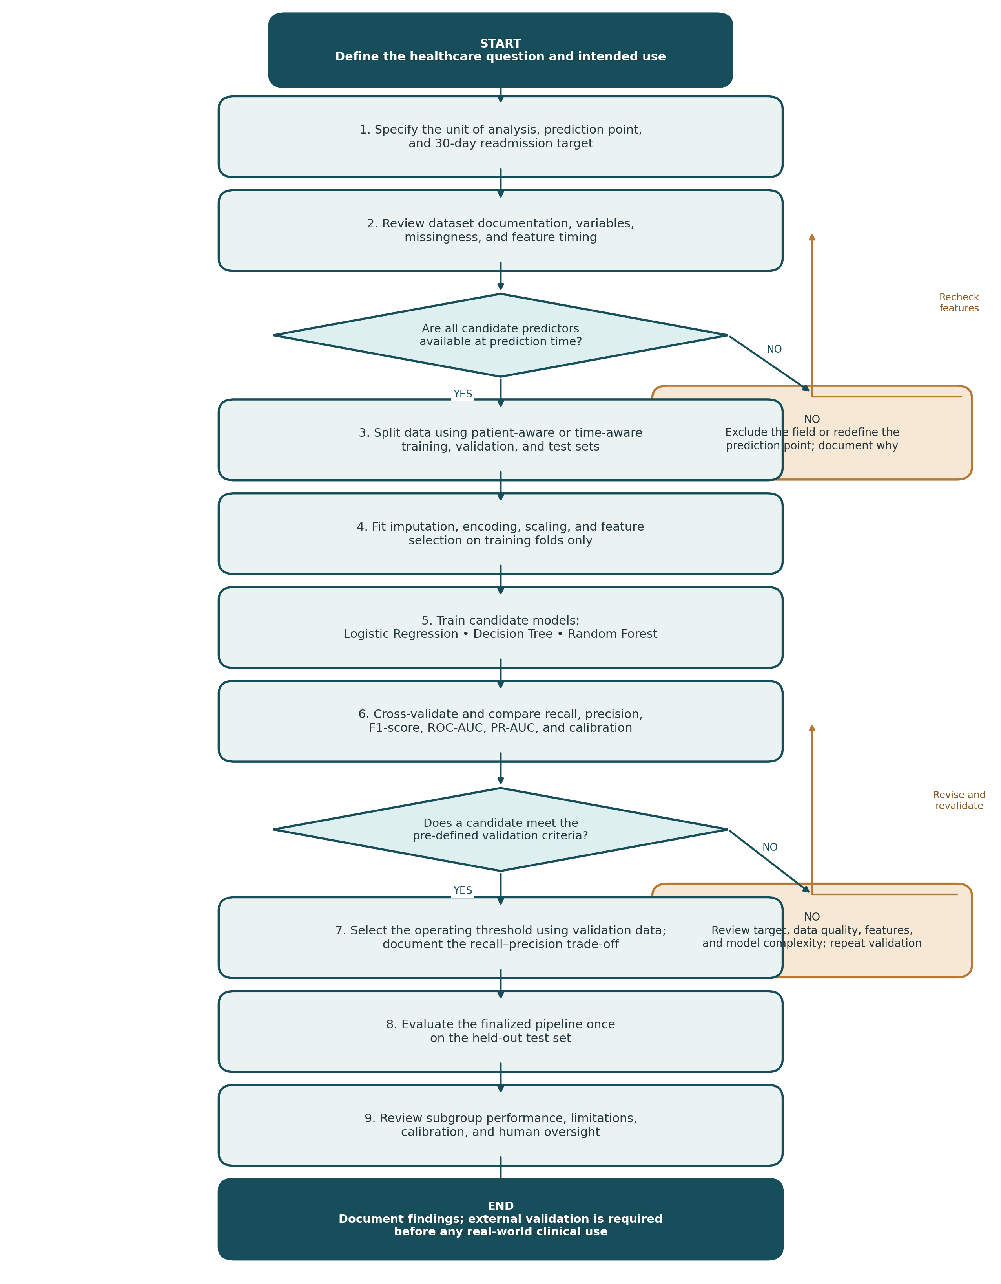

13. Proposed Deliverables and Quality Checklist
Required component | What this report provides | Completion check
Problem definition | Binary readmission scenario, prediction point, unit, target considerations. | Target mapping must be verified against source documentation.
Algorithm selection | Logistic Regression, Decision Tree, Random Forest comparison. | Strengths, limitations, and roles explained.
Feature engineering / selection | Methods plus a worked utilization-total example. | Feature timing and leakage controls stated.
Data splitting | Training, validation, and test strategy. | Patient/time dependence considered.
Evaluation metrics | Definitions and worked confusion-matrix calculations. | All sample numbers labelled illustrative.
ROC / threshold | ROC-AUC meaning and threshold trade-off examples. | Threshold chosen on validation data, not test data.
Technical detail | Pseudocode, tables, complete workflow flowchart. | No claim of actual execution.
Practical interpretation | Human review, fairness, limitations, risks. | No clinical-use claim.

14. Suggested 32-Hour Work Plan
Activity | Hours | Expected output
Problem definition and target review | 4 | Prediction question, outcome and prediction-point specification
Dataset and feature inventory | 4 | Variable list, timing checks and exclusions
Feature engineering and selection plan | 5 | Feature definitions and justifications
Algorithm selection and comparison | 4 | Model comparison table
Data splitting and leakage controls | 4 | Validation design
Metrics, worked calculations and threshold strategy | 5 | Evaluation framework and numerical example
Flowchart, pseudocode and interpretation | 3 | Technical workflow documentation
References, formatting and quality review | 3 | Final Word report
TOTAL | 32 | Complete Week 4 planning submission

Conclusion
This report provides a complete plan for developing and evaluating a healthcare predictive model. It begins with a clearly defined readmission question and emphasizes the importance of prediction timing, target verification, and leakage prevention. Feature engineering and selection are linked to the information available at the prediction point. Logistic Regression, Decision Tree, and Random Forest are compared for their interpretability and modeling flexibility. The worked confusion-matrix example demonstrates how accuracy, precision, recall, specificity, and F1-score are calculated, while ROC-AUC, PR-AUC, calibration, and threshold selection provide a broader evaluation framework. The workflow diagram, risk assessment, and responsible-use discussion show how a model plan can be made practical without overstating what historical data can establish. All numerical examples are illustrative; actual model training and clinical validation are outside the scope of this planning document.

References
- Clore, J., Cios, K., DeShazo, J., & Strack, B. (2014). Diabetes 130-US Hospitals for Years 1999–2008 [Dataset]. UCI Machine Learning Repository. Source
- Pedregosa, F., Varoquaux, G., Gramfort, A., et al. (2011). Scikit-learn: Machine Learning in Python. Journal of Machine Learning Research, 12, 2825–2830. Source
- scikit-learn developers. Model evaluation: quantifying the quality of predictions. Source
- scikit-learn developers. Preprocessing data. Source
- scikit-learn developers. Cross-validation: evaluating estimator performance. Source

