MRevision Hıstory
Date | Version | Description | Author
07/10/2022 | 1.0 | Determined the project altogether and created the repository on GitHub. | Emir Ulurak, Metin Karaca, Etkin Kinik,  Emre Besik, Baris Tudes, Efe Soykan
08/10/2022 | 1.1 | Created tables on Excel. | Emir Ulurak, Metin Karaca, Etkin Kinik,  Emre Besik, Baris Tudes, Efe Soykan
08/10/2022 | 1.2 | Created Gant Chart via Excel. | Emir Ulurak, Metin Karaca, Etkin Kinik,  Emre Besik, Baris Tudes, Efe Soykan

TABLE OF CONTENTS

Revision History 1
1 Identification 3
1.1 Document overview 3
1.2 Abbreviations 3
1.2.1 Abbreviations 3
1.3 References 3
1.3.1 Project References 3
2 Software Development Activities 3
2.1 Software development process 3
2.1.1 Overview of process phases 3
2.1.2 Technical documentation 4
2.1.3 Deliverables 4
2.2 Software development tools 4
2.2.1 Workstation 4
2.2.2 Requirements management and documentation 4
2.2.3 Software Design 4
2.2.4 Coding and automated tests 4
2.2.5 Configuration management 4
2.3 Software development rules and standards 4
3 Responsibilities 5
3.1 Activities and responsibilities 5
4 Risk Assessment 5
4.1 Risk Analysis 5
4.2 Risk Planning 5

Identification

Document overview

This document contains the software development plan of software Gesture Snake.

Gesture snake is a web-based video game which let the player control the classical snake game with hand gestures.

Abbreviations

Abbreviations

SDP: Software Development Plan
GS: Gesture Snake
UML: Unified Modeling Language
IDE: Integrated Development Environment
API: Application Programming Interface
UI: User Interface
JDK: Java Development Kit
SRS: Software Requirement Specification
STP: Software Test Plan
SDD: Software Design Document
STR: Software Test Report

References

Project References

# | Document Identifier | Document Title
[R1] | Stack Overflow | https://stackoverflow.com/
[R2] | OpenCV | https://docs.opencv.org/4.x/d6/d00/tutorial_py_root.html

Software Development Activities

The section lists and describes the software development activities of GS software development project.

Software development process

This is a course project, which adopts the waterfall model as the software development process.

Overview of process phases

The software development process for the project will be composed of the following phases:
- Planning
- Requirements Analysis
- Design
- Implementation
- Testing and Analysis

These phases will follow each other sequentially, where each phase starts just after the completion of the previous one. The following Gantt chart depicts the planned start date and duration for the phases.
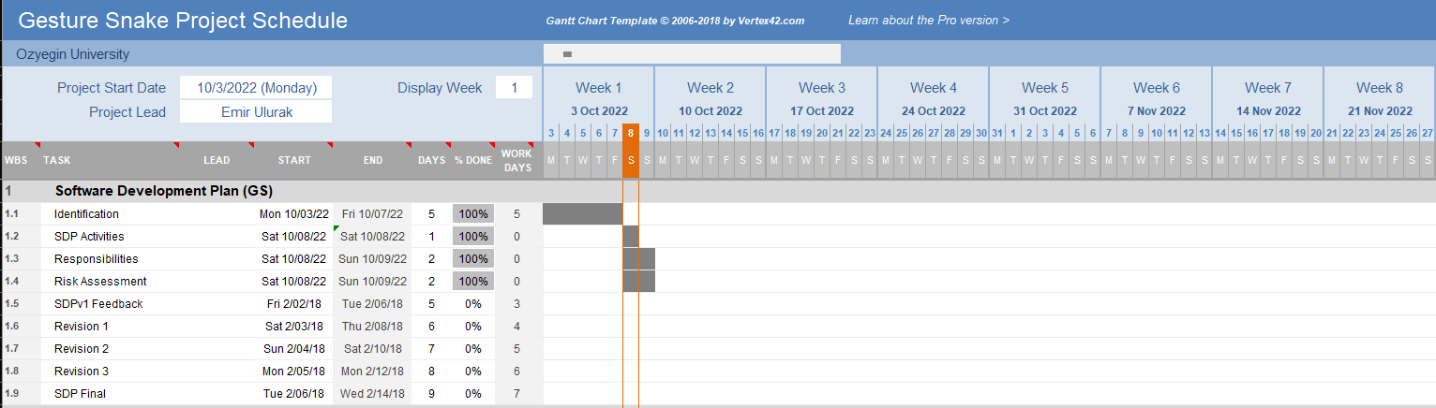

Technical documentation

The following documentation is produced during the software development phases:
- Software specification: SRS, STP
- Software detailed conception: SDD
- Software tests phases: STR
- Software analysis: SAR

Deliverables

The following items will be delivered at the end of the process:
- Technical documentation as outlined in Section 2.1.2
- Software and its configuration files

Software development tools

Workstation
Baris: Apple MacBook Air M1 16GB
Efe: Monster Notebook I7 9750H 8GB
Emir: Apple MacBook Air M1 16GB
Emre: Monster Notebook I7 10870H 32GB
Etkin: Asus TUF I7 11370 16GB
Metin: Apple MacBook Pro M1 PRO 16GB

Requirements management and documentation
Microsoft Word, Google Sheets, Microsoft Excel.

Software Design
Lucid Chart: https://www.lucidchart.com/pages/

Coding and automated tests
Microsoft Visual Studio Code,
IntelliJ with Maven,
Junit tests,
Sublime Text,
Docker

Configuration management
GitHub will be used for software configuration management and tracking issues regarding the software development. A public repository will be created for this purpose.

Software development rules and standards
UML will be used for software design documentation.

Responsibilities

Activities and responsibilities

Activity | Responsibility | Comment
Project management | Emir Ulurak | Lead the project, and submit relevant papers
Configuration tools management | Metin Karaca, Efe Soykan, Emre Besik | Responsible for Configuration tools
Setting up the Development tools | Baris Tudes, Emir Ulurak, Efe Soykan, Metin Karaca, Emre Besik, Etkin Kinik | Everyone is responsible for their own environments.
Database design | Etkin Kinik, Emre Besik, Metin Karaca, Baris Tudes | Responsible for saving GS data.
Game design | Emre Besik, Baris Tudes, Efe Soykan, Emir Ulurak | Managing game design.
Testing | Metin Karaca, Baris Tudes | In charge of testing of all software.
Controller design | Emir Ulurak | Responsible for Controller structures.

Risk Assessment

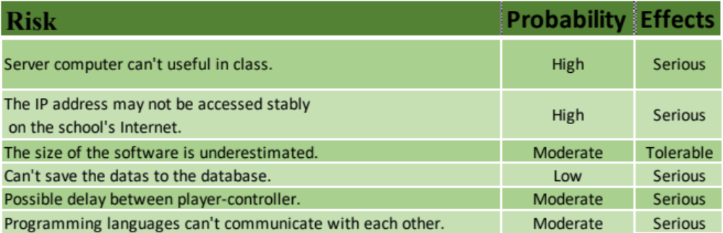Risk Analysis

Risk Planning

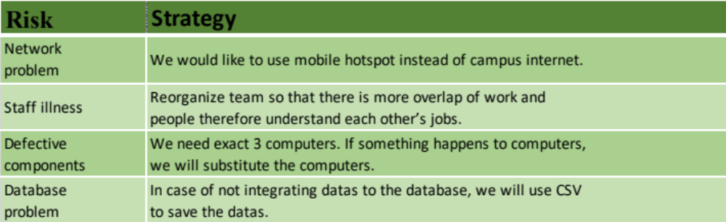

https://github.com/imemmul/CS320
http://www.uml.org/

