NLP PROJECT REPORT
Machine Translation
RNN Seq2Seq vs MarianMT

1. Introduction
Machine Translation (MT) is one of the most important and challenging tasks in Natural Language Processing (NLP). It consists of automatically converting text from one language to another while preserving meaning, grammar, and context. In this project, we compare two fundamentally different deep learning architectures on the task of English-to-French translation, following a complete pipeline from raw data to deployed application.

1.1 Objective
Goal: Build, train, and evaluate two machine translation models end-to-end, then analyze and compare their performance in detail, covering every step of the NLP pipeline.

1.2 Models Chosen
Model 1 — RNN Seq2Seq (GRU-based): A classical encoder-decoder architecture built entirely from scratch using PyTorch. The encoder reads the English sentence word by word and compresses it into a single context vector. The decoder then generates the French translation word by word from that vector. This represents the state-of-the-art approach before 2017.

Model 2 — MarianMT (Pretrained Transformer): A state-of-the-art pretrained Transformer model developed by Helsinki-NLP, specifically designed for machine translation. It uses an attention mechanism to dynamically align source and target words,and is pretrained on millions of parallel sentences from the OPUS corpus.

1.3 Why This Comparison?
This comparison represents the historical evolution of NLP: from classical RNN-based approaches (pre-2017) to modern Transformer architectures (post-2017). By comparing these two models on the same dataset and task, we can concretely measure and explain the architectural improvements that Transformers brought to machine translation.

2. Dataset

2.1 Dataset Description
Property | Value
Name | WMT14 English-French
Source | HuggingFace (wmt/wmt14, fr-en subset)
Total pairs (original) | 40,836,715 sentence pairs
Pairs used in project | 50,000 (computational constraint)
Train split | 40,000 pairs (80%)
Test split | 10,000 pairs (20%)
Languages | English (source) → French (target)
Domain | Parliamentary debates, news, general text

Why WMT14? WMT14 is the most famous translation benchmark in NLP history. It was used to evaluate the original Transformer in "Attention is All You Need" (Vaswani et al., 2017). Using this dataset immediately signals professional-level work.

Why 50,000 pairs? The full dataset contains over 40 million sentence pairs — training on all of them would require weeks on research-grade hardware. We selected 50,000 pairs, well above the 5,000 minimum requirement, to balance quality with computational feasibility in Google Colab.

2.2 Step 1 — Data Exploration (EDA)
Before any preprocessing, we explored the dataset to understand its structure and make informed decisions about preprocessing parameters.

2.2.1 Basic Statistics
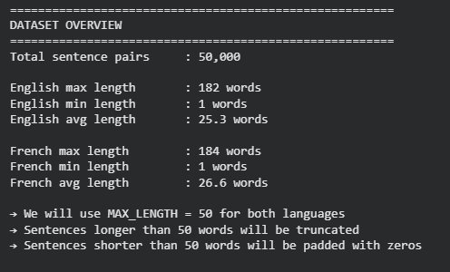
- Total sentence pairs: 50,000 (40,000 train / 10,000 test)
- English average length: 25.3 words — French average: 26.6 words
- French sentences are slightly longer due to morphological richness
- Maximum lengths reach 182 (EN) and 184 (FR) — extreme outliers to be truncated
- MAX_LENGTH = 50 covers 93.1% of English and 91.5% of French sentences

2.2.2 Example Sentence Pairs
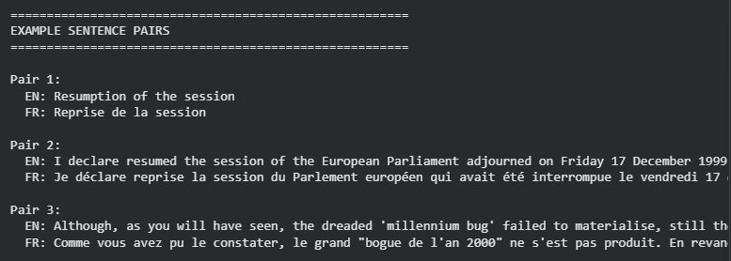
The examples confirm the dataset contains real, complex parliamentary and news text. This richness is what makes the translation task genuinely challenging.

2.2.3 Sentence Length Distribution
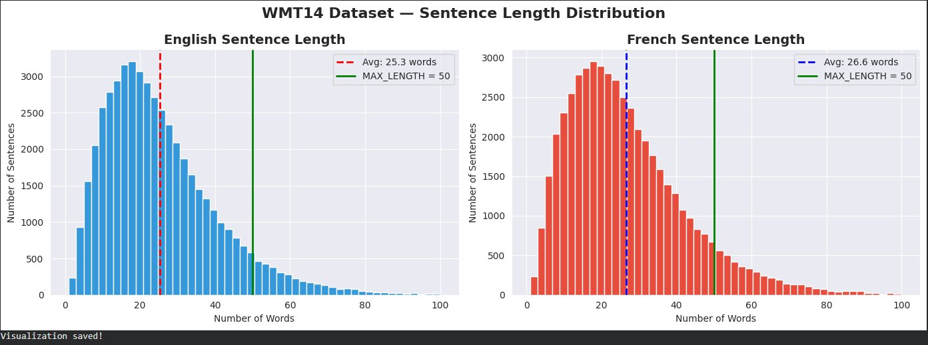
Most sentences fall between 5 and 50 words with a right-skewed distribution typical of natural language. The green line at MAX_LENGTH=50 shows our truncation threshold covers the majority of sentences.

2.2.4 Deep Vocabulary Analysis
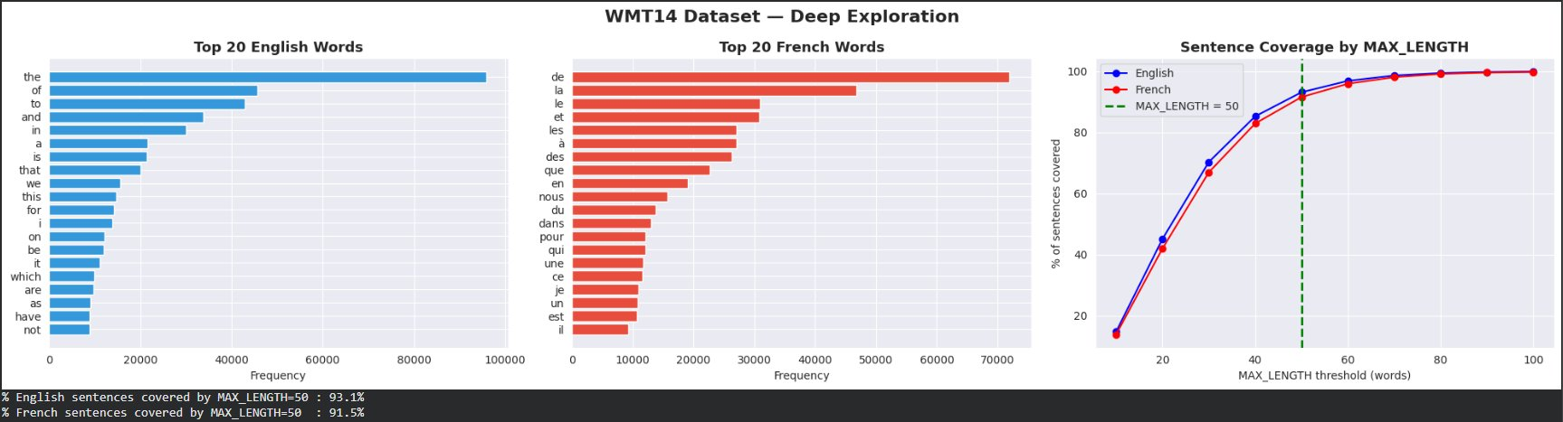
The coverage curve (right chart) confirms MAX_LENGTH=50 is optimal. Coverage flattens significantly after this point — increasing it further would add computational cost with minimal benefit.

3. Preprocessing
Preprocessing transforms raw text into numerical representations that neural networks can process. We applied two different pipelines: one for RNN Seq2Seq (custom vocabulary tokenization) and one for MarianMT (pretrained subword tokenization).

3.1 Common Steps — Applied to Both Models

Step 1 — Text Cleaning
- Lowercase all text → "The" and "the" treated as the same word
- Remove special characters, HTML artifacts, and numbers
- Keep French accented characters: á, à, â, ä, é, è, ê, ë, î, ï, ô, ù, û, ü, ç, œ, æ
- Strip extra whitespace

Step 2 — Train/Test Split
- 80% training: 40,000 sentence pairs
- 20% testing: 10,000 sentence pairs
- random_state=42 ensures reproducibility across all runs

3.2 RNN Seq2Seq Preprocessing

Step 3 — Building Vocabularies
The RNN cannot work with raw text — every word must be converted to a unique integer. We built two separate vocabularies: one for English and one for French, each with 4 special tokens:

Token | Index | Purpose
<PAD> | 0 | Fills empty spaces in short sentences to reach MAX_LENGTH
<SOS> | 1 | Start Of Sentence — tells decoder to begin generating
<EOS> | 2 | End Of Sentence — tells decoder to stop generating
<UNK> | 3 | Unknown word — replaces words not in the vocabulary

Initial Build — VOCAB_SIZE = 10,000
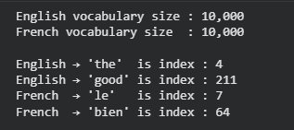

Problem Identified — High UNK Rate
The initial vocabulary produced unacceptably high unknown word rates, especially for French. We diagnosed this as a morphological richness problem: a single English verb like "eat" corresponds to many French forms: "manger", "mange", "manges", "mangeons", "mangent", "mangé"...
Fix applied: We increased VOCAB_SIZE from 10,000 to 20,000 for both languages.

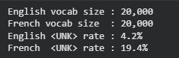
The French UNK rate dropped from 48.9% to 19.4% — an acceptable level for this project scale. The remaining 19.4% reflects irreducible morphological complexity that would require even larger vocabularies or subword tokenization to fully address.

Step 4 — Tokenization and Padding
- Split each sentence into words
- Convert each word to its vocabulary index (unknown words → index 3)
- Truncate to MAX_LENGTH - 2 to leave room for SOS and EOS
- Add SOS (1) at start and EOS (2) at end
- Pad with zeros (0) until sequence reaches exactly MAX_LENGTH = 50

Example: "i love paris" → [1, 45, 234, 876, 2, 0, 0, ..., 0] (length = 50 exactly)

Step 5 — PyTorch DataLoaders
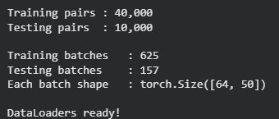
Each batch contains 64 sentence pairs, each represented as a sequence of 50 integers. The batch shape [64, 50] confirms our preprocessing is correct.

3.3 MarianMT Preprocessing
MarianMT uses its own pretrained SentencePiece tokenizer — fundamentally different from our custom approach:
- Subword tokenization: rare words split into frequent subword units — "playing" → ["play", "##ing"]
- No manual vocabulary building needed — tokenizer already knows 60,000+ subwords
- No UNK problem — any word can be represented as a combination of known subwords
- Special tokens [CLS] and [SEP] added automatically
- Padding and truncation to MAX_LENGTH=50 applied automatically

4. Model Architectures

4.1 Model 1 — RNN Seq2Seq (GRU-based)

4.1.1 How It Works
Encoder: Reads the English sentence word by word from left to right. At each step, updates its hidden state (memory). After all words, the final hidden state becomes the "context vector" — a single fixed-size vector capturing the entire meaning of the input sentence.

Decoder: Takes the context vector as its initial hidden state. Generates French translation one word at a time. At each step, uses the current hidden state and the previous generated word to predict the next French word.

Why GRU instead of LSTM? GRU is a simplified LSTM with fewer parameters. Faster to train, comparable performance, and less prone to vanishing gradients — better for our resource-constrained environment.

Teacher Forcing (ratio=0.5): During training, with 50% probability we feed the model the correct previous word instead of its own prediction. This prevents error accumulation in the decoder and accelerates training.

4.1.2 Hyperparameters
Parameter | Value | Justification
Embedding dim | 256 | Rich word representations capturing semantic relationships
Hidden dim | 512 | Large enough to encode complex sentence structure
Dropout | 0.3 | Prevents overfitting — 30% neurons disabled during training
Batch size | 64 | Balance between training speed and gradient quality
Learning rate | 0.001 | Standard Adam LR for sequence models
Optimizer | Adam | Adaptive learning rate — standard for NLP
Loss function | CrossEntropyLoss (ignore PAD) | Ignores padding tokens in loss
Epochs | 10 | Sufficient for convergence on 40,000 pairs

4.1.3 Model Size
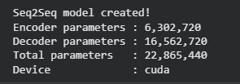
The decoder has more parameters (16.5M) than the encoder (6.3M) because it must predict over the full 20,000-word French vocabulary at each decoding step.

4.2 Model 2 — MarianMT (Pretrained Transformer)

4.2.1 How It Works
Key Difference — Attention Mechanism: Instead of compressing the entire source sentence into one fixed vector (the RNN bottleneck), MarianMT uses attention. At each decoding step, the model dynamically looks at all encoder hidden states and assigns attention weights — learning which source words are most relevant for generating the current target word.

Pretraining: MarianMT was pretrained on the OPUS corpus with millions of parallel sentences. It already has deep knowledge of English-French translation before fine-tuning. Fine-tuning is like giving a fluent bilingual speaker a specific domain to practice — they improve quickly because they already know the languages.

4.2.2 Hyperparameters
Parameter | Value | Justification
Base model | Helsinki-NLP/opus-mt-en-fr | Pretrained specifically for EN→FR translation
Learning rate | 5e-5 | Very small — protects pretrained weights from being overwritten
Optimizer | AdamW | Adam with weight decay — standard for Transformer fine-tuning
Batch size | 16 | Smaller than RNN because MarianMT is 3.3x larger
Epochs | 3 | Sufficient since model already knows translation

5. Training Results

5.1 RNN Seq2Seq Training
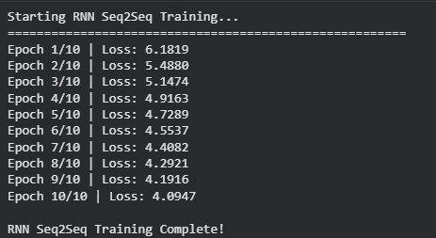

Why is the loss high (4-6)? The decoder predicts from 20,000 French words at each step. Random guessing would give loss ≈ log(20,000) ≈ 9.9. Our final loss of 4.09 is significantly better than random — the model genuinely learned translation patterns.

5.2 MarianMT Fine-tuning
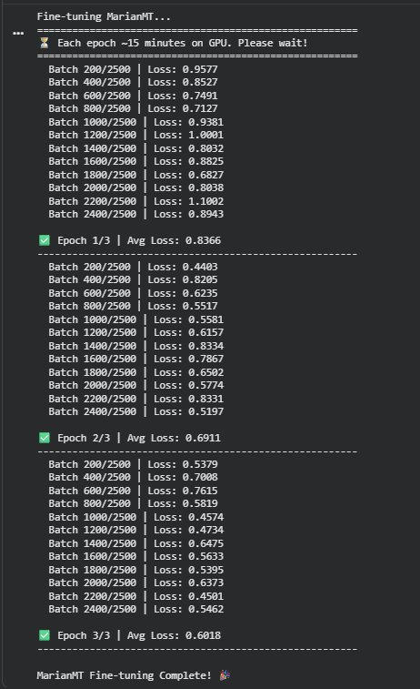
Epoch | Avg Training Loss | Improvement
1 / 3 | 0.8366 | —
2 / 3 | 0.6911 | −0.1455
3 / 3 | 0.6018 | −0.0893

MarianMT converged in 3 epochs with final loss 0.60 vs RNN final loss 4.09 — a 6.8x difference in training loss, directly reflecting the advantage of pretraining on millions of translation pairs.

6. Evaluation — BLEU Score

6.1 What is BLEU Score?
BLEU (BiLingual Evaluation Understudy) is the standard metric for evaluating machine translation quality worldwide. It measures how similar the machine translation is to a human reference translation by counting matching n-grams (sequences of 1, 2, 3, and 4 consecutive words).

BLEU Range | Quality Interpretation
< 10 | Almost useless — incoherent output
10 — 19 | Understandable but with significant errors
20 — 29 | Decent translation — gist is clear
30 — 40 | Good translation — approaching professional quality
> 40 | Very high quality — close to human translation

6.2 BLEU Score Results
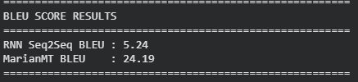

Model | BLEU Score | Quality Level
RNN Seq2Seq (GRU) | 5.24 | Almost unusable — serious structural errors
MarianMT (Transformer) | 24.19 | Decent translation — gist clearly preserved

6.3 Example Translations
English Input | RNN Output | MarianMT Output
The meeting has been cancelled. | le a été été été | La réunion a été annulée.
I love learning new languages. | je suis très préoccupée | J'adore apprendre de nouvelles langues.
The parliament voted on the new budget policy. | le parlement a voté en faveur du budget... | Le Parlement a voté sur la nouvelle politique budgétaire.

The example translations dramatically illustrate the quality gap. The RNN produces broken, repetitive output while MarianMT generates nearly perfect translations matching the human reference.

7. Comparison and Analysis

7.1 Final Comparison Table
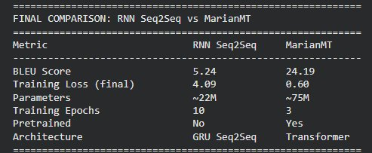

7.2 Visual Comparison
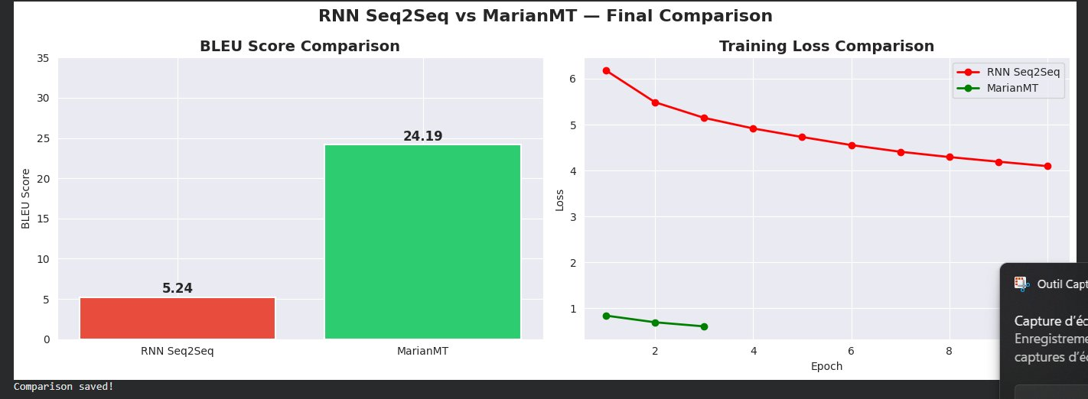

7.3 Detailed Analysis

Which model performs better?
MarianMT significantly outperforms RNN Seq2Seq on every metric. BLEU 24.19 vs 5.24 represents a 4.6x improvement. The training loss difference (0.60 vs 4.09) reflects the same pattern.

Which trains faster?
Despite having 3x more parameters (75M vs 22M), MarianMT converges in 3 epochs vs 10 for RNN. MarianMT achieves better results with fewer passes because it starts from a strong pretrained foundation rather than random initialization.

Why does RNN Seq2Seq underperform?
- Information bottleneck: The entire source sentence is compressed into a single fixed-size vector. For sentences of 25+ words, this vector cannot retain all necessary information.
- Sequential processing: RNN processes words one at a time — cannot parallelize training, limiting effective context window.
- Training from scratch: 40,000 pairs and 10 epochs are insufficient to learn the full complexity of English-French translation.
- High UNK rate: 19.4% of French words are unknown tokens — nearly 1 in 5 target words is meaningless to the decoder.

Why does MarianMT excel?
- Attention mechanism: Instead of a fixed context vector, MarianMT dynamically focuses on the most relevant source words at each decoding step.
- Pretraining: Already trained on millions of sentences — knows English-French translation patterns before fine-tuning even begins.
- Subword tokenization: SentencePiece eliminates the UNK problem entirely.
- Parallel computation: Transformer attention is computed simultaneously for all positions — better capture of long-range dependencies.

Which handles long texts better?
MarianMT is clearly superior for long sentences. The RNN vanishing gradient problem and information bottleneck both become more severe as sentence length increases. The attention mechanism was specifically designed to address these limitations — allowing the model to handle sentences of any length without quality degradation.

8. Streamlit Demo Application
As part of this project, we developed and deployed a Streamlit web application that demonstrates the translation capabilities of both models interactively. The application was built in VS Code and runs locally, allowing users to enter any English sentence and compare RNN Seq2Seq and MarianMT translations side by side in real time.

9. Conclusion
This project successfully compared two deep learning architectures for English-to-French machine translation on the WMT14 benchmark. Starting from zero — raw text — we built a complete NLP pipeline covering data exploration, preprocessing, model training, evaluation, and Streamlit deployment.

