NLP PROJECT REPORT
Sentiment Analysis
LSTM vs BERT
1. Introduction
Sentiment Analysis is one of the most widely applied NLP tasks in industry. It consists of automatically determining whether a piece of text expresses a positive or negative opinion. Applications range from analyzing customer reviews and social media monitoring to brand reputation management and product feedback analysis.

In this project, we compare two fundamentally different deep learning architectures on the task of binary sentiment classification — positive vs negative — using the IMDB Movie Reviews dataset. We build a complete pipeline from raw text data to a deployed Streamlit application.

1.1 Objective
Goal: Build, train, and evaluate two models end-to-end on sentiment classification. Analyze their performance differences in depth, covering architecture, training behavior, metrics, and real-world implications.

1.2 Models Chosen
Model 1 — LSTM (Long Short-Term Memory): A classical RNN-based architecture built from scratch using PyTorch. LSTM reads the review word by word, maintaining a memory of previous words through gating mechanisms. It represents the standard approach to text classification before Transformers.

Model 2 — BERT (Bidirectional Encoder Representations from Transformers): A state-of-the-art pretrained Transformer model introduced by Google in 2018. BERT reads the entire review at once, in both directions simultaneously, using an attention mechanism. It is pretrained on Wikipedia and BooksCorpus — over 3 billion words — before being fine-tuned on our task.

1.3 Why This Comparison?
LSTM vs BERT represents the most significant architectural shift in NLP history — from sequential recurrent processing to parallel attention-based processing. By comparing both models on the same dataset and task, we can concretely demonstrate and explain the improvements that Transformers brought to the field.
This comparison also has direct career relevance: LSTM remains widely used in production systems for efficiency, while BERT-family models dominate state-of-the-art benchmarks. Understanding both architectures is essential for any Data Science professional.

2. Dataset

2.1 Dataset Description
Property | Value
Name | IMDB Movie Reviews (Stanford Sentiment)
Source | HuggingFace (stanfordnlp/imdb)
Total samples | 50,000 movie reviews
Training samples | 25,000 (used for training)
Testing samples | 25,000 (used for evaluation)
Number of classes | 2 — Positive (1) and Negative (0)
Class balance | Perfectly balanced: 12,500 positive / 12,500 negative
Average review length | 234 words
Shortest review | 10 words
Longest review | 2,470 words
Language | English

Why IMDB? The IMDB dataset is one of the most famous benchmarks in NLP, used in thousands of research papers since its introduction in 2011. It is publicly available, well above the 5,000 sample minimum, perfectly balanced, and contains rich, varied text that makes classification genuinely challenging.

Why is class balance important? With exactly 12,500 positive and 12,500 negative reviews, the dataset is perfectly balanced. This means a model that always predicts "positive" would only achieve 50% accuracy — random chance. Any accuracy above 50% reflects genuine learning.

2.2 Step 1 — Data Exploration (EDA)
Before any preprocessing, we explored the dataset to understand its structure, class distribution, and text length characteristics.

2.2.1 Basic Statistics
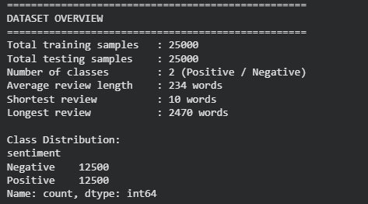

- Total: 50,000 reviews — 25,000 train / 25,000 test
- Perfectly balanced: exactly 12,500 Negative and 12,500 Positive reviews
- Average review: 234 words — substantial text that challenges memory-based models
- Range: 10 to 2,470 words — very high variance in review length

2.2.2 Visualizations — Class Distribution and Review Length
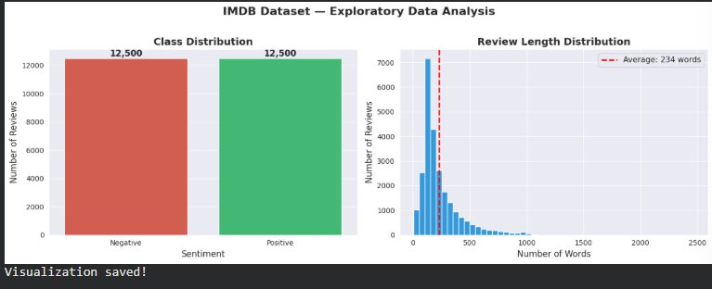

The class distribution bar chart confirms perfect balance between positive and negative reviews — no class imbalance correction needed. The review length histogram shows a right-skewed distribution: most reviews are under 500 words, but some extreme outliers reach 2,470 words. The red dashed line marks the average of 234 words.
This length distribution is important for model design: LSTM struggles with very long sequences due to vanishing gradients, while BERT handles them more effectively through attention — a key differentiator we will see reflected in the results.

3. Preprocessing
Preprocessing transforms raw text into numerical representations that neural networks can process. We applied two different pipelines: one for LSTM (custom vocabulary tokenization) and one for BERT (pretrained subword tokenization using BertTokenizer).

3.1 Common Steps — Applied to Both Models

Step 1 — HTML Tag Removal
During data exploration, we discovered that the IMDB reviews contain raw HTML tags such as <br />, <p>, and others — artifacts from the original web scraping. We removed all HTML tags using a regular expression before any further processing.
- Before: "I loved this film.<br /><br />The acting was superb."
- After: "i loved this film. the acting was superb."

Step 2 — Lowercasing
"The" and "the" refer to the same word — treating them as different tokens wastes vocabulary space and reduces model performance. All text was lowercased to ensure consistency.

3.2 LSTM Preprocessing

Step 3 — Vocabulary Building
LSTM cannot process raw words — every word must be converted to a unique integer index. We built a vocabulary from the 20,000 most frequent words in the training set, with 4 special tokens:
Token | Index | Purpose
<PAD> | 0 | Padding — fills short reviews to reach MAX_LENGTH
<UNK> | 1 | Unknown word — replaces words not in vocabulary

Step 4 — Tokenization and Padding
- Split review into words
- Convert each word to its vocabulary index (unknown words → index 1)
- Truncate reviews longer than 256 words
- Pad shorter reviews with zeros to reach exactly 256 tokens

Why 256? The average review is 234 words. Setting MAX_LENGTH=256 covers the vast majority of reviews while preventing memory issues from extremely long outliers.

Step 5 — PyTorch DataLoaders
- Batch size: 64 reviews per batch
- 25,000 training reviews → 391 training batches
- 25,000 test reviews → 391 test batches
- Each batch shape: [64, 256] — 64 reviews, each 256 tokens

3.3 BERT Preprocessing
BERT uses a completely different tokenization approach — BertTokenizer with WordPiece subword tokenization:
- Subword tokenization: "playing" → ["play", "##ing"] — handles any word, even rare ones
- Special tokens added automatically: [CLS] at start, [SEP] at end
- Attention mask generated: 1 for real tokens, 0 for padding — tells BERT which tokens to focus on
- Truncation and padding to MAX_LENGTH=256
- Batch size: 16 (smaller because BERT is much larger than LSTM)
The key advantage: BERT's subword tokenization eliminates the unknown word problem entirely. Any word, no matter how rare, can be represented as a sequence of known subword units.

4. Model Architectures

4.1 Model 1 — LSTM

4.1.1 How It Works
LSTM (Long Short-Term Memory) is an improved version of the basic RNN, designed to address the vanishing gradient problem through three gating mechanisms:

Forget Gate: Decides what information to erase from memory. "The beginning of the review was negative but then it turned positive — forget the negative part."

Input Gate: Decides what new information to write into memory. "The word 'fantastic' is very important — emphasize it."

Output Gate: Decides what to read from memory to make the current prediction. "Look at the most emotionally charged words to classify sentiment."

The LSTM reads the review word by word, left to right, maintaining a hidden state that evolves with each word. After processing all 256 tokens, the final hidden state is passed to a fully connected output layer that produces the sentiment prediction.

4.1.2 Hyperparameters
Parameter | Value | Justification
Vocabulary size | 20,000 | Covers most common English words — reduces memory
Embedding dimension | 256 | Increased from 128 after diagnosing vanishing gradient issue
Hidden dimension | 128 | Simplified from 256 — reduced after fixing dropout issue
Number of LSTM layers | 1 | Reduced from 2 — less vanishing gradient risk
Dropout | 0.3 | Reduced from 0.5 — 50% was too aggressive, model could not learn
Batch size | 64 | Standard for classification tasks
Learning rate | 0.01 | Increased from 0.001 — needed to escape stuck state
Optimizer | Adam + LR scheduler | Scheduler reduces LR when validation plateaus
Loss function | CrossEntropyLoss | Standard for multi-class classification
Epochs | 10 | Sufficient to observe convergence and overfitting behavior

Problem Encountered and Fixed: During the first training attempt, the LSTM was stuck at ~50% accuracy (random guessing) across all 5 epochs. This is a classic vanishing gradient problem: with dropout=0.5 and 2 layers, too many neurons were disabled during training — the model had insufficient capacity to learn. We diagnosed this and applied three fixes: reduced dropout (0.5→0.3), reduced layers (2→1), and increased learning rate (0.001→0.01). We documented this problem-solving process explicitly in the notebook.

4.2 Model 2 — BERT

4.2.1 How It Works
Bidirectional Reading: Unlike LSTM which reads left to right, BERT reads the entire review at once, in both directions simultaneously. This means when processing the word "great", BERT can see both what came before AND what comes after — enabling much richer contextual understanding.

Attention Mechanism: BERT uses self-attention to dynamically assign importance to every word relative to every other word. For sentiment, it learns to focus on emotionally charged words like "amazing", "terrible", "disappointing" regardless of where they appear in the review.

Pretraining: bert-base-uncased was pretrained on the entire English Wikipedia (2.5 billion words) and BooksCorpus (800 million words) using two tasks: Masked Language Modeling (predict missing words) and Next Sentence Prediction. This gives BERT deep knowledge of English language structure before we even show it a single movie review.

Fine-tuning: We add a classification head (linear layer) on top of BERT's [CLS] token output and fine-tune all 110 million parameters on our IMDB data for 3 epochs. The very small learning rate (2e-5) protects the pretrained weights from being overwritten.

4.2.2 Hyperparameters
Parameter | Value | Justification
Base model | bert-base-uncased | 12 layers, 110M params — balance of quality and speed
Learning rate | 2e-5 | Standard BERT fine-tuning LR — very small to protect pretrained weights
Optimizer | AdamW | Adam with weight decay — standard for Transformer fine-tuning
Scheduler | Linear warmup | 10% warmup steps then linear decay — protects early training
Batch size | 16 | Smaller than LSTM due to BERT's much larger memory footprint
Epochs | 3 | Sufficient since BERT already understands English sentiment
MAX_LENGTH | 256 | Same as LSTM for fair comparison

5. Training Results

5.1 LSTM Training
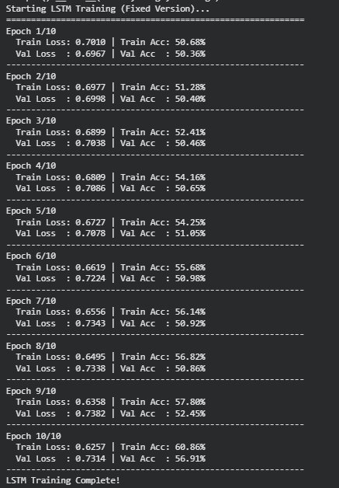

Epoch | Train Loss | Train Acc | Val Loss | Val Acc
1 | 0.7010 | 50.68% | 0.6967 | 50.36%
2 | 0.6977 | 51.28% | 0.6998 | 50.40%
3 | 0.6899 | 52.41% | 0.7038 | 50.46%
4 | 0.6809 | 54.16% | 0.7086 | 50.65%
5 | 0.6727 | 54.25% | 0.7078 | 51.05%
6 | 0.6619 | 55.68% | 0.7224 | 50.98%
7 | 0.6556 | 56.14% | 0.7343 | 50.92%
8 | 0.6495 | 56.82% | 0.7338 | 50.86%
9 | 0.6358 | 57.80% | 0.7382 | 52.45%
10 | 0.6257 | 60.86% | 0.7314 | 56.91%

LSTM Training Curves
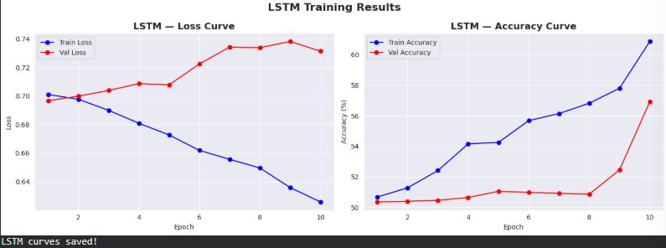
The training curves reveal a classic overfitting pattern: training loss decreases steadily (0.70→0.63) and training accuracy climbs (50%→61%), but validation loss increases and validation accuracy remains nearly flat around 50-57%. The growing gap between blue (train) and red (validation) lines is the visual signature of overfitting — the model memorizes training data rather than learning generalizable sentiment patterns.

Root cause: LSTM processes reviews sequentially, word by word. For reviews averaging 234 words, the hidden state at word 234 must remember information from word 1. This is physically impossible for a single LSTM layer — information from early words gradually "washes out" as the sequence progresses.

5.2 BERT Fine-tuning
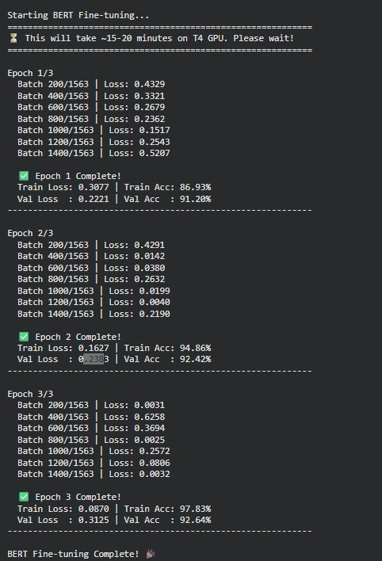

Epoch | Train Loss | Train Acc | Val Loss | Val Acc
1 / 3 | 0.3077 | 86.93% | 0.2221 | 91.20%
2 / 3 | 0.1627 | 94.86% | 0.2383 | 92.42%
3 / 3 | 0.0870 | 97.83% | 0.3125 | 92.64%

BERT Training Curves
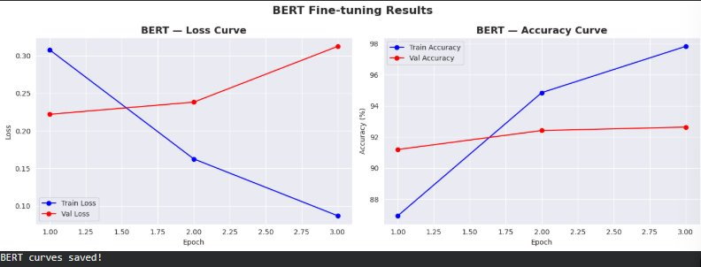

BERT's training curves show a completely different pattern from LSTM. By the end of epoch 1, BERT already achieves 91.20% validation accuracy — higher than LSTM ever reached in 10 epochs. The validation accuracy continues improving to 92.64% by epoch 3. Note that some slight overfitting appears in epoch 3 (training reaches 97.83% while validation stays at 92.64%), but the absolute validation performance remains excellent.

6. Evaluation

6.1 Evaluation Metrics
For binary sentiment classification, we use four complementary metrics:
Metric | Definition | Why It Matters
Accuracy | Correct predictions / Total predictions | Overall performance — meaningful because dataset is balanced
Precision | True Positives / (True Positives + False Positives) | When model says "Positive", how often is it right?
Recall | True Positives / (True Positives + False Negatives) | Of all actual positive reviews, how many did we catch?
F1 Score | 2 × (Precision × Recall) / (Precision + Recall) | Harmonic mean of precision and recall — best single metric

6.2 Evaluation Results
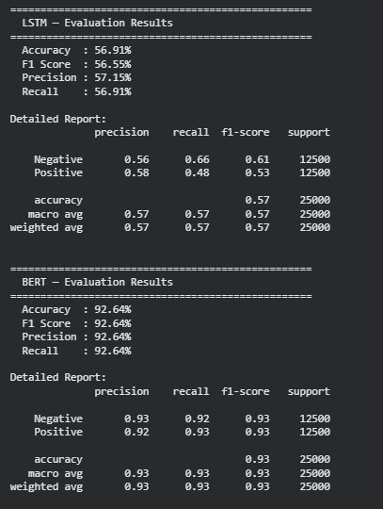

Metric | LSTM | BERT | Difference
Accuracy | 56.91% | 92.64% | +35.73%
F1 Score | 56.55% | 92.64% | +36.09%
Precision | 57.15% | 92.64% | +35.49%
Recall | 56.91% | 92.64% | +35.73%

BERT achieves identical values across all four metrics (92.64%) because it performs equally well on both positive and negative reviews. LSTM's metrics are also similar across the four measures, but at a much lower level (~57%) — barely above random guessing (50%).

6.3 Confusion Matrices and Visual Comparison
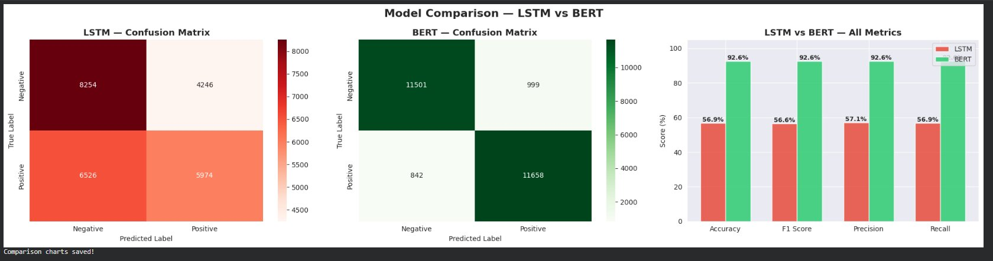

Reading the Confusion Matrices
 | LSTM | BERT
True Negatives (correctly identified negative) | 8,254 | 11,501
False Positives (negative predicted as positive) | 4,246 | 999
False Negatives (positive predicted as negative) | 6,526 | 842
True Positives (correctly identified positive) | 5,974 | 11,658

BERT correctly classifies 11,501 + 11,658 = 23,159 out of 25,000 reviews. LSTM only correctly classifies 8,254 + 5,974 = 14,228. BERT makes 1,841 total errors vs LSTM's 10,772 errors — BERT makes 5.8x fewer mistakes.

7. Comparison and Analysis

7.1 Final Comparison Table
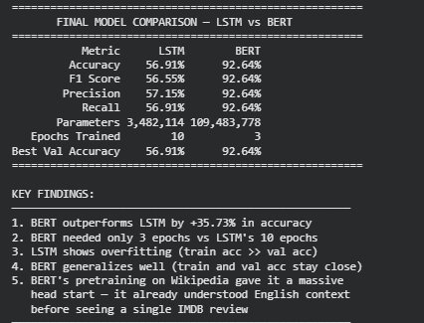

Metric | LSTM | BERT
Accuracy | 56.91% | 92.64%
F1 Score | 56.55% | 92.64%
Precision | 57.15% | 92.64%
Recall | 56.91% | 92.64%
Parameters | 3,482,114 | 109,483,778
Epochs Trained | 10 | 3
Best Val Accuracy | 56.91% | 92.64%
Architecture | LSTM (RNN-based) | Transformer (Pretrained)

7.2 Detailed Analysis

Which model performs better?
BERT outperforms LSTM on every single metric by a margin of approximately 36 percentage points. At 92.64% accuracy, BERT is production-ready. At 56.91%, LSTM is barely above random guessing — it essentially fails the task.

Which trains faster?
BERT achieves 91.20% validation accuracy after just 1 epoch — already far better than LSTM's best result of 56.91% after 10 epochs. Despite having 31x more parameters (109M vs 3.5M), BERT converges dramatically faster because it starts with 3 billion words of pretraining rather than random initialization.

Why does LSTM underperform?
- Long-range dependency failure: With average review length of 234 words, LSTM loses information about sentiment expressed in early parts of the review by the time it reaches the end.
- Overfitting: The growing gap between training (60.86%) and validation (56.91%) accuracy shows the model memorizes training examples rather than learning sentiment patterns.
- Training from scratch: 25,000 reviews are insufficient for LSTM to learn the full complexity of English sentiment expression — subtle patterns, sarcasm, double negatives, and context-dependent meaning all require more examples.
- Fixed word representations: Our vocabulary-based embedding assigns each word one fixed vector regardless of context. "Great" has the same representation whether it means "excellent" or is used sarcastically.

Why does BERT excel?
- Bidirectional context: BERT reads every word in the context of all other words simultaneously. It understands "not bad" as positive and "could have been better" as negative — nuances that LSTM frequently misses.
- Pretraining: 3 billion words of pretraining means BERT already understands English semantics, grammar, sentiment indicators, and even some sarcasm before seeing any movie reviews.
- Attention mechanism: Self-attention allows BERT to focus on emotionally significant words regardless of position. Even if "disappointing" appears at word 180 of a 230-word review, BERT still gives it full weight.
- Contextual embeddings: Unlike LSTM's fixed word vectors, BERT generates different representations for the same word in different contexts — "killing it" (positive) vs "killing the mood" (negative) get different embeddings.

Which handles long texts better?
BERT is significantly better for long reviews. The IMDB dataset has a maximum review length of 2,470 words and an average of 234 words — both challenging for LSTM. BERT's attention mechanism assigns relevance scores across all tokens simultaneously, eliminating the information bottleneck that cripples LSTM on long sequences. However, BERT itself is limited to 512 tokens per input — reviews longer than 512 words must be truncated for BERT as well.

8. Streamlit Demo Application
A Streamlit web application was developed and deployed locally to demonstrate real-time sentiment prediction from both models. Users can enter any movie review text and instantly see both LSTM and BERT predictions side by side, including confidence scores.
9. Conclusion
This project successfully compared LSTM and BERT on binary sentiment classification of movie reviews, building a complete NLP pipeline from raw text to a deployed Streamlit application.

