



N-ABLE (PVT) LTD
36, Bristol Street, Colombo 01, Sri Lanka.
PRIVATE & CONFIDENTIAL
Version: 0.0.1
Issue Date: 5th of January 2026

GUIDELINE DOCUMENT
Jenkins CICD Pipeline Walkthrough
-
DFCC ESB Modernization

This publication has been prepared and written by N*able (Pvt) Ltd. and is subject to copyright. Other than for the purpose of and subject to the conditions prescribed under the Copyright Act, no part of it may in any form or by any means (electronic, mechanical, micro copying, photocopying, or otherwise) be reproduced, stored in a retrieval system, or transmitted without prior written permission from the document controller. Product or company names are trademarks or registered trademarks of their respective holders.
Note for non-N*able readers: The contents of this publication are subject to change without notice. All efforts have been made to ensure the accuracy of this publication.
ORIGINAL COPY
Contents
Introduction 2
Prerequisites 2
High-Level pipeline Flow 2
Step-by-Step Deployment Guide 4
Summary 8

Introduction

This document provides a simple, step-by-step guide to deploy applications using the established CI/CD pipeline for DFCC, as part of the Integration Modernization Project. It is intended for developers, QA engineers, and operations teams who need a clear and consistent deployment process.

Prerequisites
Before starting a deployment, ensure the following are in place:
- Access to the source code repository
- Required groovy functions
- Application configuration values (environment variables, override properties)
- Target environmental availability
- Artifact repository access

High-Level pipeline Flow
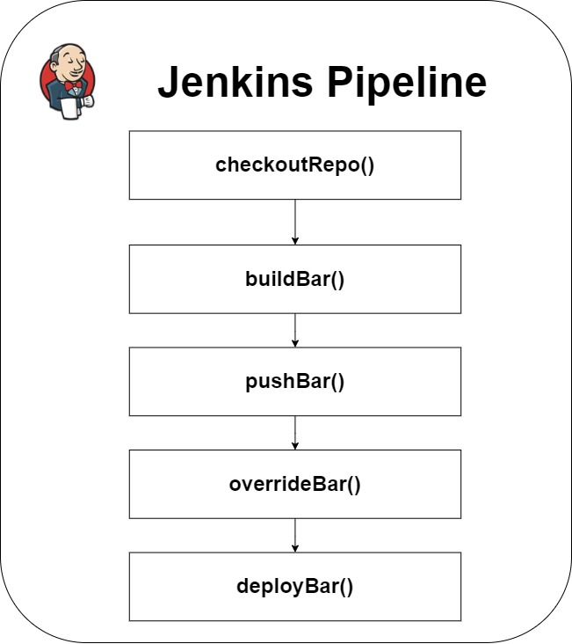
- The pipeline script is defined as following,
- All the required functions are stored as groovy files and are maintained at a bitbucket repository called “jenkins-shared-library” (branch: master) inside ESB_upgrade.
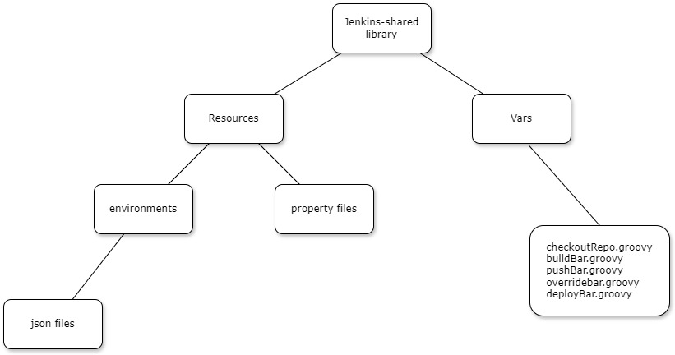
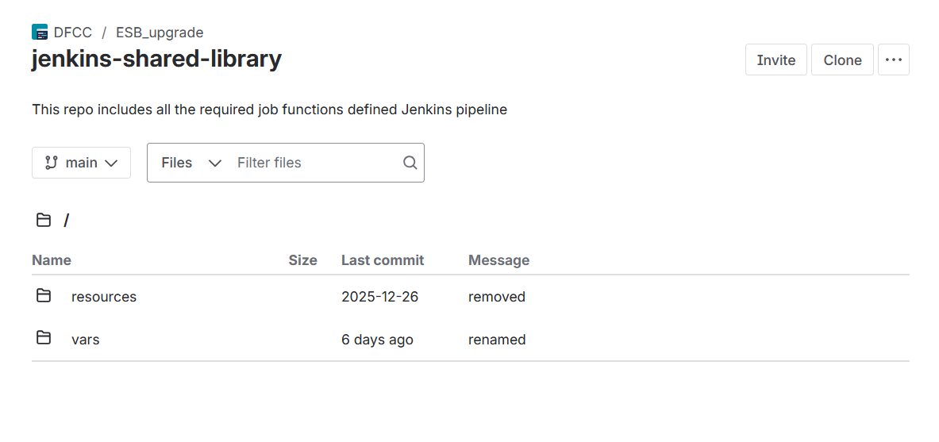

Step-by-Step Deployment Guide
Step 1: Make a Code Change
- Update application code or configuration in the assigned branch.
- Follow the agreed branching strategy.
Step 2: Commit and Push Code
- Commit changes with a clear message.
- Push the code to the remote repository.
- Pipeline build mainly focuses on master branch of source code repository.

Step 3: Accessing the Jenkins UI
This can be accessed with VDI (192.168.199.22) using the Remote Desktop Connection on Windows.
- Open any appropriate web browser (e.g., Google Chrome)
- Use the following details to access Jenkins UI,
  - Jenkins UI: http://10.18.51.139:8080/
  - Username: admin
  - Password: will be shared separately.
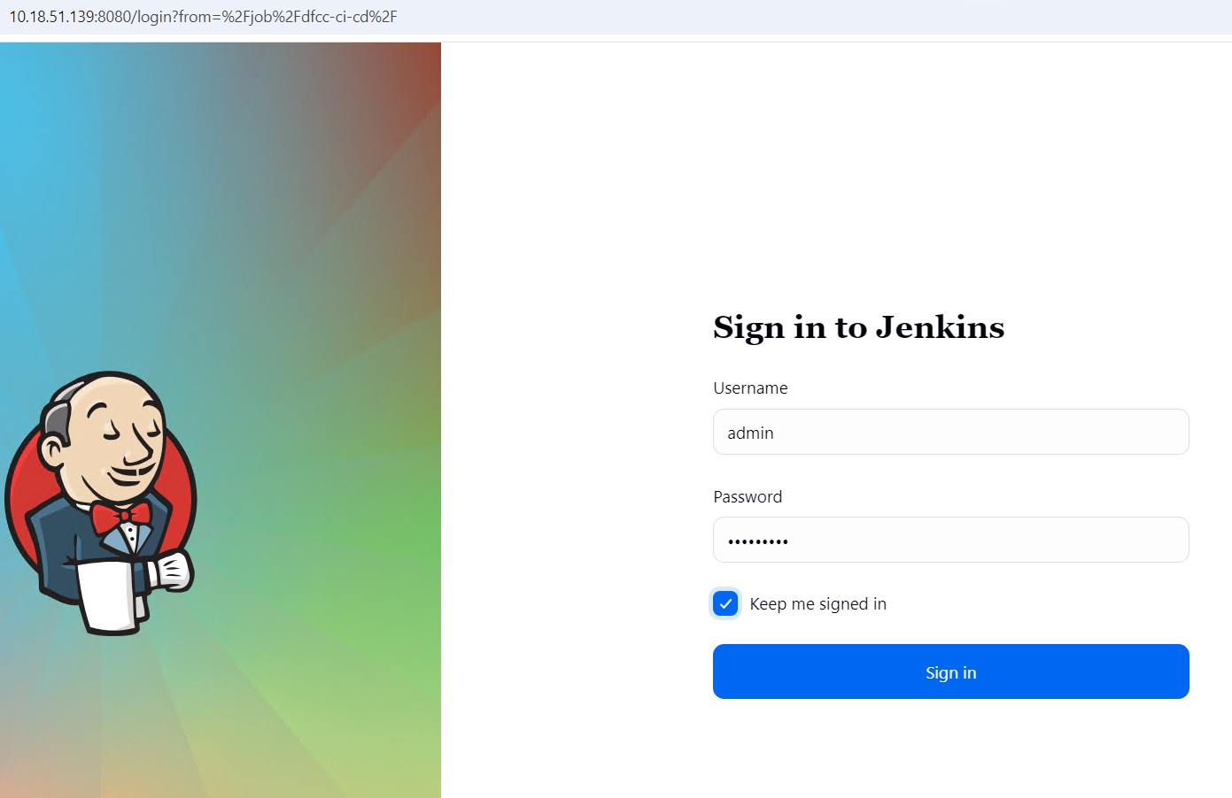
- Once the login is successful, the dashboard will be loaded.
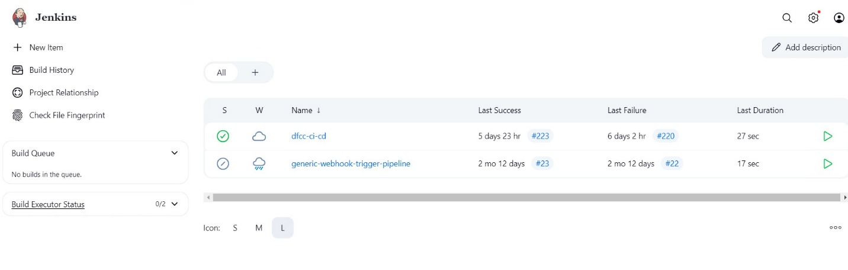

Step 4: Building deploying pipeline
- Click on the dfcc-ci-cd.
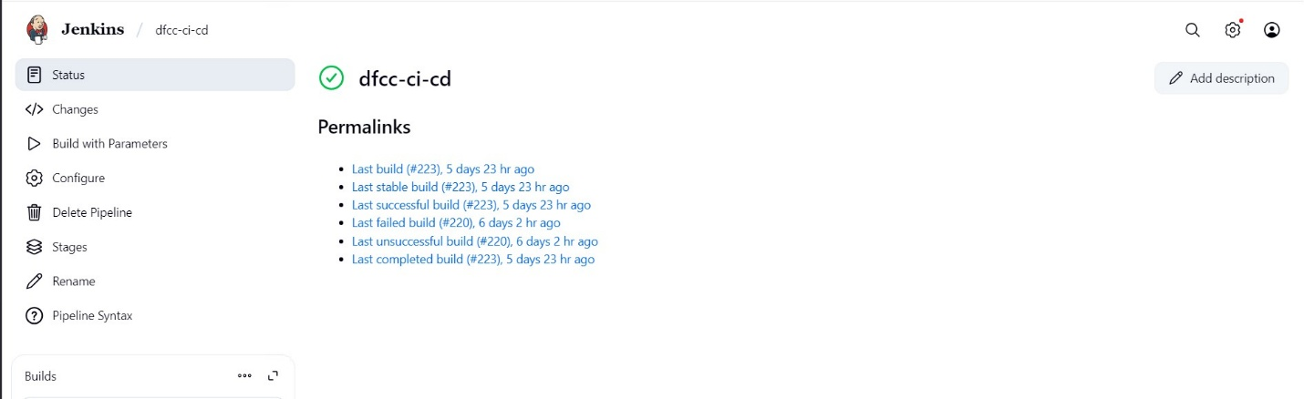
- On the next page, click on “Build with Parameters” button on the left side.

Step 5: Entering the required parameters
- On the next page, required parameters need to be filled before building.
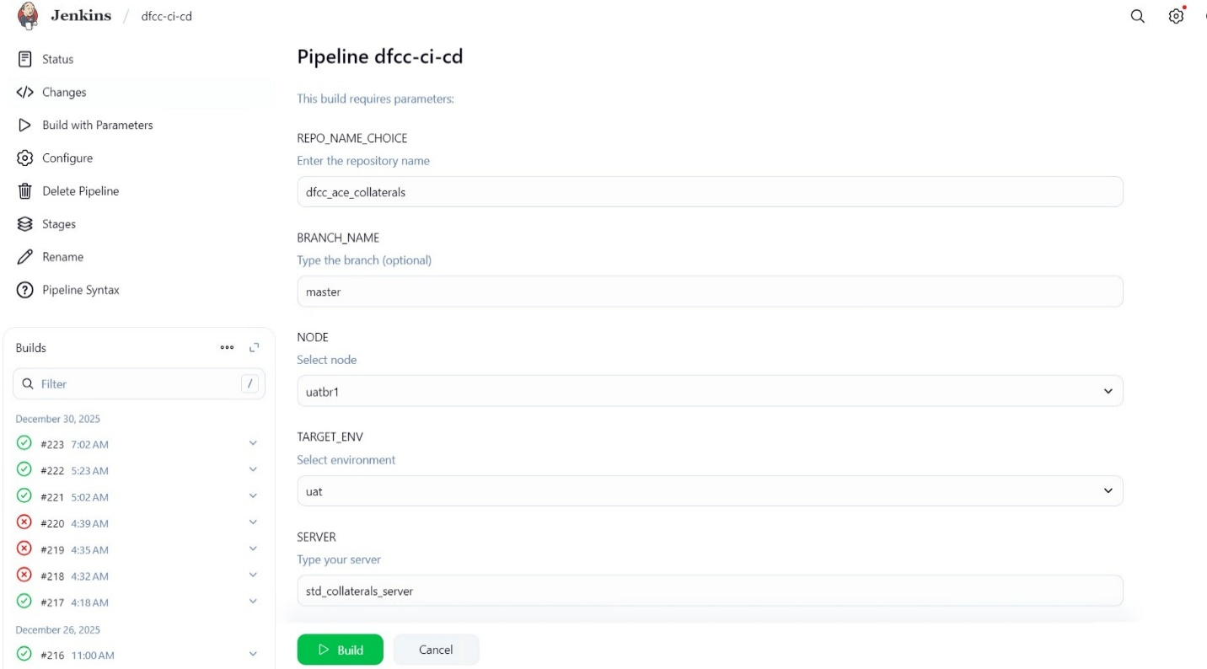
- Then click the “Build” button.
- Once the build button is clicked, the pipeline will start building and deploying to the server.

Step 6: Checking pipeline logs
- Click on the running pipeline on the Builds section on the left side of the screen.
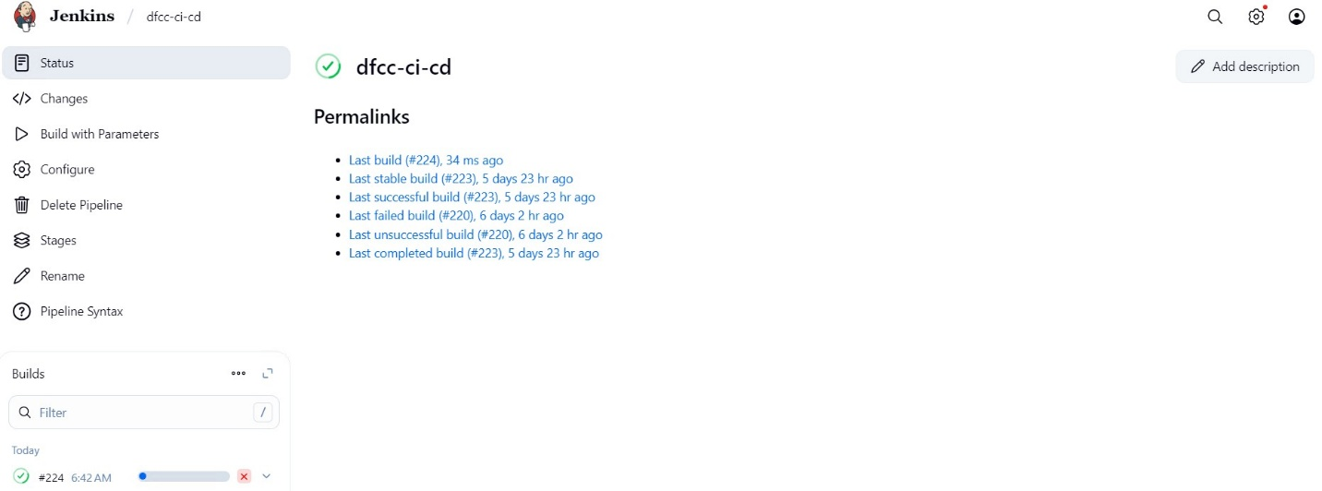

- On the next page, click on the “Console Output” button to see the pipeline logs.
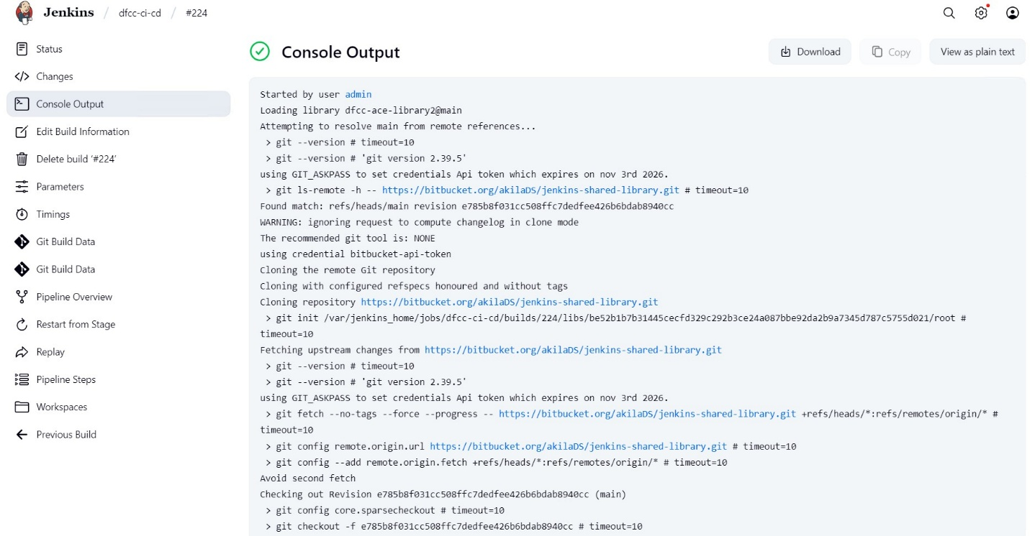

Summary
The DFCC CI/CD pipeline enables:
- Automated, repeatable deployments.
- Improved release reliability.
- Standardized deployment process across environments.
- Reduced manual intervention and human error.
- Faster feedback through automated build and deployment logs.
- Consistent artifact generation and versioning.
- Centralized management of pipeline logic via shared Groovy libraries.
- Better collaboration between Development, QA, and Operations teams.
- Alignment with CI/CD best practices under the Integration Modernization Project.

