Contents
Introduction 2
Purpose 2
Scope 3
Proposed CI/CD Solution Design 3
Core Components and Tools 4
SCM and Continuous Integration 4
Repositories 4
Branching Strategy and CI Workflow 4
Branching Strategy 4
Continuous Integration (CI) workflow 5
Automated CI Tests/Checks 6
Continuous Delivery 7
Continous Artifact Build 7
Environment Management 8
Application Runtime Environments 8
Development Environment 8
SIT/QA Environment 8
Staging Environment 8
Production Environment 8
Pipeline Execution Environment 8
Rollback Strategy 8

Introduction
This document outlines a solution design for a Continuous Integration Continuous Deployment (CICD) practice for DFCC as part of the ongoing Integration Modernization project.

Purpose
Currently DFCC doesn’t have a CICD practice and integration applications are deployed in an ad hoc manner. Following are some reason DFCC might need to adopt CICD practice.
Faster Time-to-Market and Agility:
- Rapid Iteration: Integration needs evolve quickly. CI/CD pipelines automate the build, test, and deployment processes. This enables you to make changes, add new integrations, or update existing ones much faster than manual methods. You can respond swiftly to changing business requirements and market demands.
- Frequent Releases: Instead of large, infrequent releases that carry more risk, CI/CD facilitates smaller, more frequent deployments. This reduces the impact of any potential issues and allows for continuous improvement based on feedback.
Improved Quality and Reliability:
- Automated Testing: CI/CD pipelines incorporate automated testing at various stages (unit, integration, end-to-end). This ensures that your App Connect flows and connections are thoroughly validated before deployment, catching errors early in the development lifecycle.
- Consistent Environments: Infrastructure as Code (IaC) practices, often integrated with CI/CD, ensure that your development, testing, staging, and production environments are consistent. This minimizes environment-specific issues that can plague integration projects.

- Rollback Capabilities: In case of a failed deployment, automated rollback mechanisms in a CI/CD pipeline allow you to quickly revert to a stable previous version, minimizing downtime and impact on business operations.
Better Governance and Compliance:
- Audit Trails: CI/CD pipelines often maintain detailed logs of changes, deployments, and test results, providing a clear audit trail for compliance and governance purposes.

Scope
This document outlines the design for a Continuous Integration and Continuous Delivery (CI/CD) solution specifically for the development and deployment of integration solutions built using IBM App Connect Enterprise (ACE). The scope includes the automation of build, test, and deployment processes for ACE flows, connections, and associated configurations across development, testing, and production environments. This document covers the selection of tools, the definition of pipeline stages, and considerations for security and rollback strategies relevant to the ACE integrations. It does not explicitly cover the CI/CD processes for the source applications or systems that ACE integrates with, nor does it detail infrastructure provisioning beyond what is directly required for the ACE environments within the CI/CD pipeline.

Proposed CI/CD Solution Design
The following diagram depicts the proposed CICD solution design for DFCC.
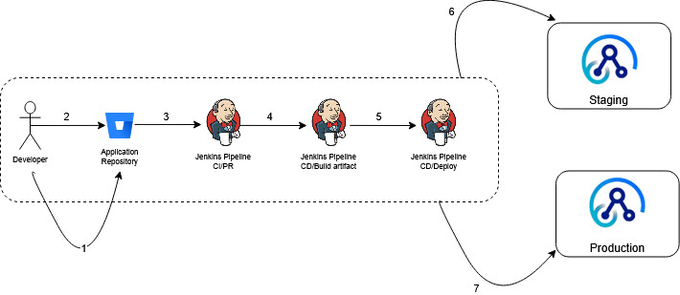
1 - Developer continuously commits changes of a project source code to a feature branch of Bitbucket
2 - Once tested and confident for a release, a pull request is initiated to the main branch.
3 - The pull request (PR) will trigger a build pipeline.
4 - Subsequent pipeline will trigger a deployment pipeline for the App Connect Enterprise artifact.
5 - In the next step a pipeline will deploy the artifact to a staging environment.
6 - Once deployed in the staging environment necessary testing (functional, regression, smoke, integration) can take place and release can be deemed production ready.
7 – The testing is successful, another Jenkins pipeline can deploy the artifact to production.

Core Components and Tools
Following section describes core components and tools that will be used in the CICD implementation.

SCM and Continuous Integration
Git is a distributed version control system that tracks changes to files over time, allowing you to revert to specific versions, compare modifications, and collaborate effectively on projects. It is expected to install git on all the development workstations.

Repositories
Each component will have its own Git repository. The high-level architecture and the workflow apply independently for each repository.

Branching Strategy and CI Workflow
The branching strategy and workflow are defined for all the Git repositories.

Branching Strategy
The adopted branching strategy is trunk-based development. Trunk based development is well suited for continuous integration.
The following diagram depicts branching strategy for trunk-based development,
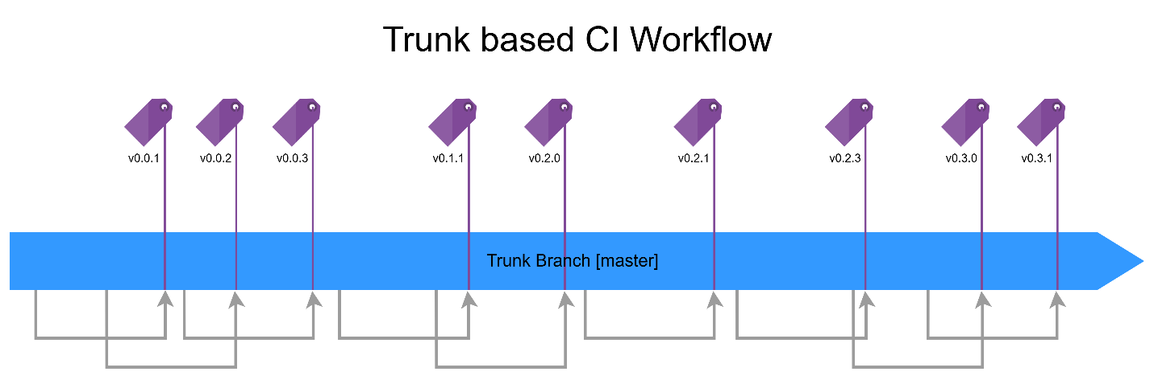
- There is only the main branch called ‘master’ that exists, and all the changes are integrated into it.
- The changes to the master branch are introduced through pull requests from short-lived branches.
- Every successful merge to the master branch creates a release tag which signifies a source release with a version number.
- Each arrow in the diagram represents a successful merge to the master branch which in turn signifies one instance of a continuous integration workflow discussed in detailed in the next section

Continuous Integration (CI) workflow
The continuous integration/continuous delivery workflow is built around the branching strategy, The CI workflow cycle is depicted in the diagram below,
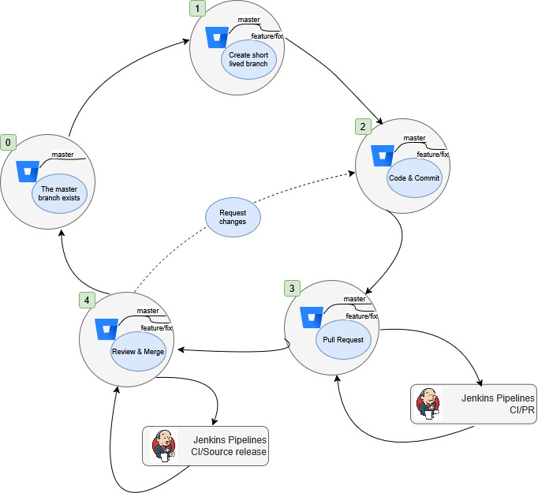

- Signifies the state of which no work has started yet and master branch is in clean state.
- The application developer creates a short-lived branch to commit changes into of new feature or fix.
- The application developer makes changes to the code and commits to short-lived branch
- Once the application developer is confident that the changes are ready to be merged into the master branch, a pull request is created. That triggers the “CI/PR” Jenkins Pipeline to run a set of tests and checks to validate the proposed changes to master branch by the pull request. The “CI/PR” Jenkins Pipeline reports back the pull request page on Bitbucket.
- A manual review is done considering the results of the “CI/PR” Jenkins Pipeline and if the changes meet the standards and PR is merged into the master branch. If not, changes are requested such that the purposed changes pass the standards. In the case of a successful merge to the master branch, “CI/SourceRelease” Jenkins Pipeline is triggered. The “CI/SourceRelease” Jenkins Pipeline creates a release tag in the Bitbucket repository marking the successful merger. The release is only a source release, and no build is done.

Automated CI Tests/Checks
Automated CI tests/checks are run before a pull request is merged to the master branch to validate the changes being introduced.
The following named checks/tests would be run as a part of the Automated CI tests/checks,
  - Checks whether the short-lived branch is up to date with the master branch.
  - Code quality analysis (Optional)
  - Unit tests (Optional)
The following Jenkins CI Pipeline would perform the automated CI tests/checks.
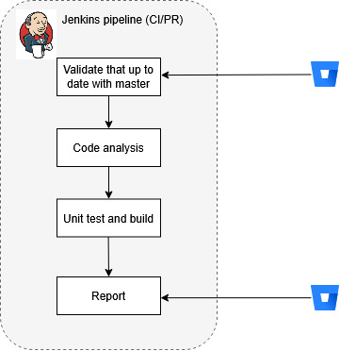

Automated CI Release
The automated CI release would create a source code release in the Git repository. The following Jenkins pipeline would perform the automated CI release.
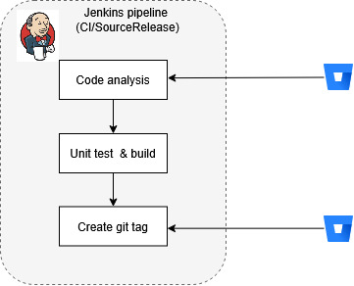

Continuous Delivery
The continous deployment is starts with the automated CI release at the end of each CI cycle. The deployment involves building and packaging source code into a runnable artifact. Once the artifact is published to a container registry, it will trigger a deployment pipeline.
The continous delivery process starts when a new source release becomes available in the Application Repository on GitHub. It consists of two stages,
- Continous Artifact Build
- Continous Artifact Release

Continous Artifact Build
The “CI/ImageBuild” Jenkins Pipeline is triggered on an automated CI release, it carries out the following tasks,
- Build a new container image from the Git commit that the CI source release tag is pointing to.
- Copy the built artifact to a secure location

Continuous Artifact release

Environment Management

Application Runtime Environments

Development Environment
The development environment is where the developers develop and perform developer testing. The development environment is untouched by automated processes.

SIT/QA Environment
The SIT/QA environment is used for continuously deploying CI releases for automated integration testing and optional manual QA testing.

Staging Environment
The staging environment is a replica of the production environment to allow pre-prod testing in a production-like environment.

Production Environment
The production environment is used for running production workloads continously deployed using contionous deployment pipeline once all the pre-production integration tests have passed.

Pipeline Execution Environment
The pipeline execution environment will be a dedicated Jenkins container environment. Jenkins platform provides the capability of ‘Jenkins Pipelines’ which is used for execution of pipelines.

Rollback Strategy
Following section describes a rollback strategy in case of a deployment failure.
- Automated Failure Detection and Notification: Jenkins should be configured to automatically detect build failures. Upon failure, it should immediately trigger notifications (e.g., email, Slack, etc.) to the development and operations teams, including details about the failed build (build number, commit hash from Bitbucket, error logs).
- Identify the Last Successful Deployment: The team needs to quickly identify the last known good deployment. This information should be readily available, potentially tracked by Jenkins, a deployment management tool, or even a simple log. Knowing the exact commit hash or release tag associated with this successful deployment is crucial (this information would ideally be linked back to Bitbucket).
- Initiate the Rollback Procedure: Based on the deployment method, the rollback process will vary.
  - Automated Deployment Pipeline: Ideally, Jenkins (or your deployment tool) has a pre-configured "rollback" job or script. This job would take the identifier of the last successful deployment (e.g., commit hash, release tag, previous build number) as input. It would then redeploy that specific version to the target environment.
  - Manual Rollback: If automation isn't fully in place, the operations team would manually retrieve the deployment package or configuration associated with the last successful deployment (potentially from an artifact repository or version control) and redeploy it to the target environment.
- Verification and Testing: After the rollback is complete, automated and manual tests should be immediately executed on the rolled-back environment to confirm its stability and functionality. This step ensures that the rollback was successful and didn't introduce new issues.

