Contents
Introduction 1
Prerequisites 1
High-Level pipeline Flow 2
Step-by-Step Deployment Guide 3
Summary 7

Introduction

This document provides a simple, step-by-step guide to deploy applications using the established CI/CD pipeline for DFCC, as part of the Integration Modernization Project. It is intended for developers, QA engineers, and operations teams who need a clear and consistent deployment process.

Prerequisites
Before starting a deployment, ensure the following are in place:
- Access to the source code repository
- Required groovy functions
- Application configuration values (environment variables, override properties)
- Target environmental availability
- Artifact repository access

High-Level pipeline Flow
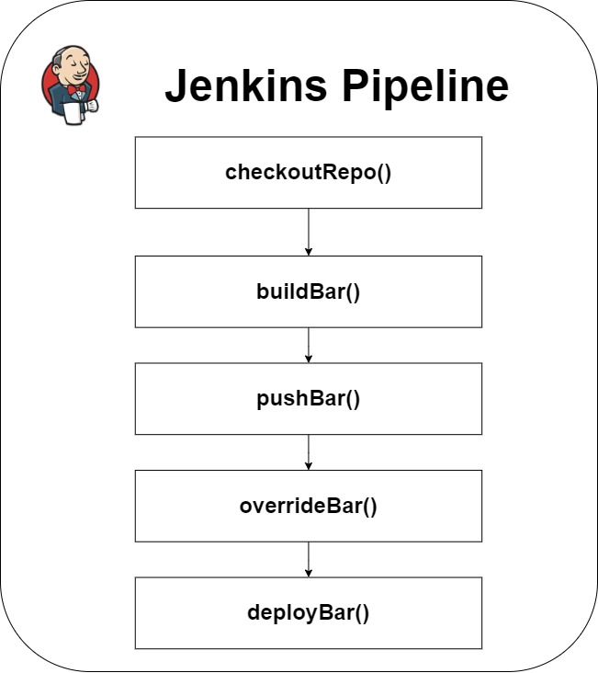
- The pipeline script is defined as following,
- All the required functions are stored as groovy files and are maintained at a bitbucket repository called “jenkins-shared-library” (branch: master) inside ESB_upgrade.
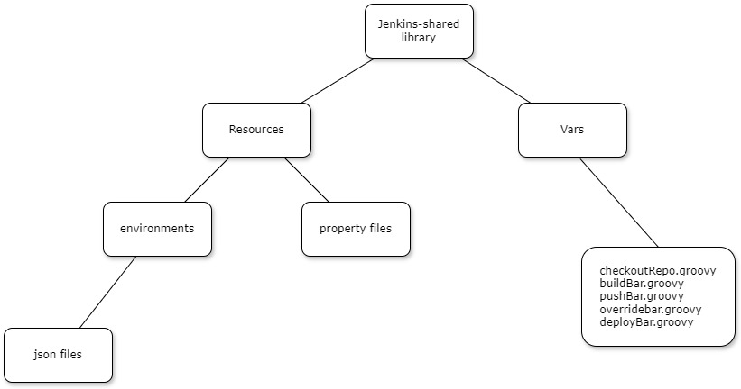
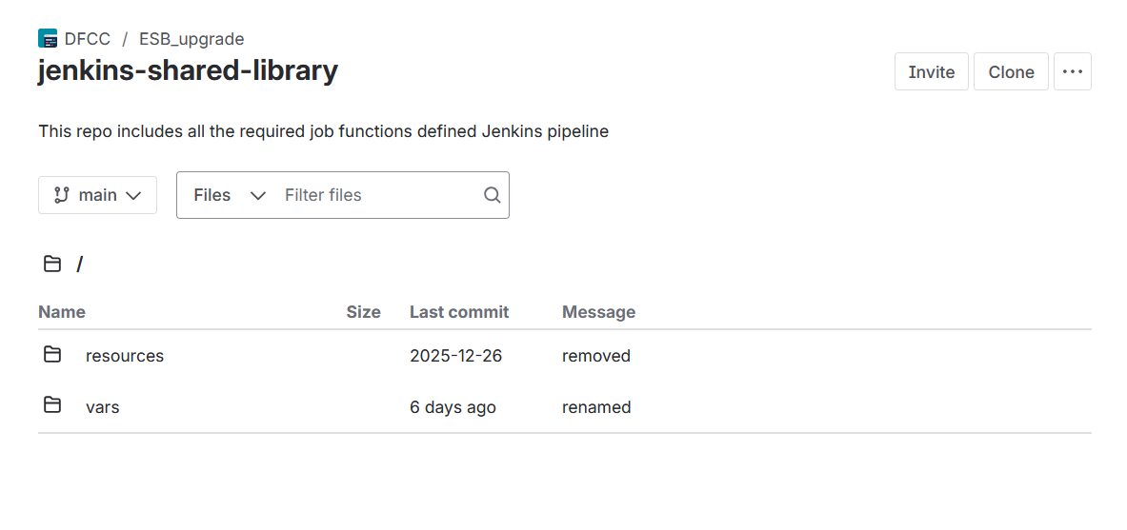

Step-by-Step Deployment Guide
Step 1: Make a Code Change
- Update application code or configuration in the assigned branch.
- Follow the agreed branching strategy.
Step 2: Commit and Push Code
- Commit changes with a clear message.
- Push the code to the remote repository.
- Pipeline build mainly focuses on master branch of source code repository.

Step 3: Accessing the Jenkins UI
This can be accessed with VDI (192.168.199.22) using the Remote Desktop Connection on Windows.
- Open any appropriate web browser (e.g., Google Chrome)
- Use the following details to access Jenkins UI,
  - Jenkins UI: http://10.18.51.139:8080/
  - Username: admin
  - Password: dfccAdmin
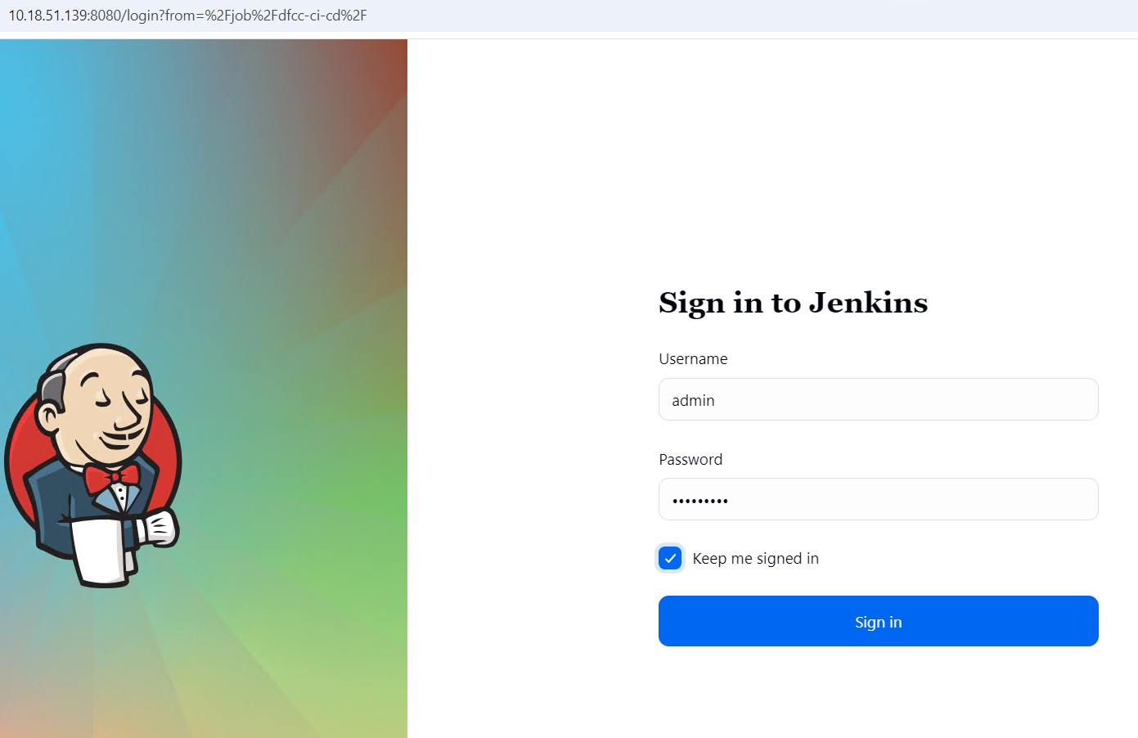
- Once the login is successful, the dashboard will be loaded.
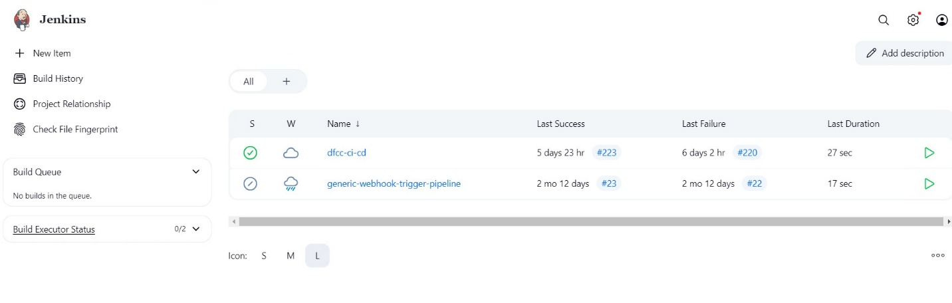

Step 4: Building pipeline
- Click on the dfcc-ci-cd.
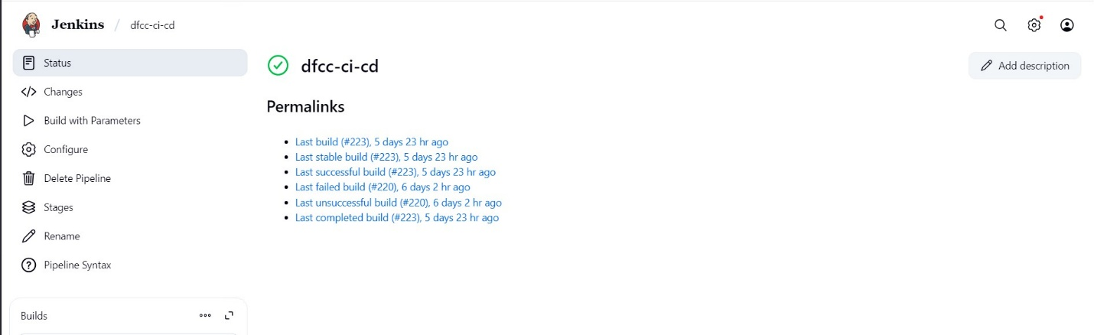
- On the next page, click on “Build with Parameters” button on the left side.

Step 5: Entering the required parameters
- On the next page, required parameters need to be filled before building.
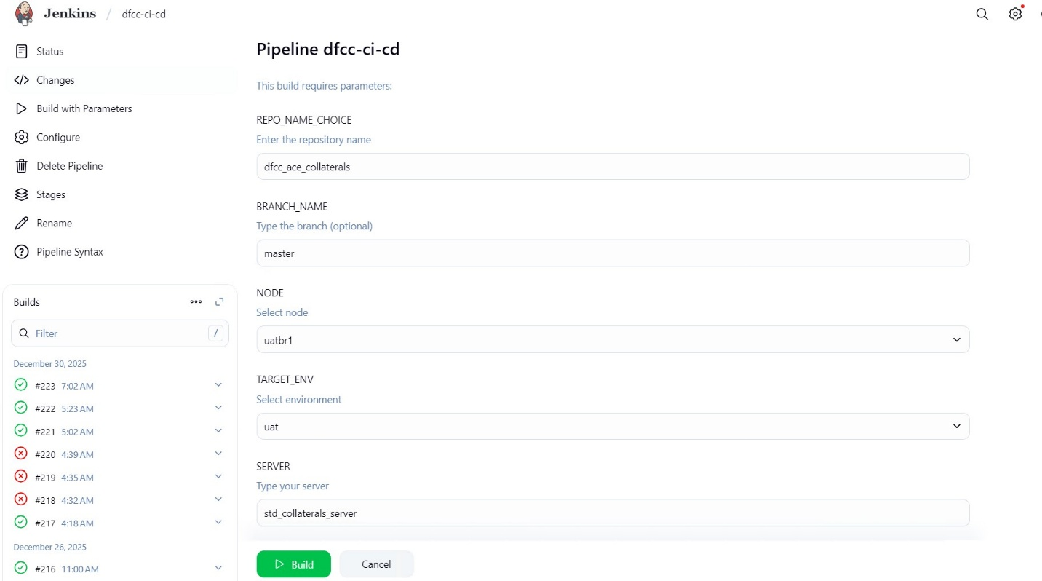
- Then click the “Build” button.

Step 6: Checking pipeline logs
- Click on the running pipeline on the Builds section on the left side of the screen.
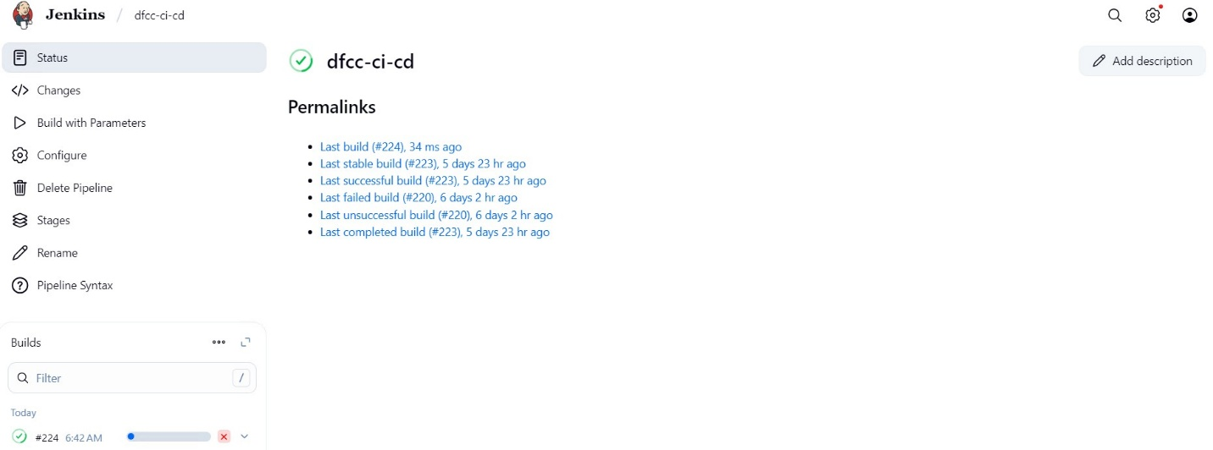

- On the next page, click on the “Console Output” button to see the pipeline logs.
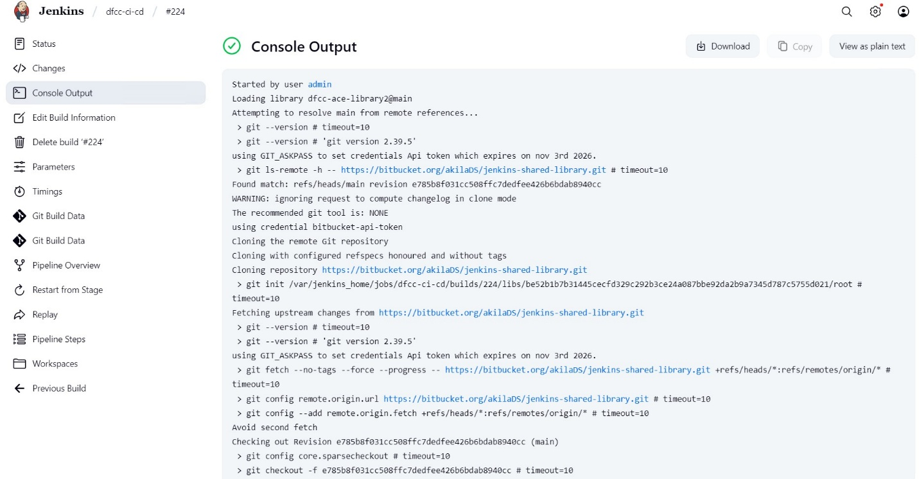

Summary
The DFCC CI/CD pipeline enables:
- Automated, repeatable deployments.
- Improved release reliability.
- Standardized deployment process across environments.
- Reduced manual intervention and human error.
- Faster feedback through automated build and deployment logs.
- Consistent artifact generation and versioning.
- Centralized management of pipeline logic via shared Groovy libraries.
- Better collaboration between Development, QA, and Operations teams.
- Alignment with CI/CD best practices under the Integration Modernization Project.

