Contents
Introduction 1
Purpose 2
Scope 2
Proposed CI/CD Solution Design 3
Core Components and Tools 5
SCM and Continuous Integration 5
Repositories 5
Branching Strategy 5
Continuous Integration (CI) 6
Continuous Deployment (CD) 6
Environment Management 6
Application Runtime Environments 6
Development Environment 6
SIT/QA Environment 7
Staging Environment 7
Production Environment 7
Pipeline Execution Environment 7
Rollback Strategy 7

Introduction
This document outlines a solution design for a Continuous Integration Continuous Deployment (CICD) practice for DFCC as part of the ongoing Integration Modernization project.

Purpose
Currently DFCC doesn’t have CICD practice and integration applications are deployed in an ad hoc manner. Following are some reasons DFCC might need to adopt CICD practice.
Faster Time-to-Market and Agility:
- Rapid Iteration: Integration needs to evolve quickly. CI/CD pipelines automate the build, test, and deployment processes. This enables you to make changes, add new integrations, or update existing ones much faster than manual methods. You can respond swiftly to changing business requirements and market demands.
- Frequent Releases: Instead of large, infrequent releases that carry more risk, CI/CD facilitates smaller, more frequent deployments. This reduces the impact of any potential issues and allows for continuous improvement based on feedback.
Improved Quality and Reliability:
- Automated Testing: CI/CD pipelines incorporate automated testing at various stages (unit, integration, end-to-end). This ensures that your App Connect flows and connections are thoroughly validated before deployment, catching errors early in the development lifecycle.
- Consistent Environments: Infrastructure as Code (IaC) practices, often integrated with CI/CD, ensure that your development, testing, staging, and production environments are consistent. This minimizes environment-specific issues that can plague integration projects.

- Rollback Capabilities: In case of a failed deployment, automated rollback mechanisms in a CI/CD pipeline allow you to quickly revert to a stable previous version, minimizing downtime and impact on business operations.
Better Governance and Compliance:
- Audit Trails: CI/CD pipelines often maintain detailed logs of changes, deployments, and test results, providing a clear audit trail for compliance and governance purposes.

Scope
This document outlines the design for a Continuous Integration and Continuous Delivery (CI/CD) solution specifically for the development and deployment of integration solutions built using IBM App Connect Enterprise (ACE). The scope includes the automation of build, test, and deployment processes for ACE flows, connections, and associated configurations across development, testing, and production environments. This document covers the selection of tools, the definition of pipeline stages, and considerations for security and rollback strategies relevant to the ACE integrations. It does not explicitly cover the CI/CD processes for the source applications or systems that ACE integrates with, nor does it detail infrastructure provisioning beyond what is directly required for the ACE environments within the CI/CD pipeline.

Proposed CI/CD Solution Design
The following diagram depicts the proposed CICD solution design for DFCC.
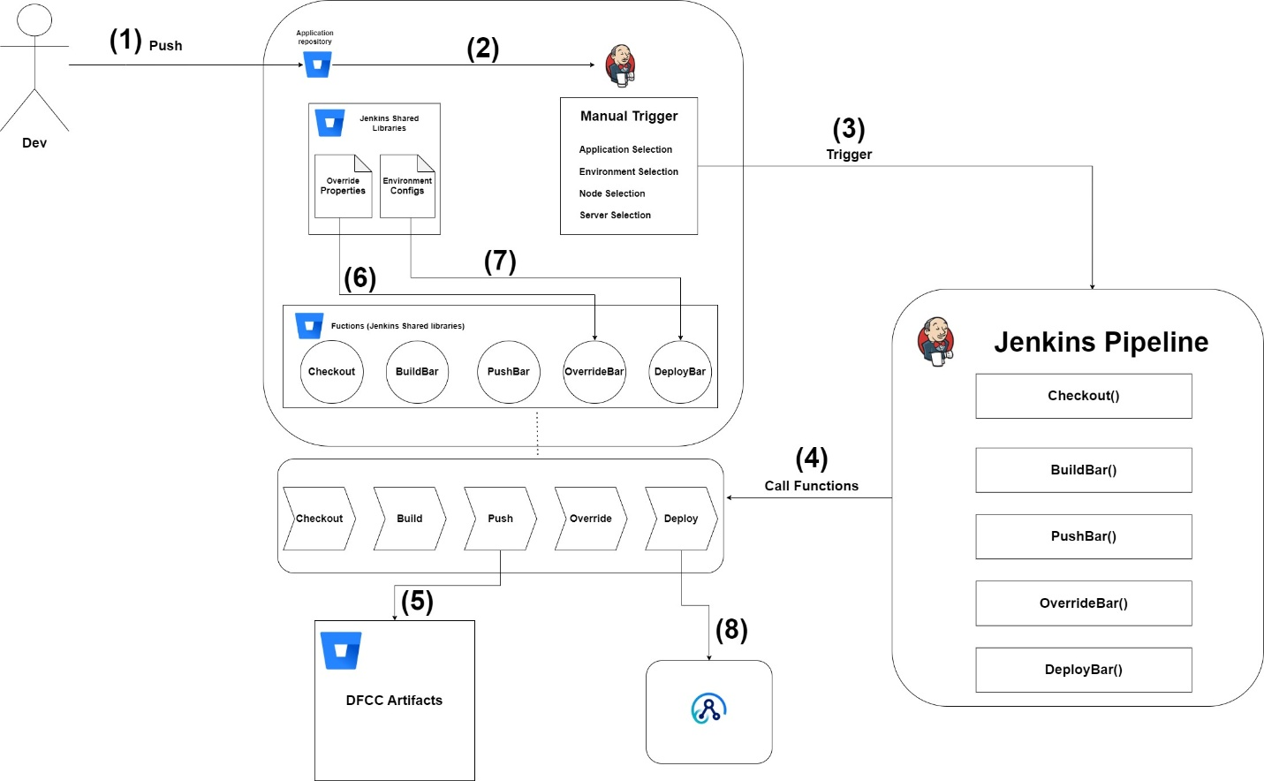

- Developers continuously commit changes to the project source code in a feature branch hosted in Bitbucket.
- Once development and local testing are completed and the changes are considered release-ready, a Pull Request (PR) is raised from the feature branch to the main branch.
- After the PR is reviewed and merged into the main branch, the Jenkins pipeline is triggered manually.
- The user provides the required runtime inputs via Jenkins UI, such as:
- Jenkins node
- Target environment
- Repository name
- Branch (default: main/master)
- The Jenkins pipeline leverages shared libraries maintained in Bitbucket, which contain:
- Environment-specific configurations
- Overridable property files
- Reusable Jenkins pipeline functions
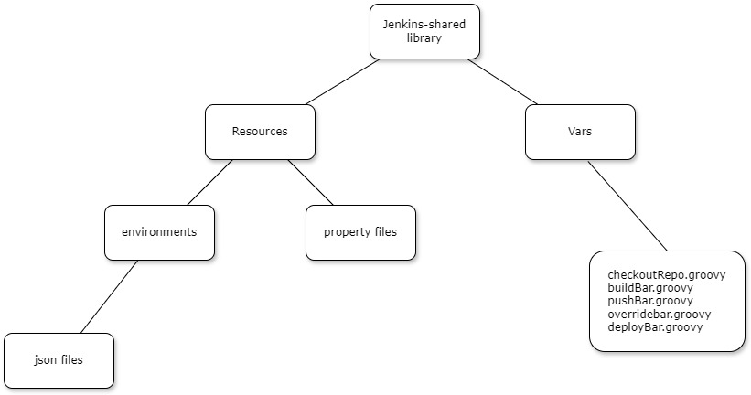
- The Jenkins pipeline itself remains lightweight and does not implement the full build and deployment logic.
Instead, it invokes predefined functions from the shared libraries to perform all operations.
- Once the pipeline starts execution, the following steps are performed sequentially:
- Checkout the source code from Bitbucket
- Build the IBM ACE BAR file
- Push the generated BAR file to the “dfcc_artifacts” repository
- Apply environment-specific overrides to the BAR using shared library configurations
- Deploy the overridden BAR file to the target server based on user input
- It is recommended to deploy to the Staging environment first.
After deployment, the following testing activities can be performed:
- Functional testing
- Regression testing
- Smoke testing
- Integration testing
Successful completion of these tests confirms that the release is production ready.
- Once staging validation is successful, a separate Jenkins pipeline can be executed to deploy the same approved artifact to the Production environment, ensuring consistency and reliability.

Core Components and Tools
Following section describes core components and tools that will be used in the CICD implementation.

SCM and Continuous Integration
Git is a distributed version control system that tracks changes to files over time, allowing you to revert to specific versions, compare modifications, and collaborate effectively on projects. It is expected to install git on all the development workstations.

Repositories
Each component will have its own Git repository. The high-level architecture and the workflow apply independently for each repository.

Branching Strategy
- The adopted branching strategy is Trunk-Based Development, which is well suited for Continuous Integration.
- There is a single long-lived branch named master.
- All code changes are ultimately integrated into the master branch.
- Changes are introduced via pull requests from short-lived feature branches.
- Feature branches are merged into master after review and validation.
- This approach enables frequent integration, reduces merge conflicts, and supports rapid delivery.

Continuous Integration (CI)

- Continuous Integration is implemented using a Jenkins pipeline and focuses on building and packaging the application artifact.
- When changes are merged into the master branch, the Jenkins pipeline is manually triggered with user-provided parameters.
- The pipeline invokes the appropriate functions defined in Jenkins shared libraries.
- Jenkins clones the source code and checks out the required branch.
- The pipeline automatically executes the build commands to generate the BAR file using the provided parameters.
- This process compiles and packages the source code into a deployable artifact.
- Once the building is completed successfully, the BAR file is published to a Bitbucket-managed artifact repository.
- The CI pipeline ensures that all changes are consistently built and packaged in a repeatable and automated manner.

Continuous Deployment (CD)

- Continuous Deployment begins after the successful completion of the CI process.
- Once the artifact is built and released, Jenkins proceeds to the deployment stages.
- In the override step, Jenkins retrieves environment-specific override property files from the shared library.
- The pipeline applies the required configuration overrides to the artifact.
- Finally, Jenkins deploys the configured BAR file to the target environment specified by the user.
This process results in the application being deployed and running in the selected environment as part of the same pipeline execution.

Environment Management

Application Runtime Environments

Development Environment
The development environment is where the developers develop and perform developer testing. The development environment is untouched by automated processes.

SIT/QA Environment
The SIT/QA environment is used for continuously deploying CI releases for automated integration testing and optional manual QA testing.

Staging Environment
The staging environment is a replica of the production environment to allow pre-prod testing in a production-like environment.

Production Environment
The production environment is used for running production workloads continously deployed using contionous deployment pipeline once all the pre-production integration tests have passed.

Pipeline Execution Environment
The pipeline execution environment will be a dedicated Jenkins container environment. Jenkins platform provides the capability of ‘Jenkins Pipelines’ which is used for execution of pipelines.

Rollback Strategy
Following section describes a rollback strategy in case of a deployment failure.
- Automated Failure Detection and Notification: Jenkins should be configured to automatically detect build failures. Upon failure, it should immediately trigger notifications (e.g., email, Slack, etc.) to the development and operations teams, including details about the failed building (build number, commit hash from Bitbucket, error logs).
- Identify the Last Successful Deployment: The team needs to quickly identify the last well-known deployment. This information should be readily available, potentially tracked by Jenkins, a deployment management tool, or even a simple log. Knowing the exact commit hash or release tag associated with this successful deployment is crucial (this information would ideally be linked back to Bitbucket).
- Initiate the Rollback Procedure: Based on the deployment method, the rollback process will vary.
  - Automated Deployment Pipeline: Ideally, Jenkins (or your deployment tool) has a pre-configured "rollback" job or script. This job would take the identifier of the last successful deployment (e.g., commit hash, release tag, previous build number) as input. It would then redeploy that specific version to the target environment.
  - Manual Rollback: If automation isn't fully in place, the operations team would manually retrieve the deployment package or configuration associated with the last successful deployment (potentially from an artifact repository or version control) and redeploy it to the target environment.
- Verification and Testing: After the rollback is complete, automated and manual tests should be immediately executed on the rolled-back environment to confirm its stability and functionality. This step ensures that the rollback was successful and didn't introduce new issues.

