1. **PUT - http://localhost:2000/user/signup**

{

"email" : "exec1@tae.com",

"name" : "exec1",

"password" : "first",

"phone" : 245235,

"type" : "ta_exec"

}

Output : userid of generated user

1. **POST - http://localhost:2000/user/login**

{

"email" : "exec1@tae.com",

"password" : "first"

}

Output : jwt bearer token

1. **POST - ​​http://localhost:2000/user/logout**

Output : JWT token gets blacklisted

1. **GET - http://localhost:2000/operations**

with bearer token in authorization

Output : list of operations for that user

1. **POST - http://localhost:2000/user/onboardInterviewer**

{

"email" : "ajit@interviewer.com",

"name" : "ajit",

"password" : "ajit22",

"phone" : 354634,

"type" : "interviewer"

}

Output : onboarded userID

1. **DELETE - http://localhost:2000/user/USERID with login as ta_exec**

Output : deleted userID

1. **POST - http://localhost:2000/candidate/onboardCandidate with form-data as body**

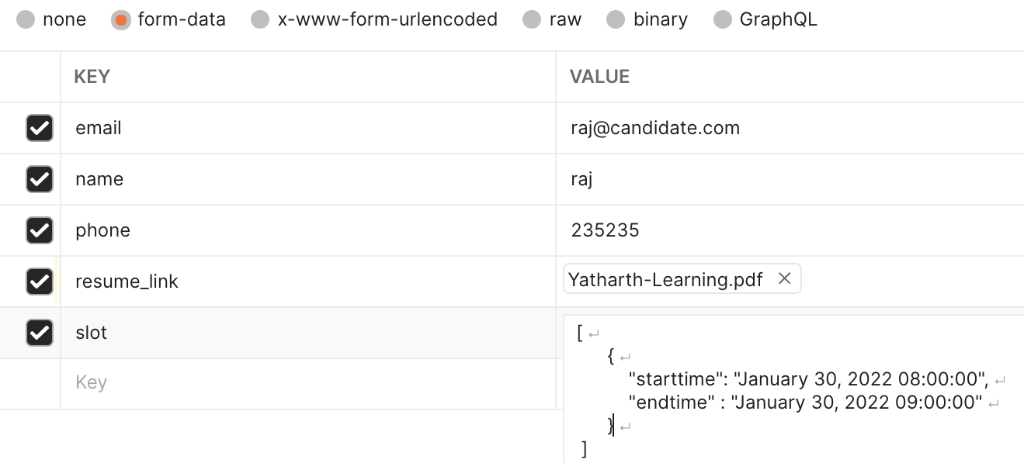

Output : candidate Userid

1. **PUT - http://localhost:2000/candidate/candidateAvailability/CANDIDATEID : overwrites**

{

"slot" :

[

{

"starttime": "February 5, 2022 10:00:00",

"endtime" : "February 5, 2022 11:00:00"

}

]

}

1. **POST - http://localhost:2000/user/login - interviewer**

{

"email" : "ajit@interviewer.com",

"password" : "ajit22"

}

1. **POST - http://localhost:2000/interviewerslot/slot/INTERVIEWERID**

{

"slot" :

[

{

"starttime": "February 5, 2022 10:00:00",

"endtime" : "February 5, 2022 11:00:00"

}

]

}

1. **PUT - http://localhost:2000/interviewerslot/slot/INTERVIEWERID**

{

"slot" :

[

{

"starttime": "February 5, 2022 10:00:00",

"endtime" : "February 5, 2022 11:00:00"

}

]

}

1. **DELETE - http://localhost:2000/interviewerslot/slot/INTERVIEWERID**
2. **GET - http://localhost:2000/schedule - start socketio**
3. **POST - http://localhost:2000/interview/feedback/INTERVIEWERID/CANDIDATEID**

{

"rating" : 4,

"feedback" : "Good in problem solving. Little subject knowledge lacking."

}

OUTPUT : candidateid with updated status - selected/rejected

1. **GET - http://localhost:2000/candidate/interviewSchedule/CANDIDATEID**

OUTPUT : Interview slot with interviewer name

1. **GET - http://localhost:2000/candidate/candidateJourney/CANDIDATEID**

OUTPUT : Complete candidate and interviewer data

1. **GET - http://localhost:2000/candidate/resume/CANDIDATEID**

OUTPUT : sends res.download() response and download resume