|  |
| --- |
| NAME: |

**Teaching Point:** SWBAT determine if a graph represents a proportional relationship

**Essential Questions**

How does the graph of a proportional relationship look?

**Review Vocabulary**

origin, x-axis, y-axis, ordered pairs, quadrant

**COORDINATE PLANE REVIEW**

Label the x-axis, y-axis, the origin and the quadrants on the coordinate plane.

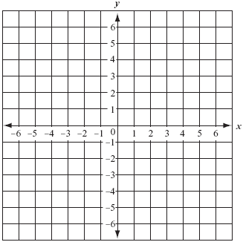

Graph the ordered pairs on the coordinate plane.

|  |  |
| --- | --- |
|  | $$A\left(-3, 6\right) B\left(-2, -4\right) C\left(1,5\right) D \left(5, -3\right)$$ $$E\left(3,0\right) F(0, 3)$$ |