PawPal+ — UML Reconciliation (Draft → Final)
Module 2 Project • diagrams/uml_final.mmd
This document revisits the Mermaid.js UML diagram drafted at the start of the project and reconciles it with the final implementation in pawpal_system.py. It answers: does the original diagram still match the code? What updates are needed? It then presents the corrected Mermaid source saved to diagrams/uml_final.mmd and the exported PNG used in the README.

1. Does the Draft Still Match the Code?
No. The draft (diagrams/uml_draft.mmd) captured the five classes and the basic Owner–Pet–Task–Scheduler–DailySchedule shape correctly, but the build added an entire persistence layer, stable IDs, recurring-task logic, a smart-logic helper layer, and redesigned the Scheduler. Roughly two-thirds of the final methods are missing from the draft, and several relationships were incomplete. The class diagram needed a substantial update to be accurate.

2. What Changed, Class by Class

Task
New attributes:
- frequency ("none"/"daily"/"weekly") and due_date — drive recurrence.
- task_id — a stable unique id so edit/remove never depend on the (non-unique) title.
- pet_name — back-reference stamped by Pet.add_task() so a multi-pet plan knows the owner of each task.
- Class constants PRIORITY_SCORES and RECURRENCE_DAYS.
New methods:
- is_recurring(), create_next_occurrence(today) — recurrence engine.
- get_priority_score(), preferred_minutes() — used by sorting/packing.
- to_dict() / from_dict() — JSON persistence.
- __post_init__() — normalizes frequency and keeps the legacy recurring flag in sync.

Pet
- Added age; care_needs corrected from String to list<str>.
- edit_task() / remove_task() now take a task_id (not a task object).
- New: _find_task() (private lookup), mark_task_complete() (completes + spawns next occurrence), get_task_list(), to_dict() / from_dict().

Owner
- Added task_preferences (free-form prefs) and the class set _DIRECT_FIELDS.
- New: get_all_tasks() (pools every pet's tasks for scheduling) and to_dict() / from_dict().

DailySchedule
- Added time_slots (task_id → "HH:MM") so placements can be ordered and labeled.
- New: add_reason() and the private _ordered() (chronological view).

Scheduler
Redesigned. The draft's per-instance fields pet, available_time, and task_list were removed — the Scheduler now holds only owner + pets and gathers tasks/availability lazily at build time, so UI edits are always reflected.
New methods:
- Private helpers: _gather_tasks(), _windows(), _place() (first-fit packing).
- Smart-logic wrappers: sort_by_time(), filter_by_pet(), filter_by_status(), filter_tasks_by(), detect_conflicts(), conflict_warnings().
- Recurrence/day control: mark_task_complete(), start_new_day().

PawPalHelpers (new — module-level pure functions)
The final code adds a layer of pure, module-level functions that both the Scheduler and the Streamlit UI reuse. They are grouped in the diagram as a «module functions» box named PawPalHelpers:
- Time: parse_hhmm(), parse_date(), fmt_minutes().
- Sort/filter: sort_by_time(), filter_by_pet/status/type(), filter_tasks_by().
- Day/conflict: reset_recurring(), detect_conflicts(), conflict_warnings(), _overlap_minutes().

3. Relationship Updates
Relationship | Draft | Final
Owner → Pet | --> has | 1 *-- 0..* composition (has)
Pet → Task | --> owns | 1 *-- 0..* composition (owns)
Scheduler → Owner | --> (plain) | --> plans for
Scheduler → Pet | --> (plain) | --> schedules
Scheduler → DailySchedule | --> produces | ..> produces (creates)
DailySchedule → Task | (missing) | 1 o-- 0..* aggregation (schedules)
Task → Task | (missing) | ..> create_next_occurrence() (recurrence)
Pet → Task (spawn) | (missing) | ..> spawns next occurrence
Scheduler / DailySchedule → PawPalHelpers | (missing) | ..> uses helper functions

4. Updated Mermaid Source (diagrams/uml_final.mmd)
The corrected diagram was saved as diagrams/uml_final.mmd. Key excerpts (full source is in the repo):
classDiagram
class Task {
+str frequency
+Optional~str~ due_date
+str task_id
+Optional~str~ pet_name
+is_recurring() bool
+create_next_occurrence(today) Optional~Task~
+get_priority_score() int
+to_dict() dict
+from_dict(data)$ Task
}
class Scheduler {
+Owner owner
+list~Pet~ pets
+sort_by_time(tasks) list~Task~
+filter_tasks_by(tasks, pet_name, completed) list~Task~
+detect_conflicts(tasks) list~tuple~
+conflict_warnings(tasks) list~str~
+mark_task_complete(task_id, today) Optional~Task~
+build_schedule(date) DailySchedule
}
Owner "1" *-- "0..*" Pet : has
Pet "1" *-- "0..*" Task : owns
DailySchedule "1" o-- "0..*" Task : schedules
Scheduler ..> DailySchedule : produces
Task ..> Task : create_next_occurrence()

5. Exported Diagram
The .mmd source was rendered to diagrams/uml_final.png (via mermaid-cli) and embedded in the README. The exported diagram:
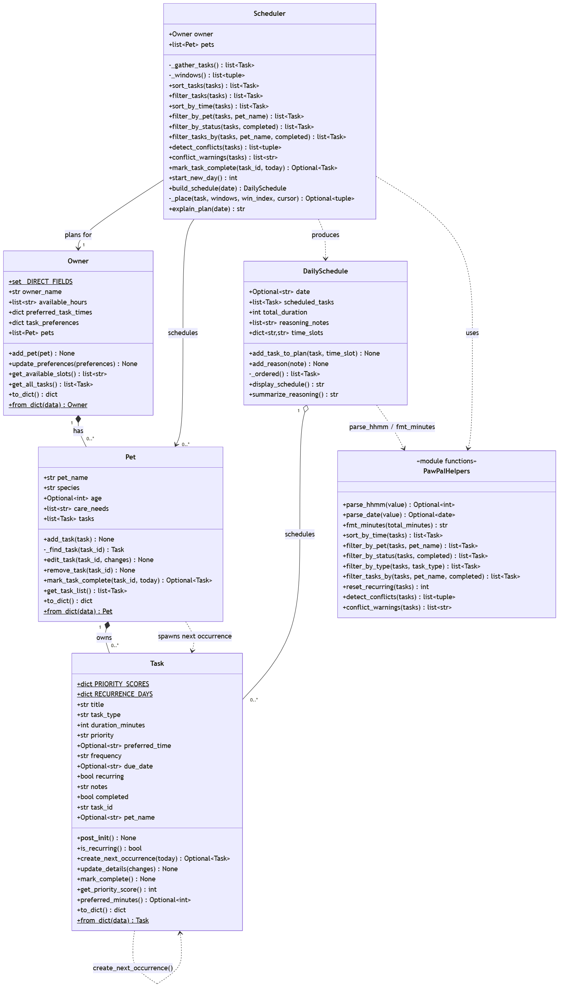
Note: the .mmd source file is the required deliverable; the PNG is an optional convenience for the README.

6. How to Re-Export the PNG
npx -y @mermaid-js/mermaid-cli@11 \
-i diagrams/uml_final.mmd \
-o diagrams/uml_final.png -b transparent -s 2

7. Files Changed / Added
- diagrams/uml_final.mmd — NEW, the required updated Mermaid source.
- diagrams/uml_final.png — NEW, exported diagram for the README.
- README.md — NEW “📊 System Design (UML)” section embedding the diagram.
- diagrams/uml_draft.mmd — kept unchanged as the historical first draft.

