PROJECT IN DCIT 24A

“Jail Management System”

**Submitted by :**  **Submitted to:**

Francis C. Ong Mr. Shane Carlo Biscocho

Paolo Dela Vega

1. **Introduction**

Jail Management System is a collection of register cases for each prisoner entering the prison. A good system for prison service should be automated, because it enhance the administrative and experience to design, develop and implement a prison management for prison defence and security.

The introduction of computer has brought many changes to various fields, such as prison, health sector, hotel, bank, and in business sector generally. Just because it helps to carry out complex and length analytical operation very rapidly to effective communication system, it is also time saving, versatile, flexible storage of large information and reduce human labour.

To this end, a simple website based prison management system will be developing to practically alert the prison staff of the capability of a computer for effective services. In this project attention will be based on Web Jail Management System.

The features of the Web Jail Management System are as follows.

* It has segment that handles prisoner’s basic information.
* It stored prisoner’s profile and information with criminal records.
* It has a security system that limits the users to access prisoner’s information.
* It is portable and convenient to have easy access with the use of search.
* It has a table that shows all the basic information of the prisoners.
* It can also edit or update and delete records and create multiple accounts that is used to access through the system.

1. **System Manual**

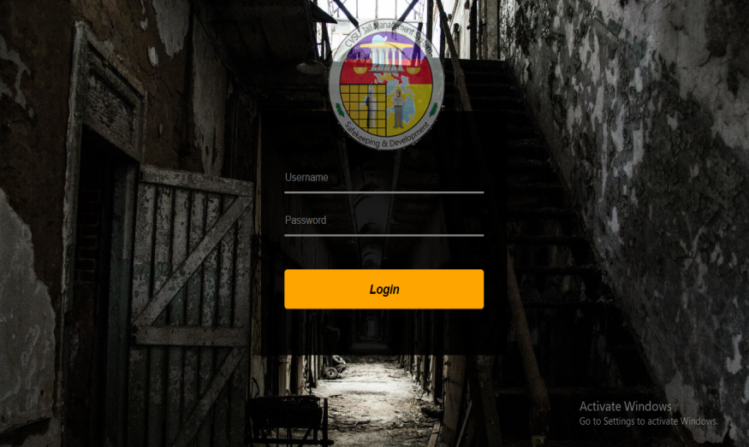

* **Log in Page**  – in order to access information and data of prisoners the user must log in

with an account. Default Username and Password via Database is

(username=warden) and (password=12345).

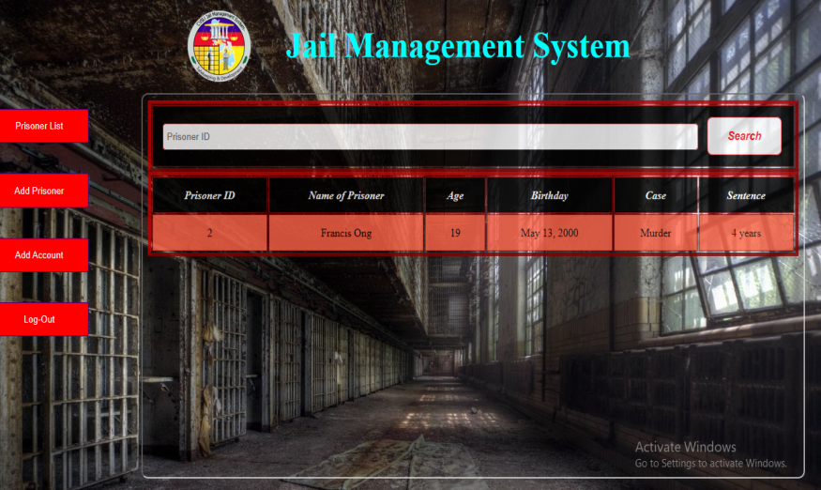

* **Prisoner List** – it shows all the information and data about the prisoners that is present

in the Database.

* **Log out** – Log out button is used to log out the user’s account and jump into log in

page.

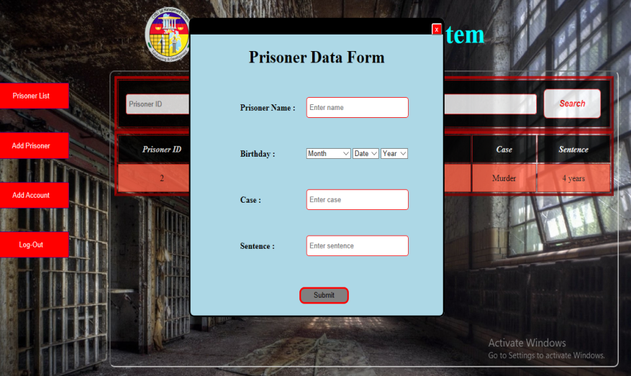

* **Prisoner Data Form** – Prisoner Data form is used to input data and all the information

about the prisoner with unique prisoner identification numbers

and auto compute age.

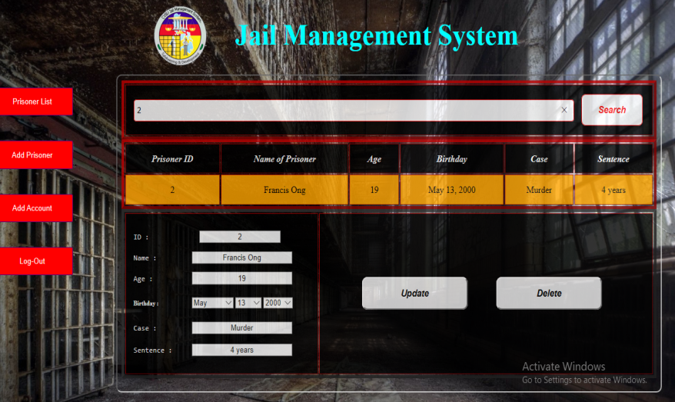

* **Search/Edit/Delete** – With the use of Search button and prisoner’s identification

number it will search the prisoner and shows all the data and

information about the prisoner. The user can edit or update the

existing information of the prisoner and it can also delete the

information of the prisoner via database.

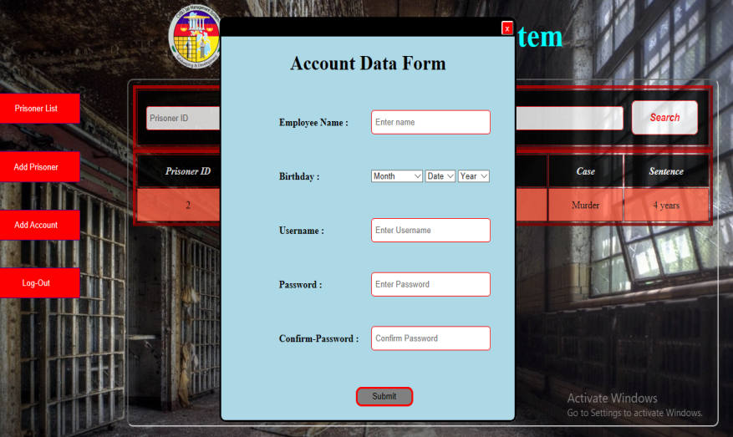

* **Account Data Form** – Account Data form is used to input and create a new account

that can be used to Log-in and access in the log in page. The

Username must be unique.

1. **Acknowledgement**

The Programmers would like to express their heartfelt gratitude and appreciation to the following good-hearted people, who in one way or another, helped in the completion of this system undertaking

Mr. Shane Carlo Biscocho , our teacher in Information Management for giving us knowledge and understanding in creating a system, and also for giving us idea on how to improve our system.

The BSIT-2B students who helped and gave ideas on how to improve our system.