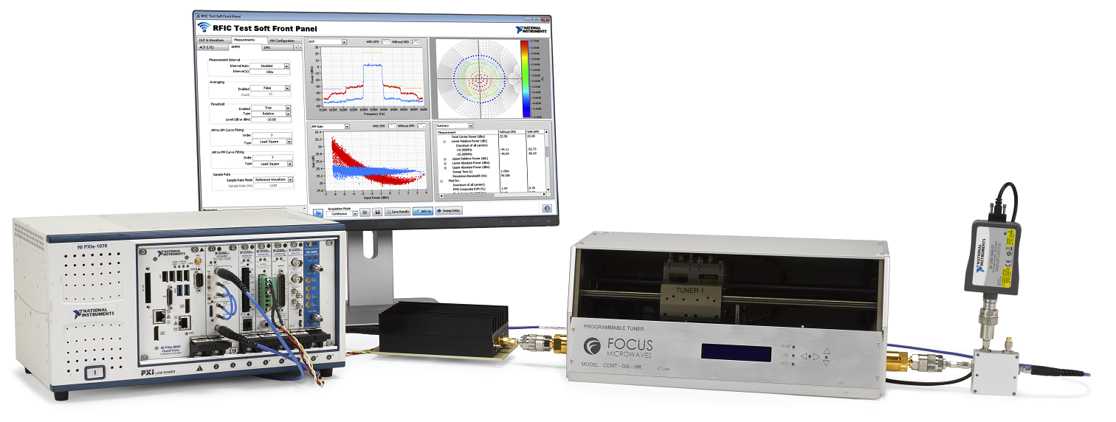

IPA: RF Front-End Validation Reference Architecture 24.0

Go Faster from Interactive RF Power Amplifier Bring-up to Extensive Automated Validation

Executive Summary:
NI’s RF Front-end Validation Reference Architecture simplifies workflows and accelerates validation of wideband RF power amplifiers (PAs) for demanding applications, like 5G NR and Wi-Fi 7. It gives users cockpit-like control of their test bench for interactive and automated validation.

RFIC Test Software, the core software in the RFFE Validation Reference Architecture, brings with it new features for GaN (Gallium Nitride) PA validation in version 24.0, enabling smoother workflows and measurements for these higher power PAs, as well as minor UI enhancements in the RFIC Soft Front Panel. Among these changes is support for oscilloscope measurements to enable fast and highly synchronized DC measurements required for GaN PAs that are not possible with DMMs. These features together with similar features included in previous releases, such as integrated system compensation and support for external driver amplifiers, make RFIC Test Software a capable and versatile tool for infrastructure, or GaN, PA validation.

Contacts:
Semi RF ADV Business Line Lead: Cristian Muresan
Business Manager, AMER: Joel Carroll
Business Manager, APAC: Phil Ouyang
SEBU System Architect: Paulo Lamas
Semi RF ADV Technical Marketer: Alejandro Escobar Calderon
SEBU Systems R&D Technical Lead: Hanrock Wang

Last Updated: February 17, 2025

When?

Important Dates:

Date | Detail
August 7, 2024 | RFIC Test Software 24.0 First Available Date
August 8, 2024 | IPA Sent

Who:

Industries and Application Alignment
Aero/Defense/Gov | Semiconductor | Transportation | Energy
General-purpose RF Power amplifiers | 5G UE RF PAs  High-power RF Infrastructure (GaN) PAs  WLAN PAs
Electrical Machinery/Equipment | Academic Teaching | Electronics (non-Semi) | Life Sciences
 |  | Radio heads with infrastructure reference designs

What is it?

IPA History

February 6, 2024 – RFFE Version 23.5
September 18, 2023 – RFFE Version 23.0
March 6, 2023 – RFFE Version 22.5
August 30, 2022 – RFFE Version 22.0

March 17, 2022 – RFFE Version 21.5
September 21, 2021 – Version 21.0
August 31, 2020 – RFFE Version 20.0

Overview

The RFIC Test Software, at the center of the RFFE Validation Reference Architecture, combines the power of the PXI platform, SMUs, AWGs, scopes and the VST (PXIe-5842, PXIe-5841, PXIe-5830 and PXIe-5831). It enables engineers working on wideband RF front ends to bring up and validate their new designs quickly. Acting as a control and visualization cockpit, RFIC Test Software simplifies:

- The generation of complex LTE, 5G, and WLAN waveforms
- Analysis of key power amplifier metrics, such as Gain, ACP, EVM, AM/AM, AM/PM, Power added efficiency (PAE)
- Test of high-power cellular infrastructure (GaN) PAs that require additional
- Support for testing PAs under DPD conditions using both classic models such as Look-up Table (LUT), Memory Polynomial (MP), Generalized Memory Polynomial (GMP) and customer defined DPD algorithms, as well as Iterative Learning Control DPD (ILC DPD) and third-party DPD like NanoSemi DPD, and AMD (Xilinx) DPD.

The RFIC soft front panel can also run detailed frequency, power and load sweeps without coding required. Additionally, it gives engineers the integrated control of instruments needed to validate Envelope Tracking (ET) DUTs with ease.

The RFFE Validation reference architecture can run PA validation scenarios under non-ideal, non-50 Ω load impedances with integrated support and integrated control of Focus Microwave and Maury Microwave load tuners. Support is limited to ceratin models, please see the sales training for more detailed information.

Incorporating the Semiconductor Device Control add-on for InstrumentStudio, the RFIC Test software gives engineers a simple way to implement digital DUT control and accurate triggering for dynamic ON/OFF measurements using MIPI RFFE and SPI digital protocols.

The Automation Wizard included in the RFIC Test Software can take users from interactive validation to fully automated PA characterization in minutes, rather than days. With just a couple of clicks, this Automation Wizard generates intuitive, easy-to-follow test code modules in the form of Reference Design Libraries in both LabVIEW and .NET, and sample test sequences in TestStand to simplify the process of automating the most common RF measurements of power amplifiers, including code for DPD linearization. The software also installs a large set of code examples in LabVIEW and .NET to give engineers a solid start if they want to write their own code modules.

New Features

New features in RFIC Test Software 24.0:
- Support for exporting VST reference clock in RFIC Test Software
  - Internal clock onboard VST is better than the VCXO clock in the PXI chassis
  - With this feature, users can now use the VST onboard clock as the reference clock for all other instruments
su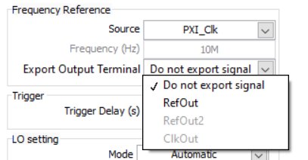
Screenshot of UI enabling exporting of VST (RefOut) clock

- Support for oscilloscope measurements in RFIC SFP
  - Measuring quiescent bias means measuring instantaneous current curve and voltage curve with an oscilloscope
  - New Power vs time and DC power graphs that highlight visualize current (I) and voltage (V) curves
  - Oscilloscope measurements can be configured in a similar way to how SMU and DMM are configured in the soft front panel
  - Allows for fast IV measurements that were not possible with DMMs. This is critical to capture “jump moment” that is characteristic of GaN power amplifiers
  - Support has been validated for the PXIe-5162 oscilloscope. While other instruments using the DC-Power driver should work, they have not been tested
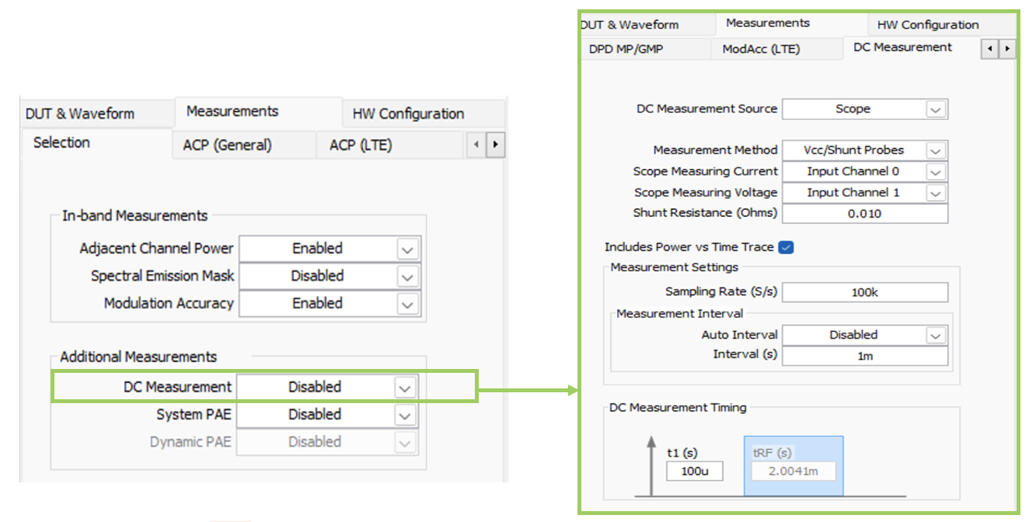
DC measurements configuration in RFIC UI
Oscilloscope support is a crucial feature for validation of GaN power amplifiers. The fast current and voltage ‘jumps’ and tight synchronization required means scopes are necessary to properly understand GaN PA performance.

Value Proposition

The RFFE Validation Reference Architecture gives engineers a cost-effective, integrated, and easy-to-automate test bench for fast validation of the latest wideband PAs. With the RFIC test software, engineers can go from manual DUT bring-up to interactive validation, and then to extensive automated validation sequences much more quickly.

RFIC Test Software is a versatile software that connects PXI VSTs, SMUs, digital pattern instruments, oscilloscopes, and third-party hardware such as load-pull tuners into one interactive software experience. This tailors a test system for PA validation and makes it easy to get started with PXI VSTs for RF test.

Pricing, Licensing, & Discounting

The software backbone of the RFFE Validation Reference Architecture is the RFIC Test Software. This software is licensed on a yearly subscription basis.

Customers can install a base version of the RFIC Test Software for free. They can use the base license (free) of this software to run common, spectral RF tests with generic waveforms (non-standard based), and to execute measurements for power amplifiers, such as AM/AM, AM/PM, P1dB, and gain. To work with 5G, LTE, and Wi-Fi signals, customers will need to purchase and install the respective RFmx Licenses. To use the NanoSemi linearization algorithms, customers will have to purchase and install from the NI Tools Network, and for RFFE MIPI control in RFIC, customers will need a license for Semi Device Control (Base or Pro). To get the Cross-correlation EVM measurement capability, they will need a subscription to the professional version of the RFIC Test Software. Alternatively, customers can purchase a stand-alone license for the Cross-correlation algorithm only.

RFIC Test Software Professional <PN:787917-35>, which offers advanced functionality, requires a $7,057 annual subscription license. The following table summarizes the free vs. licensed functionalities:
Measurement and Feature | RFIC Test Software Base | RFIC Test Software Professional
RFmx Power Amplifier (signal generation and analysis for PA test) | — | ✓
General spectral measurements | ✓ | ✓
Software-based power servo | Excludes power meter-based servo | ✓
Transmission power (TXP) | ✓ | ✓
Adjacent channel power (ACP) | ✓ | ✓
Modulation accuracy (ModAcc - including EVM) | ✓ | ✓
Spectral emission mask (SEM) | ✓ | ✓
AM-to-AM (AMAM) and AM-to-PM (AMPM) | —  (Need RFmx PA license) | ✓
Digital predistortion (DPD) | —  (Need RFmx PA license) | ✓
Load pull | Single point only, excludes sweeping | ✓
Power added efficiency (PAE) | — | ✓
Dynamic EVM (DEVM) | — | ✓
Envelope tracking (ET) | — | ✓
Crest factor reduction (pre-DPD and post-DPD) | —  (Need RFmx PA license) | ✓
Swept measurements (power, frequency, load-pull) | Power sweeping only | ✓
Complementary cumulative distribution function (CCDF) | ✓ | ✓
Routing RFIC triggers to external (non-PXI) instruments | — | ✓
Cross-correlation EVM optimization | — | ✓
DC instantaneous current and voltage measurements | ✓ | ✓

See the RFFE Validation reference architecture Sales Training to help you determine what components to recommend for different customer needs.

The central piece of hardware for the RFFE Validation Reference Architecture is NI’s third generation VST, the PXIe-5842. With best-in-class frequency coverage, bandwidth, and RF performance, the PXIe-5842 brings industry-leading EVM measurements, simplified measurements configurations, and full coverage of all Wi-Fi, 5G FR-1 and 5G FR-2 frequency bands.

For more in-depth information on the PXIe-5842, please refer to the VST Showpad page.

*NOTE: New versions of RFIC Test Software Professional now activate a license for RFmx Power Amplifier.

Offering Operationalization (O2)

O2 (Offering Operationalization) is a new part number scheme created to simplify solution quoting, connect opportunity dollars to market segments, and streamline operational process needed to build, deliver, and implement solutions to customers.

- Nothing about the offering features or capabilities has changed.
- 'Base' or bundle part numbers will contain everything a customer needs to get started (chassis, controller, VST)
- Optional add-ons include VSTs, SMU, digital instruments, etc. that customers may need on top of this.
- Software is currently not included in base part numbers and must be added separately.

The RFFE Validation Reference Architecture will include Offering Operationalization (O2) part numbers, is now orderable. Pricing varies based on the value of a given bundle and the market segment which it is intended to serve. Please refer to the RFFE Validation Sales Training for more information on pricing and specific bundles, when those become available.

Why?

Market Context

New RF Front-end designs for wideband wireless standards like 5G and Wi-Fi 7 need extensive validation efforts. Engineers need to understand the performance of these RFICs, including design, validation, and application engineering teams. Not all engineers working with these designs have the skills or the time to automate their measurements, so they need tools to help them validate and characterize the performance of the front ends.

NI’s RFIC Test Software makes it easier to interact with new designs by controlling the SMUs, scopes, digital, triggering, and RF instrumentation directly from a single soft-front panel created precisely for RF front-end measurements. Once they have proven the working condition of new DUTs, the RFIC software helps users automate their validation sequences with intuitively written, ready-to-run code modules and sequences that cover many of their test cases.

Alignment to Strategy (Why NI invested)

This solution aligns with NI’s strategic focus on RF Semiconductor devices. Because it aggregates existing platform components and makes extensive use of platform advantages, such as PXIe SMUs, AWGs, Scopes, RF instruments, and backplane synchronization and triggering, we can offer customers a simpler, more integrated setup. The RFIC software also speeds up our customers’ workflow, from bring-up to automated validation.

Account Development Value

The RFFE Validation Reference Architecture can be used to demonstrate additional capabilities of the VSTs (including frequency extended VSTs) and our RFmx software, helping us get to other design, validation, and test groups focusing on other aspects of the RF signal chain, such as transceivers and system-level test.

The high-level of reuse and flexibility offered from the PXIe-5842 also makes this a great option for applications that need to consolidate a wide range of test requirements, with the ability to include Wi-Fi, 5G, and Bluetooth and UWB test all on the same bench.

How?

Sales & Partner Enablement Resource Links

- RFFE Validation Showpad Page
- The Complete Learning Journey of RFIC Test Software
- Quick Links:
  - RFFE Validation application page on ni.com
  - Solution Brochure

Customer Email Templates

Visit RFFE Email Templates or PXIe-5842 Email Templates for various outreach email options.

- End of Document –

