Timecode in IMF

DRAFT Best Practice

This version: <https://www.imfug.com/TR/DRAFT-timecode-in-imf-20181107/>  
Latest version: <https://www.imfug.com/TR/timecode-in-imf/>

# Scope

This document recommends behaviour of IMF systems when interacting with SMPTE Timecode (SMPTE ST 12-1[1]).

# Status of this Document

This Draft Best Practice is published by the IMF User Group[2].

As a draft, it may be updated, replaced or obsoleted by other documents at any time. This document should not be cited as anything other than work in progress. Readers are encouraged to consult the following for a list of current issues, to which they are invited to contribute.

https://github.com/imfug/001-timecode-in-imf/issues

This work is © 2018 Hollywood Professional Association and licensed under the Creative Commons Attribution-NoDerivatives 4.0 International License[3].

# Background

The IMF Composition and its underlying MXF Track Files[4] do not use timecode for timing or synchronisation.

Timecode can however be present in IMF Composition[5], as illustrated in Figure 1 below.

Understanding where timecode may be present in Track Files when archived MXF files are used as MXF Track Files without rewrapping. In these scenarios, there is a potential for inconsistent/unwanted Timecode information to enter the IMF ecosystem in an uncontrolled way. The recommendations below are intended to avoid such situation.

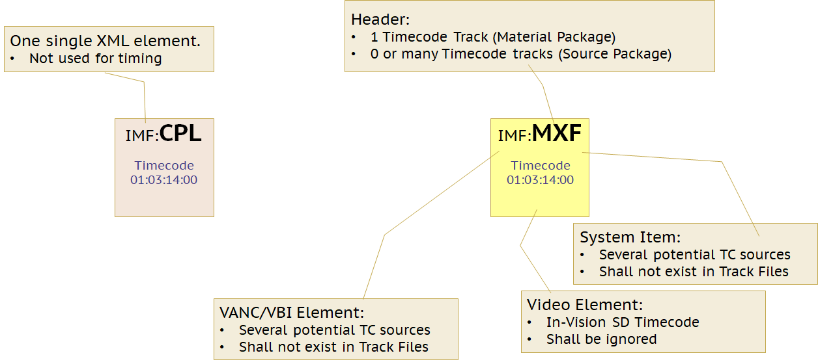

Figure 1 - Potential Timecode locations in an IMF CPL and in MXF Track Files

# Use Case: Creating a CPL

An IMF Composition Playlist[6] has the optional element: CompositionTimecode. This value can be used to generate a timecode stream when rendering the Composition into a system that requires timecode.

This value should be omitted from an IMF Composition Playlist, unless explicitly required by a delivery specification, which should specify its exact value.

This value has no impact on playback synchronization.

# Use Case: Creating an MXF Track File

## General

As shown in Figure 1 above, there are many places in which Timecode information may be stored. This use case covers the best practice for setting those values for best interoperability.

In general, no Timecode components, elements or samples should be present in MXF Track Files.

It is recognised that the default behaviour of many MXF applications is to expect or create at least a single Timecode Component in an MXF Material Package. This default behaviour should not be used when handling MXF Track Files.

In MXF Audio Track Files, the presence of timecode information is problematic at a system level.

An MXF Audio Track File is indexed, timed and synchronised using the audio sampling rate. This allows the Track File to be used, unaltered, in IMF compositions with different frame rates. When Timecode components are present in an MXF Audio Track File, there is a likelihood that the Timecode Rate may not match the IMF Composition's MainImageSequence frame rate. This is not an error because IMF does not use Timecode. It is, however surprising and leads to user confusion - especially when an IMF MainAudioSequence is made from several MXF Track Files having Timecode Components with differing Timecode Rates. The best solution is to omit all timecode information.

The sections below cover each storage location in an MXF Track File.

## MXF Track Files: Header: Material Package

IMF ignores the Material Package in MXF Track Files.

The Material Package should not contain any Timecode information.

## MXF Track Files: Header: Top Level Source Package

IMF uses the File Descriptor information in XML form in the CPL.

The Top Level Source Package should not contain any Timecode information.

## MXF Track Files: Essence: MXF System Item

IMF does not use the MXF System Item and does not use the SMPTE ST 405[7] System Scheme.

Track Files should not contain any MXF System Item and should not contain any SMPTE ST 405 System Scheme data.

## MXF Track Files: Essence: ST 436 VANC VBI Elements

The ST 436 VANC mechanism can be used for the carriage of legacy US captions in CDP Track Files.

CDP Track Files should contain only Caption Description Packets (CDPs) and should not contain any SMPTE ST 436-1[8] packets containing Timecode information.

## MXF Track Files: Essence: in-vision

IMF does not use in-vision timecode information.

SD sources with in-vision VBI data should be transcoded to an appropriate IMF Application, leaving only active pixels in the stored pixels (Stored Rectangle of Image Track Files).

# Use Case: Rendering a composition to a deliverable

Deliverables rendered from IMF compositions can require a timecode track. This value is often calculated based on the duration of a clock / leader inserted before the main content.

In general IMF compositions do not contain Timecode information, so the Timecode in rendered outputs is the subject of user/system settings and potentially a future OPL macro.

The behavior below gives the precedence for generating timecode for players and transcoders

1. User Override
2. System Timecode configuration
3. The CPL CompositionTimecode element

1. https://doi.org/10.5594/SMPTE.ST12-1.2014
2. https://wwww.imfug.com/
3. http://creativecommons.org/licenses/by-nd/4.0/
4. https://doi.org/10.5594/SMPTE.ST2067-5.2013
5. https://doi.org/10.5594/SMPTE.ST2067-2.2016
6. https://doi.org/10.5594/SMPTE.ST2067-3.2016
7. https://doi.org/10.5594/SMPTE.ST405.2006
8. https://doi.org/10.5594/SMPTE.ST436-1.2013