Packaging and Delivery

Best Practice

This Version: </link>

Latest Version: <link/>

# Scope

The objective is to craft a best practice for the creation of IMF packages and the use of the term supplemental in delivery.

# Document Status

This Draft Best Practice is published by the IMF User Group[1]. As a draft, it may be updated, replaced or deemed obsolete by other documents at any time. This document should not be cited as anything other than work in progress. This work is © 2019 Hollywood Professional Association and licensed under the Creative Commons Attribution-NoDerivatives 4.0 International License[2].

# Background

The current nomenclature pertinent to the packaging and delivery requirements of the Interoperable Master Format can lead to misinterpretation, confusion and present a number of challenges for service vendors and content owners who facilitate the mastering and version control of Composition Playlist instances and their respective assets.

The recommendations outlined in this document are intended to mitigate such confusion and act as an industry reference for the version control and business-to-business interchange of IMF packages and delivery of their contained and/or newly created Composition Playlist instances.

# 

# 4 Definitions

Below are some of the most commonly used terms and agreed upon definitions currently in use. There may be slight variances for day to day usage, but this list is provided to reduce confusion across multiple varying workflow creators and users.

**Branched**

A mastering workflow term used to describe the process of when a CPL’s playout order alternates its track file point of reference, be it to/from the initial track file or to another before referencing the initial once more.

**Complete Package**

An IMP whose Packing List references the complete set of assets which comprise one or more compositions.

**Componentised**

Content where each media track (audio, video, timed text, metadata) consists of a collection of one or more individual track files, each containing a single kind of media. The track files are assembled on the timeline of the content   by the CPL. Componentized content enables Branched methodology.

**Composition Package**

Assumes the same meaning as *Complete* *Package*.

**Consolidation**

A mastering workflow step where the resources of each virtual track within a Composition are merged, and the underlying assets are transwrapped, such that each Virtual Track of the resulting Composition references a single Resource.

**Consolidated Composition**

A Composition resulting from Consolidation.

**Differential Package**

Assumes the same meaning as *Supplemental Package*.

**Flattened Package**

Assumes the same meaning as *Consolidated Package*.

**Full Package**

Assumes the same meaning as *Complete Package*.

**Original Version**

Indicates the version originally created for distribution.

**Partial Package**

An IMP whose Packing List does not reference all assets referenced by the CPL. Missing assets might be available in another IMP in the same Delivery or in a future Delivery.

**Spot Reel**

Where a short section of a Composition timeline is replaced with a new supplemental asset to resolve a QC error.

**Supplemental**

An IMF Composition Content Kind element assigned to the CPL during its manufacturing to denote the type of viewing material the composition represents e.g. blooper reel, behind the scenes etc.

**Supplemental Package**

The process by which a Complete or Partial Package contains assets that are different from the original version with the purpose to enhance or complete it, with a CPL that adds references to the assets of the original version.

**Transwrap**

A term used to describe the process of re-wrapping essence from one MXF track file to another without any change occurring to said essence.

**Version File**

A Composition derived from an Original Version, where assets includes additional essence type that is different from that of the Original Version with an intended use for versioning e.g. Language Audio Mix, Timed Text Data, On-Screen Text inserts etc.

*NOTE: Version File does not apply to Packages or Deliveries.*

## 

## Appendix I

The following Use Case examples showcase the language defined in Section 1 applied to workflows used in the creation of IMF packages.

### A.1 Using IMF in Editorial Revisions & Assembly

When it comes to the creation of an original version, multiple revisions can be made to the respective essence types before being deemed final. Although, it is not the normal practice; IMF can be used as a mechanism to drive such a workflow. As outlined in **Figure 1**, you can see a partial package delivery of supplemental assets required to complete the sign-off of an Original Version Supplemental[3] Composition.

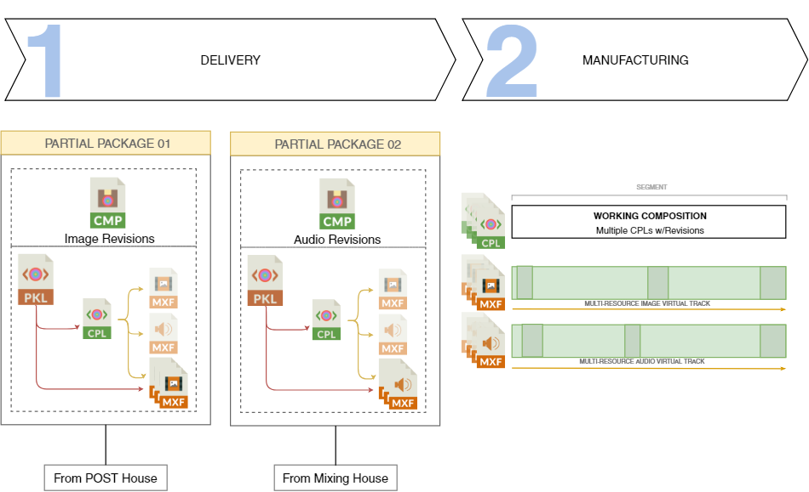

*Figure 1: Partial package delivery in the manufacturing of an OV.*

### A.2 Original Version (OV) Creation

Once deemed final, all OV essence revisions are consolidated with new track files, and a final CPL manufactured with the Supplemental Composition prepared for delivery as a Complete Package to the versioning house, as outlined in **Figure 2**.

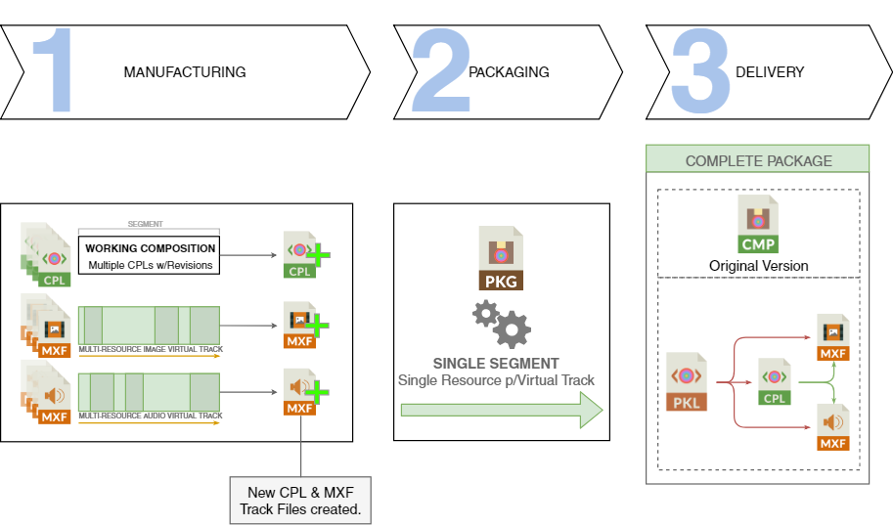

*Figure 2: OV Manufacturing as a Complete Package*

NOTE: *This use case is an example and intended for explanatory purposes only. Any workflow pertaining to the creation of an Original Version Composition is at the behest of the respective content owner.*

### 

### A.3 Supplemental Package creation

When it comes to versioning, the supplemental assets required to version against the Original Version can be delivered either as a Complete or Partial package. The most common being a Partial Package. This package only contains the differential assets to be used as supplements to the original assets of their equivalence for the purpose of versioning into a different language or edit. **Figure 3** shows an example of this. Such assets can often be prepared by a servicing vendor different from that of the versioning house.

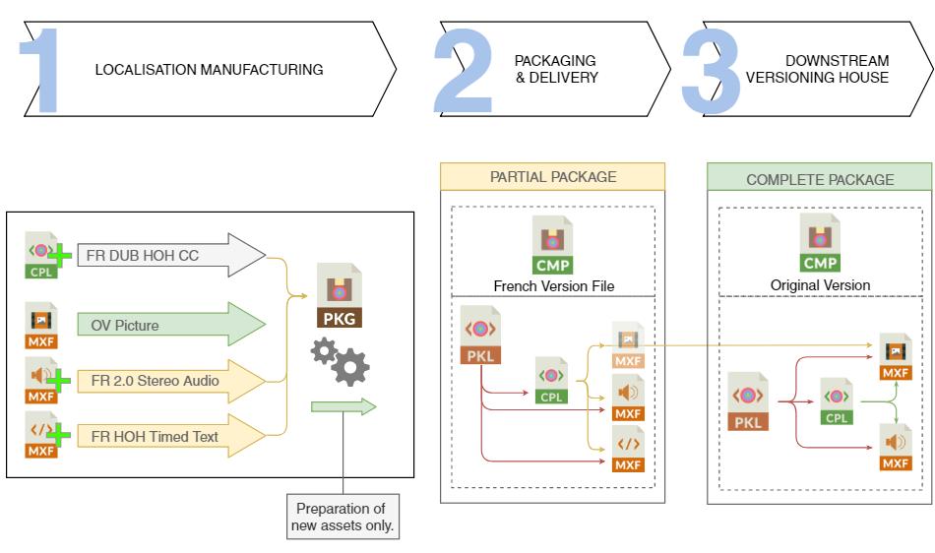

*Figure 3: Partial Supplemental deliverables of Version Files.*

NOTE: *This use case is an example and intended for explanatory purposes only. Any workflow pertaining to the creation of a Version File Composition is at the behest of the respective content owner and/or servicing parties involved.*

1. IMF User group <http://www.imfug.com>
2. Creative Commons <https://creativecommons.org/licenses/by-nd/4.0/>
3. Composition Content Kind - Table 4, Section 6.1.8: [st2067-3:2020](https://doi.org/10.5594/SMPTE.ST2067-3.2020)