Visitor Management System Documentation

1. Introduction
Purpose of the Document
This document provides a comprehensive guide on how to use the Visitor Management System, including its features, user roles, and installation instructions.

System Overview
The Visitor Management System is a Python Django-based web application designed to streamline the visitor registration process. It offers features such as visitor recording, check-in/check-out using RFID cards, user authentication, notifications, and comprehensive activity logging.

Key Features
User Authentication: Secure registration and login processes.
Visitor Recording: Capturing visitor details efficiently.
Waiting List Management: Monitoring and managing recorded visitors.
RFID Card Integration: Streamlined check-in/check-out using RFID cards.
Multiple User Roles: Four user types with distinct permissions.
Activity Logging: Comprehensive records of all system actions.
Notifications: Keeping employees informed.
2. Getting Started
Before you can use the Visitor Management System, make sure your system meets the following prerequisites:
Web Browser: Any modern web browser (e.g., Chrome, Firefox).
Python 3.x: The system is built on Python, so ensure you have a compatible version installed.
Django: This web framework is used for development.
Database System: You'll need a database system like PostgreSQL, SqLite3, etc...
RFID Card Reader: If you plan to use RFID cards for check-in.
2D Barcode Reader: for scanning National ID
Installation
To install and set up the Visitor Management System, follow these steps:
Create a Python Virtual Environment
Open your terminal or command prompt and enter the following command to create a Python virtual environment:
python -m venv vms_env # Replace 'vms_env' with the name you prefer for your environment.

Activate the Virtual Environment
Activate the virtual environment using the appropriate command for your operating system:
Windows:
vms_env\Scripts\activate
macOS and Linux:
source vms_env/bin/activate
After activation, you will see the name of your environment in your terminal, indicating that you are now working within the virtual environment.
Navigate to the Project Directory
Change your current directory to the project directory 'gate1':
cd gate1
Install Dependencies
Install the necessary Python dependencies from the 'requirements.txt' file using pip:
pip install -r requirements.txt.
This command will download and install all the required packages.
Running the Project
Once the installation is complete, you can start the Visitor Management System by running the following command:
python manage.py runserver
This command will launch the development server, and you can access the system through a web browser by navigating to http://localhost:8000/ or the appropriate URL provided by Django.
Ensure that you keep the virtual environment activated while working on the project.

3. User Roles and Permissions
The system has four user roles:
Employee: Limited access, mainly for future use with email notifications.
Security Officer: Records visitors, approves them in the waiting list, and handles check-outs.
Supervisor: Monitors system activity and logs.
Admin: Full control over the system, including user management and settings.
User Authentication
Users can login and Signup. Once logged in the users see different things depending on their roles and permissions.
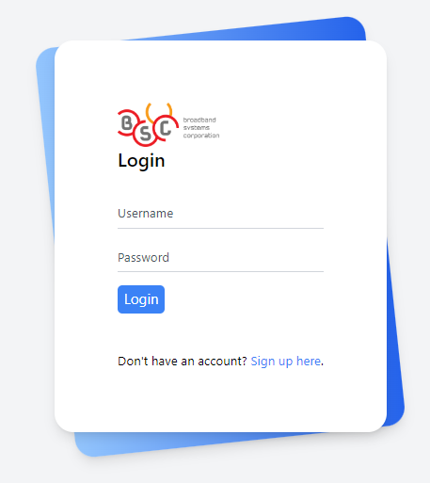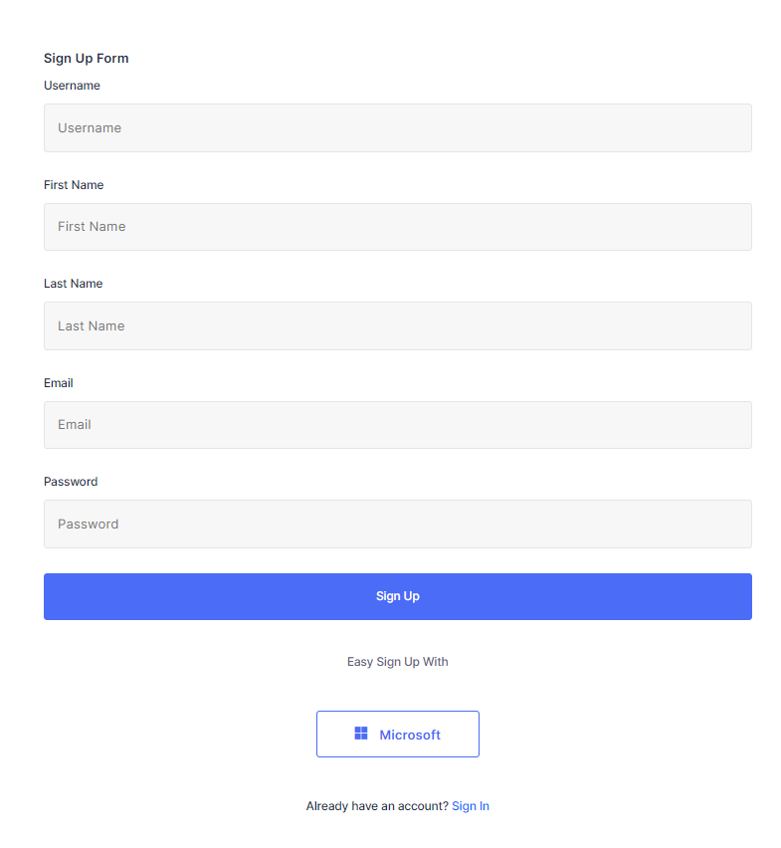
Recording a Visitor
Once logged in, users can record visitors by providing their details.

Visitor Waiting List
All recorded visitors appear in the waiting list, where you can verify and manage their information. In the waiting list you can be able to approve or delete visitors, add the purpose for their visit and be able to add the devices they have if there is any.
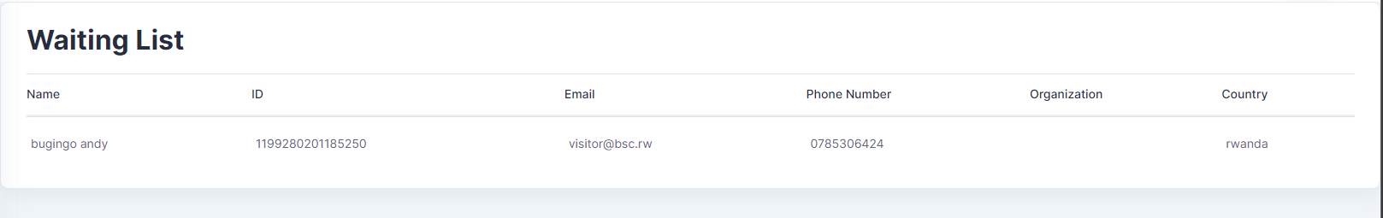

Visitor Details Page
Clicking on a specific visitor allows you to:
- Add the purpose of their visit.
- Specify the person they are visiting.
- Record the devices they have.
- Add comments if needed.
- Check them in using an RFID card.
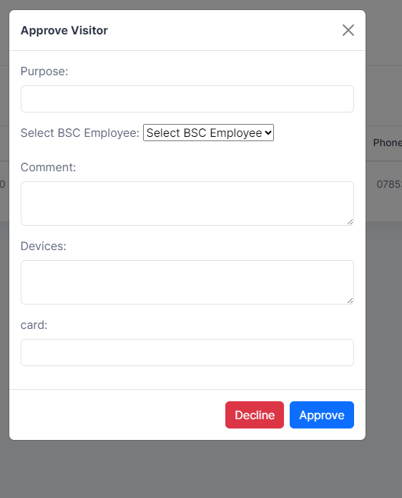
RFID Card Check-in
Visitors can be checked in swiftly using RFID cards. The system is designed for efficiency.
Checkout Options
There are two checkout options:
Manual Checkout: Click the "Checkout" button for a specific visitor.
RFID Card Checkout: Use the blue "Checkout" button in the top-right corner for quick RFID card check-out.

5. User Types and Access
Employee
Employees are currently registered for future use and will receive email notifications for incoming visitors.
Security Officer
Security officers are responsible for recording, approving, and checking out visitors.
Supervisor
Supervisors have a read-only view of system movements and logs. They can monitor actions taken by users.
Admin
Administrators have complete control over the system. They can manage users and configure system settings.

6. Notifications
Employees receive email notifications when visitors are scheduled to arrive.

7. Logs and Reporting
The system maintains detailed logs, recording actions and the users who performed them. You can access and review these logs for accountability.

8. System Administration
Administrators can access the admin dashboard to manage users and configure system settings as needed.

