Required Information for
Customizing Linkus Desktop Client

Updated Date: Oct 10, 2024

App Name
Please fill in the name of the Desktop Client: __________

Important: If you want to customize both the Linkus Mobile Client and Linkus Desktop Client, it is crucial to ensure that the app name remains consistent. For instance, if the mobile client is named "AppName Mobile Client," the desktop client must be named "AppName Desktop Client."
To better display on the mobile phone, mobile app name usually only use "AppName" without suffix.

App Logo

2.1 General Logo
The general logo will be used for all logo positions in Desktop Client. Below is an example of Linkus.
(Please note that Apple will automatically cut your logo to rounded corner, if need to keep Android system icon consistent with iOS, you need to cut the rounded corner by yourself then provide to us.)



The logo images are required in various formats and resolutions. Please follow the requirements below to provide the images.
File format | Image Size | Please name the file as follows
.png  (The PNG file should have a resolution of 72 pixels.) | 16x16px | General_Logo_16x16
.png  (The PNG file should have a resolution of 72 pixels.) | 24x24px | General_Logo_24x24
.png  (The PNG file should have a resolution of 72 pixels.) | 28x28px | General_Logo_28x28
.png  (The PNG file should have a resolution of 72 pixels.) | 32x32px | General_Logo_32x32
.png  (The PNG file should have a resolution of 72 pixels.) | 48x48px | General_Logo_48x48
.png  (The PNG file should have a resolution of 72 pixels.) | 64x64px | General_Logo_64x64
.png  (The PNG file should have a resolution of 72 pixels.) | 96x96px | General_Logo_96x96
.png  (The PNG file should have a resolution of 72 pixels.) | 128x128px | General_Logo_128x128
.png  (The PNG file should have a resolution of 72 pixels.) | 256x256px | General_Logo_256x256
.png  (The PNG file should have a resolution of 72 pixels.) | 512x512px | General_Logo_512x512
.png  (The PNG file should have a resolution of 72 pixels.) | 1024x1024px | General_Logo_1024x1024
.icns | 1024x1024px | General_Logo_1024x1024
.ico | 256x256px | General_Logo_256x256

Note: When converting the .png image to a .icns file, please ensure that it includes 8%-9% reserved transparent space. This will result in an improved display of desktop icons. Also, only the .icns files require reserved transparent space, other .png and .ico images do not need it.

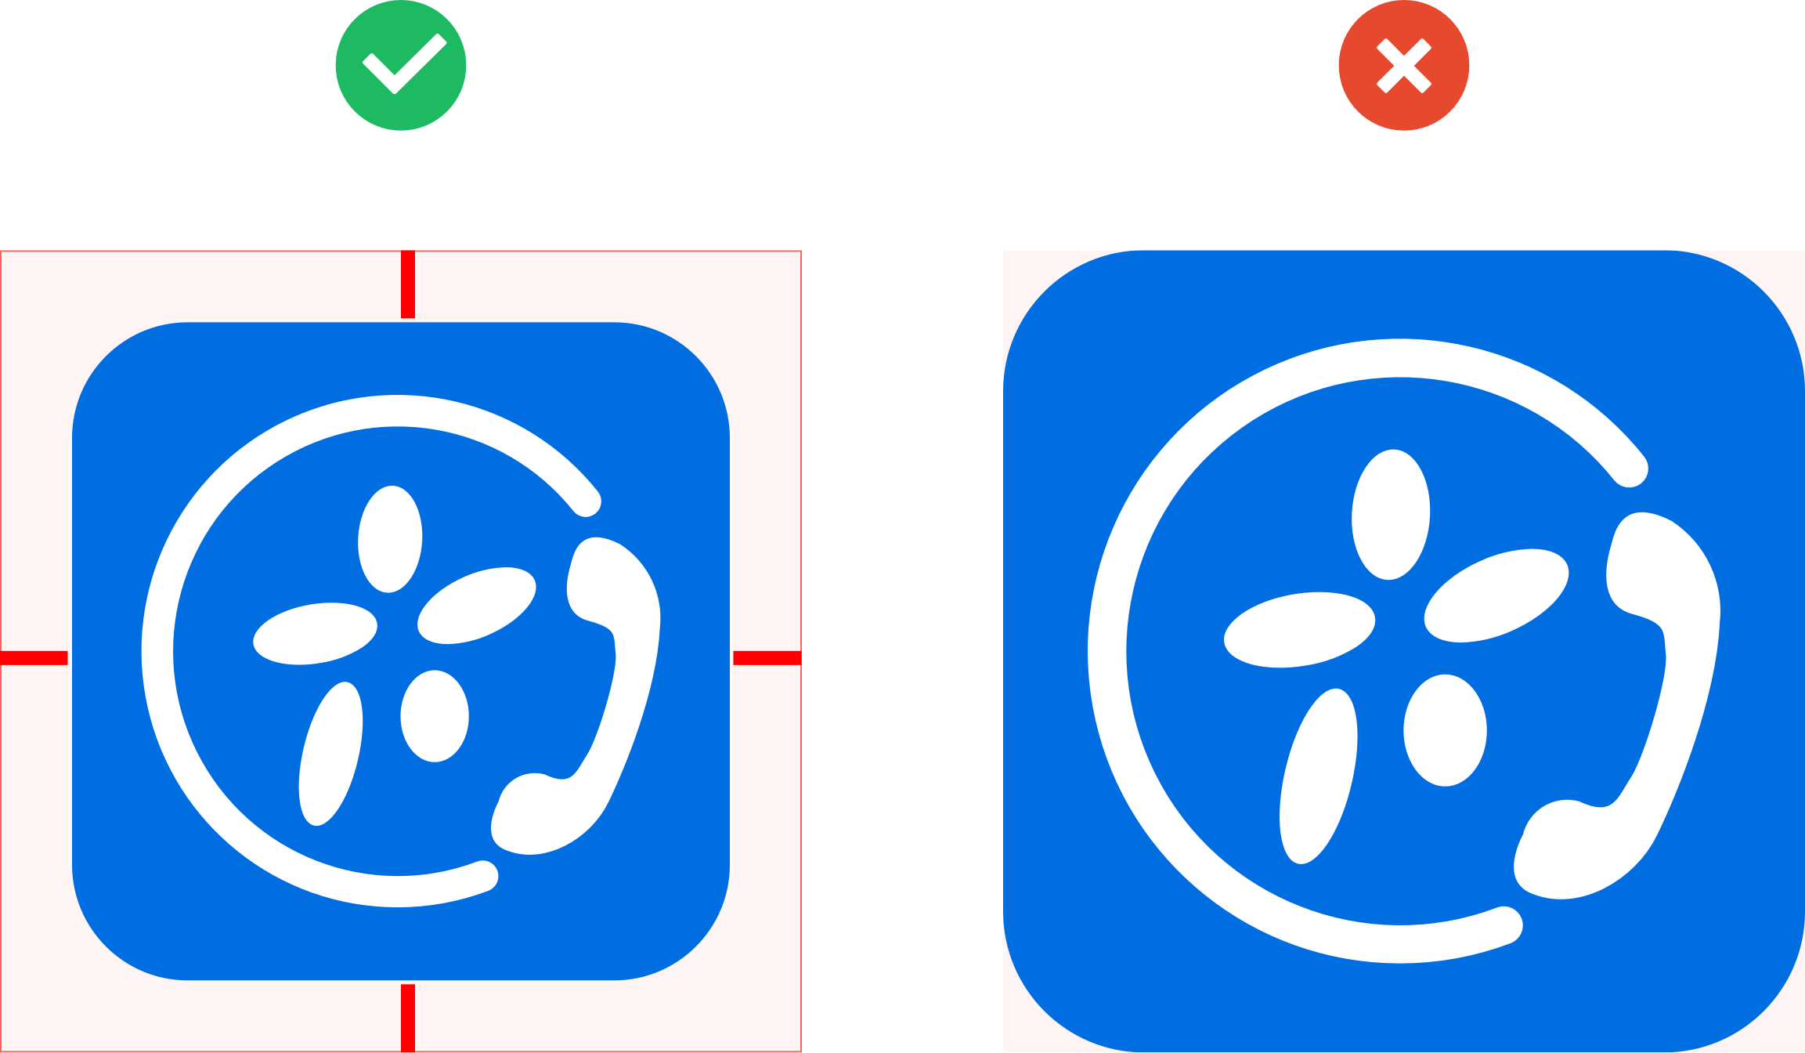

Final display result:

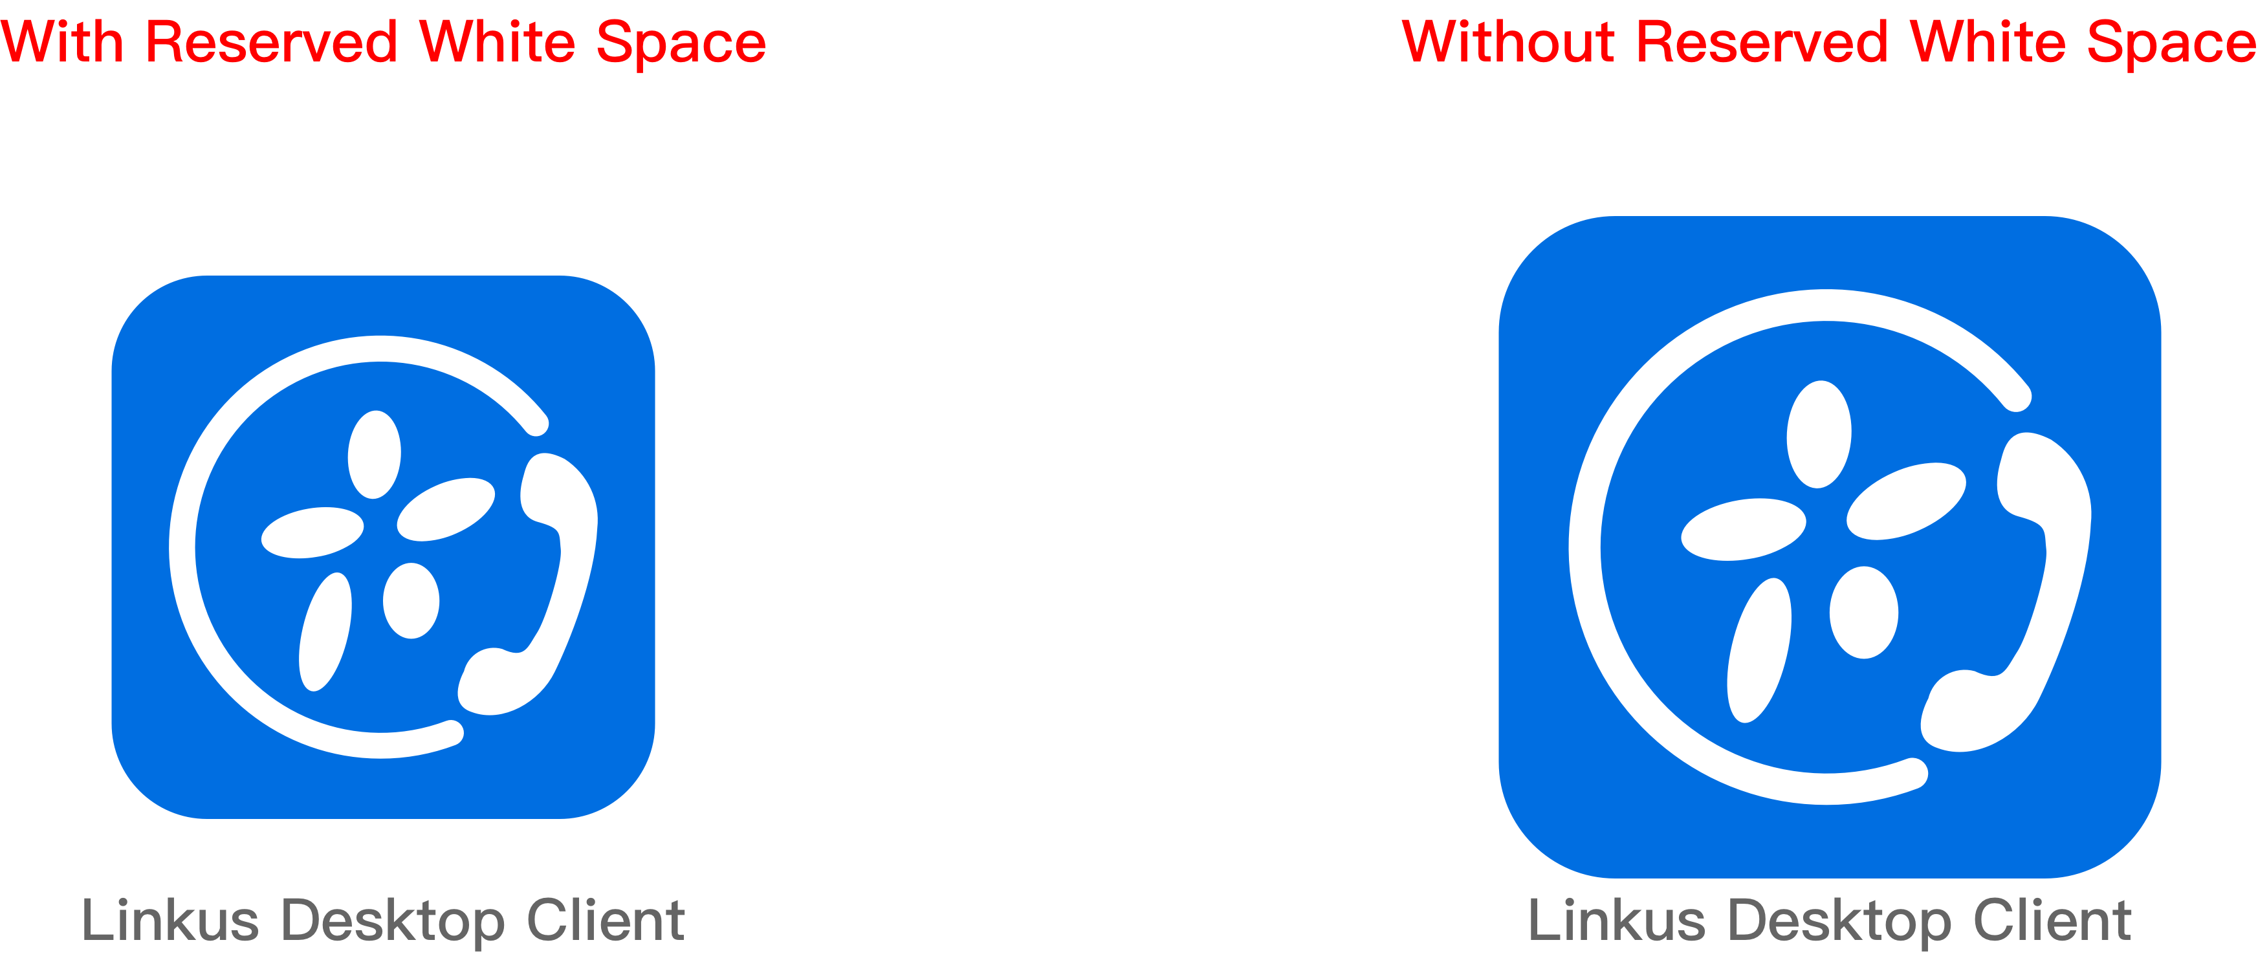

2.2 Black Logo
The black logo is used for the light mode of macOS. Below is an example of Linkus.


The logo images are required in the PNG format of different sizes. Please follow the requirements below to provide the images.
File format | Image Size | Please name the file as follows | Resolution
.png | 19x19px | Black_Logo_19x19 | 72 Pixels
.png | 38x38px | Black_Logo_38x38 | 72 Pixels

2.3 White Logo
The white logo is used for the dark/night mode of macOS. The logo graphic needs to be filled with white. Below is an example of Linkus.


The logo images are required in the PNG format of different sizes. Please follow the requirements below to provide the images.
File format | Image Size | Please name the file as follows | Resolution
.png | 19x19px | White_Logo_19x19 | 72 Pixels
.png | 38x38px | White_Logo_38x38 | 72 Pixels

The Login Page’s Illustration
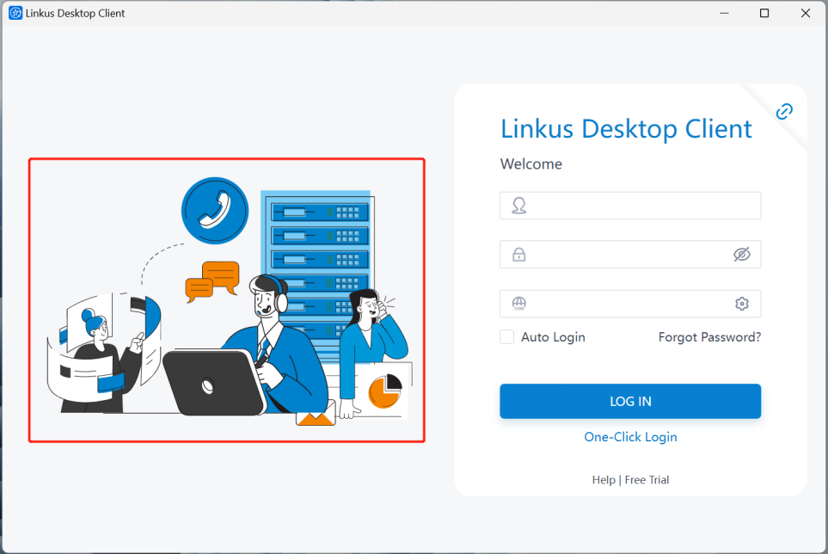
Would you like to change the illustration displayed on the left side of the login page?
- Keep the default illustration.
- Please replace it with my own illustration.
Enter your answer: __________

If you choose B, please provide the illustration file according to the following requirements:
File format | Image Size | File size | Please name the file as follows
.svg | 518x460px | Less than 100k | Illustration

Copyright Information
Please enter the copyright information to be displayed on the "About" page: ________________
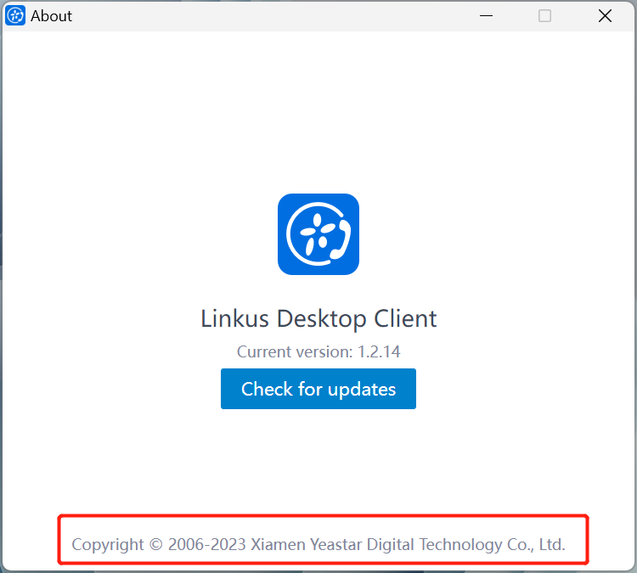

Help & Free Trial Button
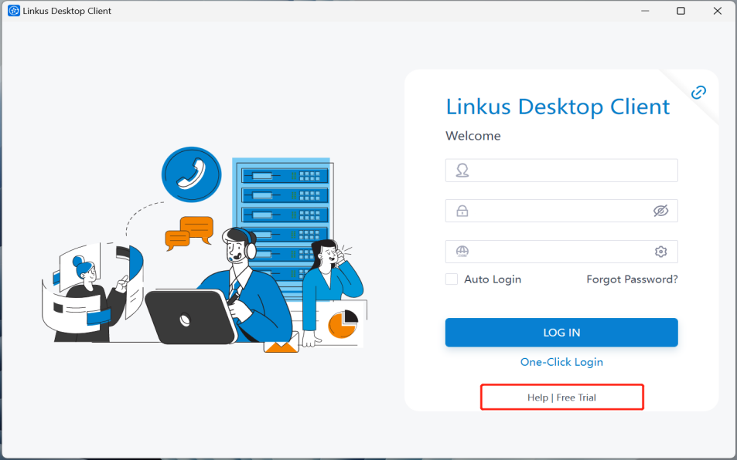
Would you like to replace the links for the Help and Free Trial buttons displayed on the login page?
- Don't show it, please remove it.
- Only keep the “Help” button and replace it with my link.
- Only keep the “Free Trial” button and replace it with my link.
- Keep both the “Help” and “Free Trial” buttons and replace them with my links.
Enter your answer: __________
(If you choose B, C, or D, please also share the respective links below.)

Link for the Help button: ____________________
Link for the Free Trial button: ____________________

Purpose:
1. “Help” button：
Provide Desktop user manuals or support channels for customers to seek guidance or help.
Please provide the corresponding entry link here. If you do not offer this service, please remove this button.
Below is an example link used by Yeastar:
https://help.yeastar.com/en/p-series-linkus-appliance-edition/index.html
2.“Free Trial” button：
Offer your customers a free trial service with the option to apply here. If you do not offer this service, please remove this button.
Below is an example link used by Yeastar:
https://www.yeastar.com/cloud-pbx-free-trial/

Outlook Integration
A. Please enter the desired name for the Outlook add-in: _____________
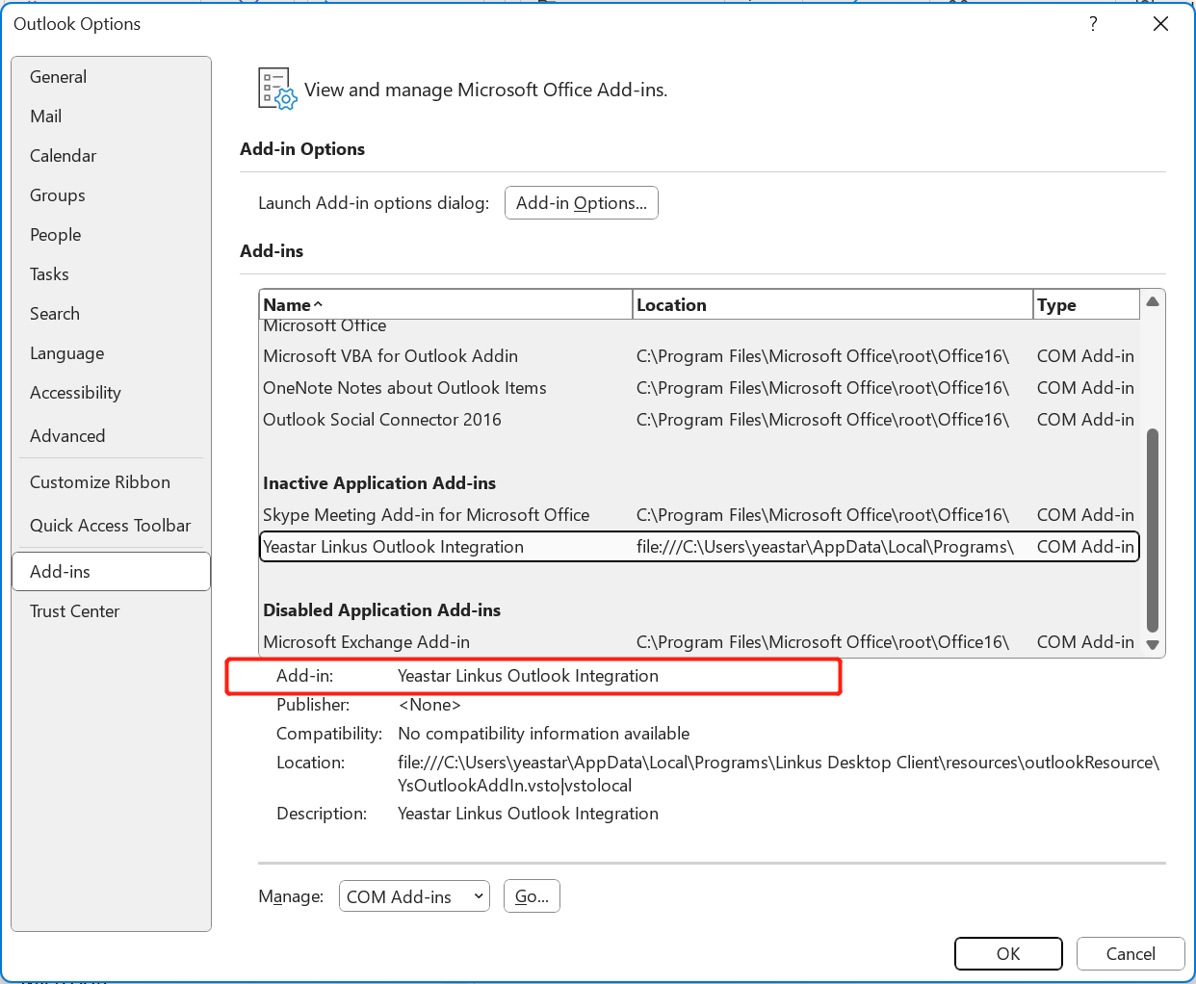
B. Please enter the desired button name for click-to-call initiation attempts: ___________
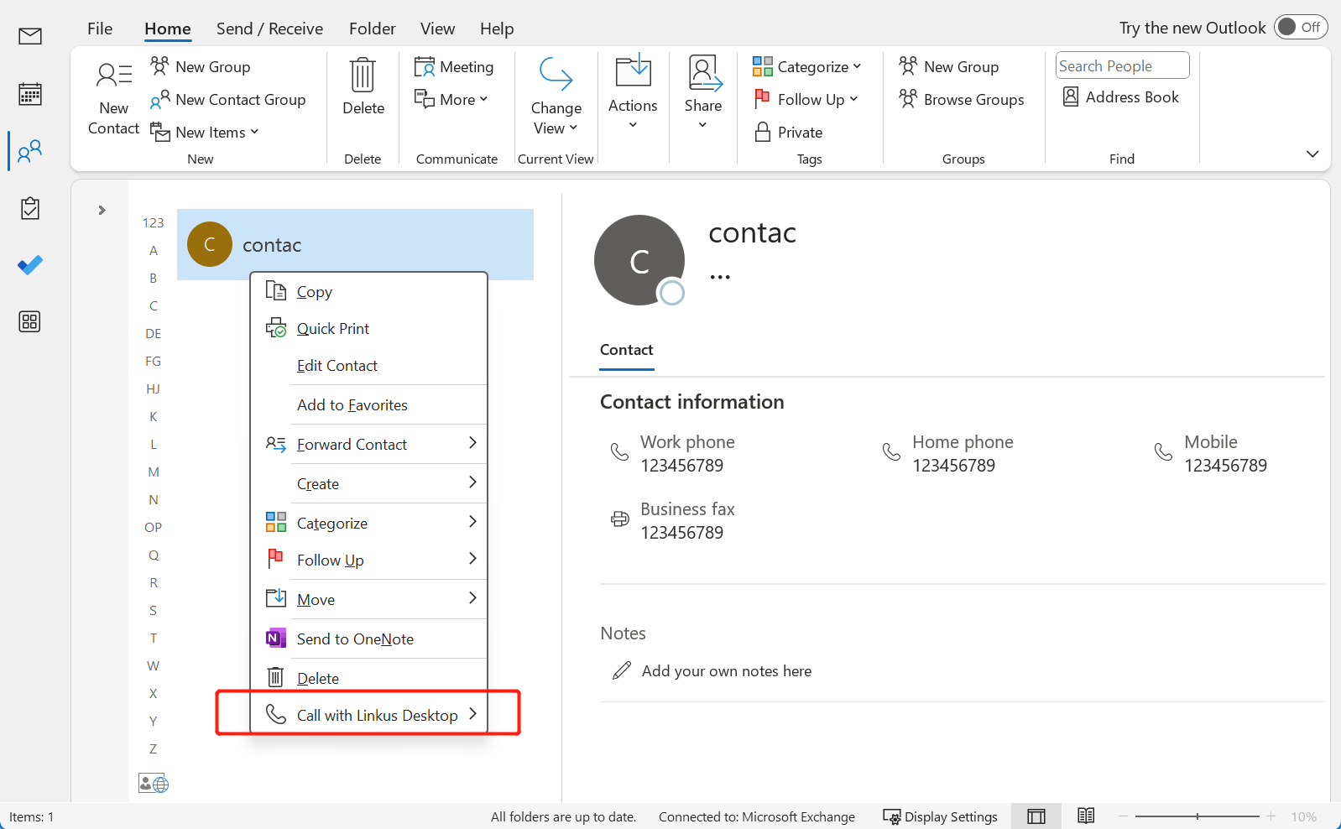

TAPI Integration
Please specify the name for the TAPI Integration: _____________
This name will be used in the Desktop Client interface, TAPI integration driver installation package, and during the installation of the TAPI integration driver.
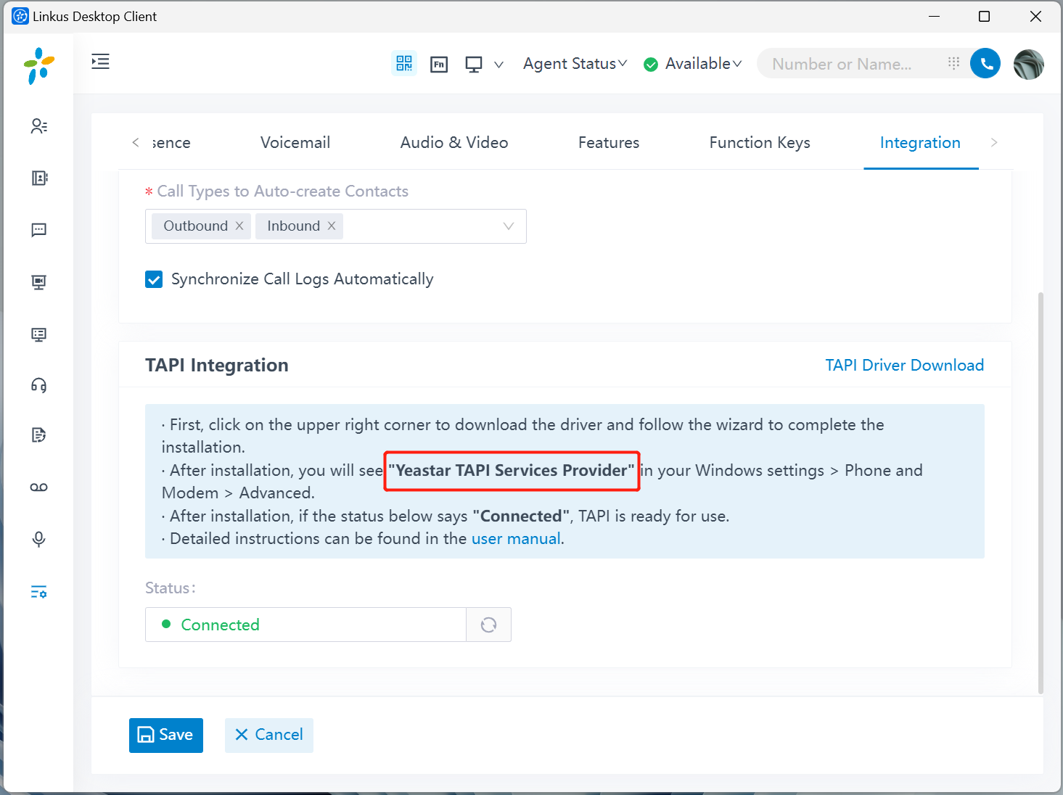
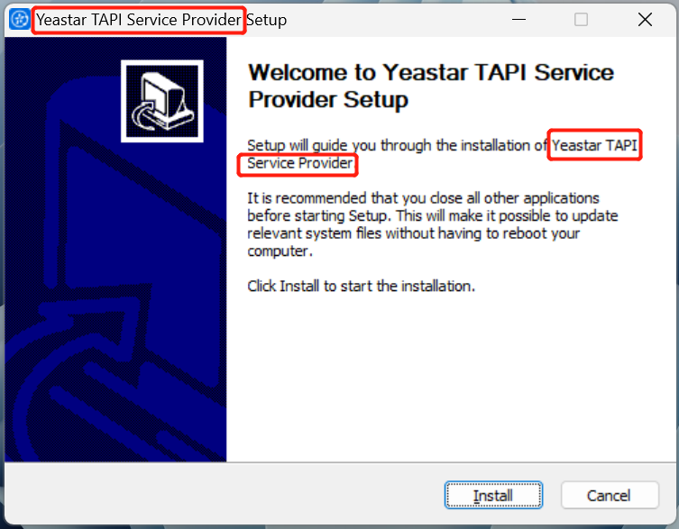

Security Verification of Desktop Client
In order to solve the security verification and error reporting issues of anti-virus software and computer systems, you need to prepare the following:
8.1 For macOS
You need to prepare an Apple developer account and provide certain information to Yeastar, and our R&D team will complete the App notarization process for you. Only when the notarization is completed, the macOS system will identify that your App is safe.
Please refer to the document “Required Information for Notarizing MacOS System App” for details on the information needed and how to obtain it.
If you don’t mind, can share Yeastar your login credentials of your apple developer account and schedule to provide us the 2FA code so we can help.
8.2 For Windows
How would like to provide the digital signature certificate for the Desktop Client on Windows?
- Use Yeastar’s digital signature certificate.
- Provide your own digital signature certificate.
Enter your answer: __________
(If you choose B, please follow the steps below to prepare your certificate.)
Note: Right-click the .exe format Desktop Client installation package, then go to Properties > Digital Signature. From there, you can see the subject of the digital signature certificate.
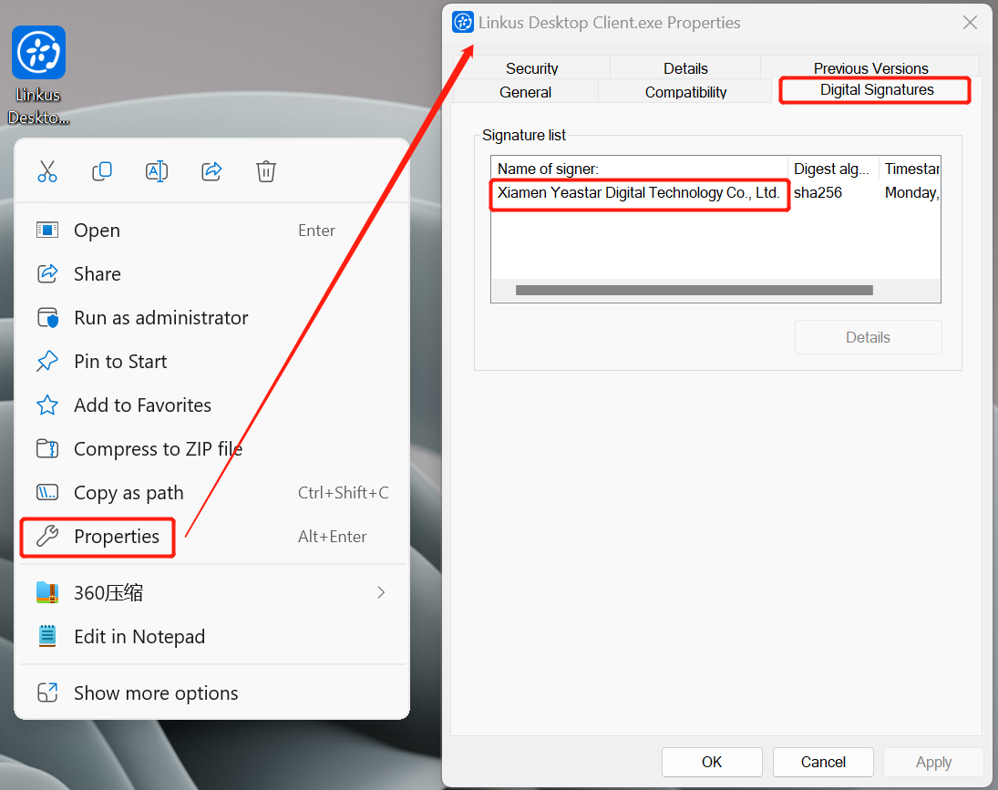
The TAPI integration driver uses the same digital signature certificate as the Desktop Client. Right-click the .exe format TAPI integration driver installation package, then go to Properties > Digital Signature. From there, you can see the subject of the digital signature certificate.
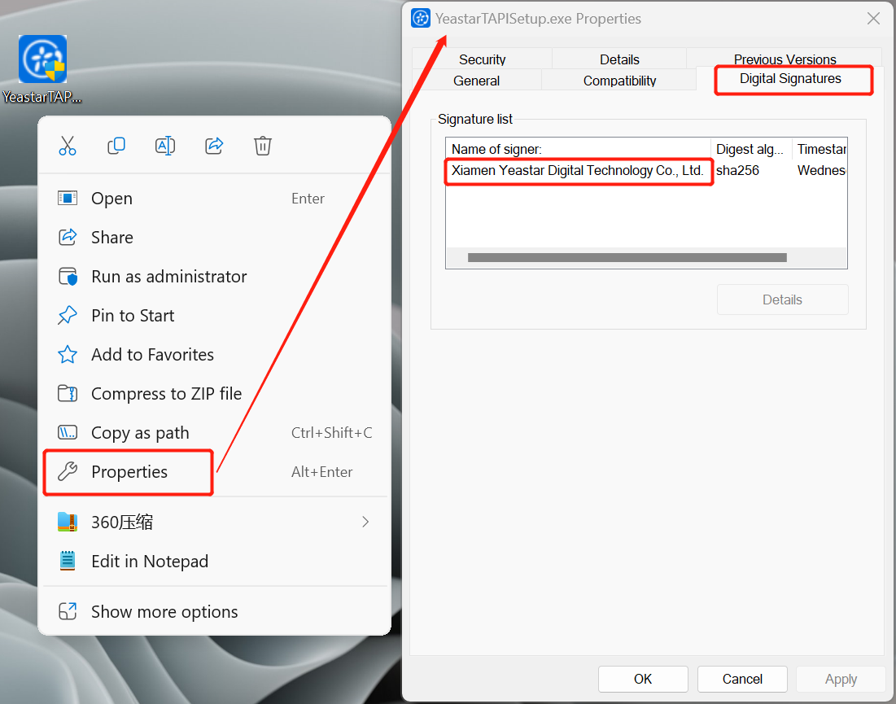

If need to use your own digital signature cert:
First, you need to purchase a EV code signing certificate. With this certificate, the Windows system and anti-virus software will identify that your App is safe.
Cause the code signing tool are vary from different cert provider, in order to save the development time of your customized app, we highly recommend you purchase the cert from Sectigo:
https://www.sectigo.com/ssl-certificates-tls/code-signing
Cert from different provider will cost more development time cause our developer need to do research for the different code signing tool and further test.

Next, after purchasing the code signing certificate, you need to mail the USB flash drive to Yeastar and provide the key password of the USB flash drive. During the code signing process, the contents of the USB flash drive need to be accessed multiple times.

Publisher Name
Please fill in the publisher name of the Desktop Client: ________________
Note: The publisher name will be displayed in the position indicated below as users uninstall the app.
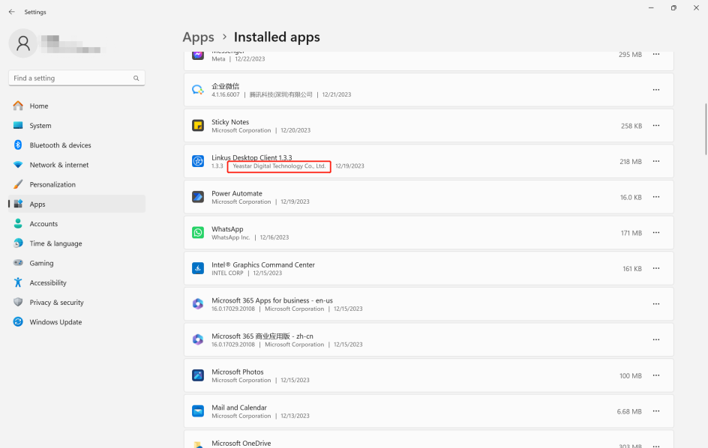

Additional Information
If you have any other special requests, please let us know in this session.

[END]

