Required Information for the ODM of
Linkus with P-Series PBX

Date: 2024.10.31

General Information
Items | Default | Substitution | Note
APP ID | com.yeastar.linkus | Please input here. | This ID will be the unique ID in APP Store or Google Play. (Suggested format: com.domainname.appname)
APP Name | Linkus | Please input here. | This name will be shown under APP icon on the OS Home Screen and push notifications. (Recommended length for App name: no more than 12 characters)
APP Logo | 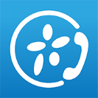 | We need the logo with high resolution:1024*1024  Please name it ‘App Logo’ and send the files as attachments. | This information will be used as APP icon on the OS Home Screen, and will be used for pushing notifications.
Copyright Information | Copyright © 2006-2024 Yeastar Information Technology Co., Ltd. All Rights Reserved. | Please input here. | This information will be shown in the launch page.  (Suggested format:  Copyright © xxxx-2024 YourCompanyName. All Rights Reserved.)
Company Name | Yeastar | Please input here. | This information will be shown in the launch page.
Company Logo |  | Please send your high-resolution logo as an attachment and input the name of the file in this place.
Upload to  App Store | YES OR NO | Please inform if you will upload the APP to App Store. | To upload the APP to the App Store or Google Play, you will need to apply for a platform developer account and upload the APP by yourself. Yeastar doesn’t provide the App upload service.
Upload to Google Play | YES OR NO | Please inform if you will upload the APP to Google Play
Dark Mode | YES OR NO | Please review the image requirements in the document. | For dark mode support, please follow these guidelines:  iOS: Rename files with a “-1” suffix for dark mode adaptation.  Android: Provide dark mode compatible designs for all components, except the Home Screen module. Use filenames consistent with the light mode designs.  To ensure icons are clear in dark mode, please don't use dark elements for dark mode.
Other Images |  | Please read the image requirements in this document. | 1. Image resolution: 72 PPI  2. Image name should be consistent with our requirements

Home Screen
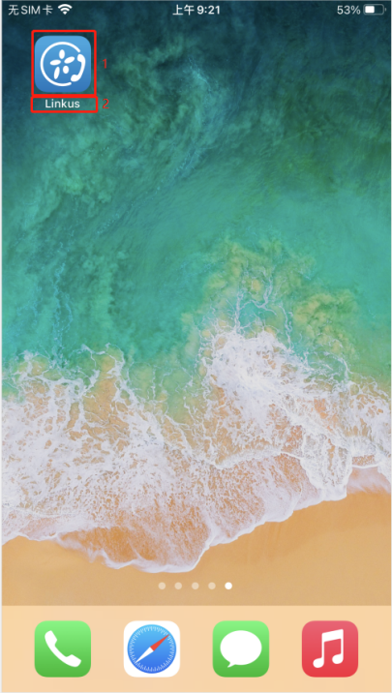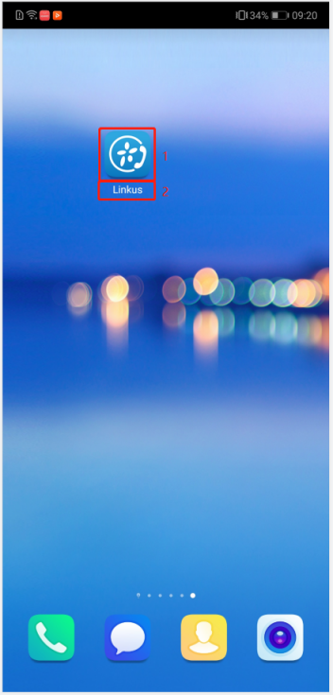
Example:
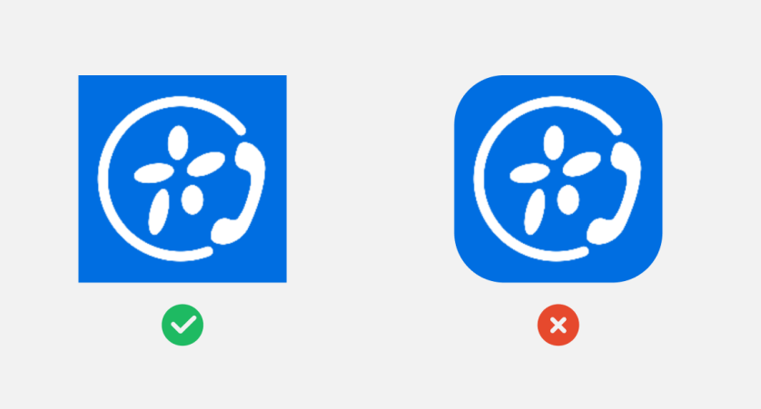
Specific Requirement: Square, padding on all sides, no transparent background, no rounded corners.
Apple Official Requirement：https://developer.apple.com/design/human-interface-guidelines/app-icons
Google Official Requirement：
https://developer.android.com/distribute/google-play/resources/icon-design-specifications

- APP Logo:
Please send the images of home screen as attachments.
Different operating systems have specific size requirements, as outlined below.
File format | Please name the icons as follow | Size | Resolution
.png | ic_launcher50x50 | 50*50 | 72 Pixels
.png | ic_launcher72x72 | 72*72 | 72 Pixels
.png | ic_launcher100x100 | 100*100 | 72 Pixels
.png | ic_launcher144x144 | 144*144 | 72 Pixels
For Android:

For IOS:
File format | Please name the icons as follow | Size | Resolution
.png | AppIcon20x20@2x | 40*40 | 72 Pixels
.png | AppIcon29x29@2x | 58*58 | 72 Pixels
.png | AppIcon20x20@3x | 60*60 | 72 Pixels
.png | AppIcon40x40@2x | 80*80 | 72 Pixels
.png | AppIcon29x29@3x | 87*87 | 72 Pixels
.png | AppIcon40x40@3x | 120*120 | 72 Pixels
.png | AppIcon60x60@3x | 180*180 | 72 Pixels
.png | AppIcon1024x1024 | 1024*1024 | 72 Pixels

- APP Name:
We will use the APP name which required in the General Information.

Languages
Linkus supports Chinese and English. By default, Linkus will set language according to the mobile phone system language. If the phone system language is not supported by Linkus, Linkus will use English.
You have 2 options:
- Use the default settings.
- Add a new language. Please note that you are required to translate the language files if you choose this option.
Which option do you choose? –>________________

Launch Page
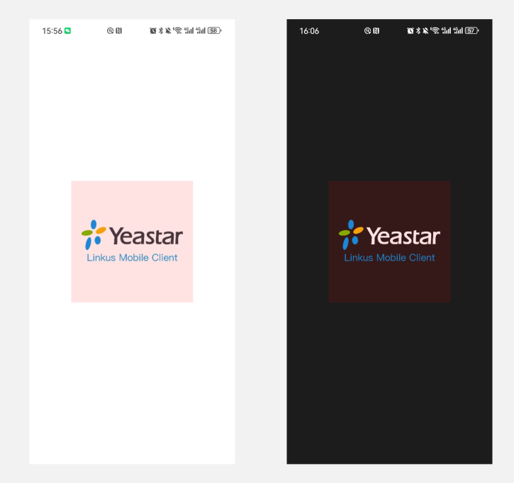

Please send the image/icon to appear on the launch page as attachments.
Different operating systems have specific size requirements, as outlined below.
For iOS:
File format | Mode | Please name the images as follow | Size | Resolution
.png | Light | LaunchScreen@2x | 320x320 | 72 Pixels
.png | Dark | LaunchScreen@2x-1 | 320x320 | 72 Pixels
.png | Light | LaunchScreen@3x | 480x480 | 72 Pixels
.png | Dark | LaunchScreen@3x-1 | 480x480 | 72 Pixels

For Android:
File format | Mode | Please name the images as follow | Size | Resolution
.png | Light | icon_splash 480x480 | 480*480 | 72 Pixels
.png | Dark | dark_icon_splash 480x480 | 480*480 | 72 Pixels

Login Page
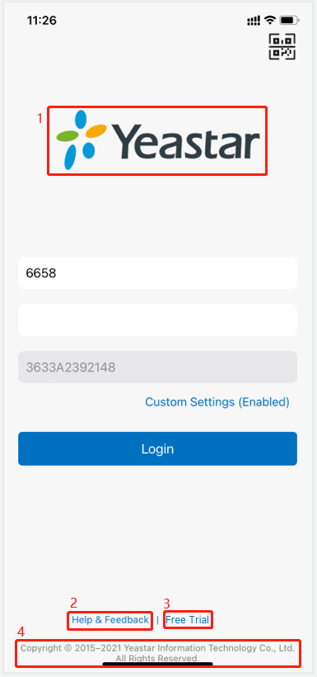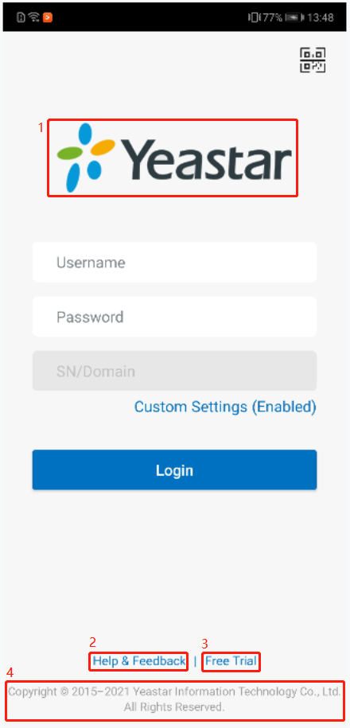

- Login Page image:
Please send the image/icon to appear on the login pages as attachments.
Different operating systems have specific size requirements, as outlined below.
For iOS:
File format | Mode | Please name the images as follow | Size | Resolution
.png | Light | LoginLogo@2x | 470*140 | 72 Pixels
.png | Dark | LoginLogo@2x-1 | 470*140 | 72 Pixels
.png | Light | LoginLogo@3x | 705*210 | 72 Pixels
.png | Dark | LoginLogo@3x-1 | 705*210 | 72 Pixels

For Android:
File format | Mode | Please name the images as follow | Size | Resolution
.png | Light | login_icon425x127 | 425*127 | 72 Pixels
.png | Dark | dark_login_icon425x127 | 425*127 | 72 Pixels

- Help & Feedback:
Do you want to remain it?
- Yes, I want to remain it. Please enter your Help & Feedback link here: ________
- No. We will remove it. Then we will not be able to troubleshoot the issues occurred.
- Free Trial (For Android Only):
Do you want to remain it?
A. Yes, I want to remain it. Please enter your Free Trial link here:
B. No. We will remove it.
Note: the iOS version does not support Free Trial.
- Copyright information:
We will use the copyright information which required in the General Information.

About
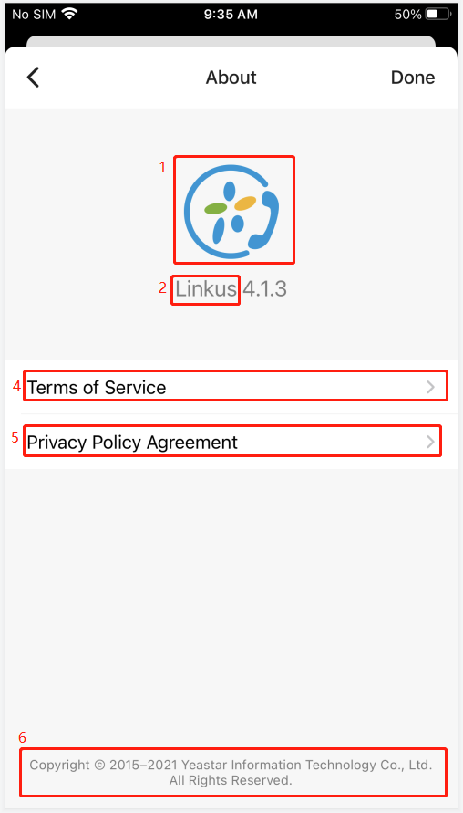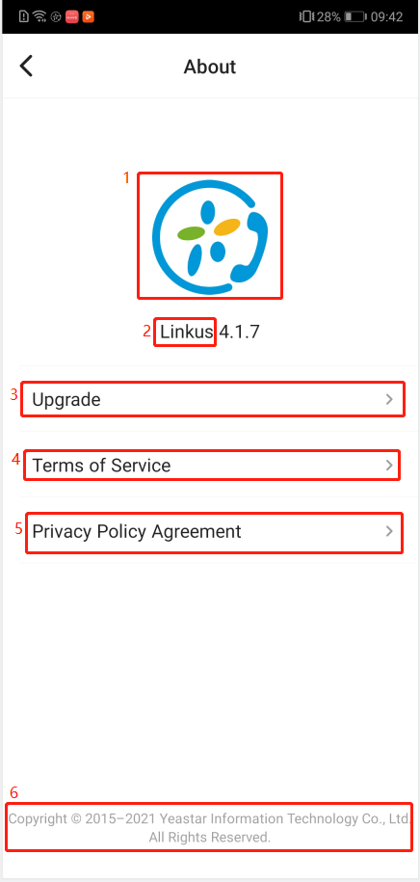

- About Logo:
Please send the icons of the about logo as attachments.
Different operating systems have specific size requirements, as outlined below.
For iOS:
File format | Mode | Please name the icons as follow | Size | Resolution
.png | Light | AboutLogo@2x | 180*180 | 72 Pixels
.png | Dark | AboutLogo@2x-1 | 180*180 | 72 Pixels
.png | Light | AboutLogo@3x | 270*270 | 72 Pixels
.png | Dark | AboutLogo@3x-1 | 270*270 | 72 Pixels

For Android:
File format | Mode | Please name the icon as follow | Size | Resolution
.png | Light | about_icon438x438 | 438*438 | 72 Pixels
.png | Dark | dark_about_icon438x438 | 438*438 | 72 Pixels

- APP Name:
We will use the APP Name which required in the General Information.
- Upgrade:
We will remove Upgrade from Android App.
- Terms of Service of Linkus:
Do you want to remain it?
A. Yes, I want to remain it. Please enter your Linkus Terms of Service link here:
B. No. We will remove it.
- Privacy Policy Agreement:
Linkus will synchronize the PBX’s Privacy Policy Agreement.
- Copyright information:
We will use the copyright information which required in the General Information.

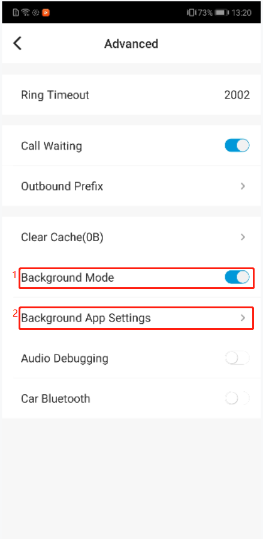
Advanced (For Android Only)

- Background Mode:
We will remove the Background Mode setting option.
- Background App Settings:
We will remove the Background App Settings option.

Call Kit (For iOS Only)
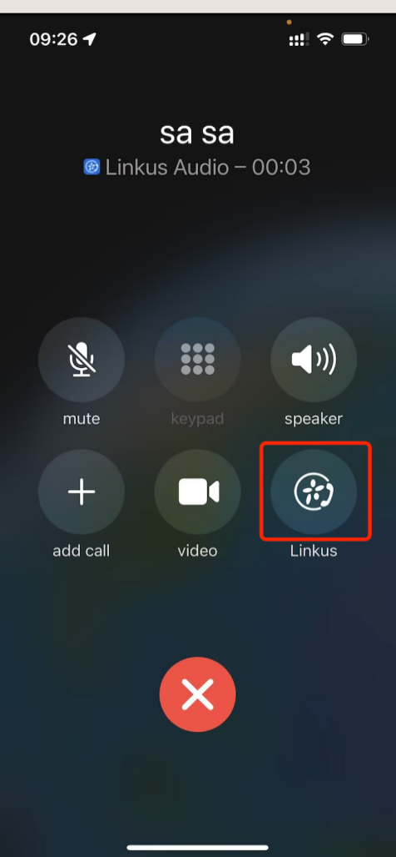
Example:
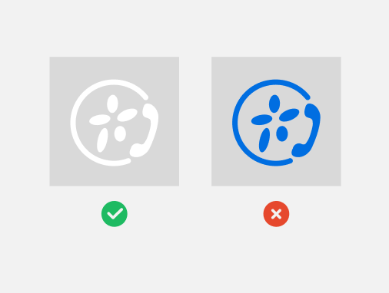
Specific Requirement: PNG format, Reverse-white.
The App Icon to Display on the Mobile Phone System's Call Interface.
Please send the App icon to display on the mobile phone system's call interface as attachments.
We need the icons with different size. The requirements are:

For iOS:
File format | Please name the icons as follow | Size | Resolution
.png | AppCallMaskIcon@2x | 80*80 | 72 Pixels
.png | AppCallMaskIcon@3x | 120*120 | 72 Pixels

Notification (For Android Only)
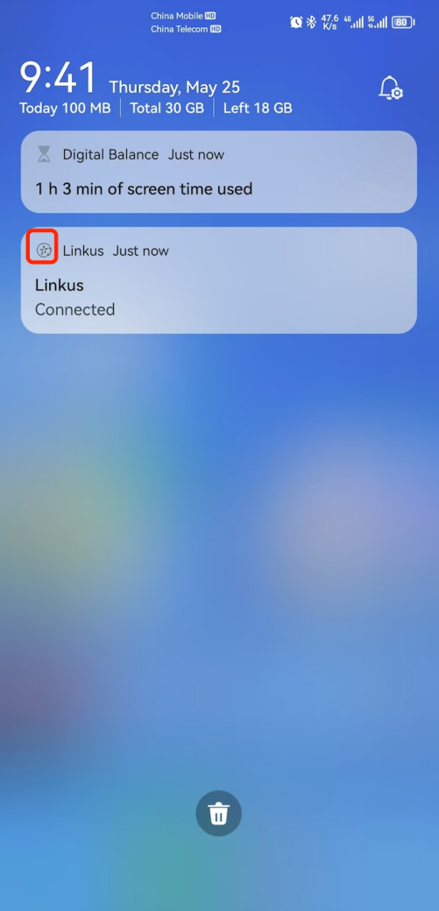

示例：
Specific Requirement: PNG format, Reverse-white.

The App Icon to Display on the Mobile Phone Notification Bar.
Please send the App icon to display on the mobile phone notification bar as attachments.
We need the icons with different size. The requirements are:
For Android:
File format | Please name the icons as follow | Size | Resolution
.png | notification_48x48 | 48*48 | 72 Pixels
.png | notification_72x72 | 72*72 | 72 Pixels
.png | notification_96x96 | 96*96 | 72 Pixels
.png | notification_144x144 | 144*144 | 72 Pixels

QR Code
We provide QR Code for customers to scan and login when extension been created or PBX send the welcome email to extension.

Basic feature: when use Linkus / your customized mobile app scan it, can login automatically without fill in login credentials manually.

Features supported for Linkus standard version:
When use camera or other software to scan Yeastar standard QR Code, customers will be link to this website :
http://linkus.yeastar.com/linkus-mobile-client-download
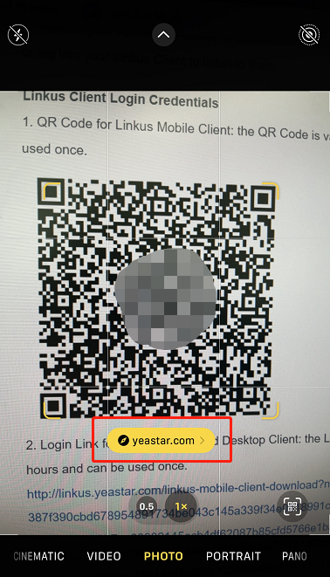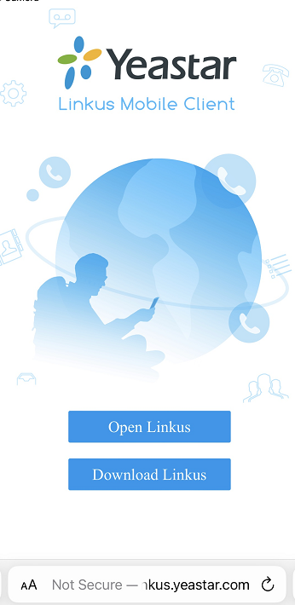

Do you want your QR Code can also jump to your website when use camera/other software scan it?
(If option B selected, pls also provide your own website address)
Website address:
A.I don’t want to customized this. And I can accept when use other mobile app scan this QR Code will show with a string of code.
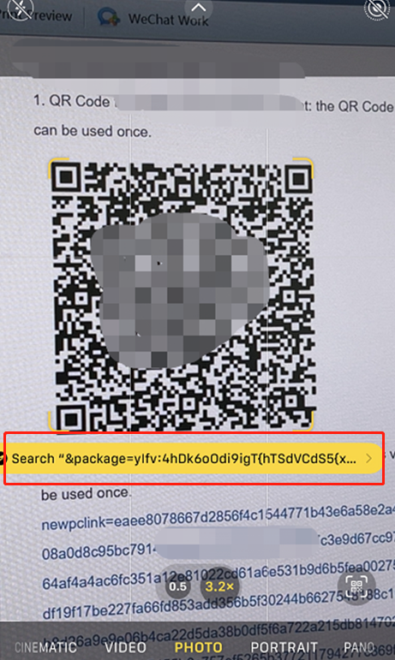
Login credentials are included in this code, but if don’t customized the website, this code would be useless.
B.I need to customized this. I will provide my own website link to Yeastar.
And I will design my website by myself if I need to implement the login information to integration and redirection to our app to auto login. (Similar effect with Yeastar Standard QR Code).

Additional Information
Any special requests, please comment here.

[END]

