# Theme : Blog Website

1. In this website you can post your blog after login.
2. Anyone can read the blog written by someone but if he wants to write then he need to register him/her self.
3. Author of blog can also edit and delete there blogs.
4. There is also contact page where anyone can contact to admin
5. Once you logged in you cannot access the login and register page.

# ScreenShots

HomePage : all the blog pots will display here

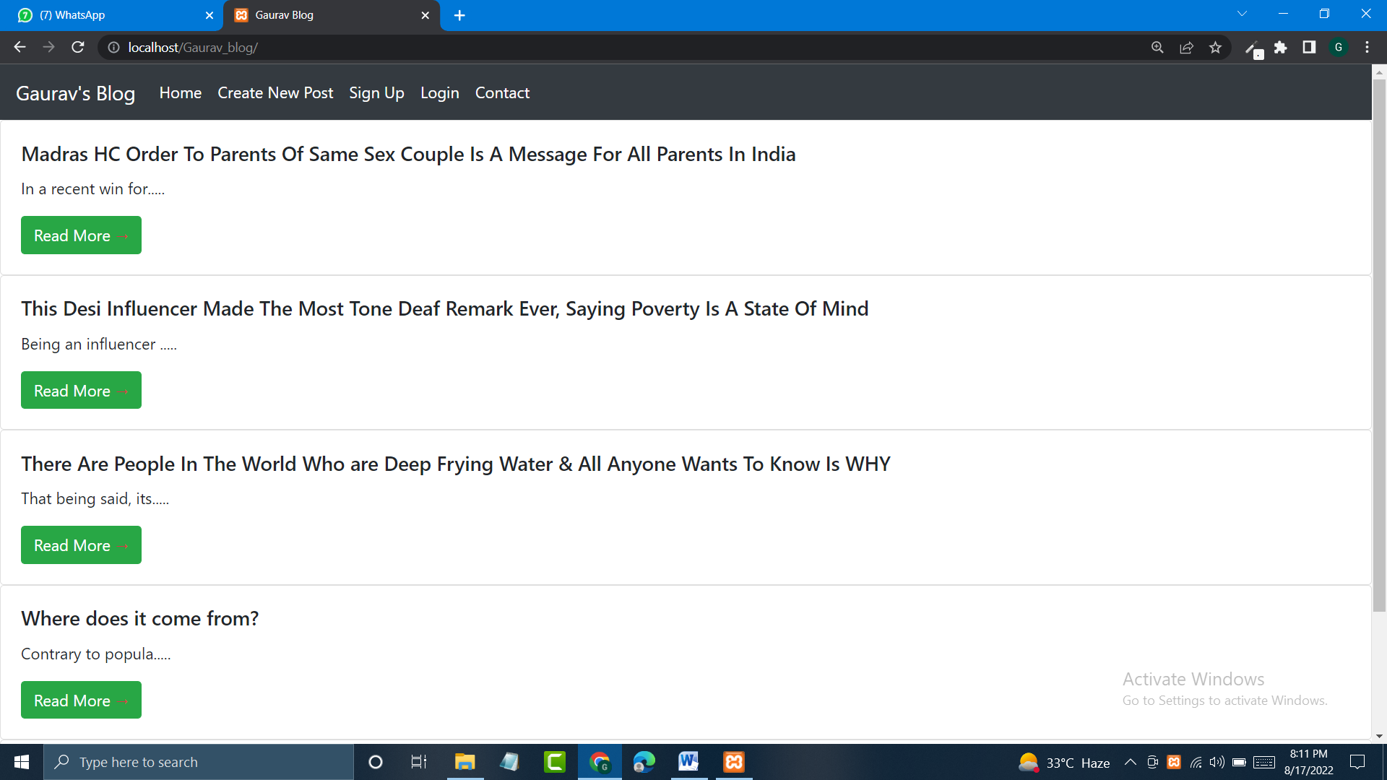

New post Page: without login it will diplay like this

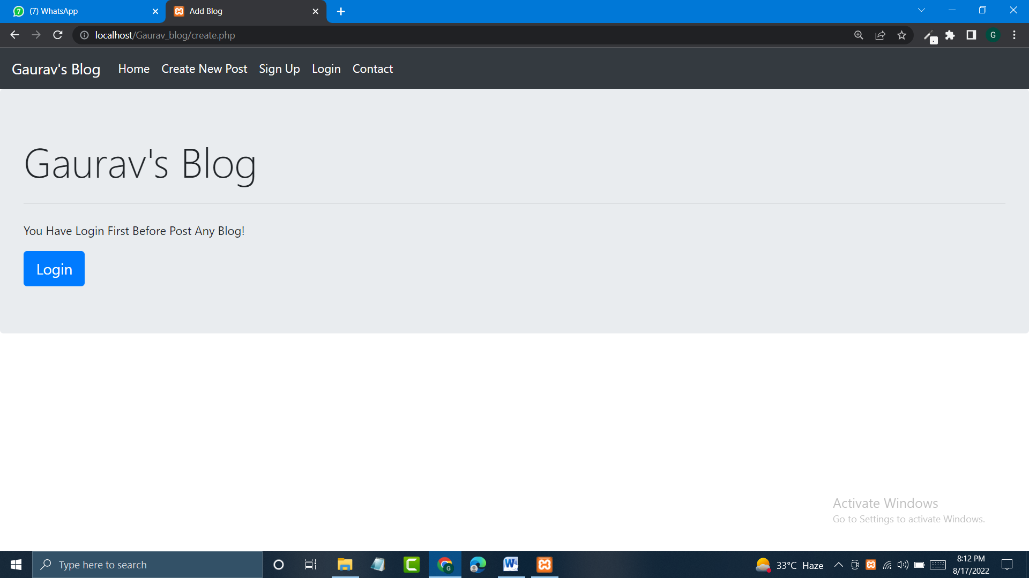

After login:

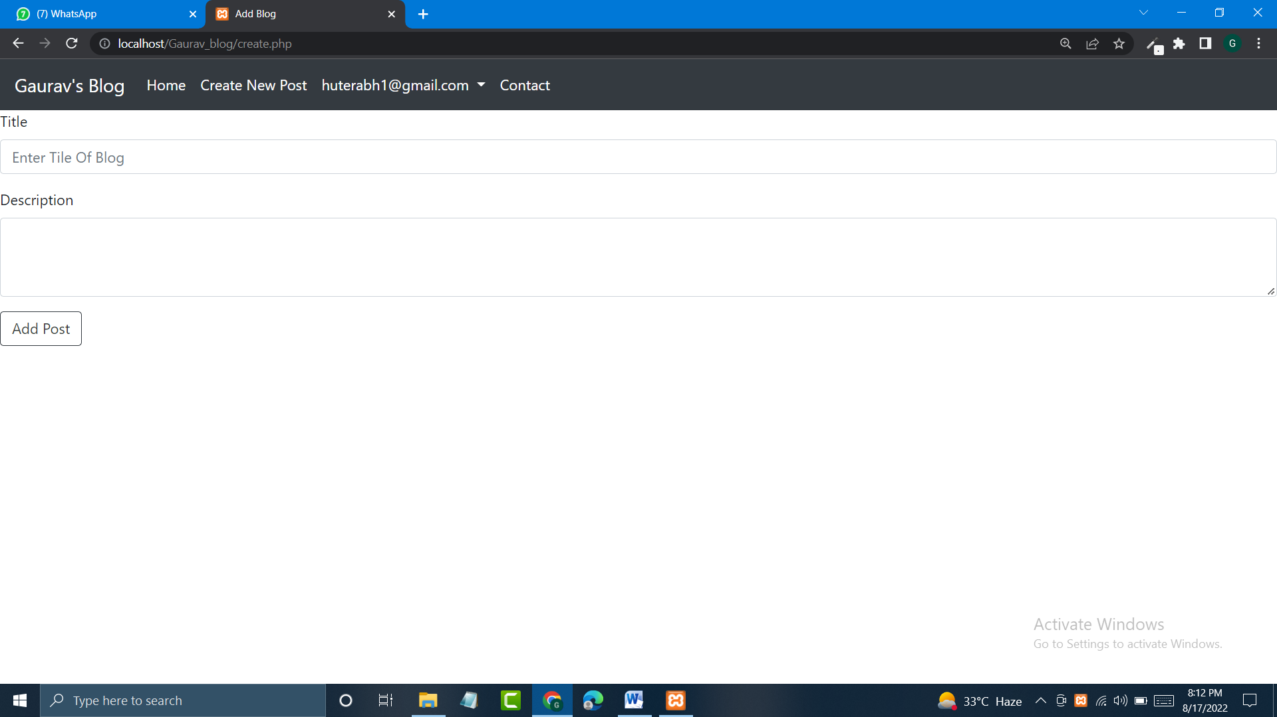

Login and Signup Page:

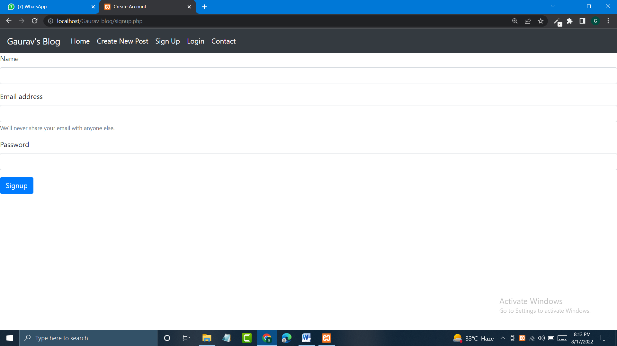

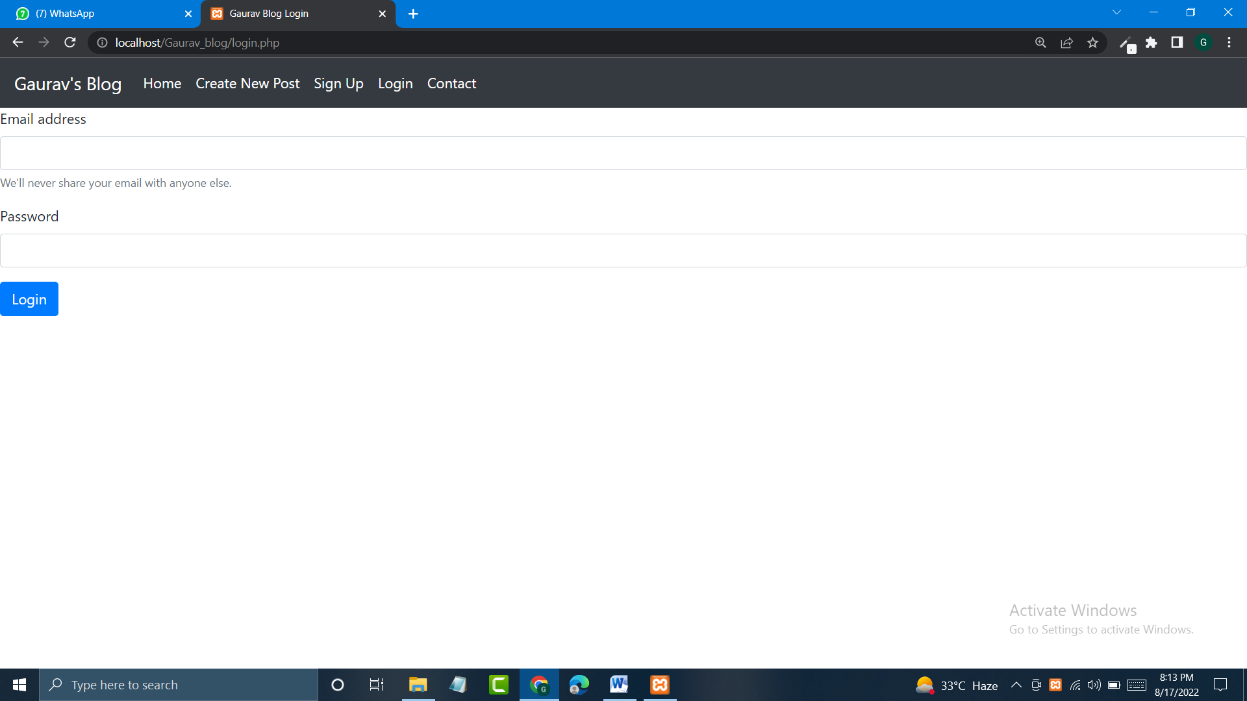

Contact Us Page:

