Part 1 Description:
We learn from the course that “encapsulation” is used frequently in networking. In this project, we will emulate TCP sender and receiver in application layer and call UDP protocol to transmit TCP packets. That is, TCP packets will be encapsulated and sent in UDP layer by the source and decapsulated in the receiver. In this project, both directions need to be implemented. Besides, there is an NAT translation at one side of the connection which you need to implement.
The TAs will tell you how to test your program. That is, TAs will write clients and/or servers to test your program. Therefore, it becomes very important to follow TAs’ formats so your program can be test. The TCP segment structure is as enclosed and you must follow the segment format and implement at least the following fields: source port, destination port, sequence number, acknowledgement number, and checksum for primitive TCP, TCP Tahoe, TCP Reno, and TCP SACK. The state diagram is as shown in the last page of the project.

Step 1: First, you would write one server and four clients, and the server and four clients can both transmit packets and ACKs. The server must be able to handle multiple file requests from multiple clients. The round trip delay is first set to be 200 ms for each connection. The variable threshold is initially set to 64K bytes. The MSS is 1K bytes. The TCP buffer size is assumed to have a buffer size of 32KB packets.
Step 2: The server provides four video files for clients to retrieve. A client can request multiple video files within each request.
Step 3: Delay ACKs are added to senders and receivers.
Step 4: The TCP congestion control consists of the slow start and the congestion avoidance mechanisms. In step 4, you implement the slow start mechanism and the congestion avoidance mechanism.
Step 5: The fast retransmit mechanism is added (Tahoe).
For the moment, there are still only two states, slow start state and congestion avoidance state. However, the fast retransmit mechanism is already included in TCP Tahoe. For TCP Tahoe, when a loss happens, fast retransmit is triggered and the slow start state is entered.
Step 6: The fast recovery mechanism is added (TCP Reno).
Step 7: Finally, the SACK option is incorporated into the standard.
Step 8: Channels may have losses.

The program consists of nine subprojects.

- Both directions have the same transmission rate of 300 kbps.
- A server and four clients. (10)
- The server with four video files for clients to access (10).
- Delay ACKs. (10)
- TCP slow start. (RTT = 200ms for both sides) and TCP congestion avoidance. (15)
- TCP with fast retransmit (TCP Tahoe). (10) (RTT = 200ms for both sides)
- TCP with fast retransmit and fast recovery (TCP Reno). (RTT = 200 ms for both sides) (10)
- The SACK option is added. (10)
- There are losses for both packets and ACKs.
- The link becomes unstable and there are 3% of loss rates. The loss rates are generated randomly. There are two connections in each direction. The direction from the server to each client has a maximum transmission rate of 200 kbps and RTT = 100ms, and the other direction from each client to the server has a maximum transmission rate of 50 kbps and RTT = 200ms. Only TCP SACK is simulated. (15)
- The link becomes unstable and there are 0.01% of loss rates. The loss rates are generated randomly. There are two connections in each direction. The direction from the server to each client has a maximum transmission rate of 300 kbps and RTT = 50ms, and the other direction from each client to the server has a maximum transmission rate of 50 kbps and RTT = 300ms. Only TCP SACK is simulated. (5)

Due: June 22, 2018
References:
The first five papers are suggested for understanding the mechanisms. The last three papers are for additional readings. They are listed below. The last two references are about the relationship about bandwidth x delay and TCP receiver window size.

[1] F. M. Allman, V. Paxson, and W. Stevens, “TCP congestion control,” RFC 2581, Apr. 19999, http://www.rfc-editor.org/rfc/rfc2581.txt.
[2] S. Floyd and T. Henderson, “The New Reno Modification to TCP’s Fast Recovery Algorithm,” RFC 2582, Apr 1999, http://www.rfc-editor.org/rfc/rfc2582.txt.
[3] M. Mathis, J. Mahdavi, S. Floyd, and A. Romanow, “TCP selective acknowledge options, RFC 2018,” Oct. 1996, http://www.rfc-editor.org/rfc/rfc2018.txt.
[4] V. Jacobson and R, Braden, “TCP extensions for long-delay paths,” RFC 1072, http://www.rfc-editor.org/rfc/rfc1072.txt.
[5] J. F. Kurose and K. W. Ross, Computer Networking: A Top-Down Approach Featuring the Internet, six edition, Addison Wesley, Reading, 2012
[6] K. Fall and S. Floyd, Simulation-based comparisons of Tahoe, Reno, and SACK TCP, Computer Communication Review, vol. 26, No. 3, July 1996.
[7] S. Floyd, “A report on some recent developments in TCP congestion control,” IEEE Communications Magazine, Apr 2001, http://www.aciri.org/floyd/papers/report_Jan01.pdf.
[8] W. R. Stevens, TCP/IP Illustrated vol. 1: The Protocols, Addison-Wesley, Reading, MA, 1994. (Due: Dec 17, 2007)
[9] http://speedtest.raketforskning.com/tuning-tcp-window-size.html
[10] http://en.wikipedia.org/wiki/TCP_tuning

PS. The TA will tell you how to test your program.
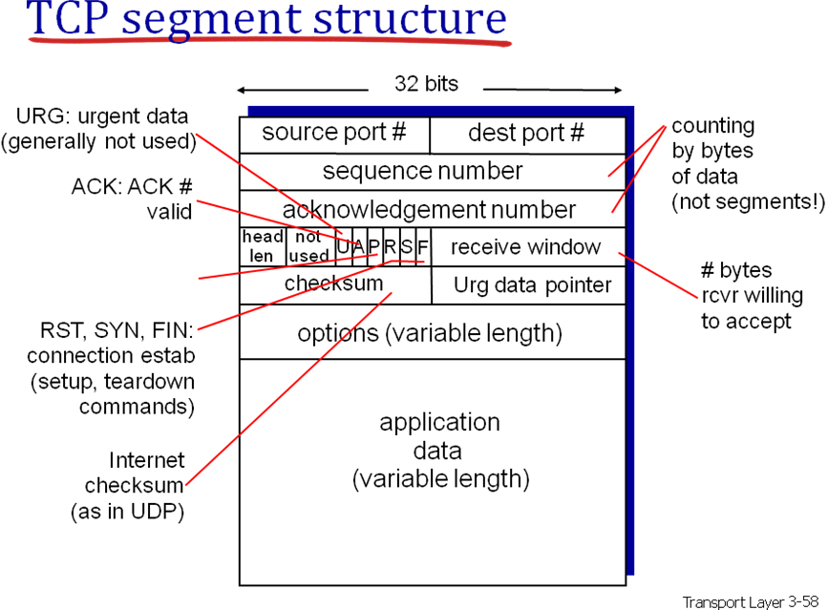

RFC 2018 TCP Selective Acknowledgement Options October 1996

The SACK option is to be included in a segment sent from a TCP that
is receiving data to the TCP that is sending that data; we will refer
to these TCP's as the data receiver and the data sender,
respectively. We will consider a particular simplex data flow; any
data flowing in the reverse direction over the same connection can be
treated independently.

2. Sack-Permitted Option

This two-byte option may be sent in a SYN by a TCP that has been
extended to receive (and presumably process) the SACK option once the
connection has opened. It MUST NOT be sent on non-SYN segments.

TCP Sack-Permitted Option:

Kind: 4

+---------+---------+
| Kind=4 | Length=2|
+---------+---------+

3. Sack Option Format

The SACK option is to be used to convey extended acknowledgment
information from the receiver to the sender over an established TCP
connection.

TCP SACK Option:

Kind: 5

Length: Variable

+--------+--------+
| Kind=5 | Length |
+--------+--------+--------+--------+
| Left Edge of 1st Block |
+--------+--------+--------+--------+
| Right Edge of 1st Block |
+--------+--------+--------+--------+
| |
/ . . . /
| |
+--------+--------+--------+--------+
| Left Edge of nth Block |
+--------+--------+--------+--------+
| Right Edge of nth Block |
+--------+--------+--------+--------+

Transport layer 3- 70, 3-104

