700 Milliarden
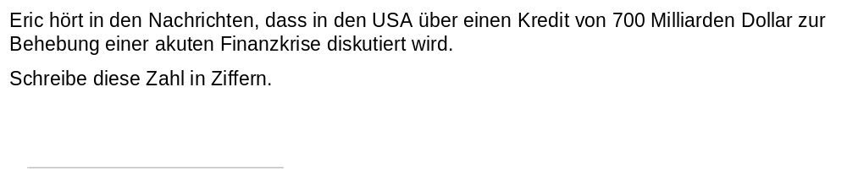 | M15034_A


