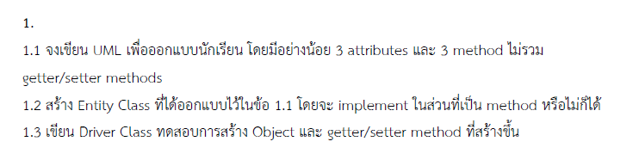

* 1. UML Class Diagrams

-studentId : long

-studentName : String

-studentGpa : double

Student Data

+setStudentId(long id) : void

+getStudentId() : long

+setStudentName(String name) : void

+getStudentName() : String

+setStudentGpa(double gpa) : void

+getStudentGpa() : double

Student

+main(args : String[]) : void

* 1. 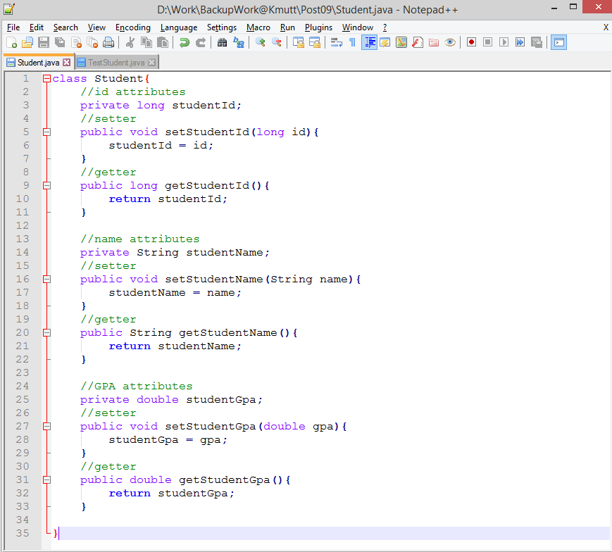Entity Class
  2. Driver Class

