2014年6月研究生英语学位课统考题答案
试卷A

PART I
LISTENING COMPREHENSION
Section A
1. C 2. C 3. A 4. D 5. B 6. D 7. A 8. A 9. B

Section B
10. C 11. A 12.B 13. C 14. D 15. A

Section C
16. the 19th century.
17. 62 kilometers.
18. a minimum of.
19. is retired.
20. was responsible.

PART II
VOCABULARY
(10 minutes, 10 points )
21. D 22. B 23. C 24. B 25. D 26. A 27. C 28. B 29. B 30. A

31. D 32. A 33. B 34. D 35. C 36. B 37. D 38. A 39. B 40. A

PART III
CLOZE TEST
(10 minutes, 10 points, 1 point each)
41. B 42. D 43. A 44. B 45. D 46. A 47. C 48. D 49. C 50. A

PART IV
READING COMPREHENSION
(45 minutes, 30 points, 1 point each)
51. A 52. B 53. B 54. D 55. A 56. B 57. C 58. D 59. C 60. B
61. D 62. A 63. D 64. B 65. C 66. C 67. B 68. A 69. A 70. C
71. D 72. A 73. C 74. B 75. B 76. C 77. D 78. A 79. B 80. C
PART V
TRANSLATION
(30 minutes, 20 points)
Section A 英译汉：
科研旨在准确地解释自然界的工作原理和变化至今的过程。但是，越来越多的科研活动是为了实现一个明确的目标——积累知识。基于科学的知识不畏质疑和修正。没有任何一个科学上的见解是“板上钉钉的”（彻底得到证明的）。我们今天完全接受的观点明天有可能根据新发现的证据被推翻或修改。科学的解释使人们期望不断，这些期望促使我们琢磨自然界当中的个体是如何相互作用的以及我们如何利用这种知识。这一切促使科学家从事独创性研究来证明一个假说的合理性。
Section B
Extensive reading is crucial (critical) to the mastery of English, but its importance has been neglected. Unlike intensive reading courses opened (offered) at college, extensive reading is intended to (aims to) enlarge students’ vocabulary, familiarize them with the different usage of words and eventually improve their comprehension. Extensive reading involves some methods that can enhance the accuracy and efficiency with which you use English at work. Believe in what you read rather than grammar books.

2015年6月研究生英语学位课统考题答案
试卷B
PART I
LISTENING COMPREHENSION
Section A
1. D 2. A 3. C 4. D 5. B 6. C 7. A 8. B 9. D

Section B
10. D 11. B 12. D 13. B 14. D 15. C

Section C
16. liquid solution
17. quit the habit
18. more than doubled
19. increasing popularity
20. restricted to adults
PART II
VOCABULARY
(10 minutes, 10 points)

21. D 22. A 23. C 24. B 25. B 26. A 27. C 28. B 29. C 30. D
31. C 32. B 33. A 34. B 35. D 36. C 37. C 38. D 39. D 40. A

PART III
CLOZE TEST
(10 minutes, 10 points, 1 point each)

41. A 42. D 43. D 44. B 45. C 46. C 47. A 48. B 49. A 50. D

PART IV
READING COMPREHENSION
(45 minutes, 30 points, 1 point each)

51. A 52. D 53. B 54. C 55. D 56. B 57. C 58. C 59. D 60. A
61. B 62. A 63. A 64. D 65. C 66. D 67. B 68. C 69. A 70. B
71. B 72. A 73. D 74. C 75. A 76. D 77. B 78. C 79. C 80. D

PART V
TRANSLATION
(30 minutes, 20 points)

Section A 英译汉：
如果人类能放弃共同的福利，借口是稳定使日常生活费用上升的经济体系，那么就能使生活方式发生重大变化，以稳定我们所有生命赖以生存的物质体系。大幅度减少温室气体排放需要许多方面的改变，这些改变将极大地提高大多数人的生活质量 – 北京的儿童可以不带口罩在室外玩耍，还可以在清洁能源领域创造无数的就业机会。我们就能致力于大幅度削减化石燃料气体的排放并开始转向使用基于再生技术的零碳能源。

Section B汉译英：
To maintain physical and mental health (to stay healthy physically and mentally), children need a minimum of one-hour exercise daily / children need to spend at least one hour on physical exercise each day. However, the obsession with video (electronic) games and reluctance to play outdoors lead to obesity as well as a decline in vision. Overweight kids are four times as vulnerable to / are four times as likely to suffer from hypertension (high blood pressure) as normal ones. Children, rural or urban, are to expose themselves (get access) to nature. They can never get interested in study unless they are happy.

汉译英部分需要扣分的译法：
- 把“保持身心健康”译为keep physical and mental health。
- 把“儿童需要…”译为children are necessary to…或children need exercising…。
- obsession和willingness或reluctance的词形错误，如but unwilling to play…leads to…。
- 用touch翻译“接触”，或expose词形有错。
- only引导的倒装句中用逗号，如only they are happy, can they…。

下列译法属于严重错误，每个可扣2分：
- 把“患高血压的概率是正常儿童的四倍”译为…are four times as possible (probable) to do…或the possibility of children to suffer from…is four times as much…，均为严重错误。
- 用no matter in the countryside or in cities翻译“不论是农村的还是城里的”，也是严重错误。
- 用only翻译“只有…才能”，如only happy / only being happy / only happiness / only they are happy。

2016年6月研究生英语学位课统考题参考答案

2016年6月研究生英语学位课统考题参考答案(试卷A)

PART I
LISTENING COMPREHENSION

Section A
1. A 2.C 3. D 4. C 5. B 6. D 7.A 8. B 9. C

Section B
10. B 11. A 12.D 13. B 14. D 15. C

Section C
16. work environment
17. plenty of time
18. shake hands
19. interesting but relevant
20. explain or repeat

PART II
VOCABULARY
(10 minutes, 10 points)

21. B 22. A 23. C 24. A 25. D 26. A 27. B 28. C 29. B 30. D
31. C 32. A 33. D 34. B 35. C 36. C 37. A 38. B 39. B 40. D

PART III
CLOZE TEST
(10 minutes, 10 points, 1 point each)

41. B 42. C 43. A 44. D 45. C 46. B 47. A 48. D 49. C 50. B

PART IV
READING COMPREHENSION
(45 minutes, 30 points, 1 point each)

51. B 52. D 53. C 54. A 55. C 56. B 57. A 58. B 59. D 60. B
61. A 62. C 63. B 64. C 65. A 66. D 67. C 68. B 69. A 70. D
71. D 72. C 73. A 74. B 75. D 76. B 77. A 78. D 79. A 80. C

试卷B
PART I
LISTENING COMPREHENSION
Section A
1. B 2. D 3. B 4. C 5. D 6. A 7. D 8. A 9. B

Section B
10. C 11. C 12. D 13. A 14. B 15. B

Section C
略
PART II
VOCABULARY
(10 minutes, 10 points)

21. A 22. C 23. D 24. B 25. C 26. B 27. D 28. C 29. C 30. A
31. C 32. D 33. A 34. A 35. B 36. B 37. C 38. B 39. D 40. A

PART III
CLOZE TEST
(10 minutes, 10 points, 1 point each)

41. A 42. D 43. B 44. C 45. B 46. C 47. D 48. A 49. B 50. D

PART IV
READING COMPREHENSION
(45 minutes, 30 points, 1 point each)

51. D 52. A 53. B 54. C 55. C 56. B 57. A 58. D 59. D 60. B
61. A 62. D 63. B 64. C 65. B 66. C 67. B 68. A 69. D 70. B
71. A 72. C 73. B 74. D 75. C 76. A 77. B 78. D 79. C 80. D

PART V
TRANSLATION
(30 minutes, 20 points)

Section A 英译汉：
对富有创造力的人和产品进行分析后发现，大多数科技和艺术的创新源于不同人之间的集思广益、激烈的讨论和共同奋斗，突出了群体层面对于创造力的重要性。对于群体创造力来说，人与人之间的交往不仅是必不可少的，而且是举足轻重的。另一方面，人们以个人的身份参与此类合作性研究和创造，他们需要时间思考或反思自己对于群体研究和创造的贡献。复杂的设计问题很少属于某个专门的领域，因此需要不同人的参与和合作，这些人背景不同，讲话的目的是使他人听到自己独特的见解。

Section B
No modern inventions have changed the way humans work and live as profoundly as the computer. What might have taken months to calculate decades ago can be finished in minutes. What we used to dream about / we dreamed about in the past has been turned into realities / has come true. Easy access to the Internet has made the information needed readily available to us. The virtual world is a good place where we can entertain ourselves / have fun.

汉译英部分需要扣分的译法：
- Any modern invention has not changed ….属于严重错误。
- human或human being的形式不正确，如the way human works and lives…或the way human being works…。
- 类似no modern inventions have changed …like the computer。
- 单数的computer或Internet前面没有任何冠词。
- 用might take months…decades ago，而不是might have taken…。
- 使用cost或spend several months属于严重错误。
- 用dreamed代替dreamed about (of)或使用现在时dream about before / in the past。
…make us easy to get the information或we are easy to get the inf

2017年6月研究生英语学位课统考题参考答案

试卷B
PART I
LISTENING COMPREHENSION
Section A
1. A 2. D 3. B 4. C 5. B 6. D 7. A 8. C 9. B

Section B
10. A 11. B 12. A 13. D 14. C 15. D

Section C
16. make sense of
17. essential difference
18. atmosphere behaves
19. vast majority
20. complicated and frustrating
PART II
VOCABULARY
(10 minutes, 10 points)

21. A 22. D 23. C 24. D 25. B 26. A 27. D 28. B 29. C 30. B
31. A 32. C 33. B 34. A 35. C 36. C 37. B 38. B 39. D 40. A

PART III
CLOZE TEST
(10 minutes, 10 points, 1 point each)

41. B 42. A 43. C 44. A 45. D 46. D 47. B 48. C 49. C 50. A

PART IV
READING COMPREHENSION
(45 minutes, 30 points, 1 point each)

51. A 52. B 53. D 54. C 55. D 56. B 57. A 58. C 59. A 60. B
61. D 62. A 63. B 64. D 65. B 66. C 67. C 68. D 69. A 70. C
71. C 72. D 73. B 74. A 75. A 76. B 77. C 78. D 79. D 80. B

2018年1月研究生英语学位课统考题参考答案
试卷B
PART I
LISTENING COMPREHENSION
Section A
1. A 2. D 3. C 4. B 5. A 6. C 7. B 8. D 9. C

Section B
10. B 11. A 12. D 13. B 14. C 15. D

Section C
16.negative effects
17. rural communities
18. might otherwise
19.conservation of wildlife
20.entrance charges
PART II
VOCABULARY
(10 minutes, 10 points)

21. B 22. A 23. D 24. A 25. C 26. B 27. B 28. A 29. D 30. C
31. D 32. B 33. D 34. A 35. C 36. C 37. A 38. D 39. C 40. A

PART III
CLOZE TEST
(10 minutes, 10 points, 1 point each)

41. D 42. A 43. B 44. C 45. A 46. C 47. B 48. A 49. D 50. D

PART IV
READING COMPREHENSION
(45 minutes, 30 points, 1 point each)

51. D 52. B 53. A 54. D 55. C 56. D 57. C 58. A 59. B 60. C
61. B 62. C 63. D 64. A 65. B 66. D 67. C 68. A 69. D 70. B
71. C 72. A 73. B 74. B 75. C 76. D 77. D 78. B 79. C 80. A

PART V
TRANSLATION
(30 minutes, 20 points)

Section A 英译汉：

令人遗憾的是，电子邮件有许多不足之处。网上交流有各种各样的形式，但每一种都有自己的要求，用户必须意识到这些要求才能避免说出任何不合适的或无法理解的话。面对面交谈时我们可以轻松理解的对方的兴趣点、肯定的话甚至恭维的话，但在电子邮件中可能被误解为揶揄讽刺。这些问题都很棘手。白天工作很忙，不可能时时刻刻克制自己反应冲动，而且不让自己想说什么就说什么并不是什么好事。但为了避免可能发生的灾难，你应该预料到别人可能如何理解自己的话。

Section B 汉译英
Undergraduates, especially the first-year students, hope to improve their ability to express themselves in English. The question is which teaching approach is more effective. Students can hardly become interested in instructions if the teacher does nothing but repeat what the textbook says. No teacher can be regarded as competent / qualified unless students can benefit as much as possible from his or her lectures. The top priority for a teacher is to make students’ use of English more idiomatic and accurate / help students to use English more idiomatically and accurately.

汉译英部分需要多扣分的译法：
- 把“英语表达能力”翻译为English expression ability或ability of English expression。
- “学生很难……”翻译为students are difficult to…或students have difficulty to do…。
- “只有使学生”翻译为only by making students…。

2019年1月研究生英语学位课统考题答案
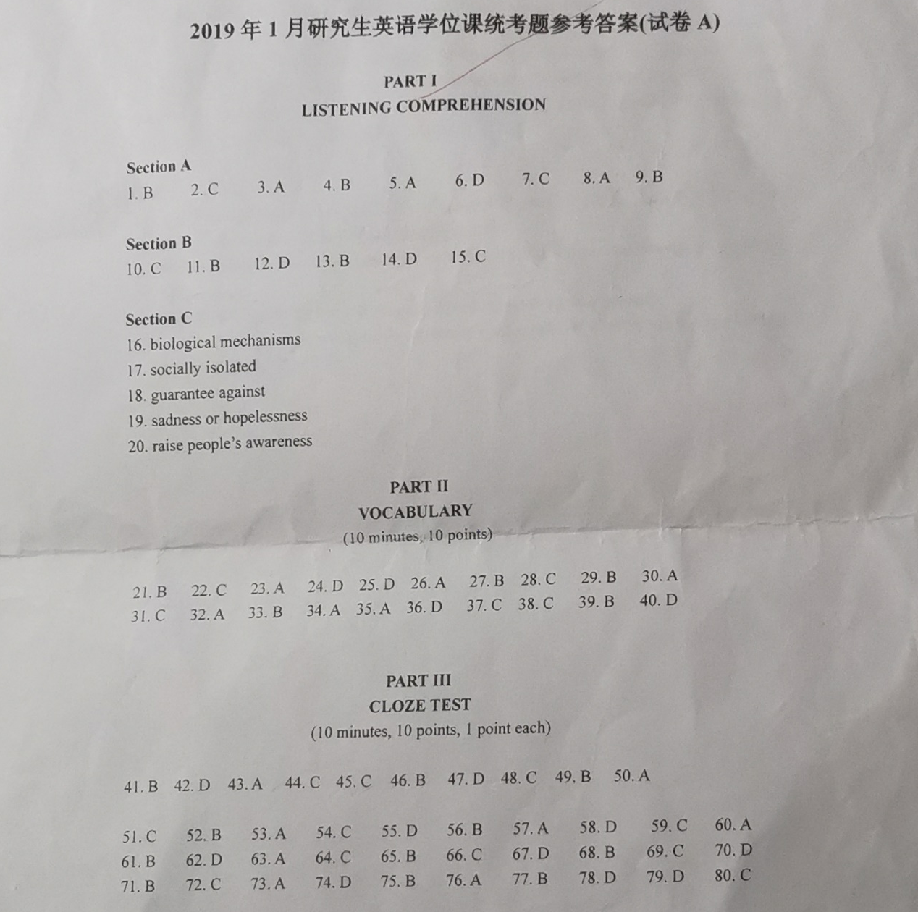
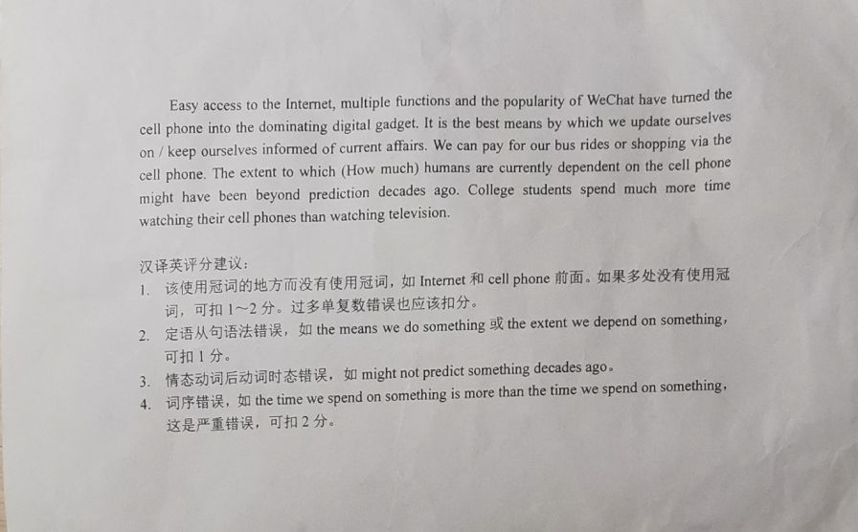
试卷A

