**EGN LONDON Practicing in Free Time:**

* Plan, Build and Manage Drupal Site.
* Understand Drupal Site Building Using core practices.
* Develop and maintain Drupal using site-building tools.
* Install and configure Drupal modules and themes.

|  |  |  |
| --- | --- | --- |
| **Time Log :** |  | **Target** |
| June-18- June-30 |  | Understanding Drupal Section / HTML CSS Standards with Example of Each one: |

Drupal Site Building:)

Drupal Current Version 8.7.2

Size of this Version 27.14 MB

Files Structure

Drupal 8 Releases significantly change the way drupal works in earlier versions. It enhances capabilities of Writing Custom Code, Working with Core Modules and Most importantly mobile first approach. Some Key Features I am listing down is here:

1. Filing Structure changed from Drupal 7
2. OOP Concept included
3. Composer Based
4. Better Security
5. Mobile First Approach
6. Views Module Included in Core
7. Better Options for Site Builders (WYSIYG MODULE)
8. Better SEO modules (Meta Tag)
9. HTML 5 Semantic Code Inclusions.

Let’s Jump on Drupal 8 Installation.

It comprises of 79 Core Modules

It comprises of 6 Core Themes

Key modules that I have noticed included in Core are :

* WYSIWYG
* Views
* Entity reference.

# Best Way to Create Your Drupal Website:

Following are some Best Practices for Creating Drupal sites

1. Plan your Website
2. Take Backup and ensure it’s working correctly, because you’ll it must should work, when you need.
3. Properly Choose Theme that you can flexible to do customization and additional development
4. Update and Security must be checked!
5. Properly choose module that matches your needs, just don’t put the first one you finded.
6. Permission! Carefully use server permission to stop entrance of hackers.
7. Custom Code! Properly do custom code, in blocks, because a single; can break whole website.

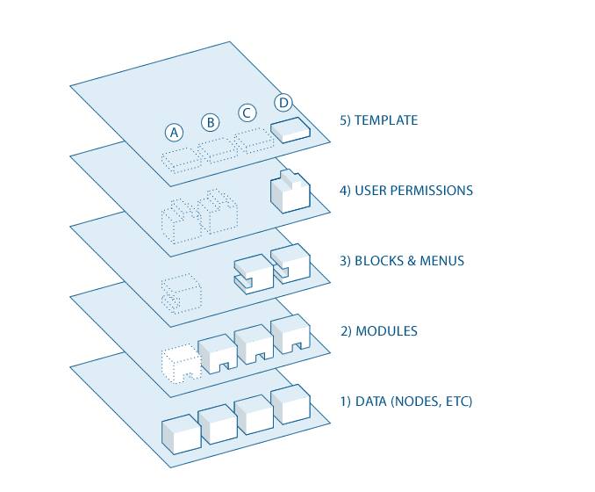

If SomeOne want to go deeper in Drupal so there are 5 Layers of Data Flow.

1. **Node etc.**
2. **Modules**
3. **Blocks Menus**
4. **User’s Permission**
5. **Templates**

# Drupalize.me Coarse Content’s

Site Building Coarse Start’s:

What is Open Source!

What is Open Source Licensing System!

What is Module.

What is Theme.

Concept of Development and Production Site etc

1. **Understanding Drupal:**

Completed

1. **Working with Drupal Site:**

<https://drupalize.me/sites/default/files/tutorials/user_guide/config-overview-toolbar.png>

Content, Structure, People, Appearance, Extends, Configuration, Reports, Help.

Content Contains all the link to manage, existing contents and modify it.

Structure Give access to Blocks, Menus, Content-types (in which we can manage fields) and taxonomies etc.

Appearance Give details about Themes Updating, Settings etc. (installing new one)

Extends as its name give indication: It Gives us the ability to add Modules, modify and uninstall it.

Configuration: It give access to various settings of the site, like Media, Development Basic Site Setting Account Settings Crons etc.

Reports:

It’s a Log of the Site contain information about the Updates, of the Site and warnings etc.

Help:

As its name give the syndication:

# **Configuring the basic site information:**

Inside configuration -> system -> basic site settings

Upon the uninstalling of a module you’ll be prompting to confirm whether are you sure want to uninstall this module.

We cannot uninstall a module until we don’t un-install its dependent modules. E.g. files is required by CCK

**People, Roles and Permissions:**

Role define group of users that have certain privileges. We assign permissions to certain roles.

Assigning permission to each role will make our work more easy.

# [Content Modeling](https://drupalize.me/topic/content-modeling)

**Important part of Drupal is content modeling:**

What is the word content model?

Obviously in normal and daily life giving content a shape is called content modelling, Let’s explain with Drupal Perspective,

Content Modelling is analyzing, identifying and structuring the building blocks of data, that comprises information for Drupal.

***Steps of Content Modeling in Drupal:***

1. What kind of Data we need?
2. How to structure this data?
3. Before any project we should at least setup all the content flow for ease of project.
4. Drupal is extremely complex managing simple to complex Data Because **of entities system and fields system.**

Content

Data - > Structuring -> Analyzing -> Setting up information to Nodes etc.

What we need while working on content:

1. Structure of Content.
2. How they relate to each other.

**Example Tasks:**

1. Understand why developing a content model is important
2. Learn about Drupal tools that support the implementation of a content model
3. Create a content model plan for a Drupal site
4. Let’s do these tasks one by one ☺

## External resources

[Content Modelling: A Master Skill](https://alistapart.com/article/content-modelling-a-master-skill) (alistapart.com)

While not Drupal-specific, this article does a great job explaining what a content model is, why you should care, and how you can go about developing one.

[Content modelling in Drupal: The accidental content strategist](http://weaveweb.com.au/blog/content-modelling-drupal-accidental-content-strategist) (weaveweb.com.au)

This blog post serves as a good transition from the one from A List Apart. It contains some good advice about how to transition from a content model to incorporate some of the Drupalisms that are required to actually implement the model you've come up with.

[Deblobbing your chunks: Building a flexible content model](https://www.lullabot.com/articles/deblobbing-your-chunks-building-a-flexible-content-model) (lullabot.com)

This blog post does an excellent job explaining why it's important to consider content reuse when developing your content model.

[Developing Drupal Sites: Plan or Perish](https://www.palantir.net/blog/developing-drupal-sites-plan-or-perish) (palantir.net)

A high level walk through of the types of things you should take into consideration when working towards your content model.

**Let’s Jump into Component Planning a Site:**

What is Region: -> It’s a segment of page on which we assign blocks.

Okay, Next topic in content modeling is:

1. Planning your site
2. Setting up content

For Example one is looking for a website for farming he’s supposed to write statements for.

1. List of the Market
2. Hours
3. Content
4. Recipies
5. Knowing your vendors

**Entity:**

Item in content data mainly consist of markup, images, text etc indended to be displayed on site in different formats.

Entities are grouped into entity-type.

Fields ? fields are the created inside entity type to store individual data, like file, image, text etc. Fields can be added through core or contrib modules like date etc are involve in core, while inline-entity-form etc should be downloaded from contrib.

### **What is modular content?**

Let’s define modular content through examples, normally it’s ideal that our data is stored in database, so it’s desirable to edit certain parts of page, rather than adding a complete page.

Example to Create Modular content:

1. Reference Field
2. Views (are best source of creating modular content)

These two examples are basically performed to create composite pages.

### Goal

Make a plan for the content structure of the site (which type and subtype of entity to use for which content), and which pages will contain listings of content.