SNGHAR006

1. Why do you see a difference in webpage fetch times with short and large router buffers?

* The difference in fetch times is due to the overhead. When a large number of packets are sent, packets will wait in a queue and hence TCP will send packets with a large window bloating the buffer. When a small number of packets are sent, TCP reduces the window size because there is no queuing and hence very less number of packets are resent which reducing the overhead.

Router buffer of 20 packets:

Average fetch time: 2.506333

Standard deviation of fetch times: 0.054738

Router buffer of 100 packets:

Average fetch time: 8.394333

Standard deviation of fetch times: 0.338964

1. How does changing the link speed affect the experiment?

The link speed does not affect the queue size, however reduces the packet response time (RTT) as the link speed is increased.

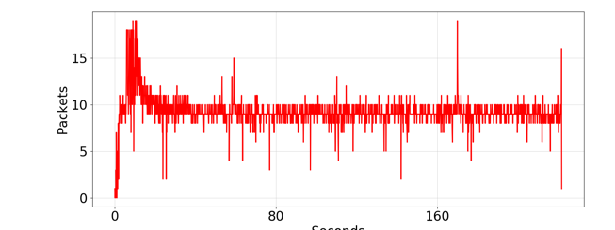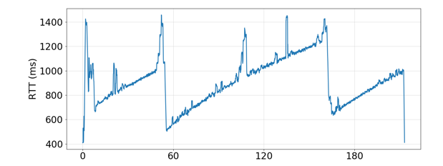

Figure 1: Queue size and RTT for 100MBps

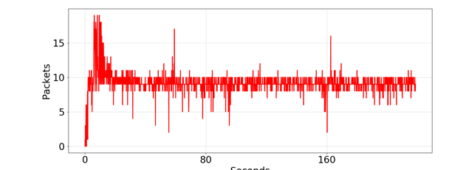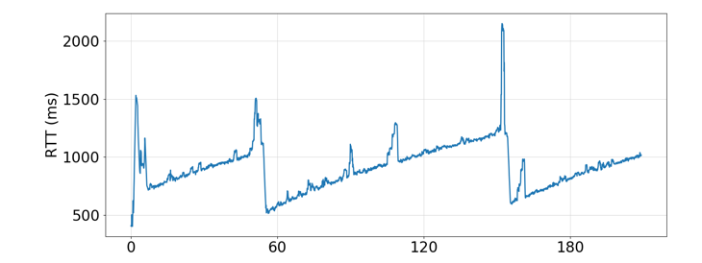

Figure 2: Queue size and RTT for 1GBps

1. How does changing the queue size affect the experiment?

As the queue size increases, the fluctuations in the queue size reduce, the queue size gradually increases and drops, however with a small queue size drops in queue size are seen.

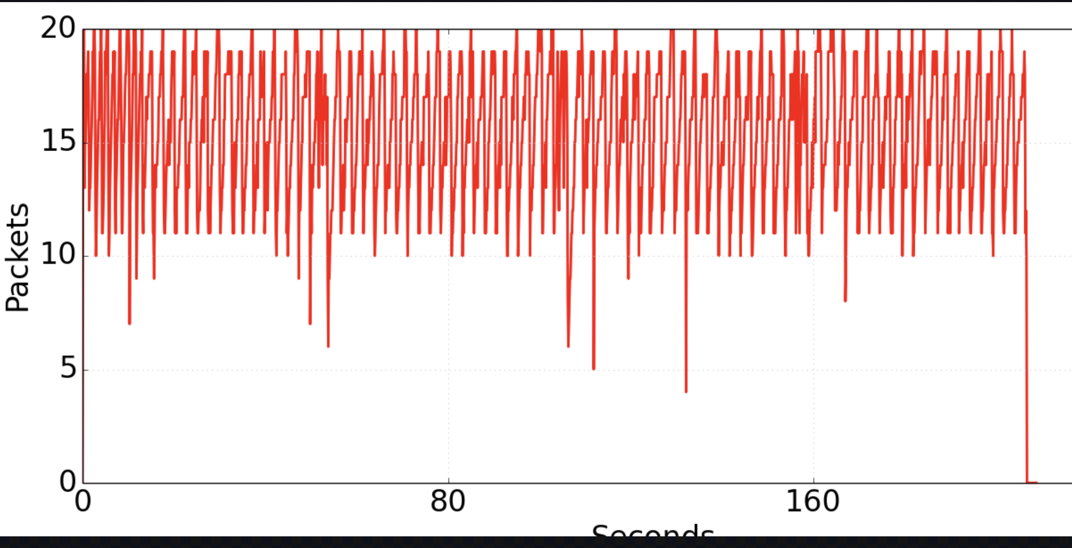

Figure 3: Queue size 20

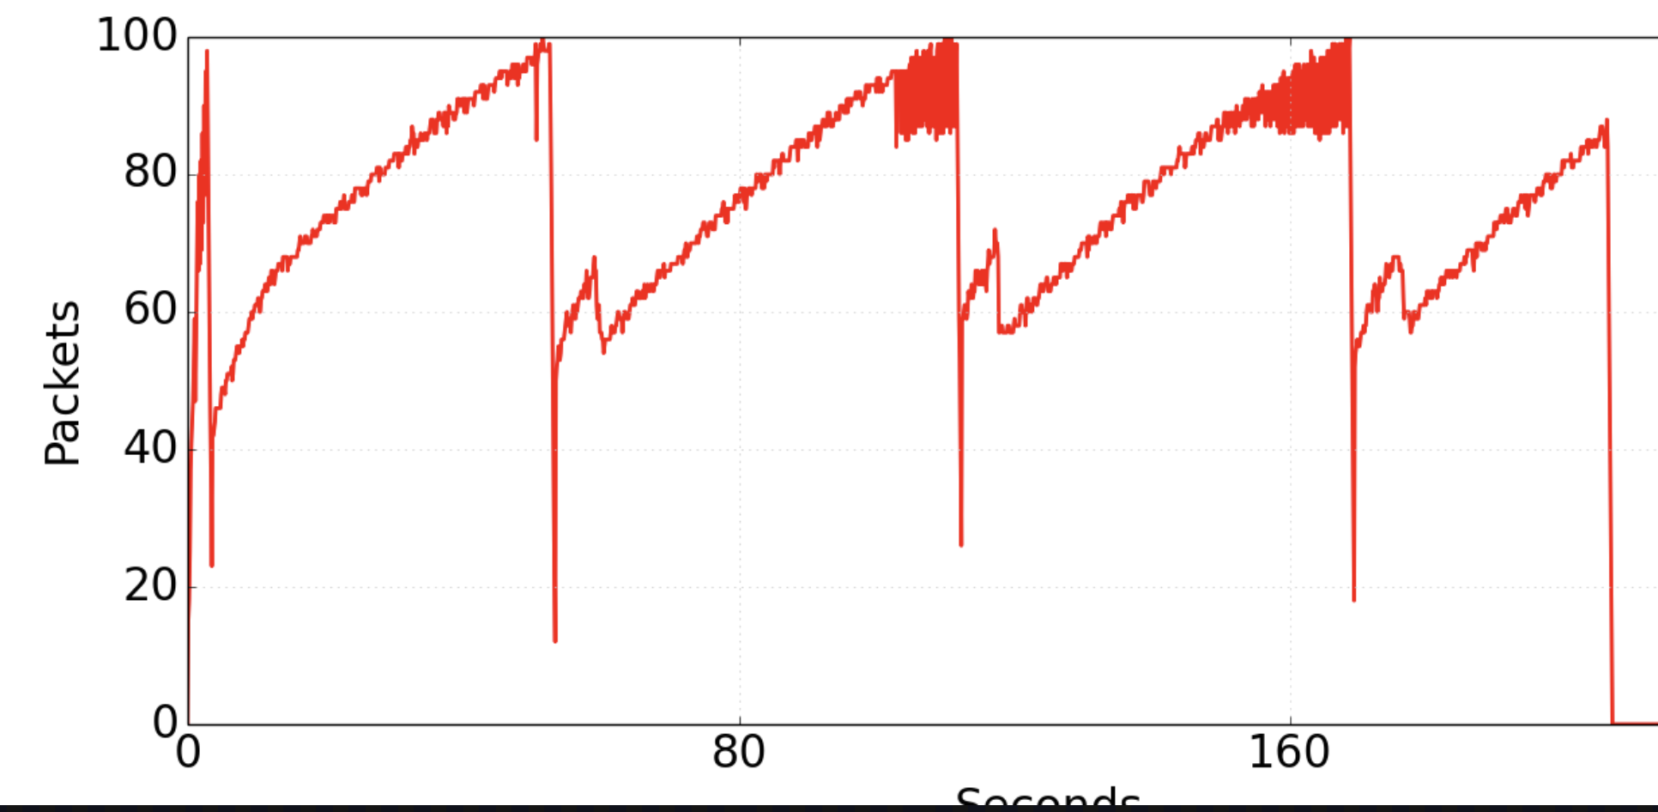

Figure 4: Queue size 100

1. How does changing the congestion control mechanism affect the experiment?

TCP BBR reduces the fluctuations of packets in the queue and tries to keep the RTT to a minimum and constant, whereas TCP Cubic has a lot of fluctuations in the queue size and the response times RTT

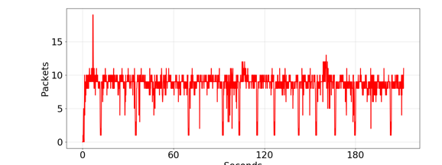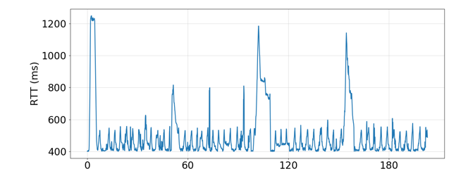

Figure 5: Queue size and RTT for TCP BBR

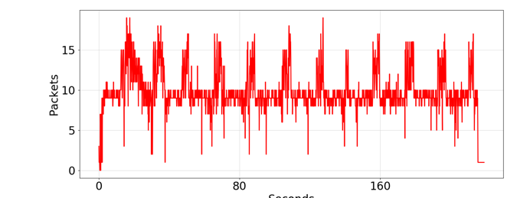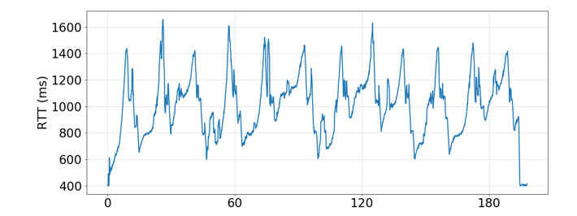

Figure 7: Queue size and RTT for TCP Cubic