***LAB 7 Performance Analysis of Arithmetic Circuit***

***(Comparator as example) – Power-Delay-Product Analysis One bit Comparator Transient analysis***

Please try to write a Comparator SPICE file with Loading 0.1p for each of the three output loads, observe the waveform and measure the Delay time and Power consumption. (Please practice adjusting the Size individually. The Delay must be less than 0.5ns.)

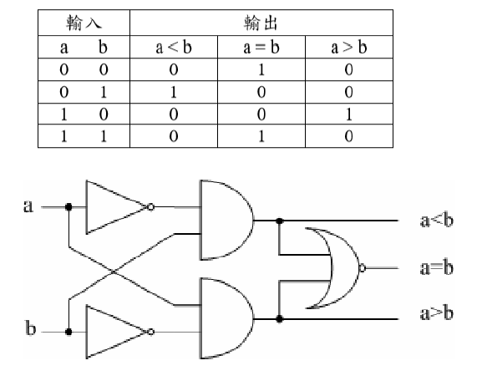

One bit comparator

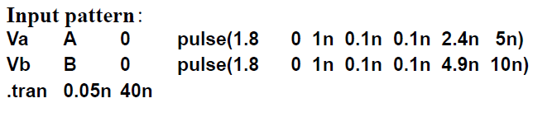

***8-Bit Comparator Transient analysis***

Expand the truth table of a bit comparator to 2 bits, and then gradually expand it to a 4-bit or 8-bit comparator. Loading 0.1p, observe the waveform and measure Delay time and Power consumption. (Please practice adjusting the Size individually. Delay must be less than 2ns.)

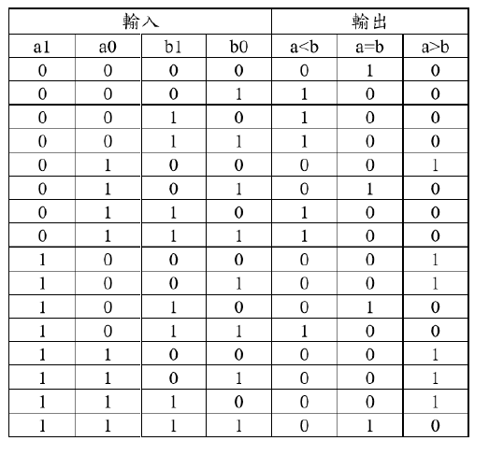

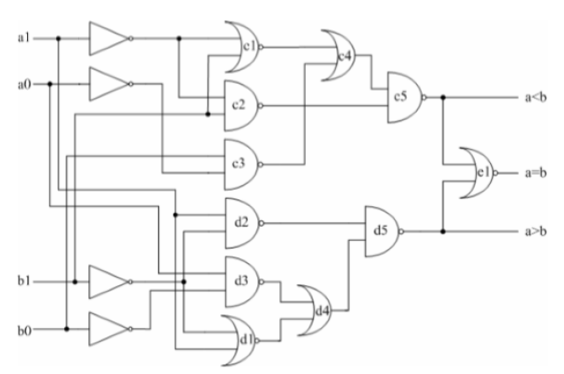

2-bit comparator

Then, the comparison results of the two two-bit digital comparators can be used to expand to a four-bit digital comparator, in which logic gates F1~F5 are expansion modules. The condition for the F3 logic gate to output high potential (a<b) must be that the comparison result in the higher bit is a<b or I1 is high; and for I1 to be high, it must be in the higher bit. The comparison result is a=b and the comparison result in the lower bit is a<b, both are true at the same time; when the F4 logic gate outputs high potential (a=b), both comparison results are a=b, Both need to be established at the same time; when the F5 logic gate outputs high potential (a>b), the comparison result in the higher bit must be a>b or I2 is high potential; for I2 to be high potential, it must be The comparison result in the higher bits is a=b and the comparison result in the lower bits is a>b, both of which are true at the same time. The expansion module composed of F1~F5 can be reused in the eight-bit digital comparator.

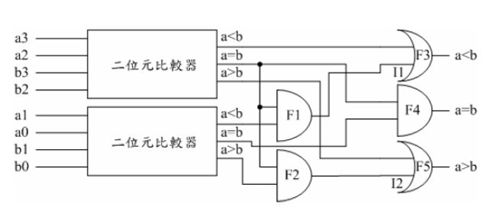

Use 2-bit comparator to compose 4-bit comparator

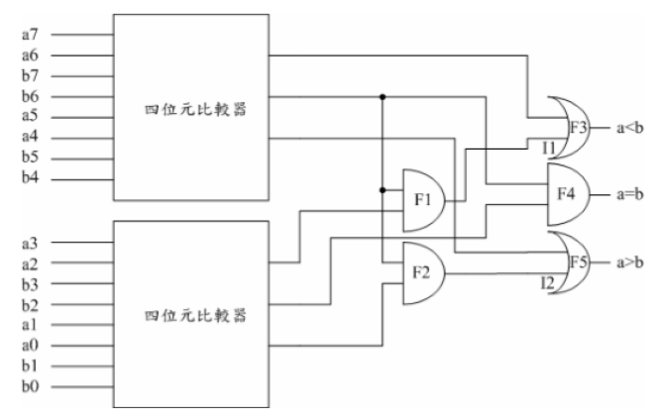

Use 4-bit comparator to compose 8-bit comparator