LAB-2 Scaling Property
1. Discuss how do fan-in, fan-out, and cascade stage affect delay and power?

*The Pattern you need:

Please test with the following pattern:
(To see how many patterns you need, ex: two inputs with va and vb, four inputs with va, vb, vc, and vd.)

Note: Please put input A to the MOS transistor most near VDD or GND.

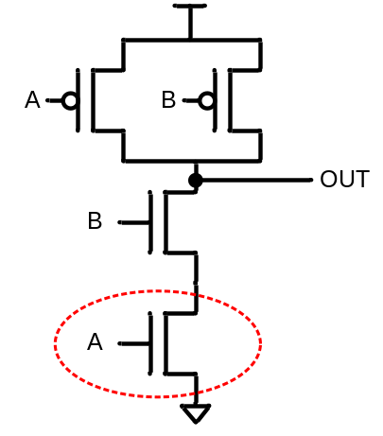
VA A 0 pulse( 1.8 0 0.1n 0.1n 0.1n 9.9n 20n )
VB B 0 1.8
VC C 0 1.8
VD D 0 1.8
VE E 0 1.8
VF F 0 1.8
VG G 0 1.8
VH H 0 1.8
.tran 0.1n 80n

Analysis of NAND fan-in, fan-out, and cascade-stage
- Please Analysis and compare the 2-input NAND, 4-input NAND, 6-input NAND, 8-input NAND circuits under various fan-in with the same loading c=0.02p. Please measure Delay time and Power consumption with transistor Size using PMOS W/L=1u/0.18u, NMOS W/L=1u/0.18u。(Using EXCEL to record Delay and Power according to various fan-in change.)
- Please Analysis and compare the 4-input NAND, under various fan-out with loading c=0.05p, 0.1p, 0.15p, 0.2p, 0.25p, .....1p, . Please measure Delay time and Power consumption with transistor Size using PMOS W/L=1u/0.18u, NMOS W/L=1u/0.18u。(Using EXCEL to record Delay and Power according to various fan-out change.)
- Please cascade the 2-input NAND as following, with fan-out loading c=0.02p.，Please measure Delay time and Power consumption with transistor Size using PMOS W/L=1u/0.18u, NMOS W/L=1u/0.18u。(Using EXCEL to record Delay and Power according to various cascade stage change.)
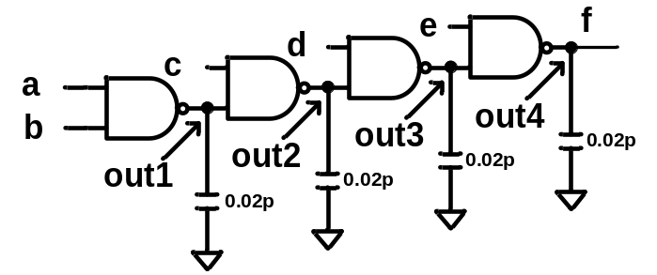
2-input NAND Cascade

