**UK HOSPITAL WEBSITE**

A Training Project Report

Submitted By

**HARSIMRAN SINGH – 1914287**

in partial fulfillment for the award of the degree

of



**BACHELOR OF TECHNOLOGY**

IN

**COMPUTER SCIENCE ENGINEERING**

At

**DEPARTMENT OF COMPUTER SCIENCE AND ENGINEERING**

**COLLEGE OF ENGINEERING**

**LANDRAN, MOHALI**

**JUNE2020**

CERTIFICATE

This is to certify that the work contained in this Project entitled “*UK Hospital Website*”, By *Harsimran Singh* has been carried out under my supervision from May 2020 to June 2020 and that this work has not been submitted elsewhere for a degree.

May, 2020

Supervisor Name and Signature

Assistant Professor

Name and Signature

Training and Placement Incharge- CSE College of Engineering

Landran, Mohali (Punjab) –140307 India

Head

Department of CSE / IT College Of Engineering

Landran, Mohali (Punjab) – 140307 India

** CGC- College of Engineering, **

**Landran, Mohal**

**CANDIDATE’S DECLARATION**

I hereby certify that the work which is being presented in the report entitled “**UK Hospital Website”** in partial fulfillment for the award of the Degree of Bachelor of Technology in Computer Science and Engineering affiliated to **Punjab Technical University, Jalandhar** and submitted to the Department of Computer Science and Engineering of CGC-College Of Engineering, is an authentic record of my own work carried out during a period from **May 2020 to June 2020**. The matter represented in this report has not been submitted by me for award of any other degree of this or any other institute/university.

**Date:**

**Name- Harsimran Singh**

**Roll no.- 1914287**

This is to certify that the above statement made by the candidate is correct to the best of our knowledge.

**Date: Training Head Head - CSE**

**ABSTRACT**

We all know that there is a global trend to a stronger active involvement of persons in the maintenance and restoring of health. Therefore the website named UK Hospital created by me and my friend has developed a lifestyle concept to enable each individual to manage his or her health. This website can help a patient suffering from a disease can directly consult to doctors within a second. The objective of this creating this website was to establish a core set of questionnaires for a self-assessment program on certain risk indications and comprehensive protection factors of health and to develop and enhance 1) tools for individual feedback, longitudinal self-monitoring, self-assessment, and (self-)care-planning; 2) training packages; 3) open notes and records for provider and patient; and 4) tools for monitoring groups and single participants in various indicators for individual coaching and scientific evaluation.

**ACKNOWLEDGEMENT**

I have taken keen efforts in this project. However, it would not have been possible without the kind support and help of my HOD Mrs. Gagandeep Kaur Bhullar. I would like to extend my sincere thanks to them.

I am highly indebted to my respected teachers of CGC-College of Engineering, Landran, Mohali for their guidance and constant supervision as well as for providing necessary information regarding the project & also for their support in completing the project.

I would like to express my gratitude towards my parents for their kind co-operation and encouragement which helped me in completion of this project.

My thanks and appreciation also goes to my friends in developing the project.

Harsimran Singh

**TABLE OF CONTENTS**

|  |  |  |
| --- | --- | --- |
| CHAPTER NO. | TITLE | PAGE NO. |
| 1. | Abstract | 4 |
| 2. | Acknowledgement | 5 |
| 3. | Introduction | 7-8 |
| 4. | Use of Html, CSS &  Java Script | 9 |
| 5. | How it is Beneficial | 10 |
| 6. | How it works | 11 |
| 7. | Reason behind making this website | 12 |
| 8. | Glimpse | 13-15 |
| 9. | Conclusion | 16 |

**INTRODUCTION**

The prevalence of obesity and stress are continuously rising, and so diseases have become a big issue for medical care and health systems. Therefore creating a medical website is an easy way to direct consult to doctors. UK Hospital website is good helping hand to decrease the overload work over the doctors.

Poor accountability and adherence of individuals are well-known obstacles that account for failure and lacking benefits of preventive and therapeutic lifestyle recommendation programs. To get the full requirements for a medical platform, you will need a comprehensive theme like UK hospital. This template takes care of all and everything that medical practitioners and patients need for smooth operations. As a medical website, it provides adequate support for handling appointments, vacations, records and other requirements. With all the practical and ready-to-use material, you can also just mix and match, brand the design and you are ready to roll.

Usually, measurable data are obtained only at the end of the program, such as in weight-reducing programs or diabetes prevention strategies. In order to enhance the accountability and adherence of the clients and patients, it is therefore recommended to conceptualize various performance measures that enable them to participate and engage their trainings and treatment plans.

UK hospital website is a sophisticated and all-in-one medical website template for doctors,dentists, hospitals, clinics, and other health institutions. With this website, you do the work yourself. Along with hundreds of ready-made sample layouts and other elements, this also contains a user-friendly page builder. Moreover, it also follows all the technical aspects of a modern page for a flawlesss, steadyand secure operation on all devices and platforms.

Different Services available on the website:

• DENTAL IMPLANTS

• WHITENING

• LABORATORY

• MEDICAL DRESSAGE

• EMERGENCY CONTRACEPTION

• HEPATOLOGY

**USE OF: HTML, CSS**

HTML gives content structure and meaning by defining that content as, for example, headings, paragraphs, or images. CSS, or Cascading Style Sheets, is a presentation language created to style the appearance of content—using, for example, fonts or colors. HTML, is a programming language used to describe the structure of information on a web page. Together, HTML, CSS, and JavaScript make up the essential building blocks of websites, with CSS controlling a page's appearance, and JavaScript programming its functionality.

An Overview:

• HTML provides the basic structure of sites, which is enhanced and modified by other technologies like CSS and JavaScript.

• CSS is used to control presentation, formatting, and layout.

• JavaScript is used to control the behavior of different elements.

**How is it Beneficial:**

The internet is one of the fastest sources of information. Since the evolution of the internet, it is flourishing into the most preferred source of information. The internet provides excellent opportunities for disseminating health information. This website makes the phone number, address, office hours and content available to patients 24 hours a day, which is especially helpful for patients experiencing medical emergencies.

It also gives patients the ability to make appointments online. This saves much time and effort. Also, instead of browsing a phone directory, patients can just type in what they need and click “search”, and the results will show up right away.

It also provides a great platform for us to add and highlight our patients’ reviews and our staff members’ testimonials. It helps us to become more accessible to our potential patients. Unless there are system errors or whatnot, a website is accessible even before our practice opens and after it closes. When potential patients look for a doctor online, chances are they’ll see us and visit our website.

Busy doctors or medical professionals may feel setting up a website is a waste of time, however, every good doctor knows that keeping their patients happy and providing excellent patient education and care is key to their success. A good website provides many value- added services and information for your patients.

**How It Works:**

Web site will provide the all-important first impression of their practice.

It provides details such as:

* Practice Work Hours
* Address, Phone Numbers and directions on how to get to the practice
* Online appointment requests
* Answers to commonly asked questions or FAQ's
* Animation and information on the treatments offered
* Pres and post-procedure instructions
* Online Patient Forms, this could shorten wait time at the practice
* post-procedure instructions

All this and more on a websites helps serve patients round the clock, without requiring them to call or visit, making your website a valuable support or contact centre.

**Social Usage**:

This website will socially help:

* to potentially improve health outcomes
* to develop a professional network
* to increase personal awareness of news and discoveries
* to motivate patients and provide health information to the community

**GLIMPSE OF WORKING MODEL:**

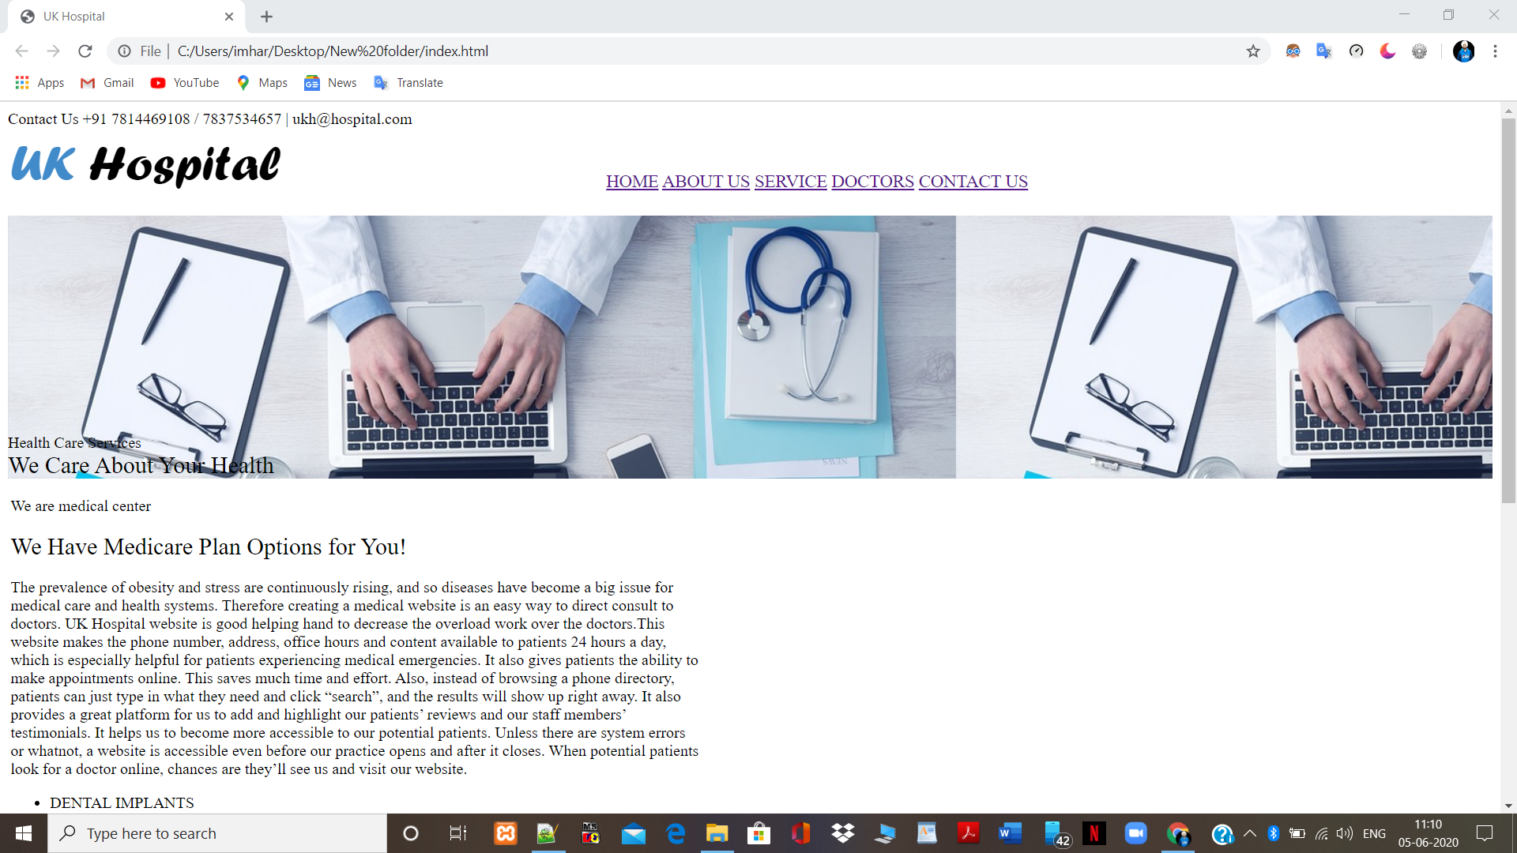

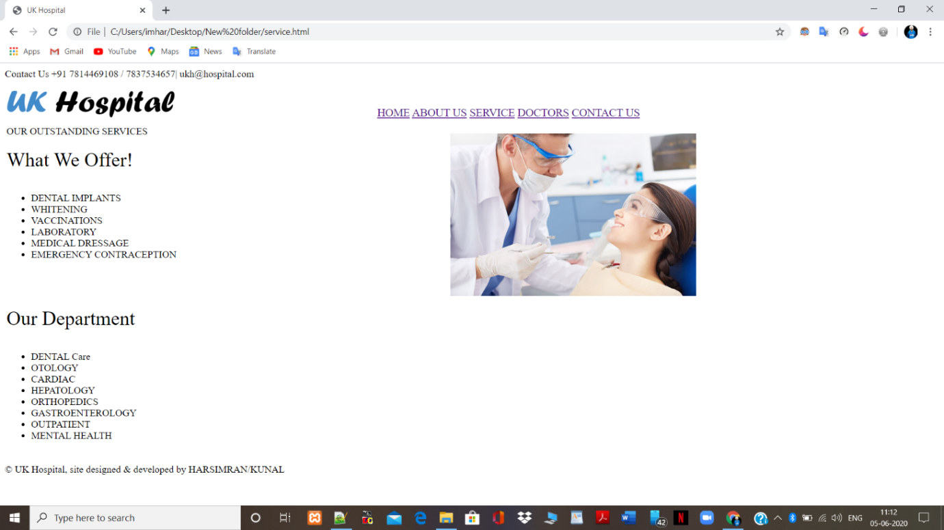

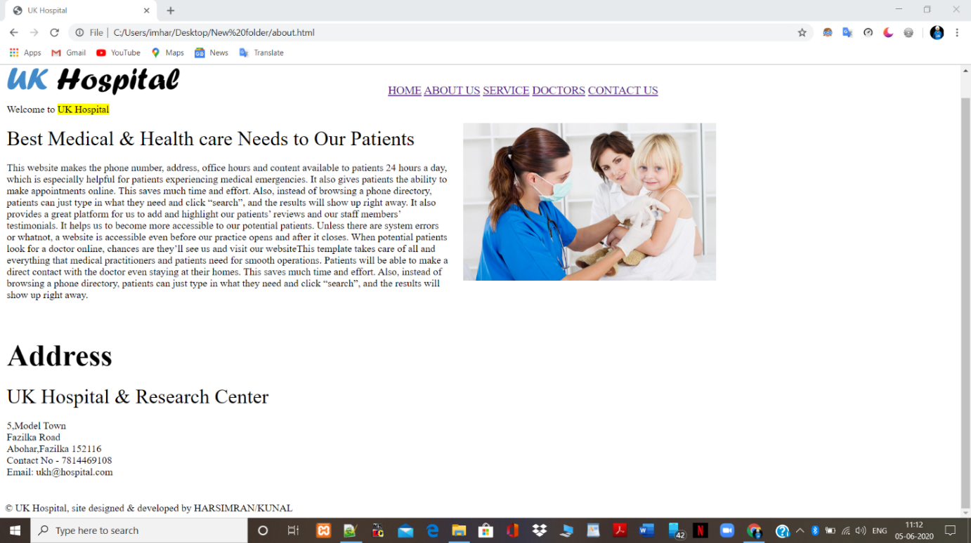

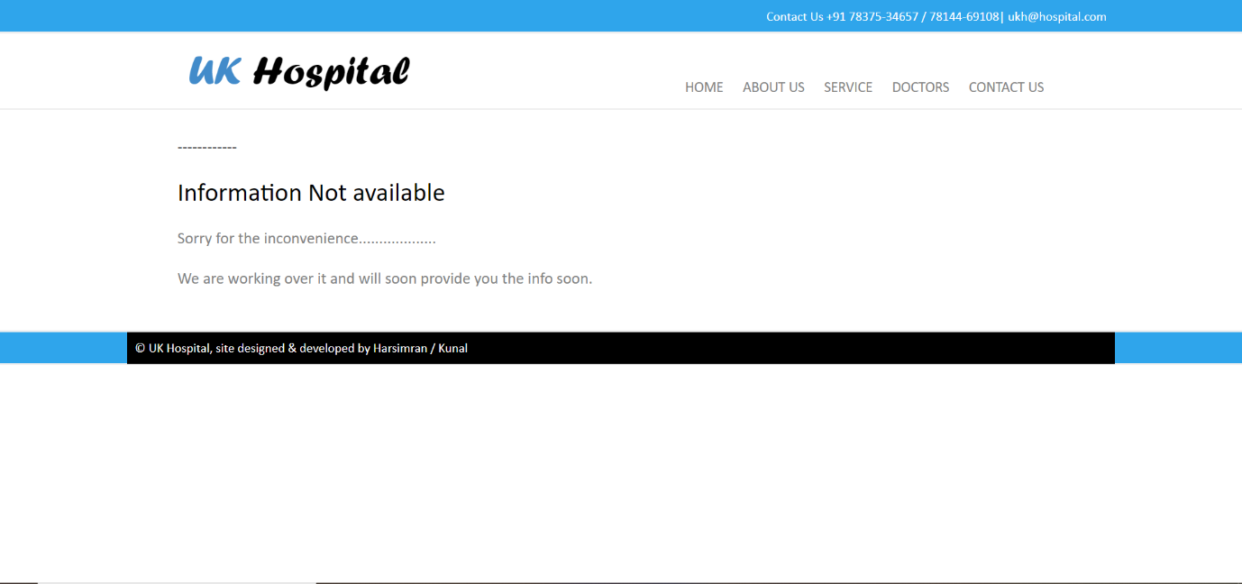

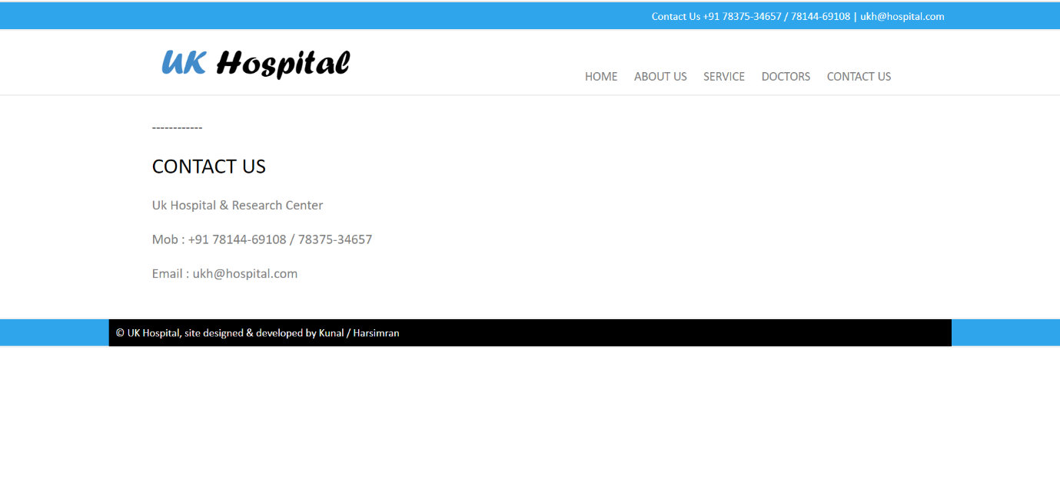

**Conclusion**

Creating a medical website is an easy way to direct consult to doctors so we thought of this idea. This will help people in many ways as mentioned earlier. So we have tried using HTML, CSS and JS to make out our website as a project. Different languages have played their different roles. This template takes care of all and everything that medical practitioners and patients need for smooth operations. Patients will be able to make a direct contact with the doctor even staying at their homes. This saves much time and effort. Also, instead of browsing a phone directory, patients can just type in what they need and click “search”, and the results will show up right away. So this idea encouraged us to make this project.

**References**

* [www.google.com](http://www.google.com)
* <http://www.cisco.com/>
* [www.wikipedia.com](http://www.wikipedia.com)
* [www.firewall.cx](http://www.firewall.cx)
* [www.encyclopedia.com](http://www.encyclopedia.com)
* [www.ebookee.org](http://www.ebookee.org)