Background-Dependent Effects of Lunar Surface Topography on Seismic Wave Propagation: From a Controlled Half-Space Profile to the Apollo 16 Impact
月球表面地形对地震波传播的背景依赖效应：从受控半空间剖面到 Apollo 16 撞击记录
Tianxiong Wu¹˒², Yanbin Wang¹˒², and Wei Zhang³
¹ Department of Geophysics, School of Earth and Space Sciences, Peking University, Beijing 100871, China
² State Key Laboratory of Earthquake Dynamics and Forecasting, Peking University, Beijing 100871, China
³ Department of Earth and Space Sciences, Southern University of Science and Technology, Shenzhen, Guangdong 518055, China
Corresponding author: Yanbin Wang (ybwang@pku.edu.cn)
Bilingual working format: English paragraphs are the journal-facing text; blue Chinese paragraphs are the author-side translation and should be removed from the final English-only submission.
双语使用说明：英文段落为投稿正文，蓝色中文段落用于作者核对；最终英文投稿版应删除中文译文。

Key Points / 要点
- A controlled half-space profile demonstrates that topography redistributes energy among Z/R/T components and lengthens weak-energy duration rather than applying a uniform amplitude correction.
中文：受控半空间剖面表明，地形会在Z/R/T分量之间重新分配能量并延长弱能量持续时间，而不是施加统一的振幅修正。
- Topographic sensitivity is background dependent: the marginal effect changes after layering, random heterogeneity, and the tested low-velocity structure are introduced.
中文：地形敏感性依赖背景介质：加入分层、随机非均匀性和所测试的低速结构后，地形的边际效应会发生变化。
- All tested models retain a predominantly finite-speed energy ridge and remain much shorter than the Apollo S12 long coda.
中文：所有测试模型的主能量脊仍以有限速度传播为主，持续时间远短于Apollo S12长尾波。

Abstract / 摘要
Apollo impact seismograms exhibit emergent arrivals, strong three-component mixing, and codas lasting thousands of seconds, but the contribution of lunar surface relief is difficult to separate from subsurface structure. We construct a staged numerical evidence chain from controlled half-space tests to an Apollo 16/Apollo 12 regional comparison. The half-space topography switch uses 800 receivers on a single 75° profile at 50 m spacing; distance trends use r20-r760 (1-38 km), and Vx/Vy are rotated to radial and transverse components. Separate 216-receiver experiments quantify topographic-resolution and layering sensitivity. The regional A16/S12 ladder uses a simple four-layer background and six states: M1 flat without random heterogeneity, M2 topographic without heterogeneity, M3 flat with heterogeneity, M4 topographic with heterogeneity, and M5-M6 low-velocity extensions of M3-M4. In the half-space profile, topography reduces the median peak-amplitude and finite-window energy ratios to 0.116 and 0.0296, increases the median T90 ratio to 4.13, and raises the transverse energy fraction from nearly zero to 27.6%. Relative to the 0.125 km reference, 0.5 km preserves waveform shape (median correlation 0.976) but retains a 19.4% median energy error; 0.25 km provides joint waveform-energy convergence (correlation 0.996; energy error 5.1%). In the regional ladder, heterogeneity and low velocity broaden the wavefield more strongly, while topography remains measurable but nonadditive. Linear-distance peak-time fits outperform simple squared-distance diffusion fits in every tested state. At S12, M5-M6 delay the synthetic envelope peaks to 213-273 s, still well before the observed median peak at 658 s and t95 at 2,805 s. Lunar relief is therefore essential for accurate early-wavefield modeling, but the tested relief, heterogeneity, and low-velocity structure are insufficient to explain the Apollo long coda.
中文：Apollo撞击记录具有渐进式初至、显著的三分量混合以及持续数千秒的尾波，但月表起伏的贡献很难与地下结构分离。本文建立从受控半空间试验到Apollo 16撞击—Apollo 12台站区域对比的分级数值证据链。半空间地形开关试验采用沿75°方位、间距50 m的800个单剖面台站；距离分析使用r20-r760（1-38 km），并将Vx/Vy旋转到径向和横向。另以独立的216台站试验评估地形分辨率和分层敏感性。区域A16/S12模型采用简单四层背景和六种状态：M1为平坦且无随机非均匀性，M2为地形且无非均匀性，M3为平坦且有非均匀性，M4同时包含地形和非均匀性，M5-M6分别是M3-M4的低速结构扩展。在半空间剖面中，地形使峰值振幅和有限时窗能量比的中位数分别降至0.116和0.0296，使T90比值中位数增至4.13，并将横向能量占比从接近零提高到27.6%。相对0.125 km参考模型，0.5 km可保持波形形状（相关系数中位数0.976），但能量误差中位数仍为19.4%；0.25 km则达到波形—能量联合收敛（相关0.996、能量误差5.1%）。在区域模型阶梯中，随机非均匀性和低速结构引起更强展宽，地形效应仍可测但不具有简单可加性。所有模型状态中，峰时的线性距离拟合均优于简单距离平方扩散拟合。在S12台站，M5-M6将合成包络峰推迟到213-273 s，但仍明显早于观测峰值中位数658 s和t95约2805 s。因此，月表起伏是准确模拟早期波场的重要因素，但当前测试的地形、非均匀性和低速结构仍不足以解释Apollo长尾波。
Keywords: lunar seismology; surface topography; seismic scattering; low-velocity layer; Apollo impacts; numerical wave propagation
中文：关键词：月球地震学；表面地形；地震散射；低速层；Apollo撞击；数值波传播

1 Introduction / 1 引言
Apollo seismic records differ from typical terrestrial seismograms through emergent arrivals, severe phase mixing, and codas that may persist for hundreds to thousands of seconds. These features are generally associated with strong scattering in a dry, fractured regolith and megaregolith combined with weak intrinsic attenuation (Nunn et al., 2020). Numerical and envelope studies show that the strength, thickness, and correlation scales of shallow heterogeneity can strongly alter lunar signals (Blanchette-Guertin et al., 2012, 2015a, 2015b; Gillet et al., 2017; Onodera et al., 2021, 2022).
中文：Apollo月震记录与典型地球地震记录显著不同，其特点包括渐进式初至、严重的震相混合以及可持续数百至数千秒的尾波。通常认为，这些特征与干燥、破碎的风化层和巨风化层所产生的强散射及较弱的本征衰减共同有关（Nunn et al., 2020）。数值模拟与包络研究表明，浅层非均匀性的强度、厚度和相关尺度能够显著改变月球地震信号（Blanchette-Guertin et al., 2012, 2015a, 2015b; Gillet et al., 2017; Onodera et al., 2021, 2022）。
The Moon also has cratered relief over a broad range of scales. Irregular free surfaces can reflect, diffract, focus, defocus, and convert elastic energy, producing large local waveform changes even when the volume model is unchanged (Hartzell et al., 1994; Pitarka & Irikura, 1996; Rodgers et al., 2010; Zhang et al., 2012). However, surface and volume scattering should not be described as fundamentally separate mechanisms. Particle-relabelling theory shows that boundary topography can be mapped exactly to an equivalent volumetrically heterogeneous representation under a transformed reference configuration (Al-Attar & Crawford, 2016). The useful distinction in our experiment is therefore operational: paired simulations isolate the consequence of changing the free surface while holding the prescribed volume model fixed.
中文：月球还具有跨越多种尺度的撞击坑地形。不规则自由表面可以反射、衍射、聚焦、散焦并转换弹性能量，即使体介质模型不变，也会产生明显的局部波形差异（Hartzell et al., 1994; Pitarka & Irikura, 1996; Rodgers et al., 2010; Zhang et al., 2012）。但是，不应把地表散射和体介质散射描述为机制上截然分离的过程。粒子重标记理论表明，在变换后的参考构形中，边界地形可以精确映射为等效的体介质非均匀性（Al-Attar & Crawford, 2016）。因此，本文采用的是操作性区分：在保持给定体介质模型不变的前提下，通过成对模拟隔离改变自由表面的后果。
A second ambiguity concerns scale. A digital elevation grid can preserve the visible shape of a synthetic waveform while still biasing its energy, and a longer scattered wave train does not automatically imply diffusion. In a simple near-field diffusion picture, a characteristic envelope time scales as R²/D, whereas the migration of a coherent or quasi-ballistic energy packet is closer to R/v. Distinguishing these regimes requires quantitative waveform similarity, energy, duration, component partitioning, and competing distance fits rather than independently normalized waveform displays.
中文：第二个问题涉及尺度。数字高程网格可能已经保持合成波形的外观形状，但仍对能量产生偏差；同样，更长的散射波列也不自动等同于扩散。在简单近场扩散图像中，特征包络时间近似按R²/D增长，而相干或准弹道主能量包的迁移更接近R/v。因此，区分两种传播状态需要同时使用波形相似性、能量、持续时间、分量占比以及竞争性距离拟合，而不能依赖分别归一化的波形图。
We address these issues with a hierarchical design. First, controlled half-space tests establish the three-component topographic signature, its distance dependence, the topographic-resolution threshold, and the effect of adding layering. Second, a regional A16/S12 ladder combines topography, random heterogeneity, and a tested low-velocity structure within one consistent M1-M6 interpretation. Third, the six synthetic records are compared with the Apollo 16 impact observed at station S12 using common three-component scaling, individual component envelopes, cumulative energy, and smoothing sensitivity.
中文：本文采用分级试验设计解决上述问题。首先，受控半空间试验确定地形的三分量特征、距离依赖性、地形分辨率阈值以及加入分层后的变化。其次，区域A16/S12模型阶梯在统一的M1-M6解释框架中组合地形、随机非均匀性和所测试的低速结构。最后，采用统一三分量尺度、各分量包络、累计能量和平滑敏感性，将六个合成记录与S12台站观测到的Apollo 16撞击记录进行比较。
Our central question is deliberately bounded: how does lunar topography modify the modeled wavefield under progressively more complex backgrounds, and do these effects approach the observed lunar envelope? We distinguish a measurable effect from a sufficient explanation. A mechanism may strongly change the first 250-400 s without explaining a record whose energy continues for nearly 3,000 s.
中文：本文的核心问题被明确限定为：随着背景模型逐步复杂化，月球地形如何改变模拟波场，这些改变是否接近观测月震包络？我们严格区分“可测效应”和“充分解释”。某种机制可以显著改变前250-400 s的波形，却仍不足以解释能量延续近3000 s的真实记录。

2 Numerical Models, Geometry, and Analysis / 2 数值模型、几何与分析方法

2.1 Numerical method and common processing / 2.1 数值方法与统一处理
Three-dimensional elastic wave propagation is calculated with CGFD3D, which represents irregular free surfaces on curvilinear grids and applies a traction-image free-surface treatment (Zhang & Chen, 2006; Zhang et al., 2012; Wang et al., 2022). Absorbing layers are applied on lateral and bottom boundaries. All reported comparisons use matched source-receiver names and identical post-processing; absolute amplitude and energy contrasts involving M5/M6 remain conditional on the unarchived run settings being unchanged.
中文：三维弹性波传播采用CGFD3D计算。该方法利用曲线网格表示不规则自由表面，并采用牵引力镜像自由表面处理（Zhang & Chen, 2006; Zhang et al., 2012; Wang et al., 2022）。侧边界和底边界设置吸收层。所有对比均使用匹配的震源—台站名称和相同后处理流程；由于M5/M6缺少完整运行清单，其绝对振幅与能量对比仍以其他运行条件未改变为前提。
Traces are demeaned and filtered at their native sampling rates with a fourth-order zero-phase Butterworth bandpass from 0.3 to 0.9 Hz, then interpolated to a common 0.02 s time axis when cross-run alignment is required. Horizontal outputs are rotated using source-receiver azimuth θ: R=Vx cosθ+Vy sinθ and T=-Vx sinθ+Vy cosθ. We report three-component correlation, peak amplitude, integrated squared-velocity energy, T90 between the 5% and 95% cumulative-energy times, smoothed energy-peak time, and Z/R/T energy fractions.
中文：记录先在原始采样率下去均值，并采用0.3-0.9 Hz四阶零相位Butterworth带通滤波；跨运行对齐时再插值到0.02 s公共时间轴。水平输出依据震源—台站方位角θ旋转：R=Vx cosθ+Vy sinθ，T=-Vx sinθ+Vy cosθ。本文报告三分量相关系数、峰值振幅、速度平方积分能量、累计能量5%-95%之间的T90、平滑能量峰值时间以及Z/R/T能量占比。

2.2 Controlled half-space profile / 2.2 受控半空间单剖面
The primary half-space topography switch contains 800 receivers generated from source coordinate (50,000, 50,000) m along an azimuth of 75° measured from +X. Receiver spacing is 50 m, giving source-receiver distances from 0.05 to 40.00 km. All 800 matched stations are used for paired distribution summaries; r20-r760, corresponding to 1-38 km, are used for distance-profile analysis to reduce endpoint effects. The r1-r216 test.station file belongs to another experimental geometry and is not used to assign coordinates to these 800 traces.
中文：主要半空间地形开关试验包含800个台站，震源坐标为(50,000, 50,000) m，台站从+X方向起沿75°方位排列，间距50 m，震源距范围为0.05-40.00 km。全部800个同名台站用于成对分布统计；距离剖面使用r20-r760，即1-38 km，以减小端点影响。现有r1-r216 test.station文件属于另一套试验几何，不能用于给这800条记录赋予坐标。
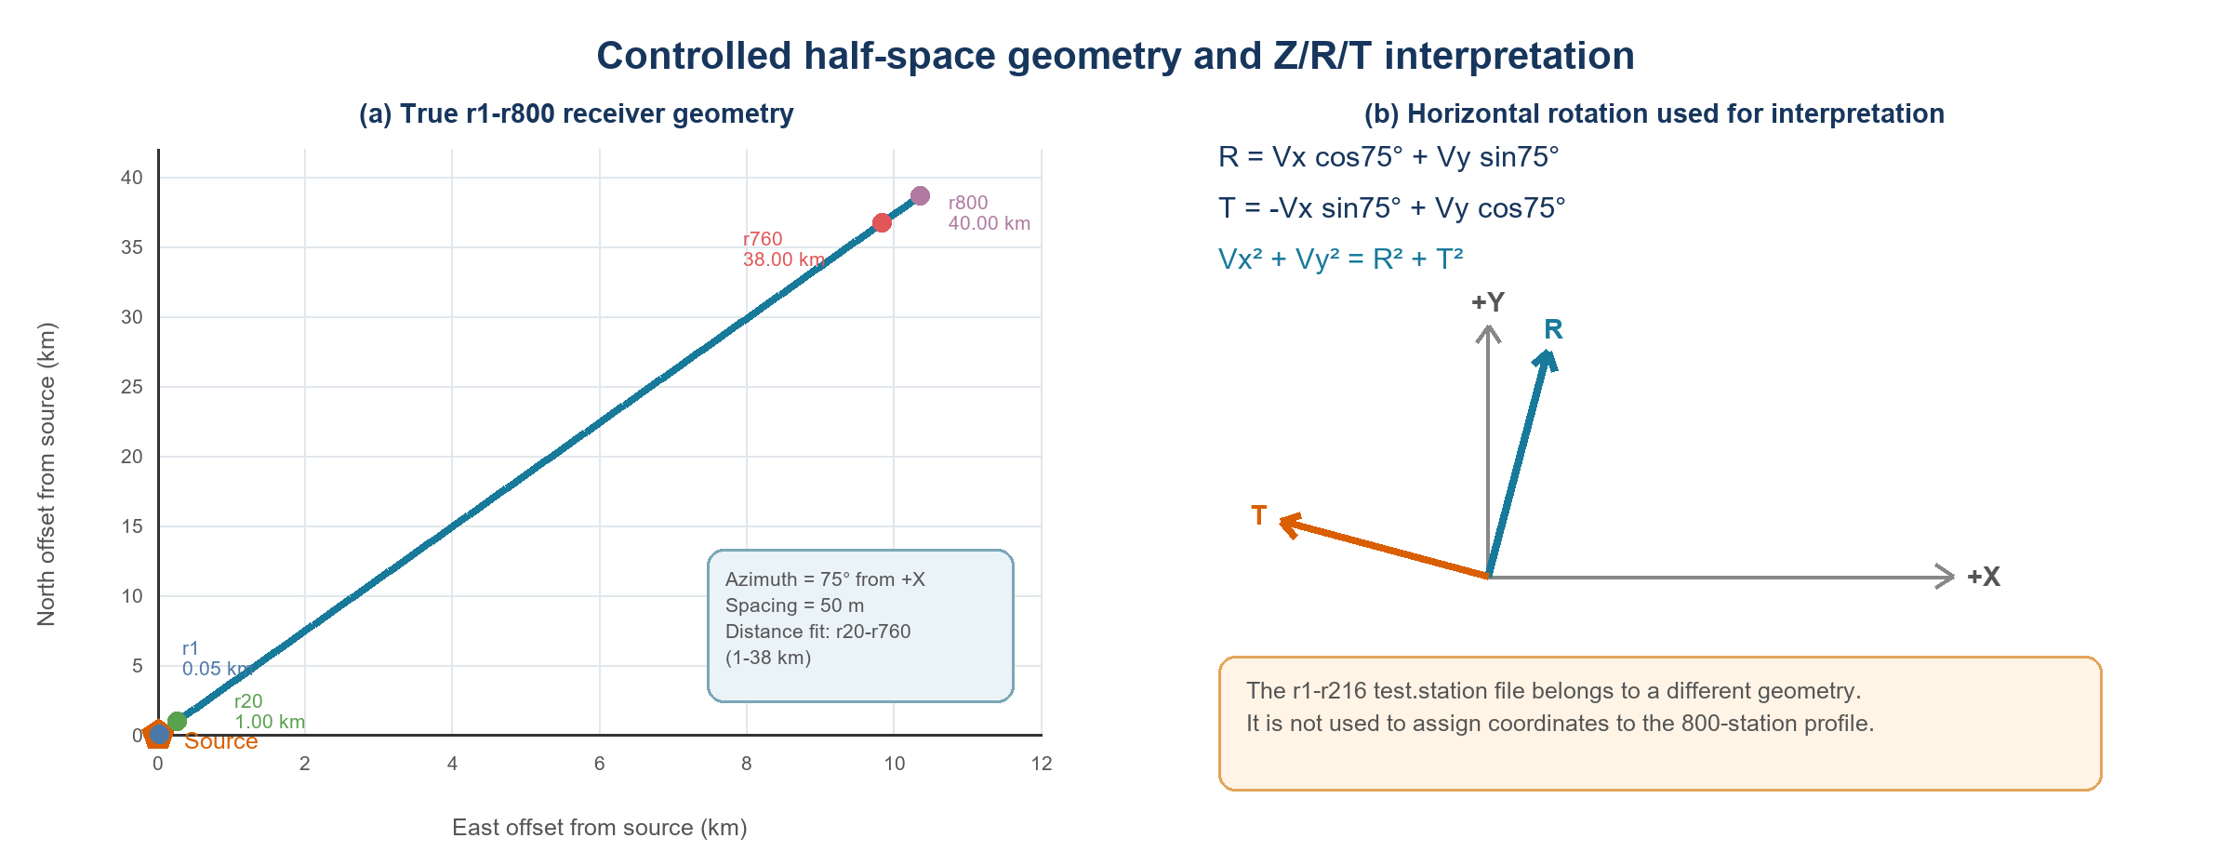
Figure 1. Geometry of the true r1-r800 half-space profile and rotation from Vx/Vy to radial/transverse components. Distance-dependent inference is restricted to the single 75° profile. 图 1：真实r1-r800半空间剖面几何及Vx/Vy向径向/横向分量的旋转。距离关系仅限于该75°单剖面。

2.3 Resolution and layering experiments / 2.3 分辨率与分层试验
Topographic-resolution tests use a separate 216-receiver geometry and grids of approximately 0.125, 0.25, 0.5, 1, 2.5, 4, 6.25, and 10 km. The numerical suffixes in the production directories denote sampling counts over the modeled span, not meter-valued grid spacing. Convergence is evaluated relative to the 0.125 km case using maximum correlation within ±2 s and finite-window energy error. A separate matched 216-receiver pair tests the consequence of adding the layered background while holding the topographic surface fixed.
中文：地形分辨率试验采用独立的216台站几何，网格尺度约为0.125、0.25、0.5、1、2.5、4、6.25和10 km。生产目录中的数字后缀表示模型范围内的采样点数，而不是以米为单位的网格间距。以0.125 km为参考，采用±2 s范围内的最大相关系数和有限时窗能量误差评估收敛性。另一组匹配的216台站试验在保持地形表面不变的条件下检验加入分层背景的影响。

2.4 A16/S12 background and M1-M6 ladder / 2.4 A16/S12背景与M1-M6模型阶梯
The regional model spans 300×300×40 km and uses a 1,500×1,500×200 grid. The verified production design is a simple four-layer model, not the 34-layer exploratory model described in an earlier response. Flat interfaces occur at 0, 5, 10, 30, and 40 km. The material parameters are listed in Table 1. In heterogeneous states, three-dimensional von Kármán-correlated velocity perturbations have standard deviations of 9% at 0-5 km and 5% at 5-10 km with a 4.5 km correlation scale. The perturbation field has zero mean; the present dataset contains one realization.
中文：区域模型范围为300×300×40 km，网格为1500×1500×200。经生产设计文件核实，实际采用的是简单四层模型，而不是先前回复中描述的34层探索性模型。平坦界面深度为0、5、10、30和40 km。介质参数见表1。在含非均匀性的模型中，三维von Kármán相关速度扰动在0-5 km和5-10 km深度的标准差分别为9%和5%，相关尺度为4.5 km。扰动场均值为零，现有数据仅包含一个随机实现。
Table 1. Verified simple four-layer A16/S12 background model. 表1. 经核实的A16/S12简单四层背景模型。
Depth / 深度 (km) | Layer / 层位 | Vp / Vs (km s⁻¹) | Density / 密度 (g cm⁻³) | Q | Heterogeneity / 扰动
0-5 | Weathered layer / 风化层 | 3.20 / 2.30 | 2.60 | 6750 | 9%
5-10 | Megaregolith / 巨风化层 | 3.20 / 2.30 | 2.76 | 5000 | 5%
10-30 | Lower crust / 下月壳 | 5.50 / 3.18 | 2.76 | 4000 | 0
30-40 | Mantle / 月幔 | 7.55 / 4.36 | 3.36 | 3750 | 0

The six states are defined by model content rather than by performance ranking (Table 2). M1 is flat without random heterogeneity; M2 is topographic without heterogeneity; M3 is flat with heterogeneity; M4 contains both topography and heterogeneity. M5 and M6 add the tested low-velocity structure to M3 and M4, respectively. Consequently, M2/M1 and M4/M3 estimate conditional topographic effects, M3/M1 and M4/M2 estimate conditional heterogeneity effects, and M5/M3 and M6/M4 describe low-velocity run differences on heterogeneous backgrounds. Missing low-velocity/no-heterogeneity cells prevent estimation of a complete three-factor interaction.
中文：六个模型状态按其物理组成定义，而不是按结果优劣排序（表2）。M1为平坦且无随机非均匀性，M2为地形且无非均匀性，M3为平坦且有非均匀性，M4同时包含地形和非均匀性。M5和M6分别在M3和M4基础上加入所测试的低速结构。因此，M2/M1和M4/M3估计条件性地形效应，M3/M1和M4/M2估计条件性非均匀性效应，M5/M3和M6/M4描述非均匀背景下的低速运行差异。由于缺少“低速且无非均匀性”单元，无法估计完整的三因素交互。
Table 2. Unified definitions of M1-M6 used throughout the manuscript. 表2. 全文统一使用的M1-M6定义。
State | Surface / 地表 | Random H / 随机非均匀性 | Low velocity / 低速结构 | Primary contrast / 主要对比
M1 | Flat / 平坦 | No / 无 | No / 无 | Reference / 参考
M2 | Topographic / 地形 | No / 无 | No / 无 | M2/M1: topography
M3 | Flat / 平坦 | Yes / 有 | No / 无 | M3/M1: heterogeneity
M4 | Topographic / 地形 | Yes / 有 | No / 无 | M4/M3; M4/M2
M5 | Flat / 平坦 | Yes / 有 | Yes / 有 | M5/M3: low velocity
M6 | Topographic / 地形 | Yes / 有 | Yes / 有 | M6/M4; M6/M5

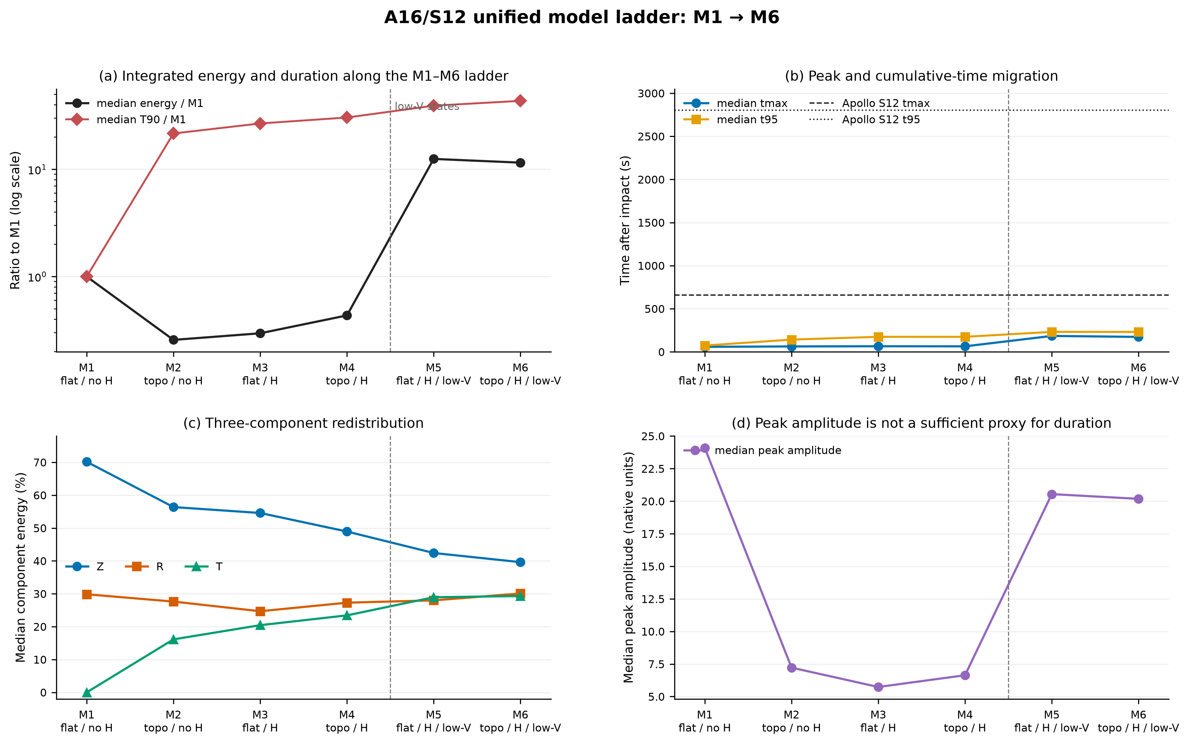
Figure 2. Unified A16/S12 M1-M6 mechanism ladder. M5/M6 are conditional low-velocity extensions of heterogeneous states, not independent low-velocity-only controls. 图 2：统一的A16/S12 M1-M6机制阶梯。M5/M6是含非均匀性模型的条件性低速扩展，并非独立的纯低速控制组。

2.5 Receiver selection and observation comparison / 2.5 台站选择与观测对比
Each A16 output contains r1-r606. One trace corresponds to Apollo station S12 and the others form three approximately radial profiles. Excluding the first and last five stations of each profile leaves 575 primary receivers; nonoverlapping blocks of 10 adjacent receivers produce 57 spatial blocks for interval estimates. M1-M4 records are approximately 250 s and M5-M6 approximately 400 s, so the common comparison window is 50-245 s and the extended low-velocity diagnostic window is 50-395 s.
中文：每个A16输出包含r1-r606。其中一条记录对应Apollo S12台站，其余台站构成三条近似径向剖面。每条剖面去除首尾各5站后保留575个主分析台站；按相邻10站构建非重叠空间块，得到57个空间块用于区间估计。M1-M4记录约250 s，M5-M6约400 s，因此公共比较窗为50-245 s，低速扩展诊断窗为50-395 s。
The Apollo comparison uses the three-component Apollo 16 artificial-impact record at Apollo 12 station S12. A single root-mean-square factor is applied jointly to all three components of each model over the shared window. Individual components are never normalized separately. Three-component analytic-signal energy is smoothed with 5, 10, 20, 40, 60, and 100 s windows; the median peak time and the minimum-maximum range quantify smoothing sensitivity. Rise time is defined as the interval from 5% cumulative energy to the smoothed energy peak, and T90 is reported separately.
中文：Apollo对比采用Apollo 12的S12台站记录到的Apollo 16人工撞击三分量数据。在公共时间窗内，每个模型仅估计一个同时作用于三个分量的均方根尺度因子，绝不对各分量分别归一化。三分量解析信号能量采用5、10、20、40、60和100 s窗口平滑，以峰值时间中位数及最小—最大范围描述平滑敏感性。上升时间定义为累计能量达到5%至平滑能量峰之间的时间，T90单独报告。

2.6 Statistical contrasts and distance models / 2.6 统计对比与距离模型
Positive metrics are compared as logarithmic ratios, whereas times and component fractions are compared as differences. The baseline interaction is [ln(M4/M3)-ln(M2/M1)], equivalently the change in the topographic effect after heterogeneity is added. Terrain-response relations are detrended by epicentral distance within profile, standardized, and evaluated with Spearman correlation on spatial blocks with Benjamini-Hochberg false-discovery-rate control. Profile-specific results are retained to avoid converting directional relations into universal laws.
中文：正值指标采用对数比值比较，时间和分量占比采用差值比较。基线交互定义为[ln(M4/M3)-ln(M2/M1)]，即加入非均匀性后地形效应的变化。地形—响应关系在各剖面内去除震中距趋势并标准化，在空间块上计算Spearman相关，同时采用Benjamini-Hochberg方法控制错误发现率。保留分剖面结果，以避免把方向性关系误写成普适规律。
For transport diagnostics, we fit tmax=a+bR and tmax=a+cR² and compare residual error and Akaike information criterion. This is a regime test, not an inversion for lunar diffusivity. A preference for the linear form indicates that the modeled main energy ridge is still dominated by finite-speed migration over the sampled distance and time window; it does not rule out a later diffusive coda beyond the numerical record.
中文：传播诊断分别拟合tmax=a+bR和tmax=a+cR²，并比较残差和Akaike信息准则。这是传播状态检验，而不是对月球扩散率的反演。线性形式更优说明在当前距离和时间窗内，模拟主能量脊仍主要由有限速度迁移控制；它不能排除数值记录结束后存在更晚的扩散尾波。

3 Results / 3 结果

3.1 Half-space topography changes all three components / 3.1 半空间地形改变全部三分量
Across the 800 matched half-space receivers, the topographic and flat records are not related by a scalar amplitude factor. Median zero-lag three-component correlation is -0.012, median peak-amplitude ratio is 0.116, and median finite-window energy ratio is 0.0296. Median T90 increases by a factor of 4.13, corresponding to an absolute median extension of 6.25 s. The strong energy reduction together with longer duration shows redistribution from a compact coherent pulse into weaker, prolonged arrivals.
中文：在800个匹配的半空间台站中，地形记录与平坦记录之间不能用单一振幅系数转换。三分量零时滞相关系数中位数为-0.012，峰值振幅比中位数为0.116，有限时窗能量比中位数为0.0296。T90中位数增加到4.13倍，对应绝对延长6.25 s。显著能量降低与持续时间增加同时出现，表明紧凑相干主脉冲被重新分配为更弱、更持久的到时。
Rotation into Z/R/T reveals that the principal change is component conversion. The flat model has median Z/R/T fractions of 72.4%/27.6%/approximately 0%; the topographic model changes them to 42.3%/28.5%/27.6%. The radial fraction is nearly conserved, while energy is transferred primarily from Z to T. Thus the correct interpretation is three-dimensional conversion and path redistribution, not uniform attenuation of the horizontal components.
中文：旋转到Z/R/T后可以看到，主要变化来自分量转换。平坦模型的Z/R/T能量占比中位数为72.4%/27.6%/接近0%，地形模型变为42.3%/28.5%/27.6%。径向占比基本保持，而能量主要从Z转移到T。因此，正确解释是三维模式转换和路径重分配，而不是水平分量的统一衰减。
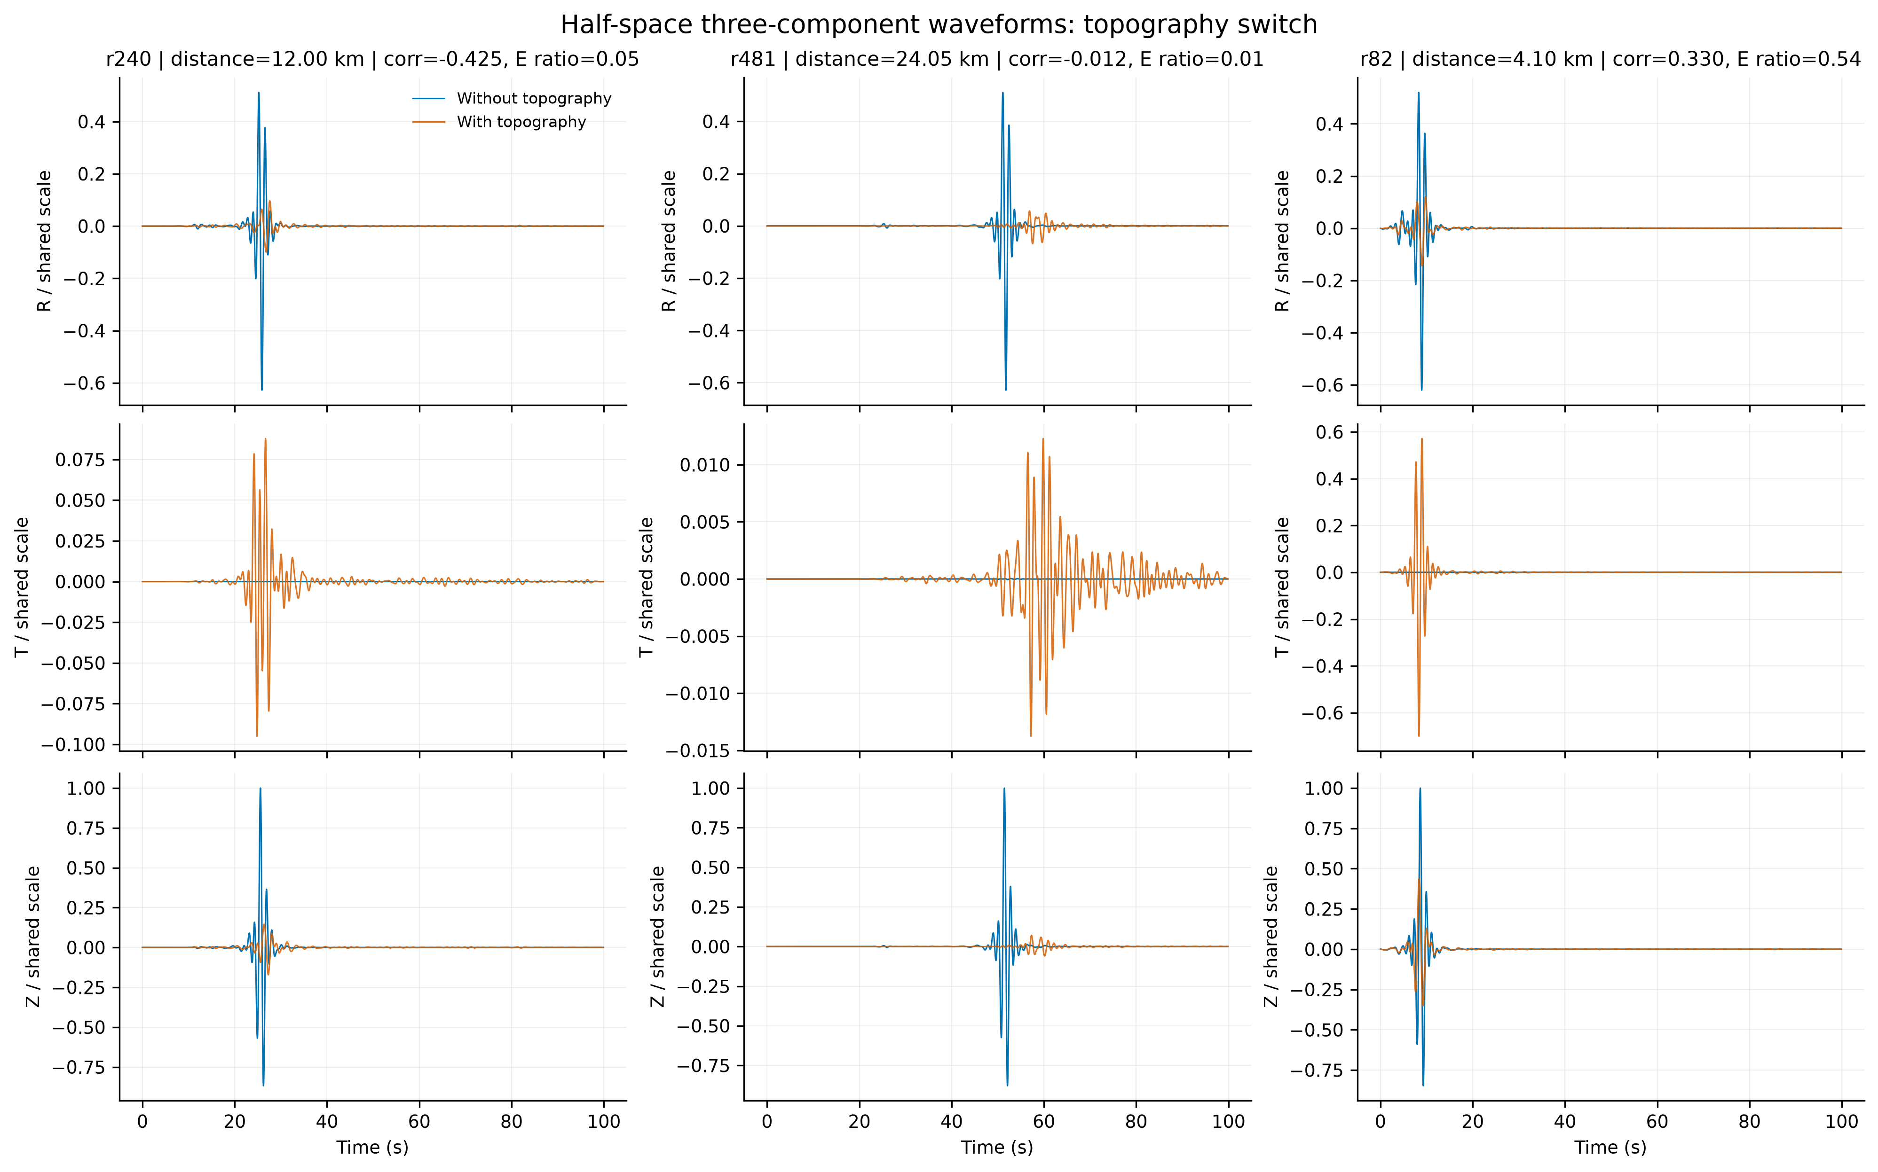
Figure 3. Representative half-space three-component waveforms with and without topography, plotted on common scales after rotation to Z/R/T. 图 3：半空间有无地形的代表性三分量波形，旋转至Z/R/T后采用统一尺度绘制。

3.2 The single-profile effect varies with distance / 3.2 单剖面地形效应随距离变化
Within r20-r760, the median energy ratio, peak-amplitude ratio, and T90 ratio are 0.227, 0.479, and 3.31 at 1-10 km; 0.0524, 0.147, and 4.66 at 10-25 km; and 0.00922, 0.0550, and 5.07 at 25-38 km. Coherent amplitude and finite-window energy therefore decrease with distance along this profile, whereas relative duration generally increases. Local relief produces pronounced nonmonotonic fluctuations around these trends.
中文：在r20-r760范围内，1-10 km区间的能量比、峰值振幅比和T90比中位数分别为0.227、0.479和3.31；10-25 km为0.0524、0.147和4.66；25-38 km为0.00922、0.0550和5.07。因此，沿该剖面相干振幅和有限时窗能量总体随距离降低，而相对持续时间总体增加，局部地形起伏在这一趋势上叠加了明显的非单调波动。
These curves should not be interpreted as intrinsic attenuation laws. They combine path-specific relief, finite recording time, geometric spreading, and redistribution outside the analyzed coherent packet. Because the geometry is one 75° profile, the distance trend cannot be extrapolated to isotropic lunar propagation.
中文：这些曲线不能解释为介质本征衰减律。它们同时受到路径特定起伏、有限记录时长、几何扩散以及能量离开所分析相干波包等因素控制。由于几何仅为75°单剖面，该距离趋势不能外推为各向同性的月球传播规律。
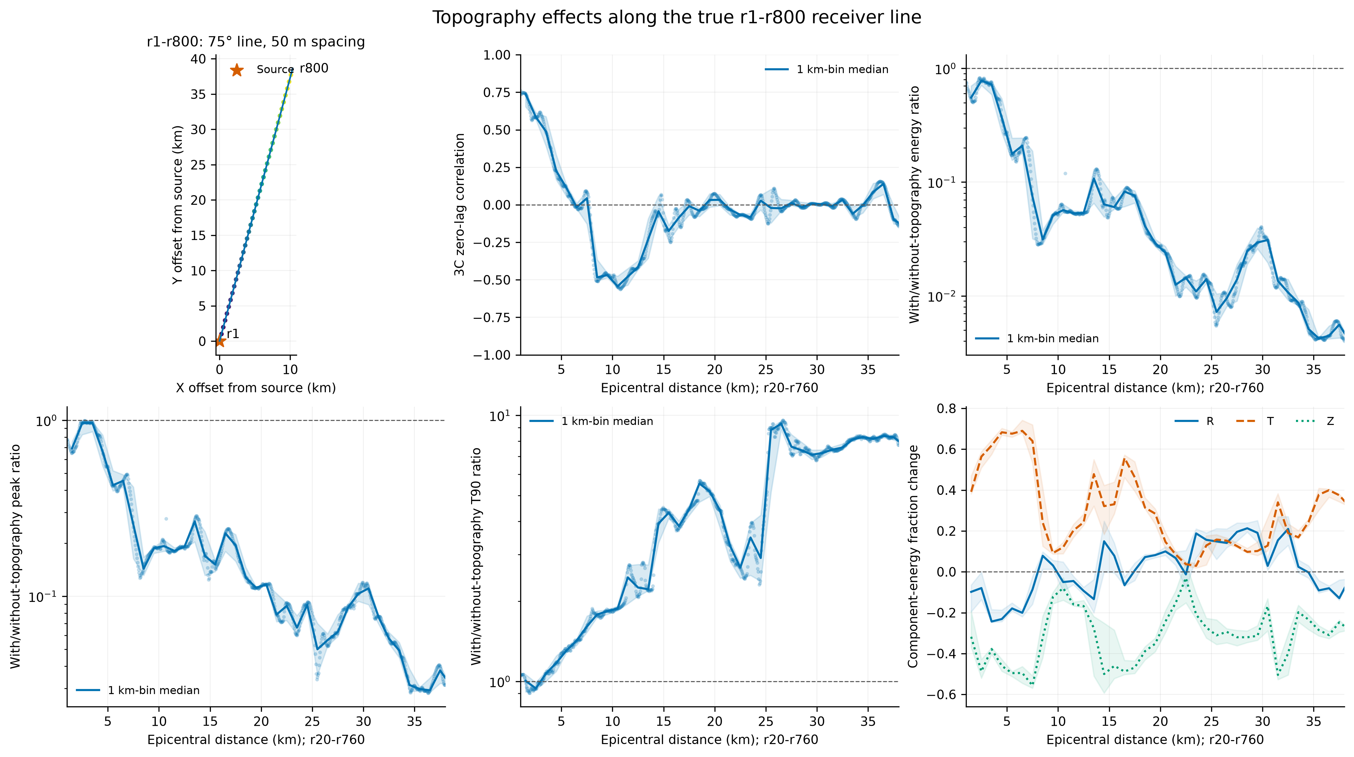
Figure 4. Stationwise half-space topographic effects on correlation, amplitude, energy, duration, and component partitioning. 图 4：半空间地形对台站相关性、振幅、能量、持续时间和分量能量分配的影响。

3.3 Resolution requires separate waveform and energy thresholds / 3.3 分辨率需要区分波形与能量阈值
Relative to the 0.125 km topographic reference, the 0.5 km model has a median maximum correlation of 0.976 and a 10th percentile of 0.950 after allowing a ±2 s alignment. Its median energy error nevertheless remains 19.4%. At 0.25 km, median correlation increases to 0.996 and median energy error decreases to 5.1%. Coarser models progressively lose both shape and energy agreement.
中文：相对0.125 km地形参考模型，在允许±2 s对齐后，0.5 km模型的最大相关系数中位数为0.976，10分位数为0.950，但其能量误差中位数仍达19.4%。在0.25 km时，相关系数中位数提高到0.996，能量误差中位数降至5.1%。更粗模型的波形形状和能量一致性均逐步下降。
We therefore report two thresholds instead of one: approximately 0.5 km is adequate for waveform-shape similarity in the tested 0.3-0.9 Hz band, whereas approximately 0.25 km is required for joint waveform-energy convergence. Neither value is universal; both depend on frequency band, relief spectrum, numerical method, and acceptance criterion.
中文：因此，本文报告两个阈值而不是一个：在所测试的0.3-0.9 Hz频带内，约0.5 km可满足波形形状相似性，而波形—能量联合收敛需要约0.25 km。两个数值均非普适常数，它们依赖频带、地形谱、数值方法和接受标准。
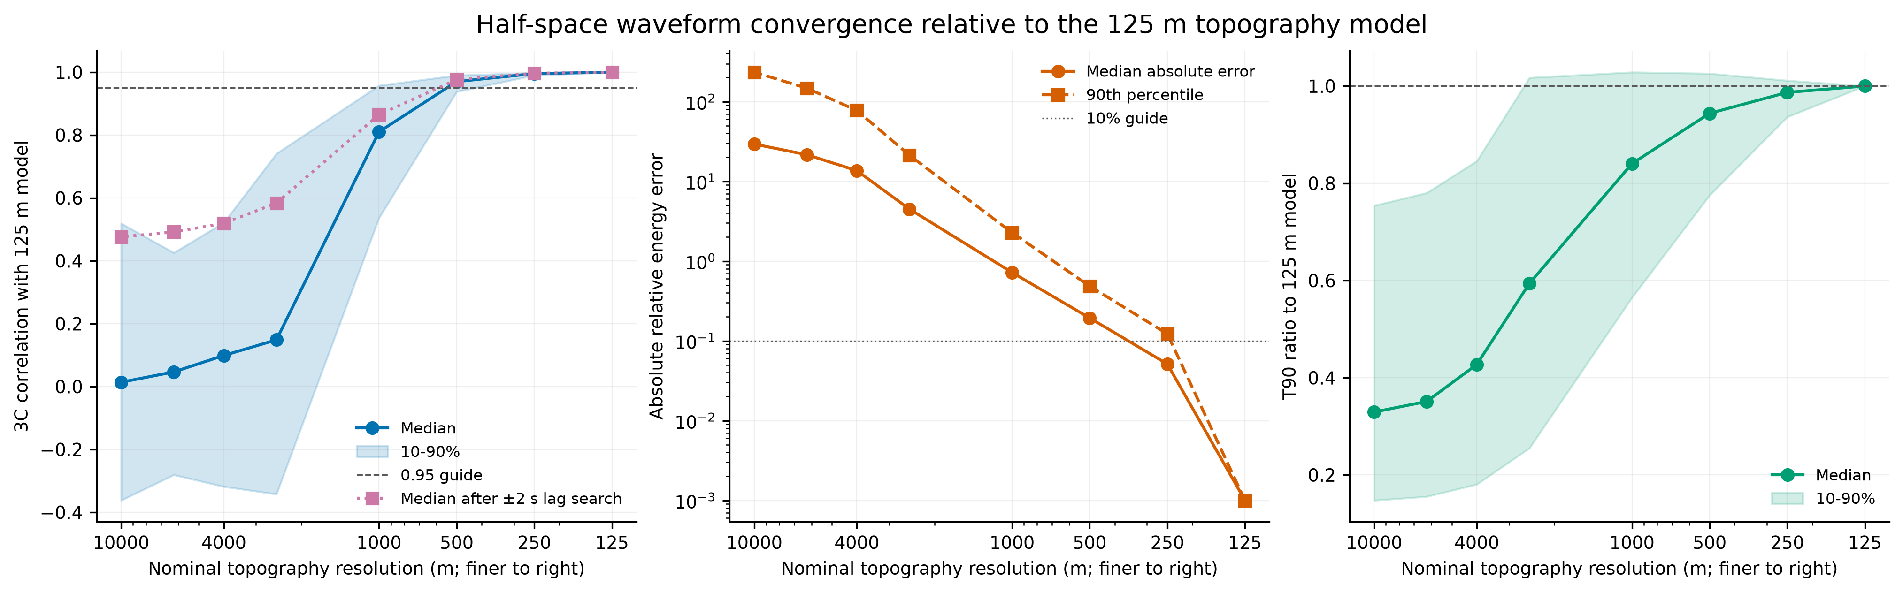
Figure 5. Topographic-resolution convergence relative to the 0.125 km reference. Waveform-shape and energy criteria lead to different practical thresholds. 图 5：相对0.125 km参考模型的地形分辨率收敛。波形形状与能量标准对应不同的实用阈值。

3.4 Layering changes late phase and duration more than the main peak / 3.4 分层对晚期相位和持续时间的影响大于主峰
In the matched 216-receiver layering experiment, the median peak-amplitude ratio is 1.02, while median three-component correlation is 0.864. Total energy increases by 22.1% and T90 by 37.8%. Similar main peaks therefore coexist with significant differences in later phase structure, energy, and duration.
中文：在匹配的216台站分层试验中，峰值振幅比中位数为1.02，而三分量相关系数中位数为0.864；总能量增加22.1%，T90增加37.8%。因此，主峰近似并不意味着完整波形相同，晚期相位结构、能量和持续时间仍存在显著变化。
This result constrains the phrase 'little difference after layering.' The defensible statement is that the strongest peak and average component partitioning are often similar, but interfaces alter the subsequent wave train along a subset of paths. Topographic effects must consequently be evaluated within the relevant layered background rather than transferred from a homogeneous half-space as a fixed correction.
中文：这一结果限制了“加入分层前后差异很小”的表述。更可靠的结论是：最强主峰和平均分量占比通常接近，但分层界面会改变部分路径上的后续波列。因此，必须在相应分层背景中评估地形效应，而不能把均匀半空间结果作为固定修正量直接移植。
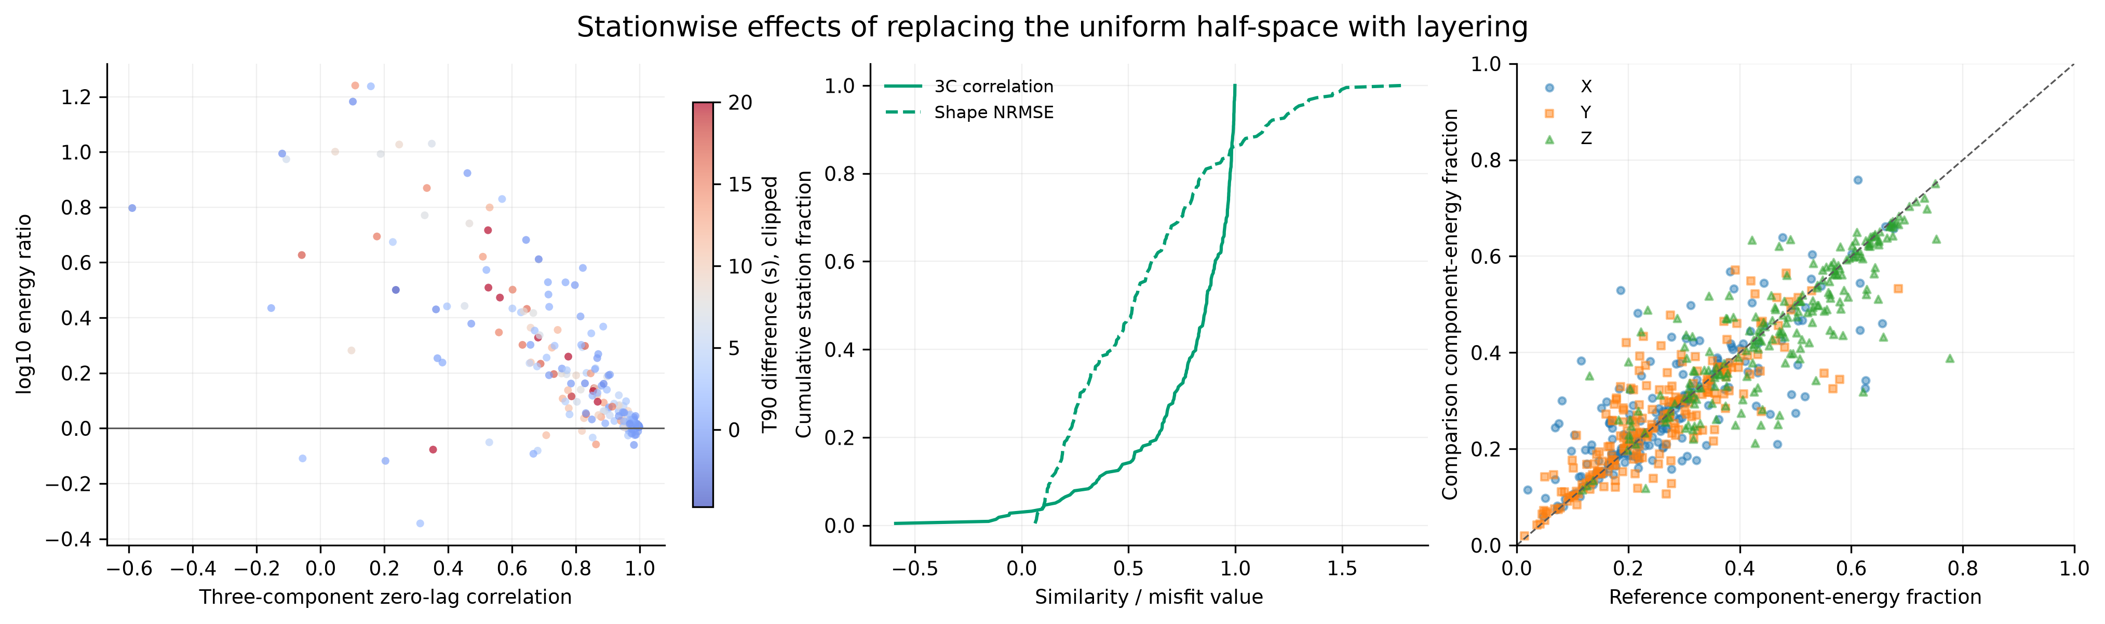
Figure 6. Paired metrics for the half-space-to-layered switch under the same topographic surface. 图 6：相同地形表面条件下，从半空间到分层模型的成对指标变化。

3.5 The regional M1-M6 sequence is nonadditive / 3.5 区域M1-M6序列表现为非加性
The A16/S12 baseline states show that heterogeneity is the strongest early broadening process in the available factorial cells. On a flat surface, M3/M1 increases the median stationwise T90 by a factor of 18.2, while reducing median peak amplitude and finite-window energy to 0.293 and 0.259 of M1. Topography alone, M2/M1, increases median T90 by 5.31 and changes peak amplitude and energy to 0.792 and 0.716 of M1.
中文：A16/S12基线状态表明，在现有因子单元中，随机非均匀性是最强的早期展宽机制。在平坦表面上，M3/M1使台站T90中位数增加18.2倍，同时将峰值振幅和有限时窗能量中位数降至M1的0.293和0.259。单独地形M2/M1使T90中位数增加5.31倍，并将峰值振幅和能量变为M1的0.792和0.716。
The effects saturate when combined. Heterogeneity increases T90 by 18.2 on the flat surface but by only 2.18 after topography is present; topography increases T90 by 5.31 without heterogeneity but by only 1.16 in the heterogeneous background. Surface relief and volume perturbations therefore do not act as independent multiplicative corrections. Their paired contrasts remain physically useful, but the interaction cannot be assigned uniquely to one process with a single stochastic realization.
中文：两种效应组合后出现饱和。非均匀性在平坦表面使T90增加18.2倍，而在已有地形时仅增加2.18倍；地形在无非均匀性时使T90增加5.31倍，而在非均匀背景中仅增加1.16倍。因此，地表起伏和体介质扰动并不是两个彼此独立的乘法修正项。成对差异仍具有物理意义，但在仅有一个随机实现时，不能把交互唯一归因于某一种过程。
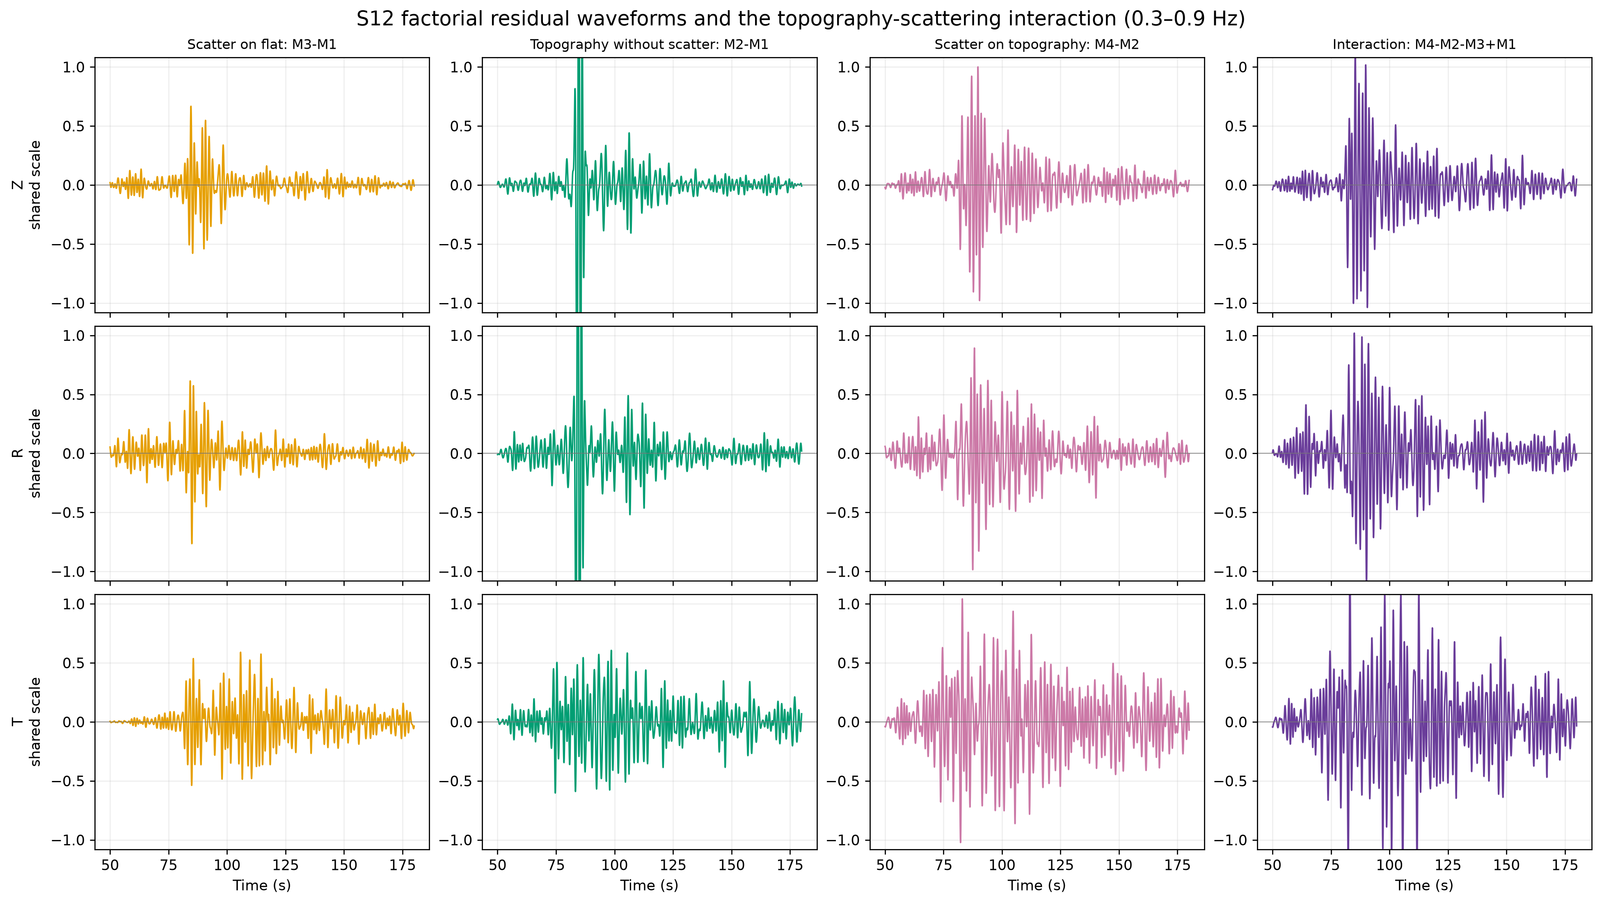
Figure 7. Three-component interaction residuals illustrating the nonadditive coupling of topography and heterogeneity. 图 7：三分量交互残差，显示地形与非均匀性的非加性耦合。

3.6 Component conversion and path dependence persist across backgrounds / 3.6 分量转换与路径依赖在不同背景中持续存在
Median Z/R/T fractions across M1-M4 are 70.1/29.9/~0%, 56.4/27.6/16.1%, 54.6/24.7/20.4%, and 48.9/27.3/23.4%, respectively. M5/M6 increase the median transverse fraction further to 28.9% and 29.3%. The monotonic interpretation is not 'more attenuation,' but progressive loss of the flat-model symmetry and redistribution into horizontal and transverse motion.
中文：M1-M4的Z/R/T占比中位数依次为70.1/29.9/约0%、56.4/27.6/16.1%、54.6/24.7/20.4%和48.9/27.3/23.4%。M5/M6进一步将横向占比提高到28.9%和29.3%。这一序列不能解释为“衰减不断增强”，而应解释为平坦模型对称性逐步破坏，能量不断转移到水平和横向运动。
After distance detrending, cumulative relief range predicts the M2/M1 topographic contrast along profiles 2 and 3 but not profile 1. For peak amplitude the profile-specific Spearman coefficients are -0.753 and -0.802; for energy, -0.824 and -0.801; and for T90, +0.750 and +0.792. Profile 1 coefficients are close to zero. Terrain accumulated along the propagation profile is therefore more informative than receiver elevation, but the relation remains directional.
中文：去除距离趋势后，累计起伏范围可以预测剖面2和3上的M2/M1地形差异，但不能预测剖面1。峰值振幅的分剖面Spearman系数为-0.753和-0.802，能量为-0.824和-0.801，T90为+0.750和+0.792；剖面1的系数接近零。因此，传播剖面上累计经历的地形比单个台站高程更有信息量，但该关系仍具有方向性。
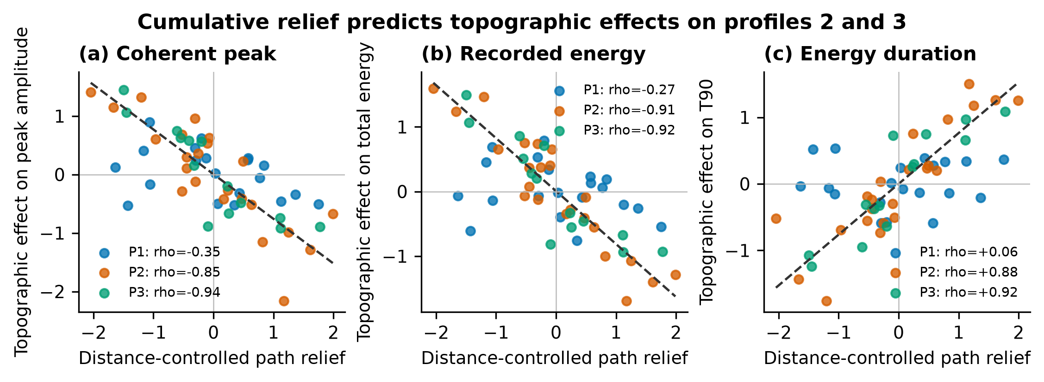
Figure 8. Distance-controlled relations between cumulative path relief and topographic effects. Strong relations occur along profiles 2 and 3 but not profile 1. 图 8：控制距离后的累计路径起伏与地形效应关系。剖面2和3关系显著，而剖面1不支持相同规律。

3.7 Low velocity delays and retains energy conditionally / 3.7 低速结构在条件背景下延迟并滞留能量
Relative to M3 and M4, the M5 and M6 runs introduce new phases on all three components and retain substantial energy beyond the 245 s baseline cutoff. Across the primary profiles, median tmax is 184.6 s in M5 and 173.1 s in M6, compared with 58.3-64.9 s in M1-M4, and median t95 is near 231 s. At S12, extended-window t95 is 368.22 s for M5 and 381.88 s for M6, both close to the 400 s record end and therefore potentially right-censored.
中文：相对M3和M4，M5和M6在三个分量上均产生新震相，并在245 s基线截止时间之后保留大量能量。在主分析剖面上，M5和M6的tmax中位数分别为184.6 s和173.1 s，而M1-M4为58.3-64.9 s；M5/M6的t95中位数约为231 s。在S12台站的扩展时间窗中，M5和M6的t95分别为368.22 s和381.88 s，均接近400 s记录末端，因此可能受到右删失。
The marginal low-velocity response depends on the surface. In the heterogeneous background, M5/M3 and M6/M4 show large but different energy and duration effects, and the topographic energy contrast changes from amplification in M4/M3 to a near-neutral estimate in M6/M5. These are conditional run-level effects because source equivalence, random seed, and all production settings cannot be reconstructed fully from station.nc alone.
中文：低速结构的边际响应依赖地表条件。在非均匀背景中，M5/M3和M6/M4表现出很大但不同的能量与持续时间效应；地形能量差异则从M4/M3中的放大转变为M6/M5中接近中性的估计。由于仅凭station.nc无法完整恢复震源一致性、随机种子和全部生产设置，这些结果属于条件性运行级效应。

3.8 The main energy ridge does not enter a simple diffusion regime / 3.8 主能量脊未进入简单扩散状态
In the half-space experiment, 5 s smoothing gives linear-versus-squared-distance RMSE values of 3.16/7.65 s for the homogeneous model and 3.65/8.15 s for the layered model; 2 and 10 s windows preserve the ranking. In A16/S12, all 12 combinations of three profiles and M1-M4 favor the linear form, with linear RMSE of 1.54-2.88 s versus 4.56-10.03 s for R² and ΔAIC of 268-672. M5/M6 remain linearly preferred after censor-safe filtering; the minimum ΔAIC favoring the linear form is 12.79.
中文：在半空间试验中，5 s平滑时均匀模型的线性距离/距离平方RMSE分别为3.16/7.65 s，分层模型为3.65/8.15 s；2 s和10 s平滑窗保持相同排序。在A16/S12中，三条剖面与M1-M4组成的12组结果全部支持线性形式：线性RMSE为1.54-2.88 s，R²形式为4.56-10.03 s，ΔAIC为268-672。M5/M6在剔除删失风险样本后仍优先支持线性形式，支持线性形式的最小ΔAIC为12.79。
Low velocity delays the ridge and increases scatter, but it does not transform the modeled transport into the simple R²/D regime expected for strong near-field diffusion. This supports the reviewer's inference that topographic scattering alone cannot explain the lunar envelope. The result is restricted to the main energy ridge and current time windows; it does not invalidate diffusion interpretations of much later observed coda energy.
中文：低速结构会延迟主能量脊并增加离散度，但不会把模拟传播转变为强近场扩散所预期的简单R²/D状态。这支持审稿人的判断：仅靠地形散射不能解释月球包络。该结论仅适用于当前时间窗内的主能量脊，并不否定对更晚观测尾波能量采用扩散解释。
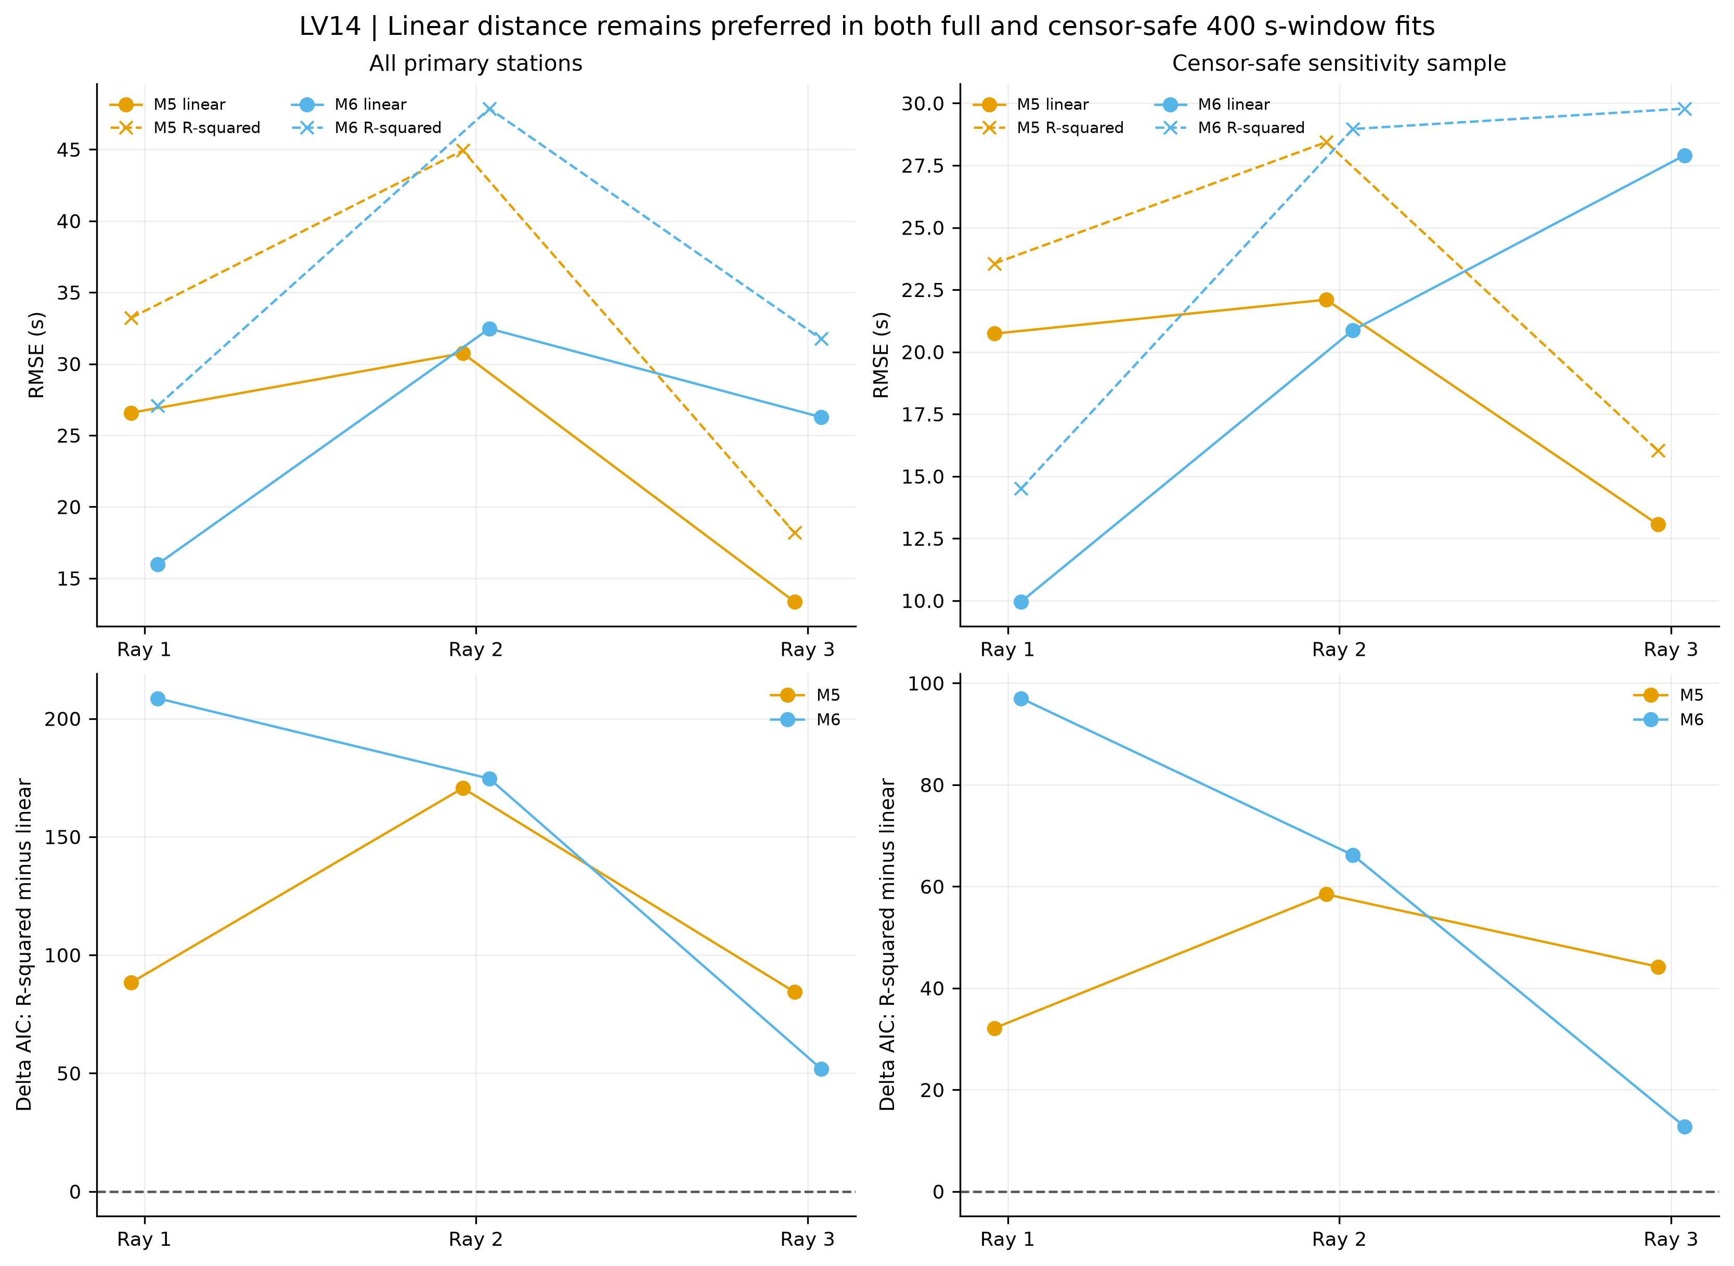
Figure 9. Linear-distance and squared-distance fits for the low-velocity states. Censor-safe comparisons continue to favor a finite-speed energy ridge. 图 9：低速状态的线性距离与距离平方拟合。控制删失风险后，结果仍支持有限速度主能量脊。

3.9 None of the six models reproduces the Apollo S12 long coda / 3.9 六个模型均未重现Apollo S12长尾波
Across the six smoothing windows, the Apollo three-component energy peak occurs at a median of 658.3 s, with a range of 647.1-770.4 s. The S12 synthetic peaks are 85.7, 92.4, 96.5, 93.7, 213.2, and 272.5 s for M1-M6. M5/M6 move the modeled envelope toward the observation, but remain 386-445 s early. Component-envelope correlations also remain low, showing that improved peak timing does not imply phase or waveform agreement.
中文：在六个平滑窗口下，Apollo三分量能量峰值时间中位数为658.3 s，范围为647.1-770.4 s。M1-M6在S12的合成峰值时间依次为85.7、92.4、96.5、93.7、213.2和272.5 s。M5/M6使模拟包络朝观测方向移动，但仍提前386-445 s。各分量包络相关性仍较低，说明峰时改善并不等于相位或波形一致。
The cumulative-energy mismatch is larger. M1-M4 reach t95 at 86.5, 160.7, 110.5, and 152.5 s. M5/M6 reach the current-record lower bounds near 368-382 s, whereas the Apollo observation reaches t95 at 2,804.6 s; only 4.0% of the observed 50-3,000 s energy occurs before 250 s. A scalar source correction cannot remove the joint mismatch in phase, component partitioning, peak time, and duration.
中文：累计能量差异更大。M1-M4的t95依次为86.5、160.7、110.5和152.5 s；M5/M6在当前记录内的下限约为368-382 s，而Apollo观测的t95为2804.6 s。观测记录50-3000 s范围内的能量仅有4.0%出现在250 s之前。单一震源尺度修正无法同时消除相位、分量分配、峰值时间和持续时间上的联合失配。
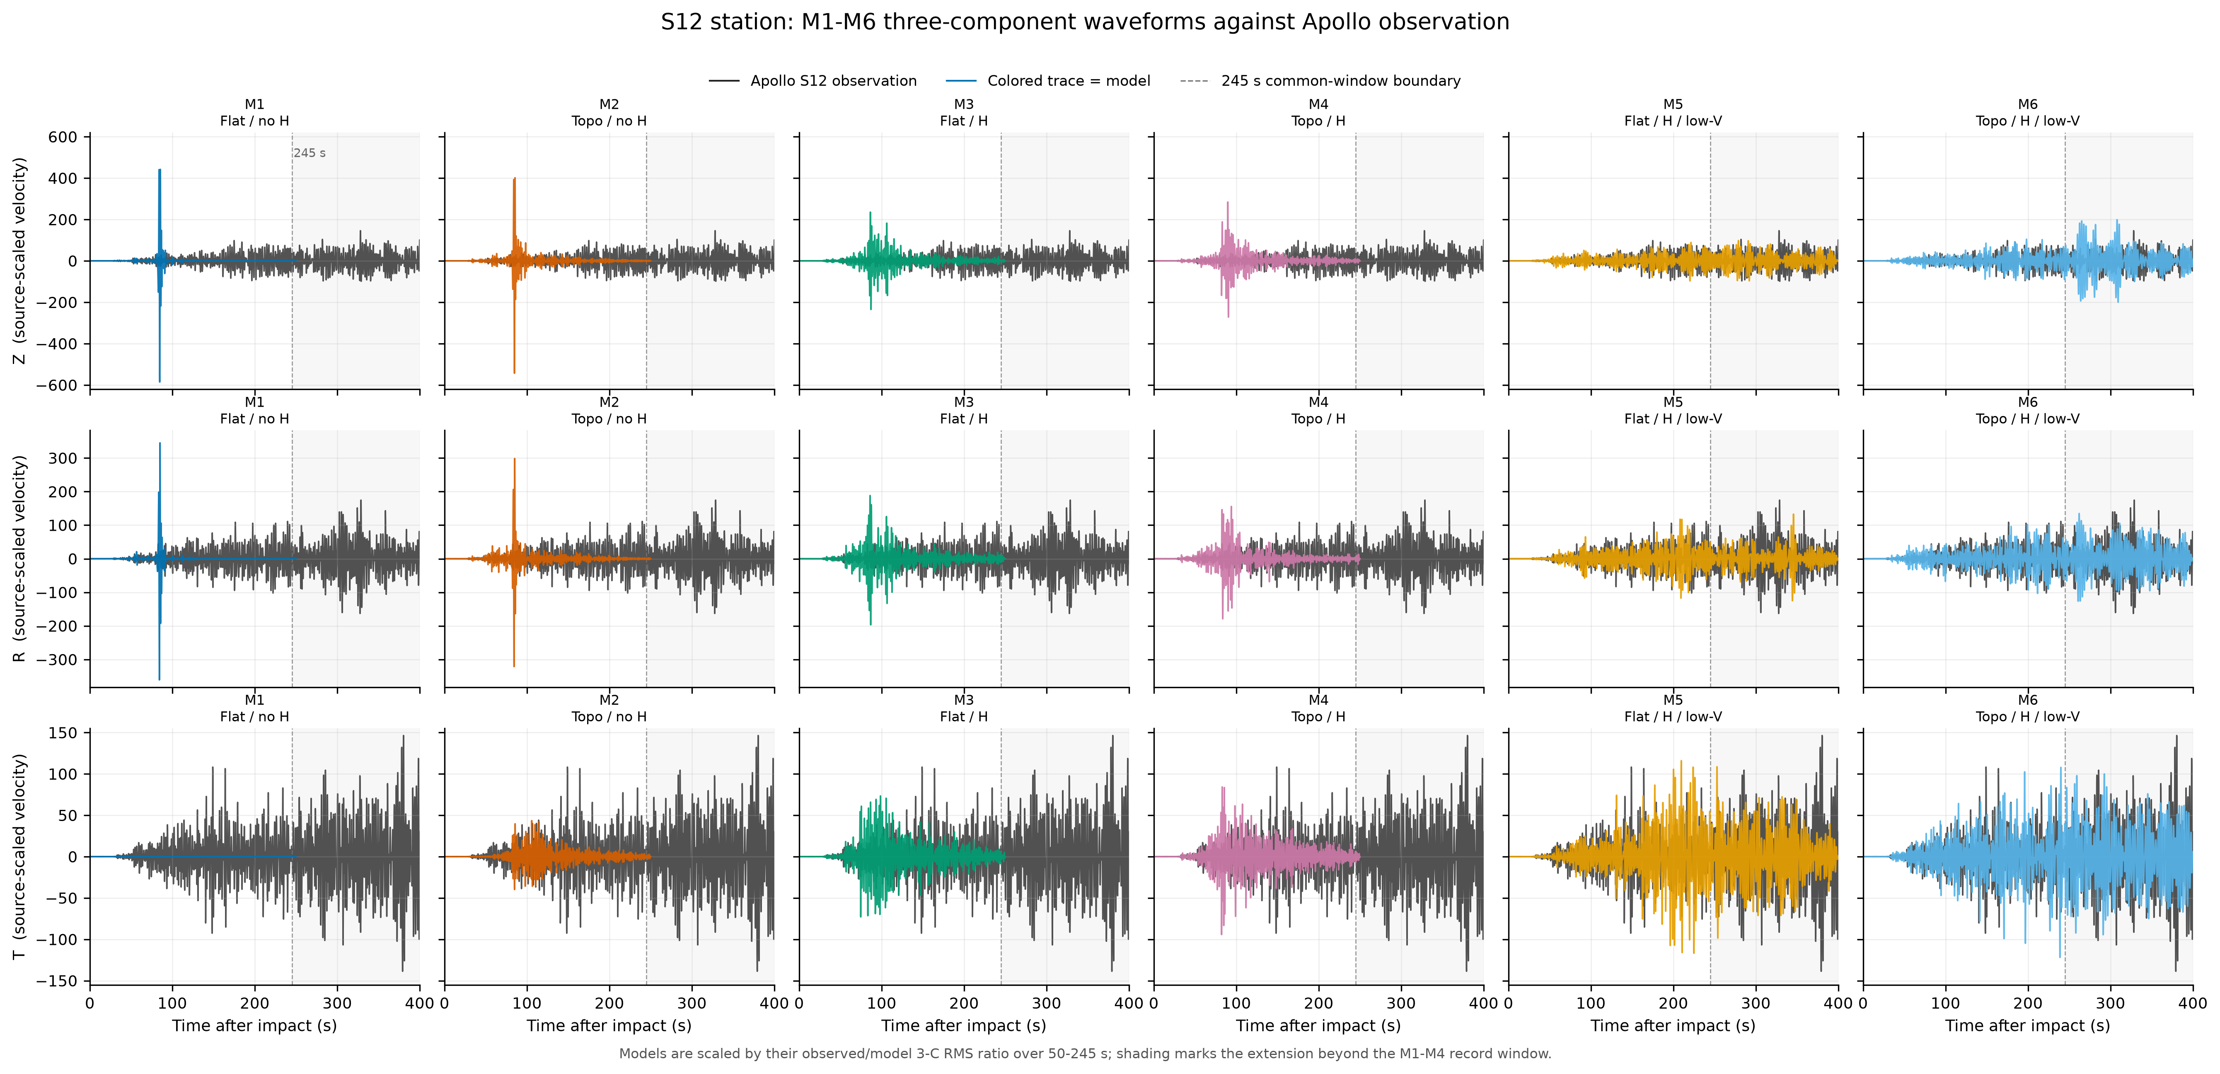
Figure 10. Common-scale Z/R/T comparison between the Apollo S12 observation and M1-M6. Separate component normalization is not used. 图 10：Apollo S12观测与M1-M6在统一尺度下的Z/R/T对比，不使用逐分量归一化。
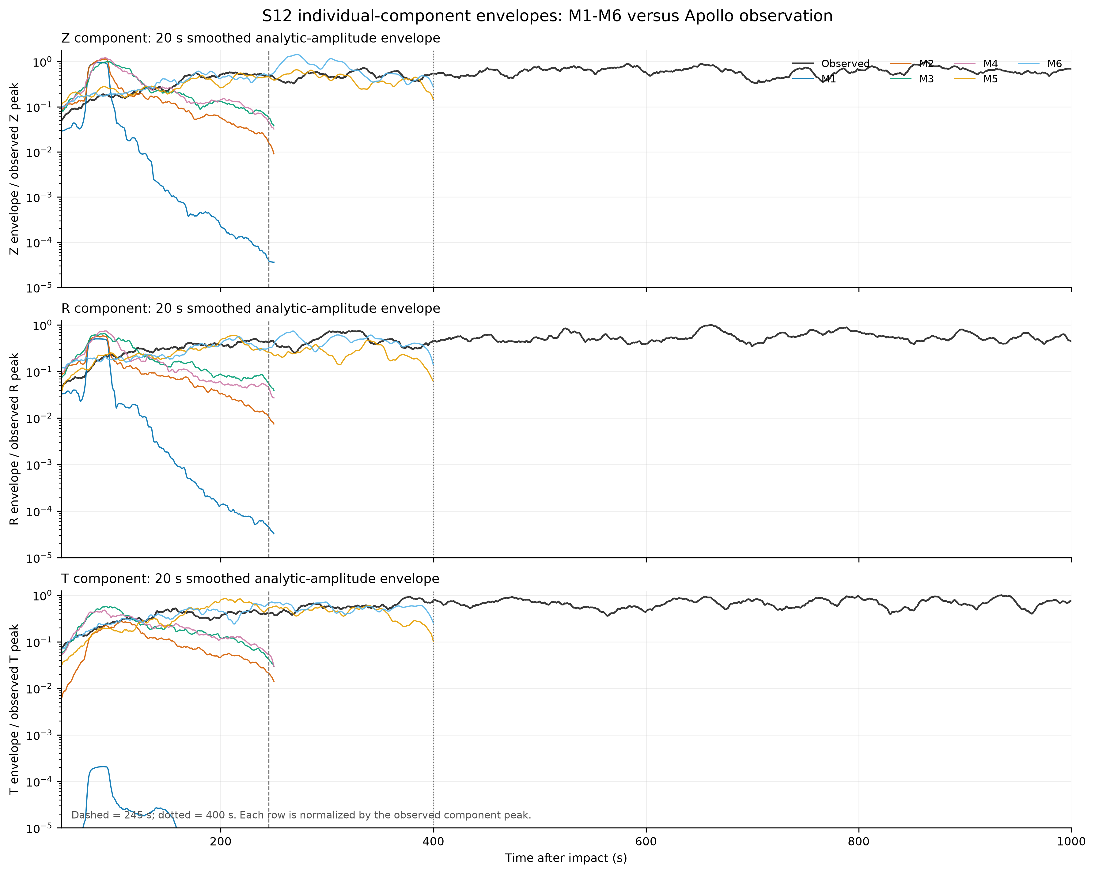
Figure 11. Individual Z/R/T envelopes for M1-M6 and the observation, showing that the low-velocity states delay early energy but do not reproduce the observed componentwise envelope. 图 11：M1-M6与观测记录的Z/R/T独立包络。低速状态延迟了早期能量，但未重现观测的分量包络。
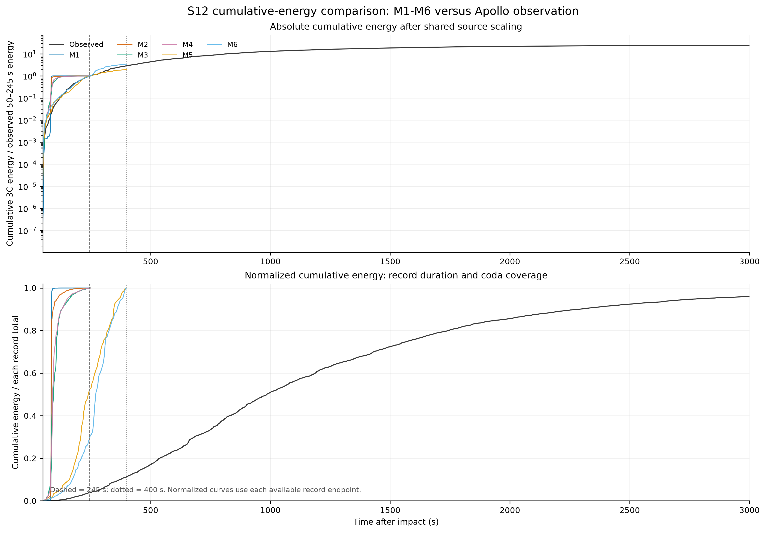
Figure 12. Three-component energy envelope and cumulative-energy comparison. The observed record retains most energy after every synthetic has effectively ended. 图 12：三分量能量包络和累计能量对比。所有合成记录基本结束后，观测记录仍保留大部分能量。

4 Discussion / 4 讨论

4.1 What the controlled hierarchy establishes / 4.1 受控层级试验能够确定什么
The half-space experiment establishes that surface relief can strongly reduce the coherent peak, broaden the weak-energy window, and create transverse motion. The resolution and layering tests then show why this effect cannot be represented by one universal correction: waveform and energy convergence occur at different topographic grid scales, and interfaces change the later wave train even when the main peak is similar. These controls provide the physical basis for interpreting the regional model ladder.
中文：半空间试验证明，地表起伏可以显著降低相干主峰、展宽弱能量时间窗并产生横向运动。分辨率和分层试验进一步说明，为何不能用一个普适修正量表示地形效应：波形与能量在不同地形网格尺度上收敛，且即使主峰相似，分层界面仍会改变后续波列。这些控制试验构成解释区域模型阶梯的物理基础。
At the same time, Al-Attar and Crawford (2016) caution against treating topographic and volumetric scattering as universally distinct physics. Our numerical labels identify which prescribed model element was changed, not an ontological separation of scattering mechanisms. This framing resolves the apparent contradiction between controlled attribution and mathematical equivalence.
中文：与此同时，Al-Attar和Crawford（2016）的研究提醒我们，不能把地形散射与体介质散射视为普遍不同的物理过程。本文的数值标签仅标识给定模型中被改变的元素，而不是对散射机制进行本体上的分割。这样既保留了受控归因的意义，也与数学等效性保持一致。

4.2 Why the topographic effect depends on background / 4.2 地形效应为何依赖背景
A wavefield arriving at rough relief has already been shaped by interfaces, random velocity perturbations, and low-velocity retention. Conversely, topographic conversion changes the polarization and coherence entering later volume scattering. The strong negative T90 interaction in M4 and the altered topographic energy contrast in M6/M5 therefore have a physically plausible origin: each perturbation changes the incident field experienced by the next. Duration and energy fractions are also nonlinear summaries, so additivity is not expected even though the elastic equations are linear for a fixed medium.
中文：到达粗糙地形的波场已经受到分层界面、随机速度扰动和低速滞留的塑造；反过来，地形模式转换又会改变进入后续体介质散射的偏振和相干性。因此，M4中显著的负T90交互以及M6/M5中地形能量差异的改变具有合理物理来源：每一种扰动都会改变下一种扰动所接收的入射波场。此外，持续时间和能量占比本身是非线性摘要指标，所以即使固定介质中的弹性方程是线性的，也不应预期这些差异简单相加。
The current design nevertheless cannot distinguish systematic saturation from realization-specific interference. Multiple random seeds and complete low-velocity/no-heterogeneity cells are required to estimate a full topography×heterogeneity×low-velocity response surface. Until then, M5/M6 amplitude and energy effects should be presented as conditional run-level contrasts, whereas timing, duration, and component redistribution provide the more robust evidence.
中文：然而，当前设计仍不能区分系统性饱和与特定随机实现造成的干涉。只有增加多个随机种子并补齐“低速且无非均匀性”单元，才能估计完整的地形×非均匀性×低速结构响应面。在此之前，M5/M6的振幅和能量效应应作为条件性运行级差异报告，而时间、持续性和分量重分配是更稳健的证据。

4.3 Implications of the two resolution thresholds / 4.3 两种分辨率阈值的含义
The 0.5 km waveform threshold is appropriate when the scientific target is arrival morphology or correlation-based detection in the tested band. It is insufficient when the target includes energy budget, duration, or amplitude-calibrated comparison, for which the 0.25 km result is the safer criterion. Reporting both thresholds prevents an apparently converged waveform plot from being interpreted as full physical convergence.
中文：当科学目标是在当前频带内研究到时形态或基于相关性的检测时，0.5 km波形阈值是合适的；当目标还包括能量收支、持续时间或振幅定标对比时，该阈值并不充分，此时0.25 km结果是更稳妥的标准。同时报告两个阈值，可以避免把“波形图看起来已经收敛”误解为完整物理收敛。

4.4 Why the Apollo mismatch is scientifically useful / 4.4 Apollo失配为何具有科学意义
The failure to reproduce the long coda is not a null result. It bounds what realistic relief, the tested shallow random medium, and the tested low-velocity structure can explain. These ingredients generate early waveform complexity, transverse conversion, path dependence, and delayed energy, but they do not produce the squared-distance main-envelope scaling or multi-thousand-second energy retention seen in lunar data. The observation therefore requires additional or stronger physics rather than a reinterpretation of a scalar source amplitude.
中文：未能重现长尾波并不是无意义的阴性结果，它限定了真实地形、当前浅层随机介质和当前低速结构能够解释的范围。这些因素可以产生早期波形复杂性、横向转换、路径依赖和能量延迟，但不会产生月球观测中距离平方型主包络尺度和数千秒能量滞留。因此，观测失配要求引入额外或更强的传播物理，而不是重新解释一个标量震源振幅。
Candidate missing ingredients include a thicker and more strongly scattering megaregolith, depth-dependent and multiscale correlation lengths, crater-related subsurface damage, lateral variation in regolith thickness, stronger near-surface velocity gradients, deeper scattering, and a consistently verified attenuation model. Simulations should extend to at least 3,000-5,000 s, conserve late energy at the boundaries, and include multiple stochastic realizations before diffusion coefficients or unique layer properties are inferred.
中文：可能缺失的因素包括更厚且散射更强的巨风化层、随深度变化的多尺度相关长度、撞击坑相关地下破碎、风化层厚度横向变化、更强的近表面速度梯度、更深部散射以及经过一致核实的衰减模型。在反演扩散系数或唯一层参数之前，模拟应延长到至少3000-5000 s，确保边界对晚期能量的合理处理，并包含多个随机实现。

4.5 Limitations / 4.5 局限性
Five limitations define the inference boundary. First, the 800-station half-space result represents only one 75° profile. Second, the 216-station resolution/layering geometry must not be mixed with the 800-station coordinates. Third, the regional random medium contains one realization. Fourth, M5/M6 lack complete colocated run manifests and low-velocity/no-heterogeneity controls. Fifth, 250-400 s synthetics cannot measure the full Apollo coda, and the M5/M6 t95 values approach the output boundary. These restrictions are incorporated directly into the wording of all conclusions.
中文：五项局限限定了本文的推断边界。第一，800台站半空间结果只代表一条75°剖面。第二，216台站的分辨率/分层几何不能与800台站坐标混用。第三，区域随机介质只有一个实现。第四，M5/M6缺少共址的完整运行清单以及“低速且无非均匀性”控制组。第五，250-400 s合成记录无法测量完整Apollo尾波，且M5/M6的t95接近输出边界。全文所有结论均按这些限制进行了限定。

5 Conclusions / 5 结论
- Controlled half-space modeling shows that lunar relief strongly redistributes the three-component wavefield: it suppresses the coherent peak, lengthens T90, and transfers substantial Z energy into T motion.
中文：受控半空间模拟表明，月表起伏会显著重新分配三分量波场：它削弱相干主峰、延长T90，并将大量Z分量能量转移到T分量。
- Topographic resolution has two practical thresholds in the 0.3-0.9 Hz band: approximately 0.5 km for waveform shape and approximately 0.25 km for joint waveform-energy convergence.
中文：在0.3-0.9 Hz频带内，地形分辨率存在两个实用阈值：波形形状约为0.5 km，波形—能量联合收敛约为0.25 km。
- Layering, random heterogeneity, and low velocity change the marginal topographic response; topography is therefore not a background-independent correction. M1-M6 must be interpreted as one conditional ladder.
中文：分层、随机非均匀性和低速结构都会改变地形的边际响应，因此地形不是与背景无关的固定修正量，M1-M6必须作为一个条件性模型阶梯解释。
- Across the half-space, layered, and regional models, the main energy ridge remains better described by linear distance than by a simple R² diffusion form over the modeled windows.
中文：在半空间、分层和区域模型中，当前时间窗内的主能量脊均更接近线性距离关系，而不是简单R²扩散形式。
- M5-M6 delay and broaden the synthetic envelopes but do not reproduce the Apollo S12 peak near 658 s or t95 near 2,805 s. The tested near-surface physics explains important early signatures but is insufficient for the lunar long coda.
中文：M5-M6能够延迟并展宽合成包络，但仍无法重现Apollo S12约658 s的峰值和约2805 s的t95。当前测试的近表面物理可以解释重要的早期特征，却不足以解释月球长尾波。

Acknowledgments / 致谢
This study was supported by the National Natural Science Foundation of China (Grant 41930103). We thank the Apollo Passive Seismic Experiment teams and the producers of SLDEM2015 and GRAIL products. We also acknowledge the developers of CGFD3D.
中文：本研究得到国家自然科学基金项目（41930103）资助。感谢Apollo被动地震实验团队以及SLDEM2015和GRAIL数据产品的制作团队，并感谢CGFD3D开发者。

Open Research / 开放研究
SLDEM2015 topography and GRAIL products are publicly available from their original archives, and CGFD3D is available at https://github.com/zw-sustech/CGFD3D. Derived tables, selected synthetic station files, Apollo traces, analysis scripts, and checksums are assembled in the companion project archive. A persistent repository DOI must be inserted after author-approved deposit and before submission.
中文：SLDEM2015地形和GRAIL产品可从其原始数据档案公开获取，CGFD3D可从https://github.com/zw-sustech/CGFD3D获取。派生表、选定的合成台站文件、Apollo记录、分析脚本和校验和已整理到配套项目档案中。作者批准数据存储后、正式投稿前，应补充永久仓储DOI。

Author Contributions / 作者贡献
Tianxiong Wu: Conceptualization, methodology, investigation, formal analysis, visualization, and writing-original draft. Yanbin Wang: Conceptualization, supervision, funding acquisition, and writing-review and editing. Wei Zhang: Software, numerical methodology, resources, and writing-review and editing. All authors should confirm this statement before submission.
中文：吴天雄：概念设计、方法、研究、正式分析、可视化和初稿撰写；王彦斌：概念设计、监督、经费获取和审阅修改；张伟：软件、数值方法、资源和审阅修改。正式投稿前应由全体作者确认。

References / 参考文献
Al-Attar, D., & Crawford, O. (2016). Particle relabelling transformations in elastodynamics. Geophysical Journal International, 205(1), 575-593. https://doi.org/10.1093/gji/ggw032
Barker, M. K., Mazarico, E., Neumann, G. A., Zuber, M. T., Haruyama, J., & Smith, D. E. (2016). A new lunar digital elevation model from the Lunar Orbiter Laser Altimeter and SELENE Terrain Camera. Icarus, 273, 346-355. https://doi.org/10.1016/j.icarus.2015.07.039
Benjamini, Y., & Hochberg, Y. (1995). Controlling the false discovery rate: A practical and powerful approach to multiple testing. Journal of the Royal Statistical Society: Series B, 57(1), 289-300.
Blanchette-Guertin, J., Johnson, C. L., & Lawrence, J. F. (2012). Investigation of scattering in lunar seismic coda. Journal of Geophysical Research: Planets, 117, E06003. https://doi.org/10.1029/2011JE004042
Blanchette-Guertin, J., Johnson, C. L., & Lawrence, J. F. (2015a). Effects of lateral variations in megaregolith thickness on predicted lunar seismic signals. Geophysical Research Letters, 42, 10117-10125. https://doi.org/10.1002/2015GL066151
Blanchette-Guertin, J., Johnson, C. L., & Lawrence, J. F. (2015b). Modeling seismic energy propagation in highly scattering environments. Journal of Geophysical Research: Planets, 120, 515-537. https://doi.org/10.1002/2014JE004654
Gillet, K., Margerin, L., Calvet, M., & Monnereau, M. (2017). Scattering attenuation profile of the Moon: Implications for shallow moonquakes and the structure of the megaregolith. Physics of the Earth and Planetary Interiors, 262, 28-40. https://doi.org/10.1016/j.pepi.2016.11.001
Hartzell, S. H., Carver, D. L., & King, K. W. (1994). Initial investigation of site and topographic effects at Robinwood Ridge, California. Bulletin of the Seismological Society of America, 84, 1336-1349.
Nunn, C., Garcia, R. F., Nakamura, Y., et al. (2020). Lunar seismology: A data and instrumentation review. Space Science Reviews, 216, 89. https://doi.org/10.1007/s11214-020-00709-3
Onodera, K., Kawamura, T., Tanaka, S., Ishihara, Y., & Maeda, T. (2021). Numerical simulation of lunar seismic wave propagation: Investigation of subsurface scattering properties near Apollo 12 landing site. Journal of Geophysical Research: Planets, 126, e2020JE006406. https://doi.org/10.1029/2020JE006406
Onodera, K., Kawamura, T., Tanaka, S., Ishihara, Y., & Maeda, T. (2022). Quantitative evaluation of lunar seismic scattering and comparison between the Earth, Mars, and the Moon. Journal of Geophysical Research: Planets, 127, e2022JE007558. https://doi.org/10.1029/2022JE007558
Pitarka, A., & Irikura, K. (1996). Modeling 3D surface topography by finite-difference method: Kobe-JMA station site, Japan, case study. Geophysical Research Letters, 23, 2729-2732. https://doi.org/10.1029/96GL02493
Rodgers, A. J., Petersson, N. A., & Sjögreen, B. (2010). Simulation of topographic effects on seismic waves from shallow explosions near the North Korean nuclear test site with emphasis on shear wave generation. Journal of Geophysical Research: Solid Earth, 115, B11309. https://doi.org/10.1029/2010JB007707
Wang, W., Zhang, Z., Zhang, W., Yu, H., Liu, Q., Zhang, W., & Chen, X. (2022). CGFDM3D-EQR: A platform for rapid response to earthquake disasters in 3D complex media. Seismological Research Letters, 93, 2320-2334. https://doi.org/10.1785/0220210309
Zhang, W., & Chen, X. (2006). Traction image method for irregular free surface boundaries in finite difference seismic wave simulation. Geophysical Journal International, 167, 337-353. https://doi.org/10.1111/j.1365-246X.2006.03113.x
Zhang, W., Zhang, Z., & Chen, X. (2012). Three-dimensional elastic wave numerical modelling in the presence of surface topography by a collocated-grid finite-difference method on curvilinear grids. Geophysical Journal International, 190, 358-378. https://doi.org/10.1111/j.1365-246X.2012.05472.x

