**Components:**

1. 1x Arduino Nano

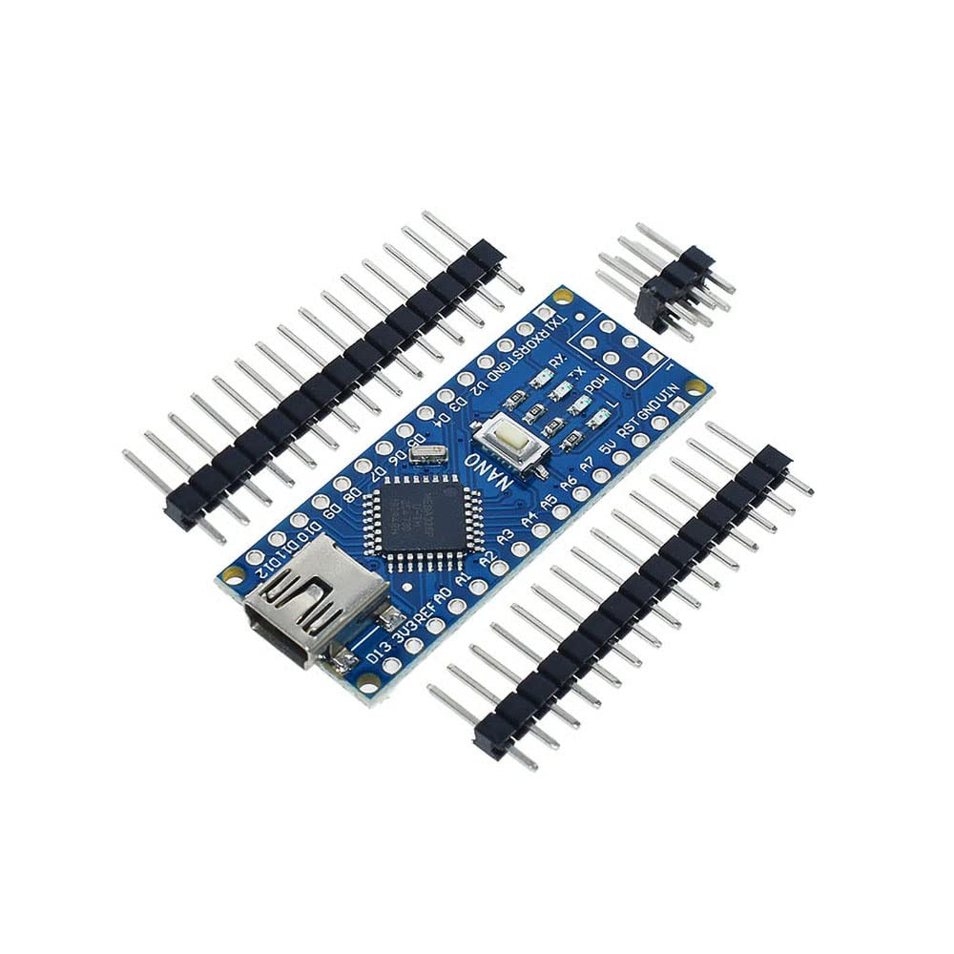

1. 1x DSN-Mini-360 Buck Converter

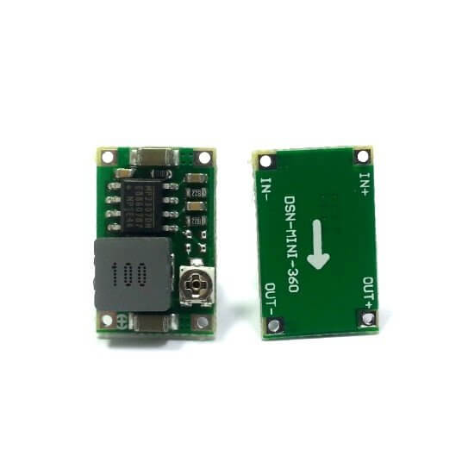

1. 1x Hw-432 Xl6009 Dc To Dc Boost Converter

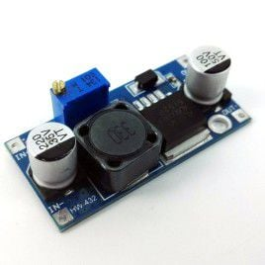

1. 1x OLED Display Module 128x64 I2C SSD 1306 LCD Screen

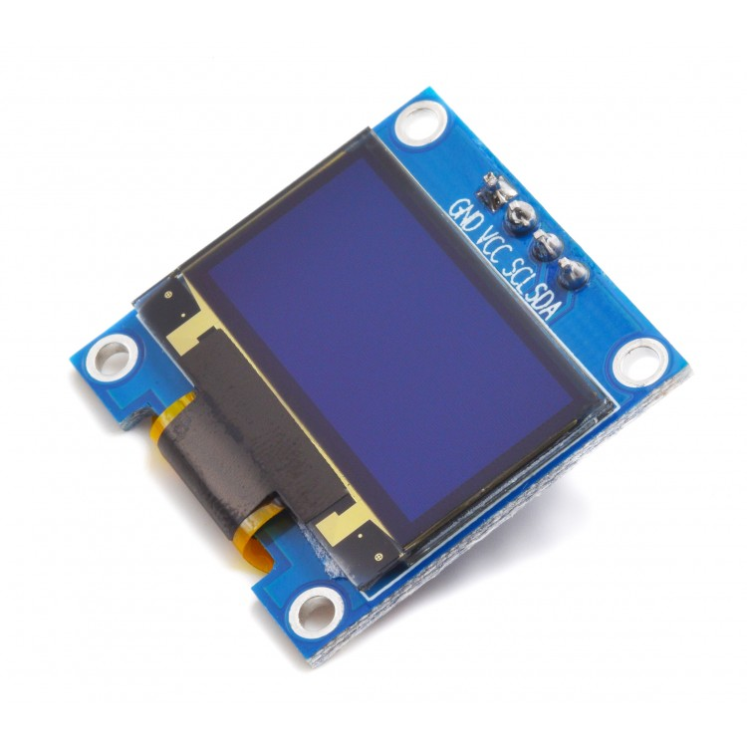

1. 1x L298N Motor Driver Module

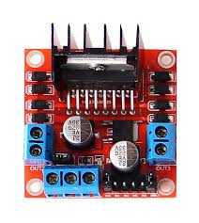

1. 1x ON/OFF Switch

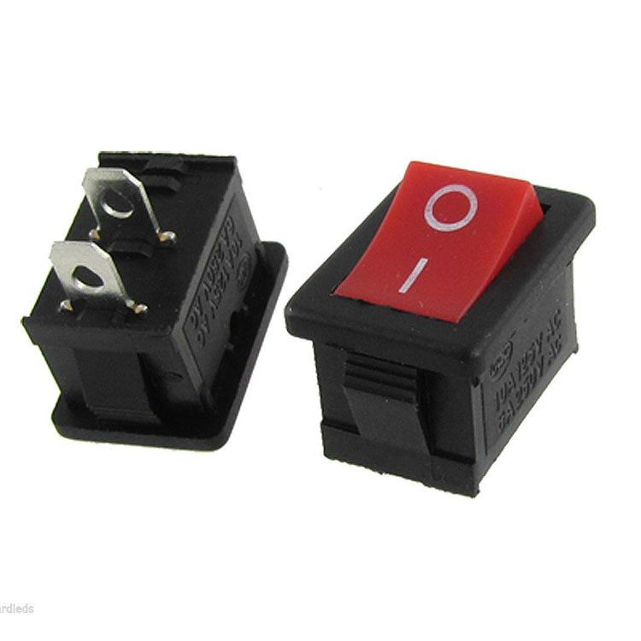

1. 2x 2-Pin Push Buttons

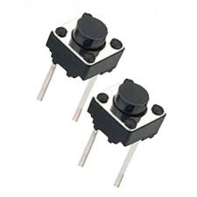

1. 1x 5mm Blue LED

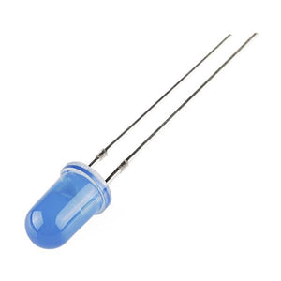

1. 3x HC-SRO4 Ultrasonic Sensors

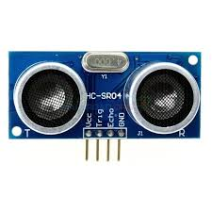

1. 25ga Gear Motor Complete KIT

Mounting brackets for 25ga motor

2x wheels for 25ga motor

Hex coupler for 25 ga motor

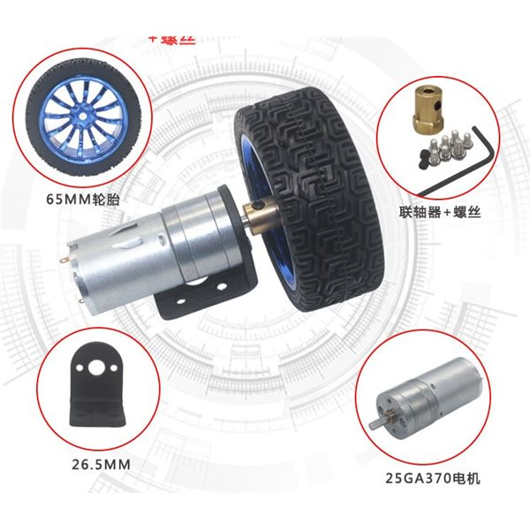

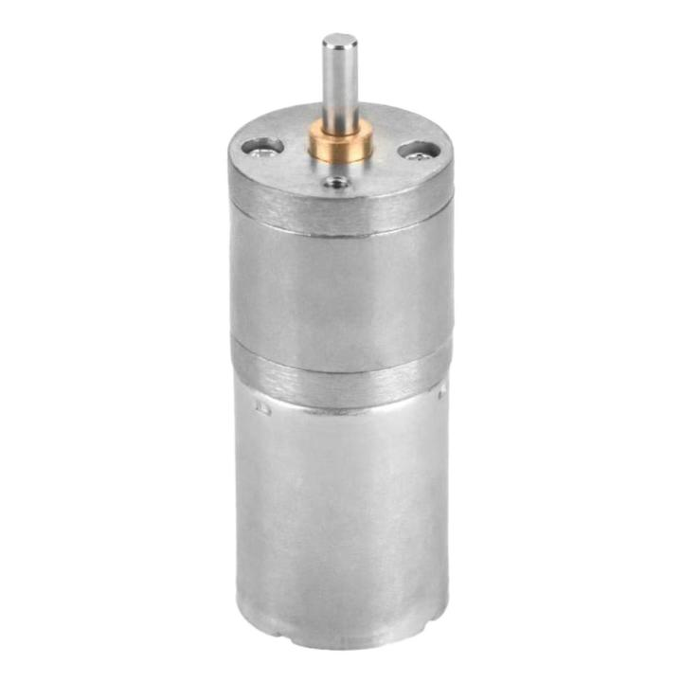

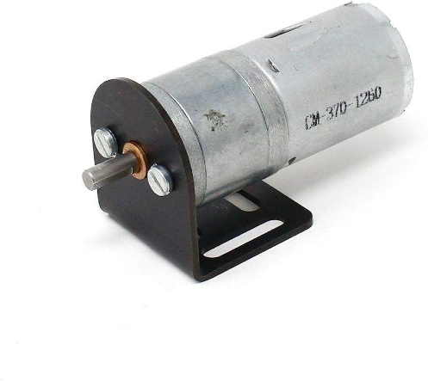

1. 1x Ball Caster for 25ga Motor

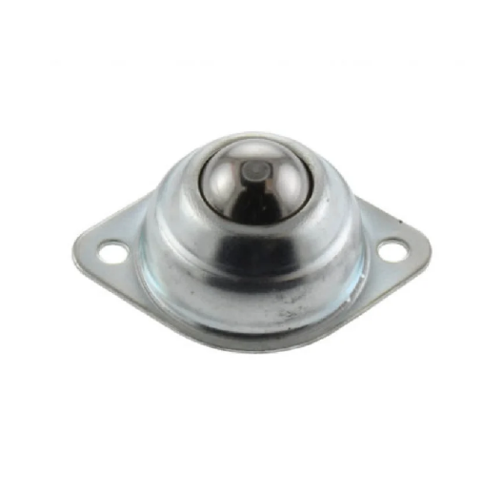

1. 6x TCRT5000 Reflective IR Sensor

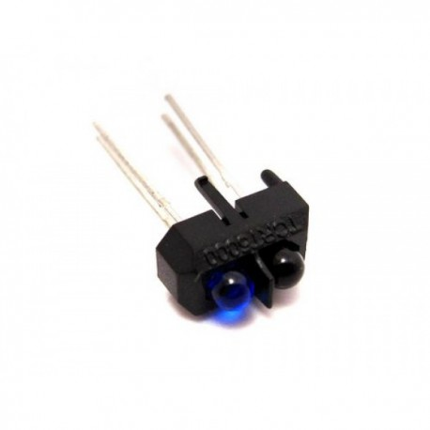

1. 10x 4.7k resistors
2. 10x 220-ohm resistors
3. 1x 8 header pins

