Software Requirements Specification Document
<Mobile Video Invitation By YourEvent.co, 24, Jalpreet Singh Nanda, Raj Patel, Manas Tewari, Vikram Ahuja>

Brief problem statement
YourEvent.co is a platform that provides users with a suite of tools that will help users in planning events such as weddings and birthdays on their own. Video Invitation over Mobile is an app that will help users to send video invitations on the fly. The app allows users to shoot a selfie video, edit it and share it across his/her social networks.

System requirements
- An Android Phone with Android version 2.3.3 or better.
- The Phone should have a Front camera.
- We also require following softwares:
  - Android Development Studio/Eclipse
  - Java (Programming Language)
  - Collaboration Tools like Git, Bitbucket
  - Some other tools like MSOffice, Google Docs, Asana, InVision

Users profile
Our Application would be used by any person who is organizing a party (Birthday, Wedding, Engagement, Reception and so on) and wants to invite his friends and relatives to the party. We assume that the person has an Android Mobile and is familiar with how to use Android. The person will be using our app in the normal user mode.
Feature requirements (described using use cases)

No. | User Case Name | Description | Release
 | Signup | User can signup to the app using two options namely Facebook( and Google+ in R2) | R1
 | Login | Once signed up user can login to the app | R1
 | Previous Invitations | User can view all his previously sent invitations | R1
 | Select event | User can select any one of the six given events to create a new video invitation | R1
 | Event details | Enter the required details in the form for the event | R2
 | Select script type | According to the previous form a script will be generated. This script can be of different types like formal, informal, family. | R2
 | Confirmation of the automated script generated | The selected script type and the form details are used to generate a script | R2
 | Record Video | Record the video invitation of the user | R1
 | Display selected script | While recording video the previously generated script is shown sequentially such that it can give promptness to the user | R2
 | Select background score | Add a background score to the recorded video according to the selected event | R2
 | Send Invitation | The user can send the video invitation to the people the user wants to invite through different platforms | R1

Use Case Diagram

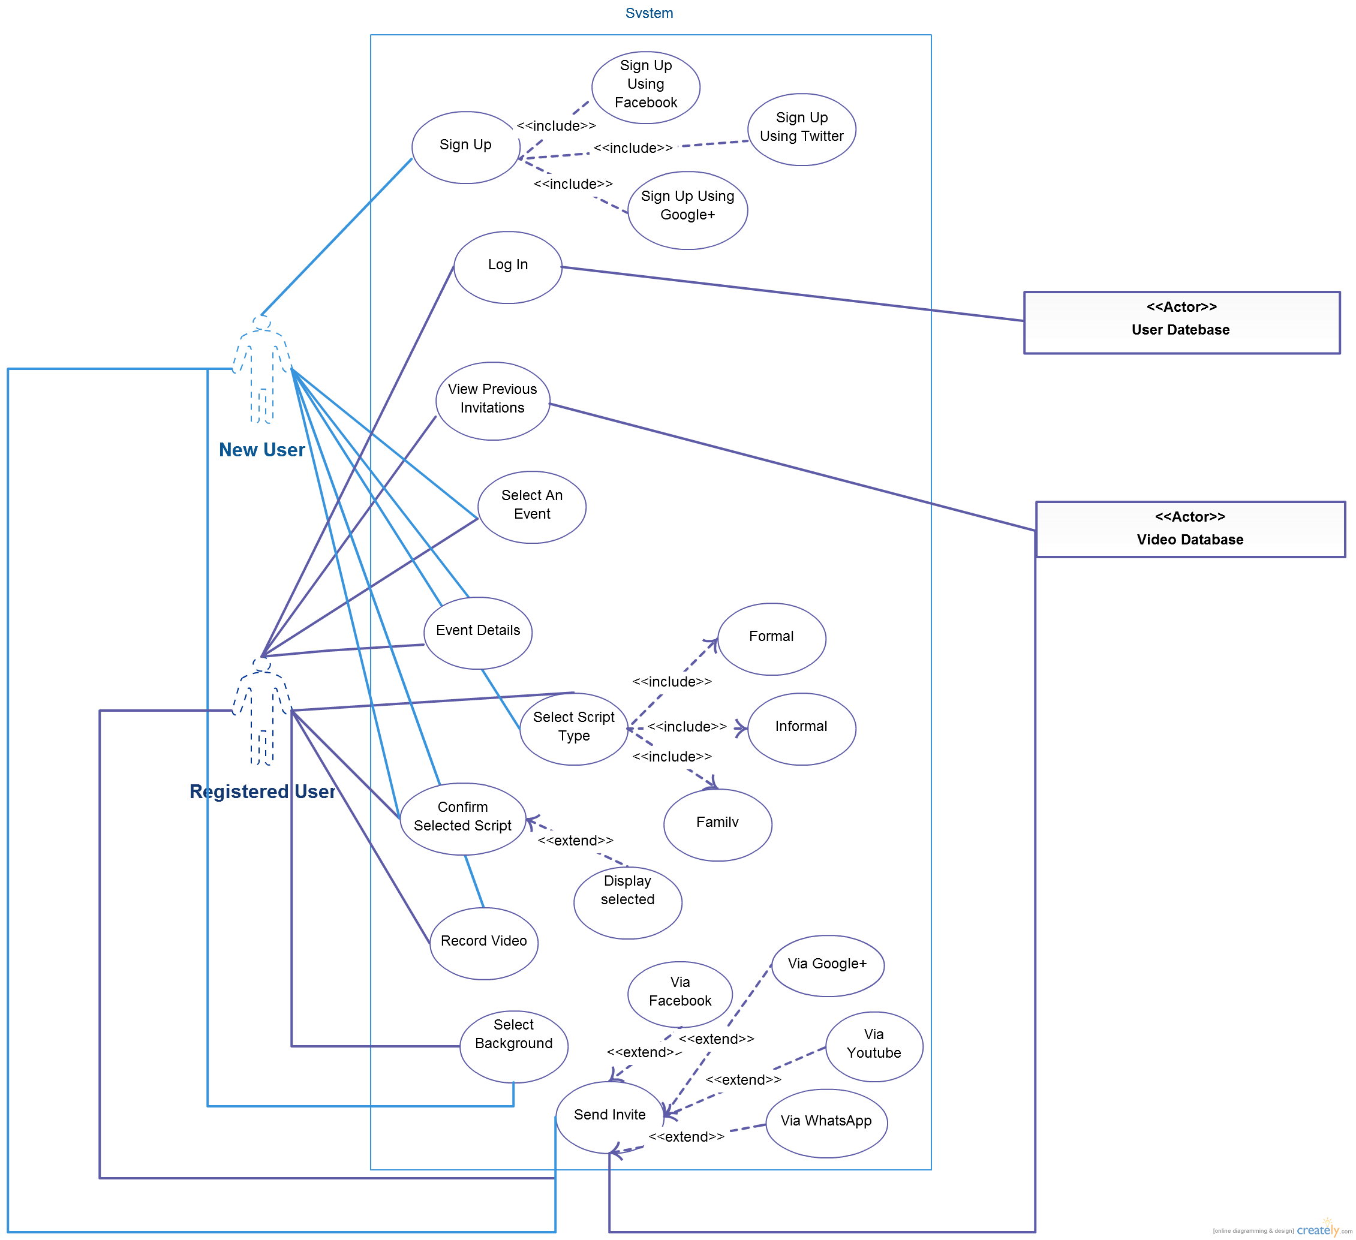

Use case description

Use Case Number: | UC-01
Use Case Name: | Signup
Overview: | Normal signing up to the app by facebook.
Actors: | Any user with a facebook account
Pre condition: | User has a facebook account
Flow: | Main (success) Flow: 1. On success user gets the select event page  2. If user is not logged in before then user gets added to the database
 | Alternate Flows: 1. On failure → give error if facebook login is not possible
Post Condition: | User gets redirected to select event page

Use Case Number: | UC-02
Use Case Name: | Login
Overview: | If user is already signed in then user is redirected to select event page
Actors: | User
Pre condition: | User has signed up once from that facebook account
Flow: | Main (success) Flow: 1. Data corresponding to the user is loaded if in the database
 | Alternate Flows: 1. Log in again if signed out from the app
Post Condition: | Redirected to select event screen

Use Case Number: | UC-03
Use Case Name: | Previous Invitations
Overview: | Show the previous invitations sent by the user (if any)
Actors: | User
Pre condition: | User is logged in
Flow: | Main (success) Flow: 1. Preview the previous invitations  2. Play the previous video invitaions
 | Alternate Flows: 1.1. If there is no invitaions sent display nothing
Post Condition: | Previous invitaions shown and played on tapping

Use Case Number: | UC-04
Use Case Name: | Select event
Overview: | Select the event for which user wants to send invitation
Actors: | User
Pre condition: | User is logged in and added into database of the app
Flow: | Main (success) Flow: 1. Selecting the event for which the invitation is to be created
 | Alternate Flows: 1.1 If user is not added into database give error
Post Condition: | Redirect to video recording page

Use Case Number: | UC-05
Use Case Name: | Event details
Overview: | The user has to enter the details of the event.
Actors: | User
Pre condition: | The User has to select an event from the select event screen.
Flow: | Main (success) Flow: 1. Once the user enters the details and clicks on continue the details get saved and are used in the upcoming screens.
 | Alternate Flows: 1. If the user leaves a field empty then he will remain on the same page.
Post Condition: | The user will be now taken to the Script selection screen.

Use Case Number: | UC-06
Use Case Name: | Select script type
Overview: | The user has to select the type of script he wants to read while recording the invitation.
Actors: | User
Pre condition: | The user has to fill the event details form.
Flow: | Main (success) Flow: 1. The user has to select one of the three script types namely Formal, Informal and Family.
 | Alternate Flows: N.A.
Post Condition: | On selection, the user will be taken to the Automated script page.

Use Case Number: | UC-07
Use Case Name: | Confirmation of the automated script generated
Overview: | The user is provided with an automated script based on the type of event and type of script he selected previously
Actors: | User
Pre condition: | The user has to select the type of script.
Flow: | Main (success) Flow: 1. The user has to click continue if he wants to use this script.
 | Alternate Flows: 1. The user can go back to the previous screen is he is not satisfied with the script.
Post Condition: | 1. The user will be redirected to the record video screen.  1.1 The user will taken back to the Select script type screen.

Use Case Number: | UC-08
Use Case Name: | Record Video
Overview: | Record the video for inviting people
Actors: | User
Pre condition: | User is added into database
Flow: | Main (success) Flow: 1. Record the video describing the event
 | Alternate Flows: NA
Post Condition: | Video recorded and stored corresponding to the user

Use Case Number: | UC-09
Use Case Name: | Display selected script
Overview: | The script selected by the user will be displayed while the user records the video.
Actors: | User
Pre condition: | The user has to confirm the script he wants to choose.
Flow: | Main (success) Flow: 1. The script that was selected by the user will be displayed on top of the screen while the user records the invitation.
 | Alternate Flows: N.A.
Post Condition: | The text gets changed on certain intervals of time as the user records the video.

Use Case Number: | UC-10
Use Case Name: | Select background score
Overview: | The user has the option to select a background score is he wants to.
Actors: | User
Pre condition: | The User has to finish recording the video.
Flow: | Main (success) Flow: 1. The user selects the background score he wants.
 | Alternate Flows: 1. The user skips the page.
Post Condition: | The user is taken to the Send invite screen.

Use Case Number: | UC-11
Use Case Name: | Send Invitation
Overview: | Share the created video invitation
Actors: | User
Pre condition: | Video recorded and saved
Flow: | Main (success) Flow: Share the video recorded by facebook or whatsapp.
Alternate Flows:1.1 Record another video
1.2 Retake the video
Post Condition: | Video invitation sent

